Welcome to My-Parish !


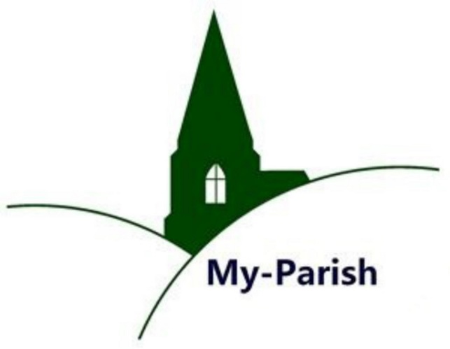

My-Parish is an online community and resource for everyone interested in parishes, from the Middle Ages to the present, in Britain, Europe and beyond: http://warwick.ac.uk/my-parish
Whether you are a student, academic or museum professional, a private researcher or a member of a local society, My-Parish offers open space to share your work and experience of parish history, art, heritage and culture. All information is freely accessible at any time.

By becoming a My-Parish member, you will additionally be able to ...
- upload images, videos and other parish-related materials
- promote and disseminate your own projects, large or small
- publish longer or shorter pieces of original research
- interact with other My-Parish members across the globe
An initiative of the Warwick Network for Parish Research
represented by Beat Kümin (co-ordinator) and Joe Chick (webmaster) –
to join us very easily and for free just contact: my-parish@warwick.ac.uk
with your email address and (if applicable) affiliation / website.

