Fifteenth Warwick Symposium on Parish Research:
‘The Digital Parish’ (University of Warwick, 20 May 2017)

Beat Kümin (University of Warwick) began the day by welcoming delegates, thanking the Humanities Research Centre for its continuing support and introducing this year’s topic: The Digital Parish. This was the first symposium to take place since the My Parish website was relaunched at its new web address.

Many new members have joined and now have the opportunity to contribute content in the form of ‘Posts’ or ‘Texts’. The new website has been designed to make it much easier for users, who no longer need to log in to access resources or advertise news and events on the Forum. Just before the symposium, for example, a member drew attention to the Digital Pilgrim II project, which will use GIS software to map pilgrim badge finds linked to medieval shrine sites. The webmaster for the relaunched website is Joe Chick, who can be contacted on my-parish@warwick.ac.uk with any queries.
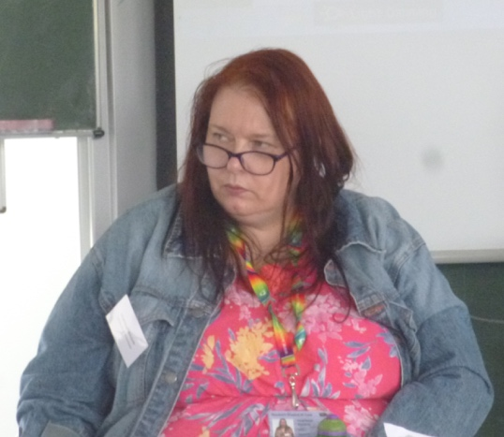
The first session, chaired by Andrew Foster (University of Kent), was on the theme of ‘Digital Approaches to the Parish’. Hàìghlèàgh Winslade (University of Winchester) spoke first on her experience of using an Access database in her research, having had no prior experience with the program. In her presentation she showed attendees how she had extended her project beyond this program through the use of mapping software. Using digimap to plot cases of Catholic recusants in Sussex, she demonstrated how the geography of the county served to isolate certain communities from Chichester, the centre of the diocese. For those who did not attend the conference, her map is soon to be added to the My Parish website.
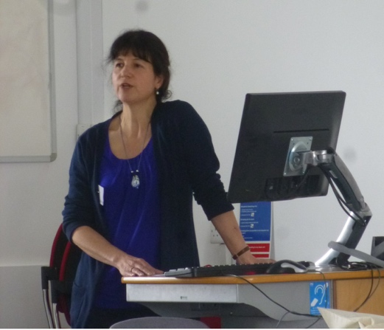
Rebecca Warren (University of Kent) then shared lessons she had learned during a project that used Access to analyse registers of 'state approvals' of parish ministers in the years 1654-60. Her motivation for using the programme had been the need to find a way of handling the unwieldy quantities of data contained in the registers. She proposed a number of methodological guidelines for database projects, which became a popular topic of discussion across the day. She suggested, for example, that researchers should make no assumptions, which in her case meant requiring a high level of certainty that two mentions of an individual refer to the same person before treating them as such in a database. Another rule was that a database should make clear which data comes from the researcher’s own findings and which comes from other sources.
Next, Charmian Mansell (University of Exeter & Institute of Historical Research) presented a range of digital methods to analyse church court records. Firstly, she had compiled a database of deposition evidence from the dioceses of Gloucestershire and Exeter to explore the lives of female servants in the early modern period. Secondly, the coding program NVivo helped her to understand the context and frequency of textual information. Thirdly, she had made use of mapping software to locate church court evidence by parish, revealing that cases were more likely to come from the centre of Gloucestershire. She proposed that this reflected, among other factors, the difficulty of making a long journey to attend a court.
Susan M. Cogan (Utah State University) concluded the first session with a paper on visual mapping. Her talk included an introduction to NanoHistory, an online tool she is developing in collaboration with Matt Milner. Its aim is to help users to map day-to-day interactions between parishioners. Her own research tracks the networks of Catholic recusant families and, after having drawn family trees by hand, she realised the desirability of digitalizing the process. Her presentation engaged with some of the challenges of this type of research, in particular the difficulty of choosing the right query to enter into a database to yield the most interesting insights.

The discussion of the first session focused in particular on the use of mapping and the challenges of using spatial approaches. One consideration is choosing the level of detail to be presented. It was felt that too much information on a map can detract from the key points that a researcher wishes to make. Another issue was the difficulty of finding a map of historic English parishes. Attendees were directed towards two possible resources: the Kain and Oliver visualisations of boundaries deposited in the UK Dataservice and, for specific regional information, volume two of the Victoria County History series.

The second session of the symposium, chaired by Felicita Tramontana (Warwick), looked at the database of the churchwardens’ accounts of England and Wales currently being prepared for online dissemination via My Parish. Valerie Hitchman (University of Kent), the project initiator and director, outlined how churchwardens’ accounts can be used to explore a range of topics, in particular providing insights into the lives of ordinary people and religious change. She emphasised the difficulty of locating reliable information on surviving sets. The database will list all churches and chapels, giving, where possible, their dedication; diocese, arch-deanery, and deanery; the years of their surviving accounts; the total expenditure for each year; and a map of the parish’s location.

Dave Toulson (University of Warwick) built on her talk with an update on the design of the churchwardens’ accounts database. The fundamental guidelines are simplicity and collaboration; the latter informed by his own realisation - part way through his PhD – that someone had already digitised much of the data he had been working on. He then invited delegates to consider two important questions for the future direction of the project. Firstly, what information is useful to researchers? Secondly, can there be too much data?
Helpful guidance on these points emerged in a wide-ranging discussion which also raised the fundamental question of source definition. Valerie Hitchman explained a number of exclusions such as documents kept by other parish officials (like overseers of the poor) or representatives of townships and urban corporations with only incidental information on churchwardens’ activities. Specifically, on the most convenient ways in which to present the data, delegates stressed the importance of search facilities providing quick access to locations and surviving years of coverage.
The third session, chaired by Alex Craven (VCH Gloucestershire), looked beyond the English parish, both thematically and geographically. Josh Rhodes (University of Exeter) began the session by explaining how his project combined parish and manorial records to explore the practice of subletting in eighteenth century England. He applied GIS mapping software to plot the extent of subletting and used ESRI Storymap to produce a video depicting changes across time. It became clear that these digital tools had enabled him to understand the logic behind subletting in a way that would not have been so apparent through traditional methods of research.

The final two papers of the day provided a fascinating excursion onto the Continent by outlining recent research into Polish parishes. Artur Karpacz (Pontifical University of John Paul II) highlighted a project which catalogues and digitises parochial and episcopal records in the diocese of Krakow. A wide range of documents and artefacts have come to light in the 200 parishes catalogued so far, many of which continue to be kept in the parish churches themselves. This includes liber memorabilium (essentially parish chronicles), inventories and visitation records, architectural plans, income and expenditure records, liber documentorum (recording privileges and manorial rights), lists of priests, photo albums, brotherhoods’ books, and seal matrices.

Finally, Stanisław Witecki (Jagiellonian University) surveyed his database of the books available to parish priests in five eighteenth-century dioceses of Poland-Lithuania. Recorded information covers the individual clerics, titles of works (classified with regards to their ‘enlightenment’ content and episcopal recommendations); and parishes (including their church dedication and patronage rights). Taken together, this data can help to trace the spread of enlightened ideas in Poland-Lithuania. Yet, as illustrated by the popularity of texts by Jan Wijkowski, many works were neither enlightened nor recommended by the bishop. Another finding, made possible by the database’s recording of book contents, was how there appears to have been little preaching on the topic of equality.
A number of themes raised by these papers were then picked up in questions. There was an interesting comparison of Polish and English visitations, with the former tending to be more interested in economics, compliance with episcopal orders (e.g. on book purchases) and the material condition of churches rather than issues of moral standards. The question of how to define an enlightened book was also raised. Witecki explained that his database categorised books based on his own content criteria, rather than that of contemporary Church figures.

The event concluded with a general discussion of the opportunities and pitfalls of the ‘Digital Parish’. In relation to beginning an IT-based project, delegates emphasised careful considerations of source materials and research questions, the extent to which options are limited by the software to which an institution subscribes, and the difficulty of ensuring a project has long-term sustainability in a world where technology is constantly changing. Other prominent themes of discussion were the need for collaboration and intra- and inter-disciplinary exchange, in particular regarding the transparency of processes as well as results, the question of whether researchers receive credit for database design or just for the analytical results they produce, and the feasibility of a wider pooling of resources and the creation of one-stop access points for the sharing of digital information. As a small step in this direction, delegates resolved to post to My Parish a Digital Resources Guide, listing all of the tools and sites used during the day. There was universal agreement on the utility of such methodological and practical exchange, with the suggestion to hold a similar, hands-on workshop in the future. The next annual symposium of the Parish Network will be held in May 2018 on the topic of ‘Parishes and Migration’.

Programme of papers

Beat Kümin (University of Warwick): ‘Welcome and Introduction’

Session 1: ‘Digital Approaches to the Parish’

Hàìghlèàgh Winslade (University of Winchester): ‘Person, Parish, Place: Writing a Database in Microsoft Access’

Rebecca Warren (University of Kent): ‘Registers of ‘State Approvals’ of Parish Ministers between 1654 and 1660’

Charmian Mansell (University of Exeter & Institute of Historical Research): ‘Church Court Records and the Early Modern Parish: A Digital Approach’

Susan M. Cogan (Utah State University): ‘Networking the Parish: Nanohistory and the Visual Mapping of All Saints/ St. Peter’s Rushton, Northamptonshire’

Session 2: ‘Churchwardens’ Accounts Database: Why, What, How and ... When?’

Valerie Hitchman (University of Kent): ‘The Project’

Dave Toulson (University of Warwick): ‘The My-Parish Database’

Session 3: ‘Beyond the (English) Parish’

Josh Rhodes (University of Exeter): ‘Evidence of Subletting in Eighteenth-Century England using GIS: A New Methodological Approach’

Artur Karpacz (Pontifical University of John Paul II): ‘Seals, Documents and Books. Digitalizing Parish and Bishops’ Archives of Cracow’

Stanisław Witecki (Jagiellonian University): ‘Archdiocese-Database of 18th C Parish Book Collections in Poland-Lithuania’

General Discussion & Wine Reception

