Sixteenth Warwick Symposium on Parish Research

'Parishes & Migration'

University of Warwick, Humanities Building, Saturday 12 May 2018

CALL FOR REGISTRATIONS

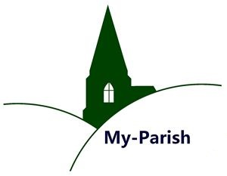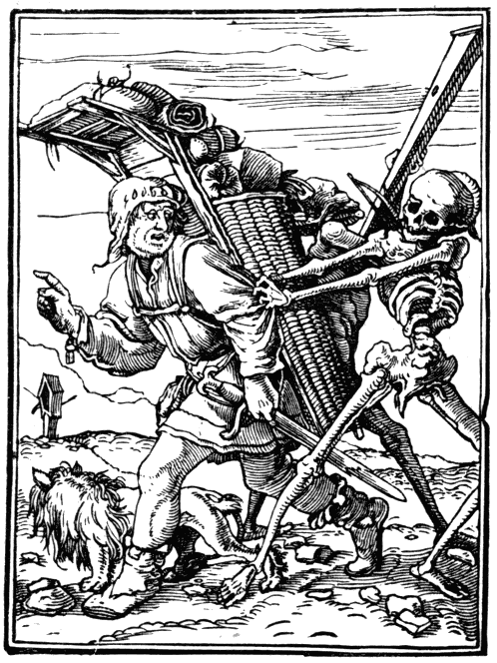

Our annual symposium will take place at the University of Warwick on Saturday 12 May 2018 between 10.30 and 18.00. It explores developments and historiographical trends linking parishes and migration from different perspectives. This includes classic demographic approaches as well as new insights inspired by cultural and global history. We are delighted to announce that Richard M. Smith (Cambridge) will be giving the key-note address:

'55 years since Laslett's “Clayworth and Cogenhoe”:
What have we learned about pre-modern mobility?'
Organized in conjunction with the Marie Skłodowska-Curie project ‘Migration in the Early Modern World’ (MIGMED), the Symposium features contributions on British, German and Middle Eastern parishes from postgraduates, early career researchers and faculty staff whose research intersects with these themes.
For the full symposium programme and (mandatory) pre-registration please visit:
http://warwick.ac.uk/my-parish/parishsymposia/2018migration/
by 30 April 2018
Further information is available from Beat Kümin (b.kumin@warwick.ac.uk)
and Felicita Tramontana (f.tramontana@warwick.ac.uk).
We gratefully acknowledge funding from:
The European Commission, Marie Skłodowska-Curie actions
in the framework of HORIZON 2020.
The Humanities Research Centre, University of Warwick
Woodcut: Hans Holbein, ‘The Pedlar’ (1538, public domain)
