Coventry Household Survey

Coventry City Council

Final Report
May 2018


Contents Page

Project details and acknowledgements 3
Executive Summary 4
Introduction 7
Results 9
1. Equalities and Communities 9
2. Culture 18
3. Community safety 21
4. Health and wellbeing 22
Demographic profile 28
Lessons learnt 31

Project details and acknowledgements

Title | Coventry Household Survey
Client | Coventry City Council
Project number | 18023
Author | Diana Danaila
Research Manager | Clare Rapkins

M·E·L Research
2nd Floor, 1 Ashted Lock, Birmingham Science Park Aston, Birmingham. B7 4AZ
Email: info@melresearch.co.uk
Web: www.melresearch.co.uk
Tel: 0121 604 4664

Executive Summary

Equalities and Communities
- Methodology
  - 3,007 face-to-face interviews were achieved.
  - A random locational quota sampling method was used so that the sample reflects the distribution of households across deprivation deciles and Middle Layer Super Output Areas (MSOAs).
  - Overall, a confidence level of +/-1.8% was achieved.
  - National comparators have been included where available. We have used LGA Polling on Resident Satisfaction with Councils (8th February 2018 – 11th February 2018), Community Life Survey 2016-2017 and the Health Survey for England 2015.
  - We also have compared your 2018 results to your previous survey in 2016 (where possible).
- Local area
  - 84% are satisfied with their local area. This result is significantly higher than national LGA figure of 81% but significantly lower than your previous survey in 2016 (4% point decrease since 2016).
  - Half of respondents (50%) felt their neighbourhood has not changed much in the past two years.
  - Since 2016, there has been a significant rise in the proportion of residents who feel their neighbourhood has got worse in the last 2 years (+4% points).
- Staying informed
  - 40% of respondents believe they are well informed by the Council. Compared to the national figure this is significantly lower (59%) although it should be noted that the wording of the question is different to the national survey.
  - The main sources of information used to find out about the Council are leaflets/posters (59%). This is significantly higher than 2016 as only 29% of residents mentioned this method. As interviews were carried out during March, a lot of residents said they received leaflets with their new council tax bills. This could be one reason for this substantial increase.
- Getting involved
  - 39% agree that they can influence decisions affecting their local area. This is significantly higher than the national figure of 26% but significantly lower compared to 2016 (decrease of 4% points).
  - The majority of residents (96%) have not been members of any decision making group in their local area. Those who have, prefer groups which try to improve the local area (36%, 44 residents).
  - 29% of residents say it might make it easier for them to influence decisions if the local council got in touch them and asked them.
  - 52% agree that there are opportunities for them to get involved in improving their local area. This year’s result is consistent with 2016’s agreement rate (not statistically significant).
  - 45% are likely to get involved if there are more opportunities for residents to take a more active role in their communities in the future. This result is identical to your last survey.
- Neighbourhood, friends and neighbours
  - The top three services and facilities located within 20 minute walk from residents are general/grocery shops (96%), public transport (87%) and parks (86%).
  - 83% feel that they belong (either very or fairly) to Coventry, while 77% of residents feel that they belong (either very or fairly) to their immediate neighbourhood. This is significantly higher than the 62% of adults who said they felt they belonged to their immediate neighbourhood in the latest (national) Community Life Survey.
  - 88% agree that their neighbourhood is a place where people from different backgrounds get on well together. This is significantly higher than the national figure of 81% but significantly lower than your 2016 survey (94%).
  - Nearly a fifth (17%) reported that all of their friends are in the same ethnic group as them. This is significantly lower than the national figure of 42%.
  - Nearly a fifth (15%) reported that all of their friends are in the same religious group as them which is significantly lower than the national figure of 28%.
  - 46% generally borrow things or exchange favours with their neighbours. This is significantly higher than the national figure of 39%.
  - 86% chat to their neighbours at least once a month. This is significantly higher than the national figure of 73%.

Culture
  - 25% rated Coventry’s city centre as fantastic (4 or 5). This is significantly higher than your 2016 survey (22%). In addition, almost one quarter (24%) gave a negative rating, while another quarter (26%) a positive one. Compared to your 2016 survey, this represents a 9% decrease in residents rating Coventry terrible and 4% increase in those rating the city as fantastic (both results are statistically significant).
  - Adults usually go to pubs, clubs and bars, or to the cinema (both 52%). A third (33%) also goes to museums and galleries.
  - Their children usually go to the cinema (54%), museums and galleries (39%) or attend activities organised by arts-based community groups (30%).
  - The most known and visited attractions are: the Coventry Transport Museum (90% awareness and 76% visited), followed by the Belgrade Theatre (90% awareness and 66% visited) and Coventry Cathedral (88% awareness and 66% visited).
  - The most known and attended events are: Godiva Festival (87% awareness and 72% attended, Christmas Lights Switch On (88% awareness and 58% attended) and Motofest (58% awareness and 28% attended).
  - 67% said that the bid to become City of Culture in 2021 made them more likely (yes or possibly yes) to speak positively about the city to family and friends.

Community safety
  - 94% feel safe in their neighbourhood during the day. This is significantly higher than the national LGA figure of 92% and significantly lower than your 2016 survey (97%).
  - 74% feel safe in their neighbourhood at night. There is a significant drop of 11%, compared to 2016. This is similar to the national LGA figure of 75% (not statistically significant).
  - Out of those who felt unsafe in the last 12 months, 70% felt unsafe outside, such as on the street, in parks or grounds.

Health and wellbeing
  - 78% consider that their general health is either “very good” (24%) or “good” (53%). This result is consistent with your 2016 survey (not statistically significant).
  - 18% currently smoke. This is consistent with the national figure of 17% but significantly lower than your last survey (21%).
  - 5% currently use e-cigarettes. This figure is also consistent with both the national figure of 5% and your previous survey (4%).
  - 34% of respondents either used to smoke (16%) or are still smoking (18%). This is consistent with your 2016 survey (35%).
  - 24% say they are eating at least 5 portions a day of fruit or vegetables a day. This result is consistent with both the national figure and your previous survey (both 26%).
  - Statements that most residents agreed with are the importance of healthy foods (91%), having everything they need in their kitchen to cook a meal from scratch (91%) and the fact that it is important for families to eat together every night (90%).
  - 26% of respondents drink soft or fizzy drinks at least once a day. This is significantly higher than your previous survey (23%).
  - 36% are eating takeaway at least once or twice a week which is significantly higher than your 2016 survey (32%).
  - 79% of respondents said that their household had enough of the kinds of foods they wanted to eat.
  - 22% consume alcohol twice or more a week. This is a slight decrease compared to your last survey (20%).
  - 74% drink more than the recommended 2-3 units once a week or less. This result is almost identical to your 2016 survey (72%).
  - Residents are most likely to do everyday activities like walking or cycling as a form of transport (31%) and cultural and social activities (28%) for more than two and a half hours a week, as compared with active recreation or sport, with 41% and 60% respectively saying they have not got involved with these two activities at all.
- The main form of transport for escorting children to school and for an individual’s own education purposes was walking (49% and 37% respectively). Most residents use their own car or a car that they drive (65%) to travel to work.
  - The mean well-being score for all adults was 52.68. This is higher than the England average score of 49.9 and your 2016 survey result of 51.48.
  - During the last few weeks, 17% have worried about money quite often or almost all the time. This is significantly higher than your 2016 survey (14%).

Introduction

Background
The Coventry Household Survey has been used for monitoring Coventry residents’ views of quality of life in the city and has also incorporated questions to understand more about residents’ perceptions of their health and wellbeing. The Life in Coventry Survey 2018 focuses on three areas: Neighbourhoods and Communities, Culture and City of Culture, and Health and Wellbeing.

Coventry City Council has the following aims and outcomes for this year’s survey:

- To assess the trends in perceptions of quality of life, community cohesion and cultural activities of a representative sample of Coventry residents.
- To assess the difference in perceptions across the city and their relation to deprivation levels.
- To understand any differences in the perceptions of residents from black and minority ethnic communities disabled people, people from different age groups and between men and women.
- Wherever possible, to benchmark life in Coventry by region and nation.

Please note: The first aim/ outcome above is being met through this report but the remaining three will require further analysis by the Council.

Methodology
Interviews were conducted face to face on residents’ door steps using tablets (CAPI). 3,007 face-to-face interviews were achieved, which are broadly representative of the Coventry population in terms of age (over 16), gender, ethnicity, disability and levels of deprivation. A random locational quota sampling method was used in order to reflect the distribution of households across deprivation deciles whilst providing coverage across Middle Layer Super Output Areas (MSOAs).
Table 1: Number of interviews and associated confidence interval
Population in Coventry* | Number of interviews | Confidence interval
254,106 | 3,007 | +/-1.8%

This means that we can be 95% certain that the results are between ±1.8% of the calculated response, so the ‘true’ response could be 1.8% above or below the figures reported (i.e. a 50% agreement rate with the fact that residents can influence decisions affecting their local area could in reality lie within the range of 48.2% to 51.8%).

Analysis and reporting
This report presents the top line results from the Coventry City Council Household Survey, which explores residents’ views of their neighbourhood, the Council, their health and wellbeing and their employment and economic situation. For each question we present overall results, comparisons with national surveys (such as LGA Polling on Resident Satisfaction with Councils – May 2018, Community Life Survey 2016-2017 and the Health Survey for England 2015). We also compare this year’s results to your last survey conducted in 2016 (where the questions are identical). Where there is a statistically significant difference between results, this has been noted in the report as a “significantly higher/significantly lower”.
Figures which are significantly higher or lower to each other are highlighted in green and red respectively with tables in the report.
For questions regarding the awareness and attendance of several cultural attractions and events, the list of the provided answer options shortened during fieldwork due to survey length (exceeding 20 minutes).
Owing to the rounding of numbers, percentages displayed visually on graphs in the report may not always add up to 100% and may differ slightly when compared with the text. The figures provided in the text should always be used.

Results
- Equalities and Communities
This section focuses on the local area, the neighbourhood, and ways to get involved in the local community.

Local area
Respondents were asked how satisfied they are with their local area. Results show that eight out of ten (84%) felt positively, with 23% stating that they are very satisfied and 61% satisfied. Only 8% are dissatisfied, leaving an additional 8% with no strong feelings either way (neither). This result is significantly higher than the national LGA figure of 81% but significantly lower than your previous survey (4% decrease since 2016).
Figure 1.1: Satisfaction with local area.
Percentage of respondents– base size 3001
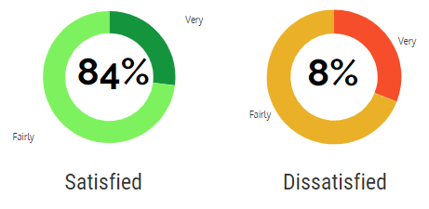

Respondents’ perceptions about the local area were further investigated by asking whether they have noticed any changes in their local area over the past two years. 9% considered their local area got better to live in. One quarter (25%) felt their local area got worse to live in over the past two years. This is a significant rise compared to your last survey 2016 (+4% points).

Figure 1.2: Change over the past two years.
Percentage of respondents– base size 2972
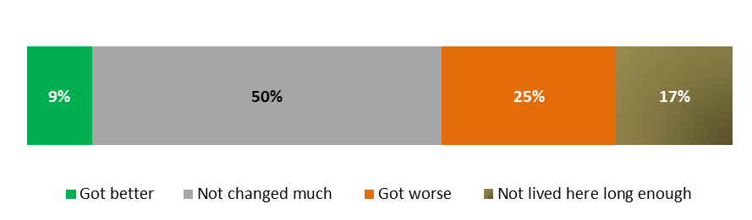

Staying informed
Residents were asked how well informed they feel about what the Council is doing. Four out of ten (40%) respondents believe they are kept informed (either very or fairly); while a similar proportion (37%) don’t feel informed (not well or not well at all). This leaves almost one quarter (24%) who do not have any felling either way. Compared to the national figure, this is significantly lower (59%) although it should be noted that the wording of the question is different in the national survey question. Therefore this comparison should be treated as indicative only.
Figure 1.3: Feeling informed.
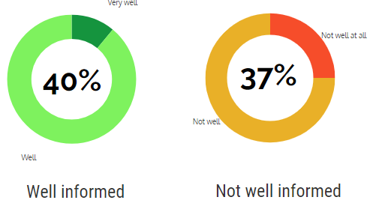
Percentage of respondents– base size 3007

Respondents were then asked how they obtain information about Coventry City Council. Figure 1.4 overleaf shows that the main sources of information are leaflets/posters, with almost six in ten (59%) choosing this option. This is significantly higher than in 2016 when just 29% mentioned this method. The difference could be due to the fact residents were starting to receive their new council tax bills (which also included information leaflets) during the fieldwork period.
Next preference is the Council website, with 31% using this method to obtain information about the Council. This figure is identical to your previous survey (not statistically significant).
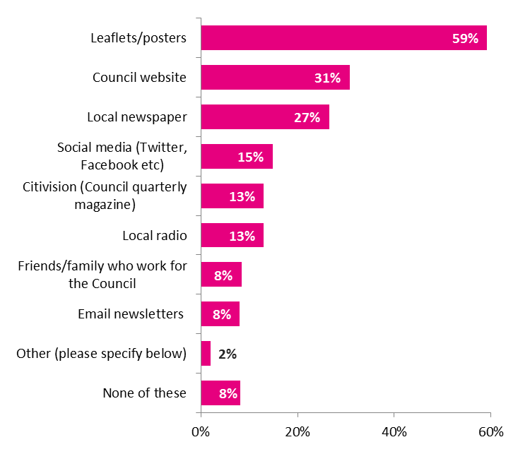
Figure 1.4: Information means
Percentage of respondents– base size 3007

Getting involved
All respondents were asked to what extent they agree or disagree that they can influence decisions affecting their local area. As seen in Figure 1.5 below, only four out of ten (39%) agree that they can influence decisions. This is significantly higher than the national figure of 26% but significantly lower compared to your 2016 survey (decrease of 4% points).
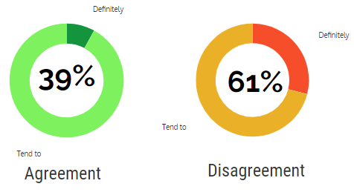
Figure 1.5: Information means
Percentage of respondents– base size 2694

Participation in decision making was probed further, by asking respondents whether they have been a member of any decision making group in their local area in the past 12 months. Results show that the majority (96%) have not been members of any group. Out of those who have 36% (44 residents) are involved in groups trying to improve the local area, followed by a tenants’ group committee (24%, 30 residents).
Figure 1.6: Involvement in decision making groups
Percentage of respondents– base size 206

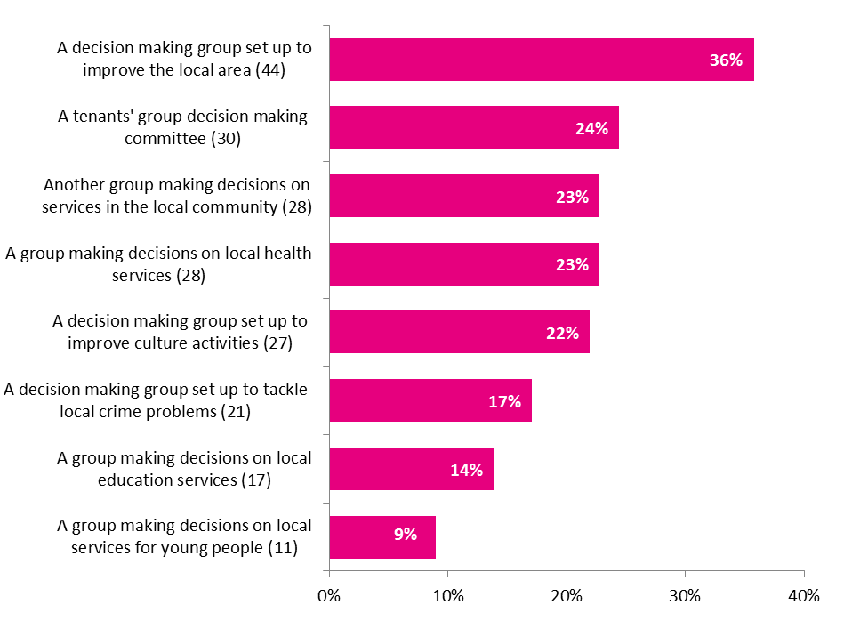

A list of suggestions was provided and respondents were asked to select which of them might make it easier for them to influence decisions in their local area. Almost one third (32%) consider there is nothing that would make it easier for them to get involved, while 27% say that ‘if they had more time’ they might get involved. One thing that the Council and its representatives could do to motivate respondents to get involved in the decision shaping process would be for ‘the council to get in touch with residents and ask them’ (29%).

Figure 1.7: Ways to influence decisions
Percentage of respondents– base size 3007

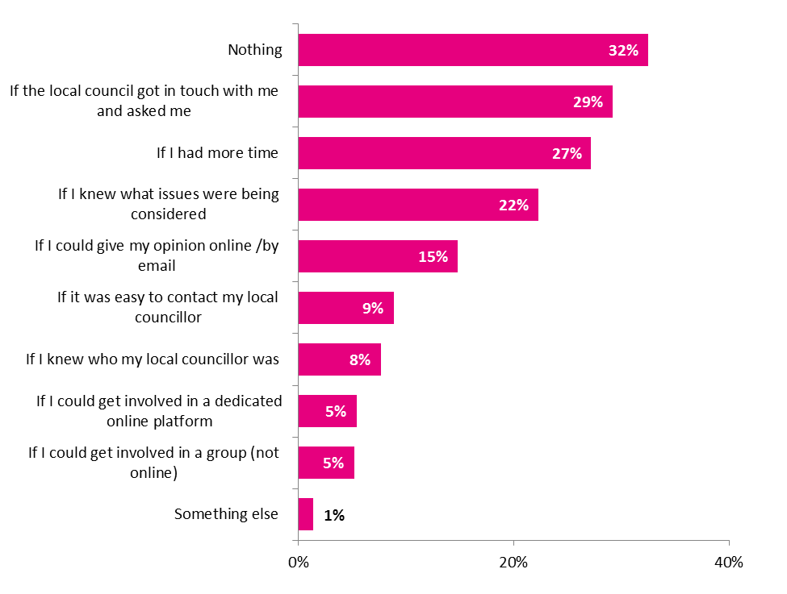

To get involved, residents need to have the opportunity to do so. That is why all respondents were asked whether they agree or disagree that there are opportunities for them to get involved in improving their local area. Little over half (52%) agreed that there are opportunities available, while 48% disagree. There is a 2% increase, compared to 2016 results, although the difference is not statistically significant.
Figure 1.8: Agreement with existence of opportunities
Percentage of respondents– base size 2453
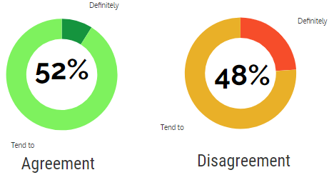

Residents were asked about the likelihood of getting involved if more opportunities were available for residents to take a more active role in their communities. Figure 1.9 overleaf shows that only 45% of them are likely to get involved, as opposed to 55% who said that it was unlikely that they would get involved with others in their local area to make improvements. This year’s results are consistent with 2016 results (not statistically significant).
Figure 1.9: Likeliness of getting involved
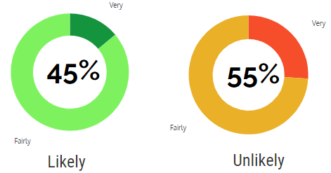
Percentage of respondents– base size 2727

Neighbourhood, friends and neighbours
All respondents were asked which services and facilities are within 20 minute walk from their home. As seen in Figure 1.10, the top three services and facilities located within 20 minute walk are general/grocery shops (96%), public transport (87%) and parks (86%), whilst the least frequently mentioned were youth centres/clubs (19%), sports (38%) or community centres/halls (39%).
Figure 1.10: Accessibility of services and facilities.
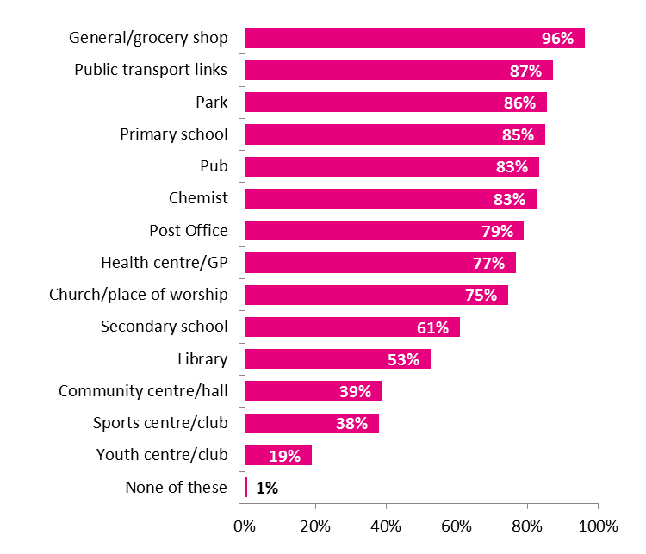
Percentage of respondents– base size 3007

When it comes to the feeling of belonging, as Figure 1.11 below shows, 83% feel that they belong (either very or fairly) to Coventry, while 77% of residents feel that they strongly belong to their immediate neighbourhood. This significantly higher than the national figure of 62%.
Figure 1.11: Feelings of belonging.
Percentage of respondents– base size 2959 – 2966
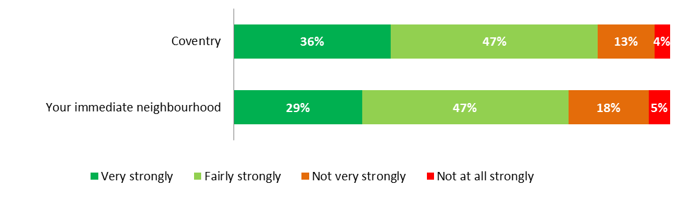

All respondents were asked to what extent they agree or disagree that their neighbourhood is a place where people from different backgrounds (i.e. different ethnic groups, faith groups, social backgrounds or countries of origin) get on well together. Almost nine out of ten residents (88%) agree with this statement, with 27% definitely agreeing and 61% tending to agree. This is significantly higher than the national figure of 81% but significantly lower than your 2016 survey (94%).
Figure 1.12: Agreement with people from different backgrounds getting along
Percentage of respondents– base size 2859
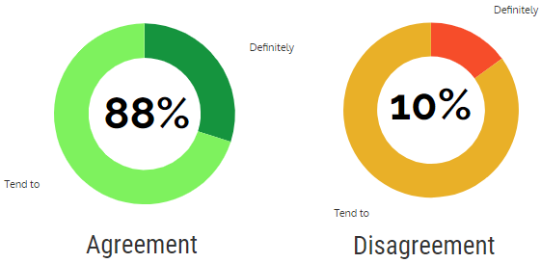

When asked what proportion of their friends are of the same ethnic group as them. Figure 1.13 shows that only 17% of residents have friends that are the same ethnic group than them. This is significantly lower than the national figure of 42%.
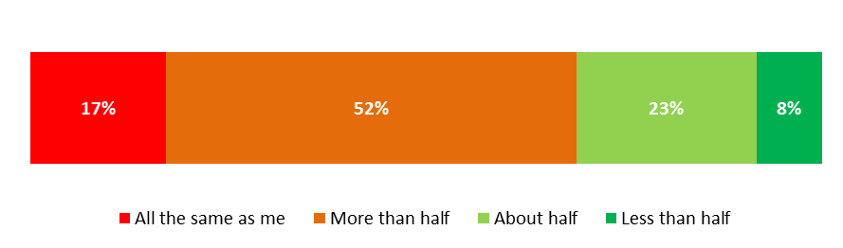
Figure 1.13: Friends’ ethnic background
Percentage of respondents– base size 2972

Respondents were also asked what proportion of their friends is of the same religious group as them. Figure 1.14 shows that 15% of residents have friends that are the same religious group as them. This is significantly lower than the national figure of 28%.
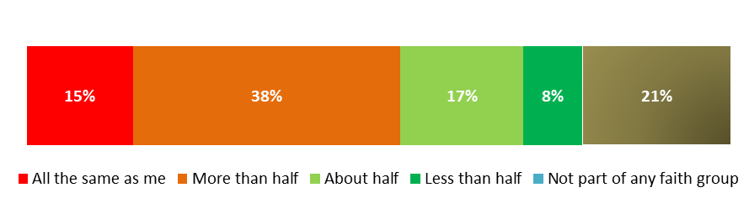
Figure 1.14: Friends’ religious group
Percentage of respondents– base size 3007

Residents were also asked about the likelihood of borrowing things or exchanging favours with their neighbours. Similar percentages agree (46%) and disagree with this statement (54%). This is significantly higher than the national figure of 39% who agreed with this statement.
Figure 1.15: Borrowing things from neighbours
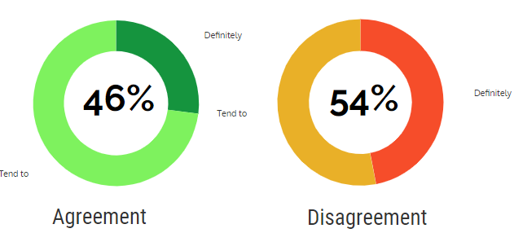
Percentage of respondents– base size 3007

All respondents were then asked how often they chat to their neighbours, more than to say hello. 86% chat to their neighbours at least once a month. This is significantly higher than the national figure of 73%.
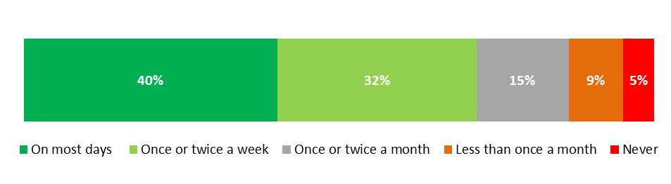
Figure 1.16: Chatting with neighbours
Percentage of respondents– base size 3007

All those who talk to their neighbours twice a week or less were asked their reasons for not talking more often. The top three reasons were: not seeing them very often (52%), lack of time (31%) and a preference to keep themselves to themselves (23%). Other reasons can be seen in Figure 1.17 below.
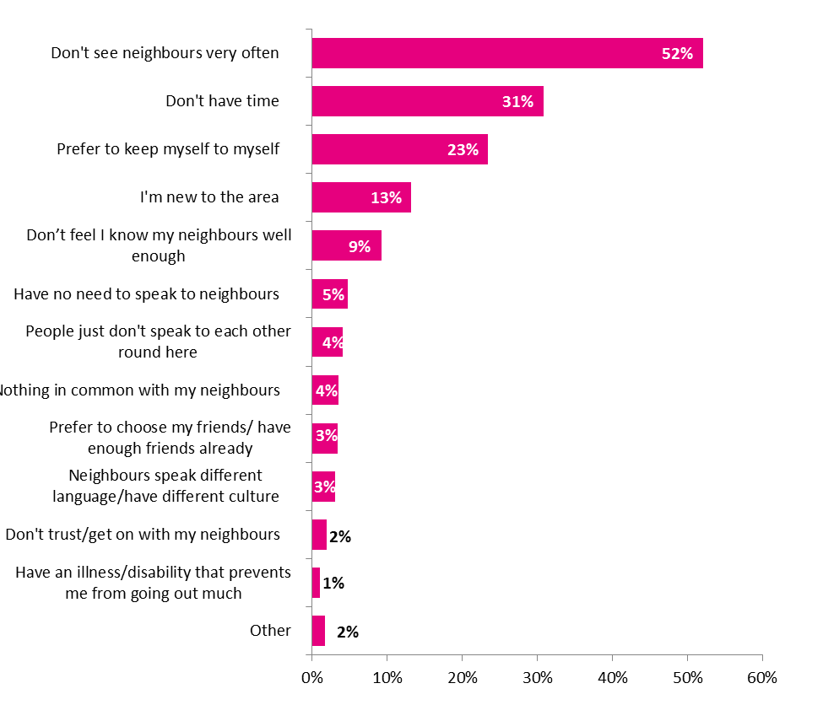
Figure 1.17: Reasons for not chatting with neighbours
Percentage of respondents– base size 1798

- Culture
Section two focuses on cultural activities, events and attractions, but also social activities that Coventry offers. The main point of interest is residents’ involvement and awareness of these opportunities. All residents were asked how they would rate Coventry as a city centre on a scale of 1 (terrible) to 5 (fantastic). Half of them gave an average rating (51%), which is significantly higher than in 2016 (45%). Almost one quarter (24%) gave a negative rating, while another quarter (26%) a positive one. Compared to your 2016 survey, this represents a 9% decrease (statistically significant) in residents rating Coventry terrible and 4% increase (statistically significant) in those rating the city as fantastic.
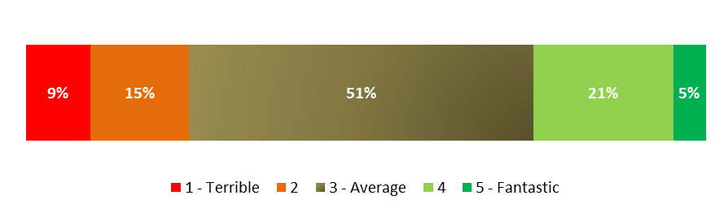
Figure 2.1: Chatting with neighbours
Percentage of respondents– base size 2999

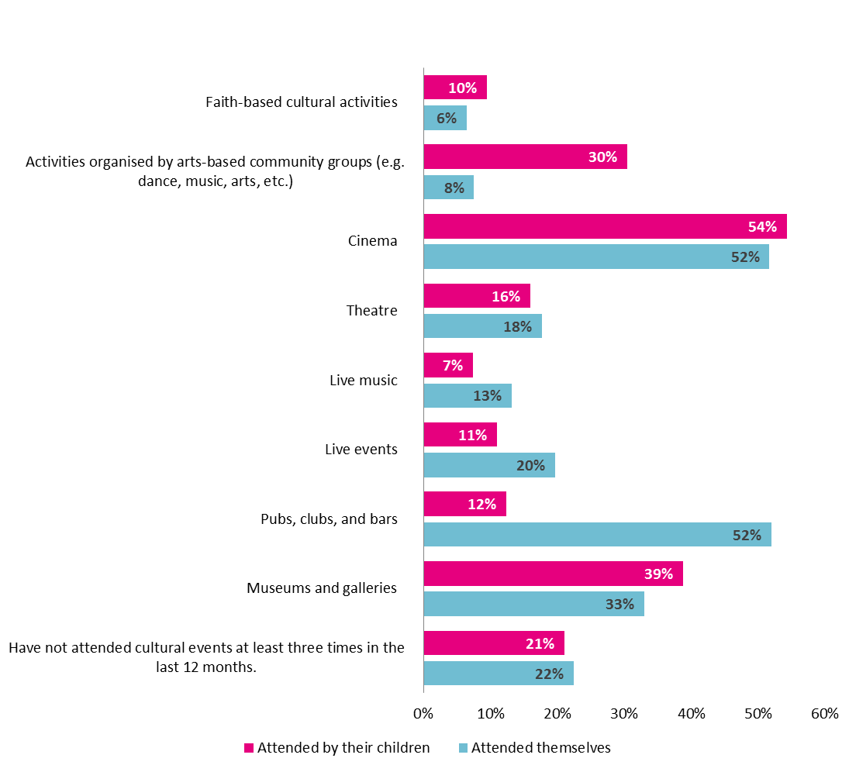
All respondents were given a list with a series of cultural events and were asked whether they or any of their children have attended any of them. Figure 2.2 below shows the attendance for both respondents and their children. One thing to be noted is that the percentages for the children’s’ attendance have been calculated after the exclusion of 1,842 of respondents (63%) who do not have children.
Figure 2.2: Attendance of cultural events
Percentage of respondents– base size 1063-3007

Another point of interest was the awareness of a number of Coventry attractions. Out of 3,007 respondents 126 (4%) were not aware of any of the attractions on the list. All of those who were aware of at least one of them were asked whether they have visited any of them. Table 2.1 below, shows that the most well-known and visited attractions are the Coventry Transport Museum (90% awareness and 76% visited), followed by the Belgrade Theatre (90% awareness and 66% visited) and Coventry Cathedral (88% awareness and 66% visited).
Table 2.1: Awareness and visit to attractions
Percentage of respondents– base size 2607-2881

Events are a large part of any city’s cultural scene so respondents were asked whether they are aware of any key events that take part in Coventry (Table 2.2, overleaf). Out of 3,007 respondents 255 (8%) were not aware of any of events. All of those who were aware of at least one of them were asked whether they have attended any of them. Table 2.2 shows that the most well-known and attended events are: Christmas Lights Switch On (88% awareness and 58% attended), Godiva Festival (87% awareness and 72% attended, and Motofest (58% awareness and 28% attended).

Table 2.2: Awareness and attendance of events
Percentage of respondents– base size 2120-2752
At the end of this section, all respondents were asked whether the bid to become City of Culture in 2021 has made them more likely to speak positively about the city to family and friends. Figure 2.3 shows that almost seven out of ten (67%) said that it did (either yes or possibly yes), while just 17% that it didn’t.
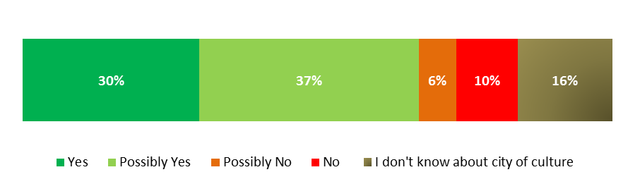
Figure 2.3: Speak positively about the city
Percentage of respondents– base size 3007

- Community safety
This section intends to find out the perceived levels of safety in Coventry and the places where people feel most unsafe.
All residents were asked how safe they feel in their neighbourhood during the day and at night. The majority (94%) feel very or fairly safe during the day, which is significantly higher than the national figure of 92%.Figure 3.1 below also shows fewer residents (74%) feel safe at night. Whilst it is almost identical to the national figure (75%), it does however represent a significant drop of 11% compared to your 2016 survey.
Figure 3.1: General feel of safety
Percentage of respondents– base size 2994-3004
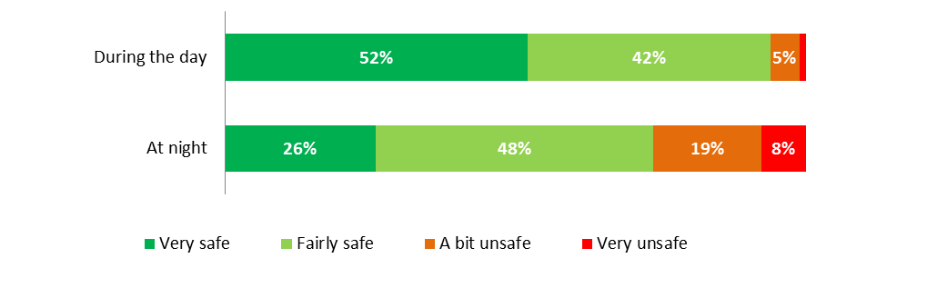Residents were then provided with a list of places and were asked to state where they felt unsafe in the last 12 months. Results show that 62% have not felt unsafe in any of these situations although just over a quarter felt unsafe outside (e.g. on the street, in parks or grounds). If we exclude those who said they didn’t feel unsafe, 70% felt unsafe outside (this includes on the street, in parks or grounds). This represents a significant 14% increase since 2016.
Figure 3.2: Situations perceived as unsafe
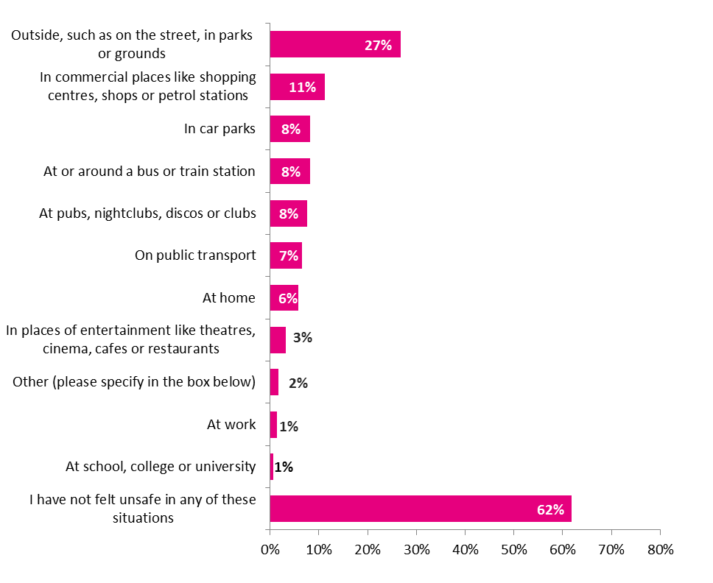
Percentage of respondents– base size 3007

- Health and wellbeing
This last section focuses on resident’s lifestyle, their general health and their finances. Wellbeing is also a focus, with all residents being asked to self-complete the validated 14 item Warwick Edinburgh Mental Well-being Scale (WEMWBS).
Almost eight out of ten respondents (78%) consider that their general health is either very good (24%) or good (53%). Only 1% consider it to be bad, which leaves 16% who consider themselves to have a “fair” general health. Compared to your 2016 survey, the proportion who rated their health as good (either very good or good) has remained unchanged but the proportion rating it as bad has decreased significantly from 7% in 2016 to 1% this year
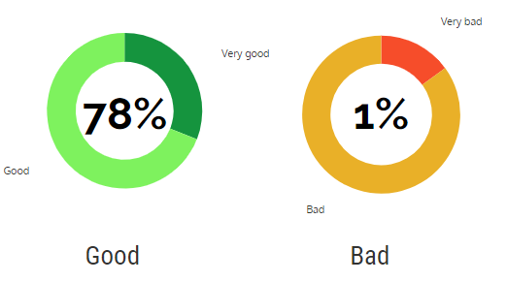
Figure 4.1: General health
Percentage of respondents– base size 3007

Smoking habits, either using tobacco or electronic cigarette, were also probed. As seen in Figure 4.2 overleaf, nearly a fifth (18%) currently smokes. In addition, 5% currently use e-cigarettes. The proportion of residents saying they currently smoke has dropped this year by 3% (statistically significant) but the proportion of residents using e-cigarettes has remained static.
In addition, the proportions currently smoking and/or using e-cigarettes are also consistent to the national figures (17% and 5% respectively).

Figure 4.2: Smoking
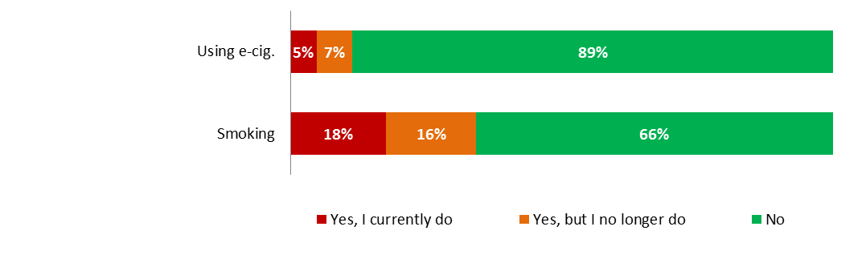
Percentage of respondents– base size 2985-2986

When it comes to having healthy and balanced diet, almost a quarter (24%) say they are eating at least 5 portions a day of fruit or vegetables a day. This result is consistent with both the national and previous survey results (both 26%).
Figure 4.3 also shows that most respondents (42%) who took part in the survey eat at least 3 portions, but less than 5. Another 33% eat less than three portions of fruits or vegetables a day.
Figure 4.3: Vegetables and fruits
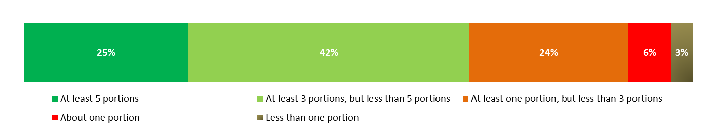
Percentage of respondents– base size 2985-2986

Residents were then provided with a series of statements relating to eating habits. Residents were more likely to agree with the importance of healthy foods (91%), having everything they need in their kitchen to cook a meal from scratch (91%) and the fact that it is important for families to eat together every night (90%). The agreement rates for all other statements are presented in Figure 4.4 overleaf.

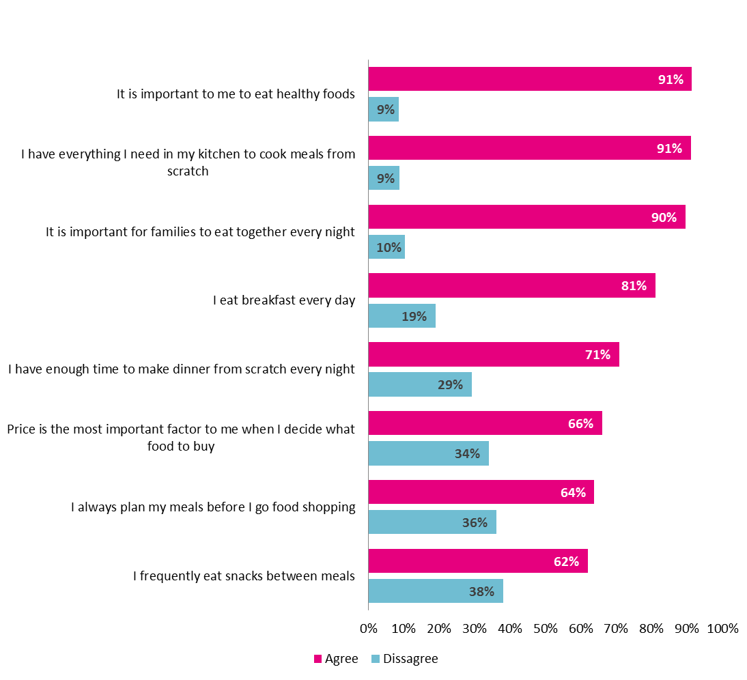
Figure 4.4: Eating habits
Percentage of respondents– base size 2975-3002

One quarter (26%) of respondents drink soft or fizzy drinks at least once a day. This represents a significant increase (3% points) compared to your previous survey.
Takeaways are also relatively popular with residents, with 36% eating takeaway once or twice a week. This represents a significant increase compared to your 2016 survey 32%).
Figure 4.5: Takeaway and drinks
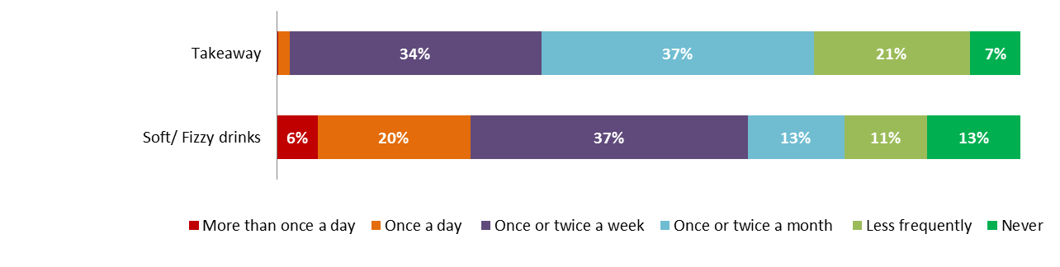
Percentage of respondents– base sizes 3007

Eight out of ten (79%) of respondents felt they have had enough of the kinds of food they wanted to eat. An additional 19% felt they and their family had enough to eat but the kind of food was not always what they wanted. 2% of respondents sometimes did not have enough to eat.
Figure 4.6: Food eaten in household
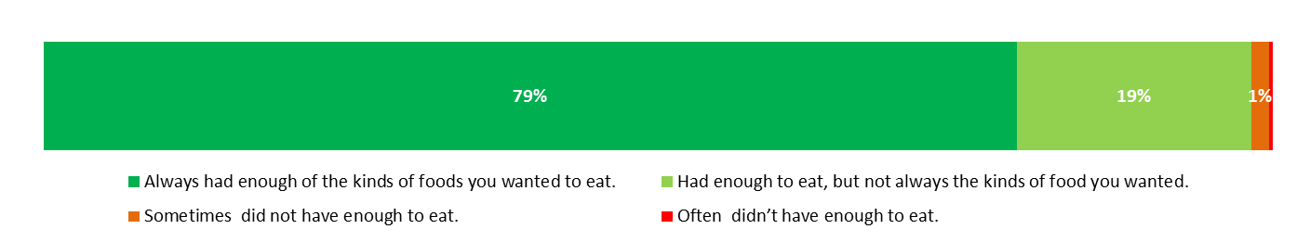
Percentage of respondents– base size 3007

Nearly a fifth of respondents (22%) consume alcohol twice or more a week, out of which 18% drink alcohol 2-4 days a week and 4% at least 5 days a week. Little over four out of ten (42%) do not drink alcohol. This figure is consistent with your 2016 survey with 42% stating they do not drink.
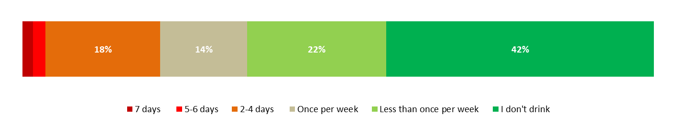
Figure 4.7: Frequency of alcohol consumption
Percentage of respondents– base size 3007

All those who said they are consuming alcohol, no matter the frequency, were asked how many days in an average week are they drinking more than 2-3 units of alcohol. The vast majority (74%) said they drink more than 2-3 units once a week or less.
Figure 4.8: Alcohol consumption
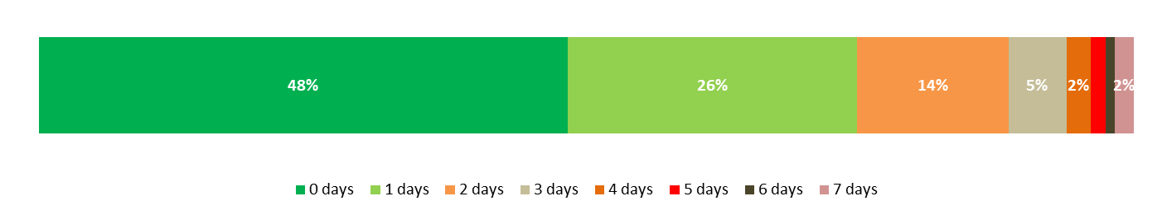
Percentage of respondents– base size 1719

Sports and other activities are important for good health and wellbeing. In order to better assess their general health, respondents were asked how many hours they spent on different activities during the previous week. Figure 4.9 overleaf shows that residents are most likely to spend more than two and a half hours on everyday activities like walking or cycling as a form of transport (31%). This result is significantly lower than the 2016 result (45% in 2016).
Similarly to 2016, residents are least likely to spend the same amount on sport and active recreation with 60% and 41% stating they do not spend any time on these activities.
Figure 4.9: Hours spent on activities
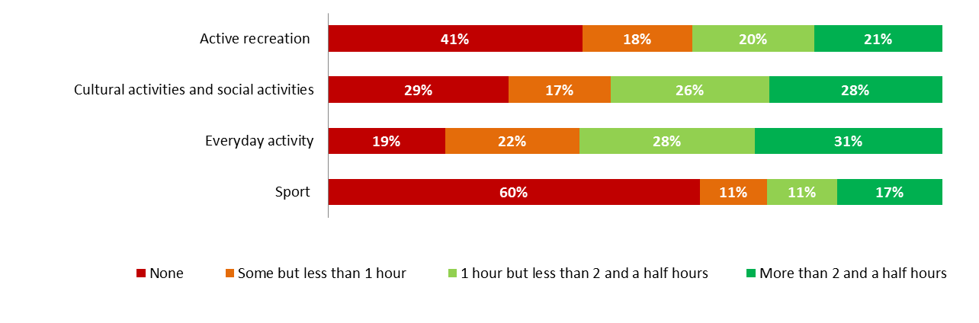
Percentage of respondents– base size 3007

All respondents were asked the main form of transport they use for different types of journeys. Figure 4.10 below shows that the main form of transport for escorting children to school was walking (49%). This result is significantly lower than 2016 when 58% walked to escort their children to school.
In contrast, when travelling to work, most residents go by car (either as a driver or passenger).
Figure 4.10: Form of transport
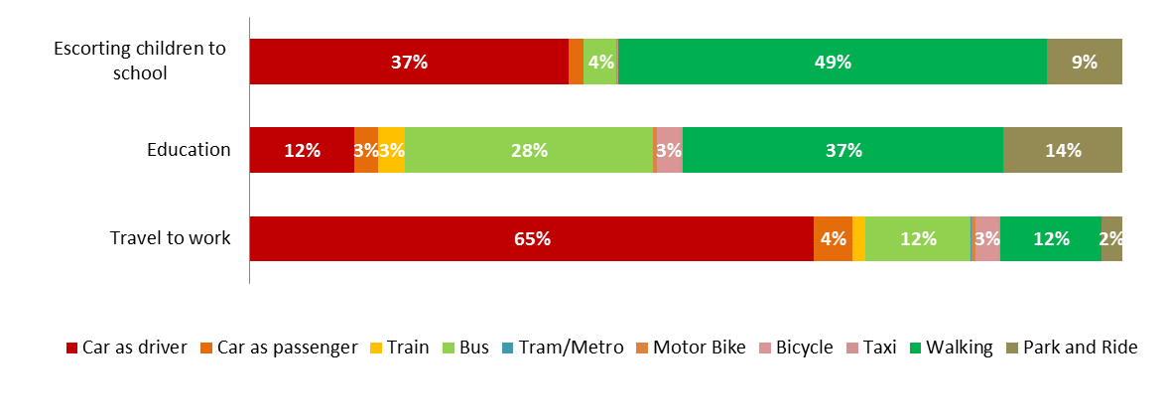
Percentage of respondents– base size 3007

Mental wellbeing
Respondents were asked to self-complete the validated 14 item Warwick Edinburgh Mental Well-being Scale (WEMWBS). This asked how they had been feeling over the past two weeks.
The WEMWBS total score is obtained by summing the score for each of the 14 statements. Each statement can be scored between 1 and 5. The total score ranges from 14 (poor mental wellbeing) to 70 (good mental well-being).
The mean well-being score for all adults was 52.68 (see Figure 4.11). This is higher than the England average score of 49.9 (Source: Health Survey for England 2016), suggesting that Coventry residents’ mental well-being might be better than the general mental well-being of England’s population. The WEMWBS score has improved by 1.2 since 2016 (from 51.48 to 52.68).
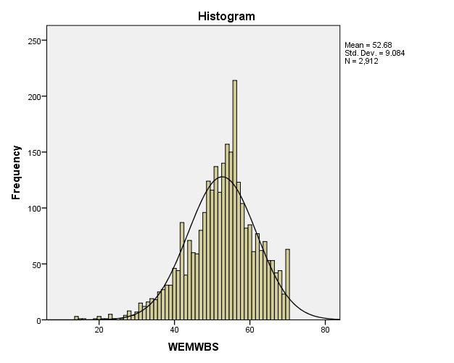
Figure 4.11: Mental Well-being
Percentage of respondents– base size 2913

Towards the end of the survey all residents were asked how often have they been worried about money during the last few weeks. 17% said they worried about it quite often or almost all the time, while 37% did so sometimes. This compares to 14% and 30% respectively in 2016 (both statistically significant).
Figure 4.12: Worries about money
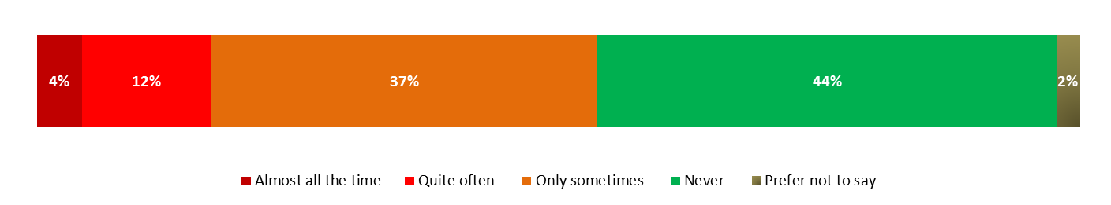
Percentage of respondents– base size 3007

Demographic profile

Age
 | Number | Percentage
16-24 | 616 | 21%
25-34 | 638 | 21%
35-44 | 501 | 17%
45-54 | 419 | 14%
55-64 | 337 | 11%
65-74 | 326 | 11%

Gender
 | Number | Percentage
Male | 1,506 | 50%
Female | 1,500 | 50%
Transgender | 0 | 0%
Prefer not to say | 1 | 0%

Disability
 | Number | Percentage
Yes, limited a lot | 257 | 9%
Yes, limited a little | 293 | 10%
Not at all | 2,457 | 82%

Religion
 | Number | Percentage
No religion | 961 | 33%
Christian | 1,472 | 50%
Buddhist | 7 | 0%
Hindu | 116 | 4%
Jewish | 2 | 0%
Muslim | 223 | 8%
Sikh | 136 | 5%
Other religion | 10 | 0%

Ethnicity
 | Number | Percentage
White: British | 1,916 | 64%
White: Irish | 37 | 1%
White: Gypsy/Irish Traveller | 0 | 0%
White: Other | 261 | 9%
Mixed: White and Asian | 12 | 0%
Mixed: White and Black Caribbean | 24 | 1%
Mixed: White and Black African | 2 | 0%
Mixed: Other | 14 | 0%
Asian: Asian British Indian | 275 | 9%
Asian: Asian British Pakistani | 73 | 2%
Asian: Asian British Bangladeshi | 28 | 1%
Chinese | 50 | 2%
Asian: Asian British Other | 53 | 2%
Black: Black British African | 138 | 5%
Black: Black British Caribbean | 35 | 1%
Black: Black British Other | 4 | 0%
Arab | 15 | 0%
Any other ethnic group | 44 | 1%
Prefer not to say | 26 | 1%

Working status
 | Number | Percentage
In full time paid work | 1,116 | 37%
In part time paid work | 381 | 13%
Self-employed | 133 | 4%
Taking part in a government training programme | 7 | 0%
Registered unemployed/signing on for Job Seekers Allowance | 66 | 2%
Not registered unemployed but actively seeking work | 25 | 1%
At home/not seeking work - (looking after the home or family) | 212 | 7%
Long-term sick or disabled | 139 | 5%
Retired | 556 | 18%
In full-time education | 334 | 11%
Doing unpaid/voluntary work | 4 | 0%
Carer | 30 | 1%
Other | 4 | 0%

Highest qualification
 | Number | Percentage
Level 1: 1+ 'O' levels/CSE/GCSE (any grade), NVQ level 1, Foundation GNVQ. | 286 | 10%
Level 2: 5+ 'O' levels, 5+ CSEs (grade 1), 5+ GCSEs (grade A - C), School Certificate, 1+ 'A' levels/'AS' levels, NVQ level 2, Intermediate GNVQ or equivalents. | 341 | 11%
Level 3: 2+ 'A' levels, 4+ 'AS' levels, Higher School Certificate, NVQ level 3, Advanced GNVQ or equivalents. | 572 | 19%
Level 4/5: First degree, Higher Degree, NVQ levels 4 - 5, HNC, HND, Qualified Teacher Status, Qualified Medical Doctor, Qualified Dentist, Qualified Nurse, Midwife, Health Visitor or equivalents. | 716 | 24%
Other qualifications/level unknown: Other qualifications (e.g. City and Guilds, RSA/OCR, BTEC/Edexcel), Other Professional Qualifications. | 379 | 13%
No qualifications | 595 | 20%
Prefer not to say | 118 | 4%

Marital status
 | Number | Percentage
Single | 1,061 | 35%
Co-habiting | 306 | 10%
Married | 1,277 | 42%
Separated but still legally married | 28 | 1%
Divorced | 139 | 5%
Widowed | 163 | 5%
In a registered same-sex civil partnership | 0 | 0%
Separated but still legally in a same-sex civil partnership | 2 | 0%
Formally in a same-sex civil partnership that is now legally dissolved | 0 | 0%
Surviving partner from a same-sex civil partnership | 1 | 0%
Prefer not to say | 30 | 1%

Housing tenure
 | Number | Percentage
Owner occupied | 1,503 | 50%
Rented from Whitefriars | 463 | 15%
Rented from another Housing Association e.g. Midland Heart | 168 | 6%
Rented from private landlord | 782 | 26%
Shared ownership | 15 | 0%
Other, please specify | 43 | 1%
Don't know | 33 | 1%

Lessons learnt

Having completed the project, we outline below our lessons learnt/considerations for the future:

  - Consider moving the fieldwork period to the spring /summer months as the poor weather (particularly during January and February) affected fieldwork progress;
  - Consider shortening the length of the survey to 15 minutes maximum as again the length contributed to high refusal rates from residents, particularly during the cold winter months;
  - If 3,000 interviews are conducted next time, the Council should ideally allow 12 weeks for fieldwork;




National Survey Question - (Overall, how well informed do you think your local council keeps residents about the services and benefits it provides

