Science from Scratch
- Funded by IATL’s Student as Producer Fund

Kieran Hall - Department of Computer Science, University of Warwick
Stephen Pithouse - Department of Engineering, University of Warwick (Graduated)
Caspar Collins - Department of Physics, University of Warwick (Graduated)
Matthew Earl - Department of Chemistry, University of Warwick
Margaret Low – WMG (Supervisor)

Abstract

Technology Volunteers developed a suite of Scratch resources and a new interactive circuit board (ExperiSense), which we presented at the Scratch@MIT 2016 conference. During the conference we delivered a workshop and a poster session, during which the board received a considerable level of interest and positive feedback. We also took the opportunity to network with other conference attendees, strengthening existing and forging new relationships with like-minded individuals and organisations. In addition, we were inspired by the wide variety of new and exciting resources on display; this has directly impacted our plans to produce a new set of resources which we will be able to disseminate to our volunteers, in schools and throughout the local community.

Introduction
The project enabled the Technology Volunteers Project Leaders – students from the University of Warwick – to present their work at Scratch@MIT 2016 in Boston USA, an internationally renowned conference. “Science from Scratch” was the name and theme of an interactive workshop and subsequent poster presentation that were held by these project leaders during the conference. Unique science-based resources had been created for these sessions, building on sensor elements of our earlier workshops in order to perform scientific experiments, which utilised the Scratch programming language in combination with Arduino. Furthermore, to aid our work we developed a new circuit board called ExperiSense, which we also showcased at the conference within the workshop and poster presentation.

The main aim was to present and share our work with the Scratch community, a global audience, at the conference in Boston USA. The intention was to not only introduce people to different ways Scratch and Arduino could be used together, but also to encourage learners’ scientific investigations through the creation of inventive applications for people to explore by opening a range of links to aspects of the STEM curriculum.

Another key objective was to learn as much as we could by attending other people’s workshops, poster sessions, Ignite presentation and panel discussions. The knowledge gained would enable us to enhance and expand our own work, helping Technology Volunteers to grow and therefore reach as many children as possible, in addition to making us better equipped to meet ever-increasing abilities of the children with whom we work.

Furthermore, participation in the conference was anticipated to build on our already excellent relationship with the Scratch community, further promoting Technology Volunteers as well as the University of Warwick on an international level. Moreover, through networking we wanted to maintain and forge new connections with like-minded individuals and organisations.

Finally, it was hoped that attendance at the conference would benefit the four Project Leaders on a more personal level, specifically the development of a range of interpersonal and transferable skills. For instance, the many opportunities to present and network would help improve communication skills.

Methodology

Chronological Account of Project

[N.B. the following activities were completed as a group of 4-6 students alongside our individual studies.]

October-November - Devised theme for workshop and poster.

In order to produce innovative and interesting material for our workshop and poster, prior to their planning we had to be aware of what had been done previously in the Scratch community. This was achieved by both looking through our past resources that we have presented in the past, in addition to asking our supervisor, who had attended other Scratch conferences, what other people had covered in previous years.

Some of our past resources involved the application of physical sensors with Scratch. This year we wanted to build on this by applying this work to the sciences, in particular chemistry and physics - subjects that two of our current Project Leaders are studying. We came up with the title “Science from Scratch”, which became the theme for our workshop.

The subject for our poster was born out of an idea from last year’s Scratch conference; we wanted to develop a new circuit board (called ExperiSense) to aid our scientific resources, and our poster focused on this board.

November-February - Conference and funding applications

Once the application process to Scratch@MIT 2016 opened we submitted proposals for both a workshop and poster session. During this time we also applied for funding, which included identifying (researching) appropriate funding bodies both within and outside the University of Warwick that would support this activity, and then filling out application forms before their associated deadlines.
- May-June - Planning stage (science resources, ExperiSense board & logistics)

During this time we planned appropriate scientific experiments that we could demonstrate in our workshop, in addition to designing the new circuit board; this included deciding upon its capabilities, what it would look like, and giving it a name (ExperiSense). We also planned the logistics of our trip such as booking flights, ESTA/visa applications, booking accommodation, organising travel within Boston, and writing an itinerary and packing list. To complete the majority of these activities we booked out a room in IMC for a week and worked together as a group.

- July - Finalising and printing resources

Within this month we fabricated the ExperiSense boards, produced worksheets to accompany both our science experiments and this new board, and designed the poster. In addition we printed the poster and worksheets, and purchased necessary equipment for the workshop.

- 3rd-6th August - Scratch@MIT 2016 conference

At the start of the conference there was an evening reception, in which we met a number of people from the Scratch community, including teachers, academics, students, and networked with some old contacts.

On day one of the conference we had both our workshop and poster sessions:
- First was our workshop, where we presented four demonstrations (“How to Measure Electrical Conductance through Liquids?”, “How Does Temperature Influence Electrical Conductance?”, “How to Make a Wind Turbine” and “How to Make a Rotation Speed Sensor”), and participants then had the opportunity to try out our new board with our scientific worksheets. At the end of the workshop we asked the workshop attendees to provide us with feedback on the session and the new boards.

- The poster session followed, in which our poster focused on the ExperiSense board, including why it was made, the software behind it, what it does, and future work. We also had some demonstrations on the stand - those from the workshop. The stand had lots of visitors, we answered conference attendees’ questions and gave out further information about our activities and the ExperiSense board. We reviewed other posters that were presented during the session, with the aim to see what other people had been doing and hopefully gain ideas for future resources (we also used this opportunity to talk to other presenters as a chance to network).

Throughout days 2 and 3 of the conference we attended a number of other workshops, panel discussions, and Ignite talks (see Supplementary Information).

Results
Feedback

There was great interest in our ExperiSense board, with just a few of the feedback comments outlined below (the rest are included in the Supplementary Information Section):

- This has great application for science at both elementary and secondary level.
- These boards need to become readily available.
- Very intuitive way into physical computing.
- Nice size, doesn’t look as intimidating.
- Built-in display is useful.
- Good to have loops for conductive thread. I like large positive and ground rails.
- Love the board. LED output is great. The crocodile clip friendly connection is nice.
- Easy to get the basic things working; built-in button to play a sound, forever reading from the dial.
- I like the incorporation of the numeric displays to the board.
- Interesting because it simplify the connections and the programming of external sensors.
- Great commercial potential! Schools would buy these boards!
- I loved it! Can we have more of such demos in the future… looking forward to it.
- Great ideas for my middle school studies (age 13-15).
- Fabulous! Great way to “see” science and tinker with ideas!
These comments show that the board was a success, and that our workshop conveyed the potential of it. Moreover, our design decisions to incorporate displays and have easy connections and built-in sensors were deemed useful and practical for use in a classroom. It is this positive feedback that has driven us to explore ways in which we can make the board readily available to schools and other people / organisations to continue to interest children in Science / sensing with the use of our board.

Workshops/Unconferences/Panels/Ignite Talks
As well as running our own workshops and poster session, a significant proportion of our time attending the conference was spent participating in a range of activities run by other members of the community. A synopsis of each of these is provided in the Supplementary Information Section.
Networking & Links with other people
Technology Volunteers are well known in the Scratch Community, having attended previous conferences. This meant that we were able to reconnect with our existing contacts and hold conversations about our progress and – importantly for us – their progress. They are producing exciting new interfaces and programs with Scratch and were more than happy to share their ideas and methods. Not least of these were:
- Stephen Howell, known for his Scratch interface to Microsoft Kinect
- Susan Ettenheim, with whom we have a long history of collaboration. Her project, TurtleStitch, uses Scratch and a sewing machine to embroider patterns into fabric
- Andy Murphy, who shared with us his experience with using the PicoBoard (an existing Scratch sensor board) and graciously gave us ideas on how to improve ours.

We also met many new people with whom we could discuss and share our ideas – these included:
- Craig Steele and Daniel Devine from CoderDojo Scotland. We have a lot in common with them as we run a CoderDojo, and are all university students; it was fascinating to share our stories with them both at the conference and during travel back to the UK.
- Melissa Norelli, a middle school teacher from Florida, USA. She is going to be introducing Arduino to her classes next year as a tool for teaching the sciences. She was very interested in collaborating with us after hearing about our scientific resources and the ExperiSense board. In particular she wanted to talk with us further about getting her hands on one of the boards and how she could implement it (and our accompanying resources) into her middle school science classroom; she is very keen to stay in touch as we further develop our resources.
- Kreg Hanning, developer of a number of ScratchX extensions including for Arduino. He was only too pleased to share his knowledge of Scratch development and we were able to contribute our experience as developers. We were encouraged by his being keen to include our extension in the official library.
- Andrew Sliwinski, Engineering Director for Scratch. He was very impressed by our design and readily shared his contact details; we expect him to be a very useful contact in our development of this project.

We also took the opportunity to strengthen our links with the international CoderDojo community, of which many members were in attendance at the conference. Everyone in the below image (including ourselves) is involved in hosting CoderDojo. Making this array of contacts was fantastic chance for us discuss and to refine our understanding of the impact that we are each making to our local communities.
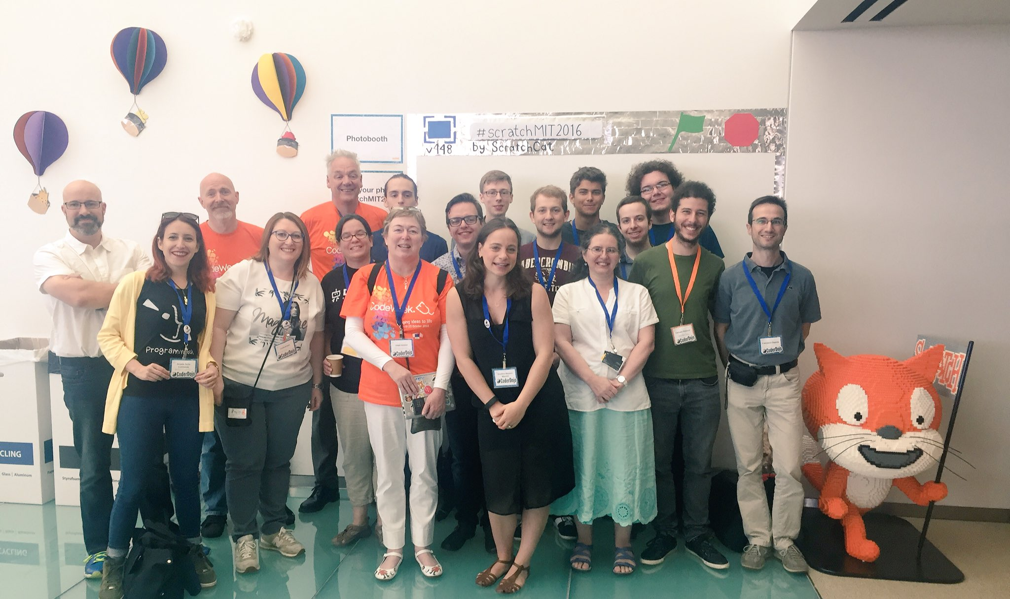

Conclusion and outcome
Summary
- Presented new worksheets and a board in a workshop and poster session to a wide range of people from all over the world – received considerable interest.
- Attended many workshops, ignite talks and discussion panels throughout the conference in which we found out how others were using Scratch to teach children and/or produce interesting resources, in addition to learning many new ideas that we can incorporate into our own activities.
- Networked effectively with other members of the Scratch community, forging new relationships with a variety of people, including teachers, students and researchers from the MIT Media Lab, which may prove significant in the future.
Dissemination of knowledge gained from Scratch@MIT 2016
- New Technology Volunteers Project Leaders and volunteers – within training sessions in Term 1.
- Technology Volunteers Website(s) and Volunteering Fair.
- Schools – within school sessions in Term 2.
- CoderDojo & DojoCon – within Saturday afternoon sessions throughout the year application, also submitted an application for CoderDojo conference in October.
- Imagineering Fair – 2-day fair within Coventry for children and families.
- Computing at Schools (CAS) – poster presentation and subsequent 50-minute talk to members of CAS in late September, and within CAS Newsletter.
- Mozilla Festival (MozFest) – application submitted for conference in October.

Reflection on Experience
At the Scratch Conference 2016 we shared our unique resources, including a sensor board designed and manufactured by us ran a workshop entitled “Science from Scratch” in which we demonstrated ways that Scratch could be used in conjunction with an Arduino and our ExperiSense board to teach science in schools. We also presented at a poster session in which we displayed the ExperiSense board; explaining its features and capabilities. We also attended a large variety of workshops, poster sessions and ignite talks, and have not only inspired us to produce a new set of resources but to also re-evaluate our teaching methods.

Our workshop and poster sessions were both great successes; the workshop was fully booked and we were kept constantly busy by interested conference attendees at our poster session. The feedback we have received has been overwhelmingly positive and has informed our decision to add a microphone and/or an extra button to the board. We also received an unprecedented level of interest at the poster session, with many attendees wishing to take boards home. It was clear from the interest that we received that there is a large demand for a cheap sensor board that combines the speed and precision of the Arduino with the simplicity of the Picoboard. This has led to the decision to produce the ExperiSense boards for the public rather than just to open source the design, as we believe the manufacture required is beyond that of the average school teacher.

Whilst attending the conference, we were inspired by the wide variety of new and exciting resources on display. This has directly impacted our plans to produce a new set of resources which we will be able to disseminate to our volunteers, in schools and throughout the local community. Most notably we plan to create fun and interactive activities using leap motion sensing and the Xbox Kinect. We will then display these resources at the Warwick Volunteers fair in the hope that we can continue to expand our pool of volunteers and develop the technology and careers skills of as many students as possible, thereby enhancing the positive impact of the Technology Volunteers on the student community. The volunteers are trained in Scratch such that they are able to go into schools to run workshops using our resources and will be presenting at several other events we hope to attend this year, including Mozfest and DojoCon.

In attendance at the conference were primarily educators from many different countries and backgrounds; hearing the great variety and creative ways in which they teach Scratch has motivated us to re-evaluate the way we teach. We were particularly interested by the idea that teachers and parents can also be considered learners and this has motivated us to start a workshop aimed at training teachers to use Scratch. We hope by doing this, we will be able indirectly impact the local community for years to come by giving teachers the confidence and know how to use Scratch in their classrooms.

Supplementary information
Comments
- This has great application for science at both elementary and secondary level.
- These boards need to become readily available.
- Driver for individual LED Segment output?
- Need to be cheap enough for school.
- Also for (Raspberry) Pi Zero?
- 2 buttons might open more opportunities, more simple applications than switches - maybe 2 buttons, 1 switch.
- Very intuitive way into physical computing.
- Scratch will make transition to Arduino etc. easier for educators or students.
- Nice size, doesn’t look as intimidating.
- Built-in display is useful.
- Good to have loops for conductive thread. I like large positive and ground rails.
- Great to see the board working with Scratch.
- Great idea to span the gap between Makey Makey and true Arduino.
- Love the board. LED output is great. The crocodile clip friendly connection is nice.
- We had loads of computer challenges, but loved seeing what the boards can do. Neat!
- Sensors read from 0 -> 100, yet display shows range 0 -> 99. Perhaps change sensor range.
- I love the board, it would be great if it was 3-digit display.
- Gaming but also temp. project perhaps for U.S version.
- Easy to get the basic things working; built-in button to play a sound, forever reading from the dial.
- I do use the sound sensor on the picoboard a lot - especially with the whole class.
- I like the incorporation of the numeric displays to the board.
- The connection points on board (mainly the A -> D ports) leave room for the clips to touch when using more than one port. This could be a problem.
- Bring a microphone back - brings greater personalisation to projects.
- Add a sewable component to make use of wearable tech.
- Interesting because it simplify the connections and the programming of external sensors.
- Great commercial potential! Schools would buy these boards!
- I loved it! Can we have more of such demos in the future… looking forward to it.
- Great ideas for my middle school studies (age 13-15).
- Fabulous! Great way to “see” science and tinker with ideas!

Details of sessions attended

- Beetle Blocks: Code, share, and 3D print. This session provided an introduction to Beetle Blocks, a blocks-based programming environment for 3D design and fabrication, based on Scratch and Snap! It works in a very similar way to Scratch, with some extra blocks incorporated to facilitate the 3rd dimension. We effectively controlled a graphical “beetle”, which we programmed to move within three axes (x, y and z) and extrude its path as a tube. We thought it was interesting to see 3D shapes and images, which could be drawn with only brief introduction to the unique blocks. Therefore, this could easily be implemented in schools to get children to understand shapes, coordinates and geometry etc.

- How to use Scratch and Physical Sensors to Teach Science. This workshop showed how Scratch could be connected to physical sensors to move a robot (not so much about science). The robot consisted of two motors (one for the left wheels and one for the right), a light sensor (controlled the robot’s movement) and a colour sensor (allowed additional features to be introduced, such as scoring points when detected red). What was the most striking was that the Scratch extension had been made by children (aged 10-12) from schools in Brazil. Although this would be an interesting thing to take into schools (the children would love it), it wouldn’t really be feasible for our short time frames – also the robots appeared to be quite temperamental (they kept breaking).

- Building kinaesthetic games using Kinect 2.0 and ScratchX. This workshop showed how to set up a kinaesthetic learning environment for students that is cheap, easy and fun. The new Kinect v2 sensor for Xbox One was showcased, alongside a new Kinect2Scratch extension that was developed to facilitate communication between the sensor and ScratchX. This looked a really fun and engaging activity that we could easily incorporate our activities in schools; get children to make a program/game that can utilise motion capture and then at the end of the session they can all try out their programs/games with a Kinect sensor.

Scratch + Lego WeDo 2.0: Imagine, Make, Share. This workshop gave participants an introduction to the new Lego WeDo 2.0 hardware and the use thereof with Scratch. Lego WeDo provides a range of physical computing attachments (we got to use motors, tilt sensors and proximity sensors) that all connect with Lego bricks. It was wonderful to see the wide range of quirky projects that were created even during the short timeframe we had in this workshop, but it easy to see how, in schools, children would easily be distracted by being given Lego to play with. This workshop also provided an opportunity to use the first Scratch extension using the new Device Manager; something we are likely to need to use in the future for our own ExperiSense extension.

- Extension mash-up: Taking Scratch to the next level. This session showed many ways in which Scratch could be interfaced with the outside world. It showed that there is a lot more that can be done with Scratch. We were particularly interested in exploring future work with the ‘Leap Motion’ controller after seeing how it detected hand movements and translated them to on-screen movements. This activity would be fantastic to have in our school sessions - on a projector so that the class could watch as students take it in turns to control a game/program interactively.

- Scratch Extensions Developers Panel. This session was aimed at the process involved with creating extensions – and the process in which to follow to make a well written extension. We learnt the importance of creating clear documentation so that others can appreciate our extension. Also, with clear documentation, we can submit our extension to be endorsed by the Scratch team so that it is featured on their list.

- Mathematical Simulation in Scratch. This workshop showed how Scratch could be used to explore complex statistical events. Such as ‘Random walk’ and other probabilistic scenarios. This created very clear distributions (i.e. normal / right skew) and was fascinating to watch experiments take place on the screen. Whilst this was designed to be at a higher level than the children we typically teach, it was an eye-opener to realise the capabilities that Scratch provides.

- What’s next for Scratch. The MIT team shared their plans for Scratch 3.0, the Scratch Pad, Educators Accounts (to support classroom teachers), and Developer support. This session was particularly valuable in light of the work we’ve done with the new board and provided an opportunity to network with key members of the Scratch team. It was interesting to hear how the development of the Scratch Pad was motivated by many of the factors that lead us to develop ExperiSense, and to see the design decisions they had taken in response to these.

Useful Links

Technology Volunteers webpage: www.warwick.ac.uk/techvolunteers
Technology Volunteers’ Scratch Resources: www.warwick.ac.uk/scratchresources
Coventry Coderdojo: www.warwick.ac.uk/coderdojo

Picture

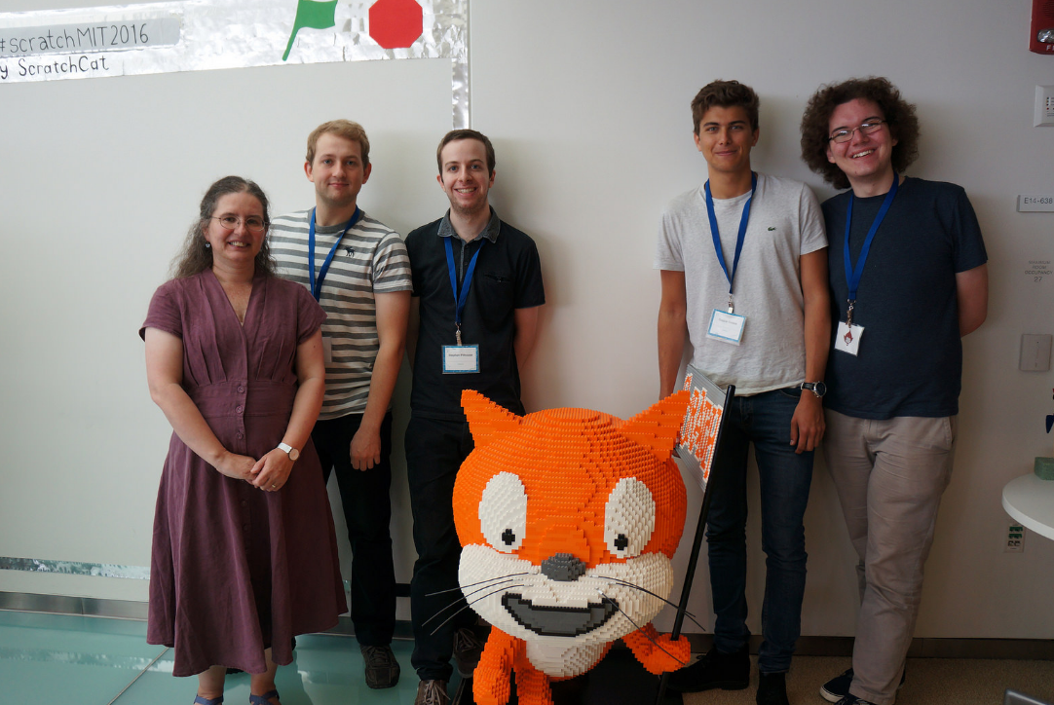

Left to right: Margaret Low, Matthew Earl, Stephen Pithouse, Caspar Collins, Kieran Hall

