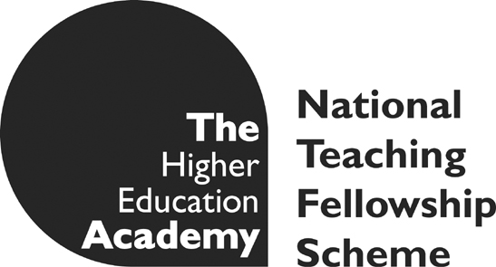
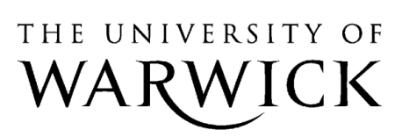

Open-space Learning in Real World Contexts

Representing the Other: Verbatim Theatre
Led by Annouchka Bayley with Nese Tosun
Aims:
1) to explore, interrogate and problematise the following topics through embodied experience of creation:
- dual heritage experience in the UK (including ex-patriot experience)
- the representation of dual heritage or ex-patriot experience
- the role of non-narrative, expressionist, and performance creation practices in the development of alternative strategies of ethnographic research and representation
2) to provide a framework within which participants can research and create their own ethnographic performances
3) to encourage dialogue between research and practice-as-research
The project will use non-traditional learning spaces at Millburn House to encourage a more diverse, inclusive and peer-centered rather than teacher centered learning experience. It will use the workshop model of learning which will combine practical, embodied creative experience with rigorous academic discussion in order to encourage students to develop their own relationship to epistemology.
Students will be encouraged to question what 'knowledge' really is, how this 'knowledge' is created and acquired, and how far they can create their own forms of knowledge building. Empowering students to participate to this extent in their own learning experience will enhance the following skills:
- ability to deal with complex, uncertain domains and to solve problems creatively
- ability to take global approaches to tasks and understand the interconnectedness of each element of an outcome
- ability to work as part of a team, and take initiative when required
- presentation skills
The Programme
Five workshops, hosted by the Institute for Advanced Teaching and Learning, engaging with the theories and practices of ethnographic representation through a Verbatim Theatre project plus a 40 minute seminar with guest speaker and a final performance/exhibition of work:
Self-Reflexivity/ The Personal vs the Private in Representation of Otherness. Wednesday, 12th January, 2011, 3-5pm, CAPITAL Rehearsal Room, Millburn House
In this workshop we will explore what our ethnicity means to us and how we might represent ourselves and our experiences within the contemporary context. We will work with creating our own ethnicity questionnaires; languages we are not currently using; neutral mask.
Otherness, Lack, & the Performance of Self. Wednesday, 19th January, 2011, 3-5pm, CAPITAL Studio, Millburn House
In this workshop we will explore theories of 'lack' created by otherness (with reference to Lacan, Irigaray and Cixous), the performance of self in the face of the foreign other, and how the tracing and observation of these occurrences can be brought into exploring creativity. We will be working with different creative media to represent and explore these issues, such as movement, painting/drawing, sound and lighting. Other creative media may be proposed by participants..
Dynamics of Observation, Representation and Difference in Performance. Wednesday, 26th January, 2011, 3-5pm, Room 3, Music Block, Westwood campus
In this workshop we will explore the worlds of difference between experience, memory and observation. By creating clay landscapes in-the-moment, peer observation and exploration of the gap between representation and intention, we will start to question and develop our own creative representational practice.
Ethnography in the Academy. Wednesday, 2nd February, 2011, 3-5pm , CAPITAL Studio, Millburn House
Following this 40-minute seminar, we will have the chance to ask questions of a current performance practitioner, Haleh Anvari, who will be online form Teheran.
From Interview to Stage. Wednesday, 9th February, 2011,3-5pm, CAPITAL Studio, Milllburn House
In this workshop we will explore alternative methods of interview including the re-writing of our own questionnaires and testing research methods we would like to explore in the studio. Here we will have the opportunity to try out new technologies and new approaches to research collection.
Creation/Rehearsal Workshop. Wednesday, 16th February, 2011; 3-5pm , CAPITAL Studio, Millburn House
In this workshop we will create and rehearse our own Verbatim piece based on our interviews, self-reflexive/autobiographical work, and the physical/artistic performance practices and transpositions we have explored throughout the workshop series. We will also have the opportunity to give and receive feedback

Performance Wednesday 23rd February, 2011
We will perform or present our Verbatim pieces to an invited audience and have the opportunity to give and receive feedback on our work.

