

(Publicity Design: Daniella Davidson-Williams)

Hear All About It

Reactivists Theatre Company
Report Co-Written By:
Helen Morley – Director
2nd year English and Theatre Studies

Leanne Ward – Producer
2nd year English and Theatre Studies

Prepared for IATL Performance Festival Bursaries

Contact: reactiviststheatreco@gmail.com

Abstract
Reactivists aim to make responsive, socially conscious, theatre that pushes theatre’s capacity to respond to and engage with contemporary society. Hear All About It was created to test how responsive theatre could be to the fast-paced nature of the news and daily events by creating bespoke, 20-30 minute weekly performances that directly respond to and engage with the news of the week before. Two companies of 2 actors, a writer and the director worked in rep, Company A writing and rehearsing whilst Company B performs, and vice versa.

Introduction
This concept was a difficult task for every member of the company, but was also extremely rewarding. After holding auditions and writing submissions, we formed a company from students at the university. They were then split into two smaller companies, consisting of 2 performers and a writer. The companies were as follows:

Company A:
Rishi Soneji, 3rd year, Law student – Performer
George Brooker, 2nd year, English and Theatre Student – Performer
Ava Davies (recently left the university) – Writer

Company B:
Caroline Taylor, 1st year, English and Theatre student – Performer
Rory Bines-Morris, 1st year, Film and Literature student – Performer
Eve Allin, 1st year, English and Theatre student – Writer

Our aim with Hear All About It was to push the boundaries of theatre’s dialogue with contemporary events, challenging the audience, writers, actors and creative team alike. We wanted to:
- Facilitate a space to engage with, challenge and discuss the news within a festival that aims to defy convention and open up communication.
- Test theatre’s capacity to engage in and rapidly respond to current affairs.
- Explore the relationship between theatre and activism.
- Create a platform for discussion.
- Develop our individual practical skills and theatrical understanding.

Methodology
- Initial Workshops

We began the workshop process by developing a sense of trust and comradery within the company, we knew we would likely be addressing difficult, and at times personal, events and issues whilst working on Hear All About It so it was important to establish a strong bond within the group.
We ran several trial runs of the quick response process, experimenting with different exercises and methodologies to determine what methods were best suited to both the unique challenges of quick response and to the styles of the writers and actors involved. Each week we gradually extended the quantity of work the writers were asked to produce, to ease them – and the actors - into the process.
In Edinburgh, each company had a full week to create a 30-minute show, but during this workshop phase each company had approximately 3 days. This worked in our favour when it came to Edinburgh as, having become accustomed to making work in an even shorter time frame, the task felt less daunting and more achievable. Moreover, after this period of workshopping, Helen felt confident that she understood how the two companies worked and thus knew how to effectively structure and support them during each week to ensure two good shows.

- Warwick Fringe
Marissa Beaty, Societies Officer for 2016/17, invited us to perform at the Warwick Arts Centre Studio as part of the Warwick Fringe on the 23rd of June. Both companies had the opportunity to perform and had the week leading up to the event to discuss, write and rehearse. This was an invaluable experience for every member of the company. For Helen, this gave her the opportunity to test a time frame and judge how best the writer and actors worked with the time restraints of a week. For the writers, not only did this give them the opportunity to grapple with subjects such as nuclear war and the Grenfell tragedy, but also gave them the confidence in knowing that they could indeed write powerful 10-minute performance within a week.
We received some very helpful feedback from Warwick Fringe that helped shape how we approached the process in Edinburgh and helped us confirm what our aims were as a company.

3. Edinburgh Fringe Festival
i. Company A
Our selected news story was the Child X case. We spent the first two days discussing and brainstorming around the story, examining personal experiences and exploring how the news story could help platform a wider debate about the provision of mental health services in the UK currently. On Wednesday Ava spent the day writing and on Thursday the company began to work with and develop the script. The script was finalised on Friday, the company rehearsed the play all of Friday and Saturday, teched the show on Sunday and began the run on Monday. It was important to us that the play enabled and encouraged audiences to feel more informed on mental health services and support and so created 7 information packs utilising the resources of various charities:
- CREATING YOUR OWN CAMPAIGN
- GENERAL INFORMATION PACK
- FRIENDS PACK
- SCHOOL PACK
- WORKPLACE PACK
- MINORITY ETHNIC COMMUNITIES PACK
- PARENTS' GUIDE
- HELPLINE AND SERVICES

We also held a collection for MIND at the end of the show and raised £70.
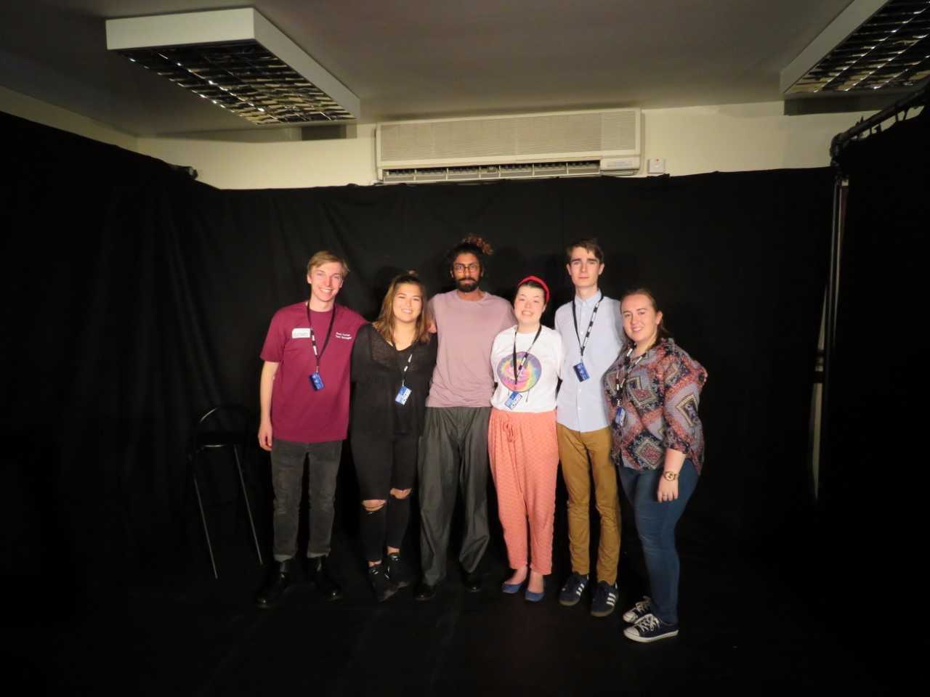
Company A (From Left: Ross, Ava, Rishi, Helen, George, Leanne)
ii. Company B
Our selected news story was the riots taking place in Charlottesville. On our first day of rehearsals we went to a solidarity march on the Mile where we met a group of artists from Charlottesville. They agreed to be interviewed and we were lucky enough to spend an hour discussing their own responses to the riots and the political climate and history of Charlottesville which immeasurably aided our understanding. One of our big concerns with this topic was how we – as, at this point, a wholly white group – could productively talk about Charlottesville. Given that the audiences at Edinburgh are predominantly white and left-leaning, we decided it was important to challenge the audience and not just preach to the converted. We therefore decided to address our own white complicity and internalised racism. We followed near enough the same structure as Group A, discussing and brainstorming on Tuesday before Eve began to write on Wednesday. The terror attack in Barcelona occurred on the Thursday, leading to us returning to a brainstorming session to work out how we could/whether we should, address that event in the play. We decided to alter one section within the play that where the character’s description of a riot could be mistaken for description of a terrorist attack. We added an analogy between the hatred that drives terrorist attacks to the hatred that causes a white supremacist to drive into a crowd of peaceful protesters, but otherwise the script remained consistent. For this show, we raised £66 for NAACP.
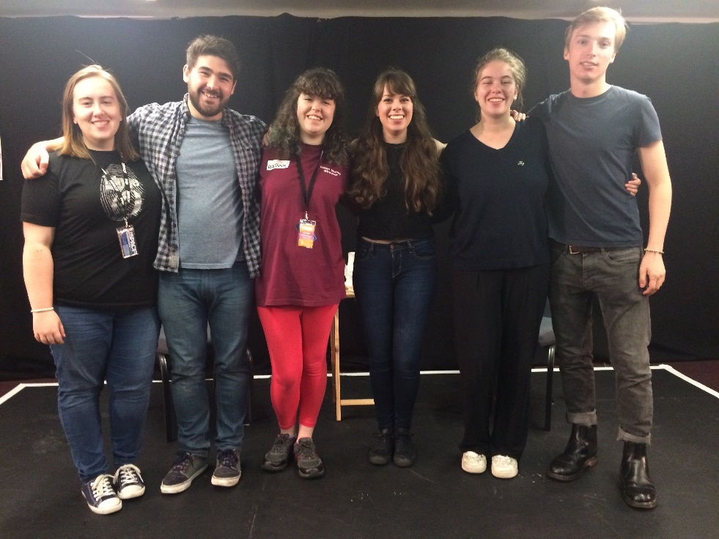
Company B (From Left: Leanne, Rory, Helen, Caroline, Eve, Ross)
- Marketing and Publicity
i. Physical
Our poster (displayed on the cover page of this report) was designed by Daniella Davidson-Williams. The design was used for all posters and flyers during our time at the Fringe. Posters were displayed in all theSpace venues across Edinburgh and we also placed some in local shops, businesses and cafes.
Both companies would flyer along the Royal Mile and the Half Mile every day to encourage people to get tickets for upcoming performances. We also created speech bubbles with #keepreacting on which we took to the Mile whilst flyering. We would ask those on the Mile what their favourite/ most memorable news story of that week was and post it on Twitter.
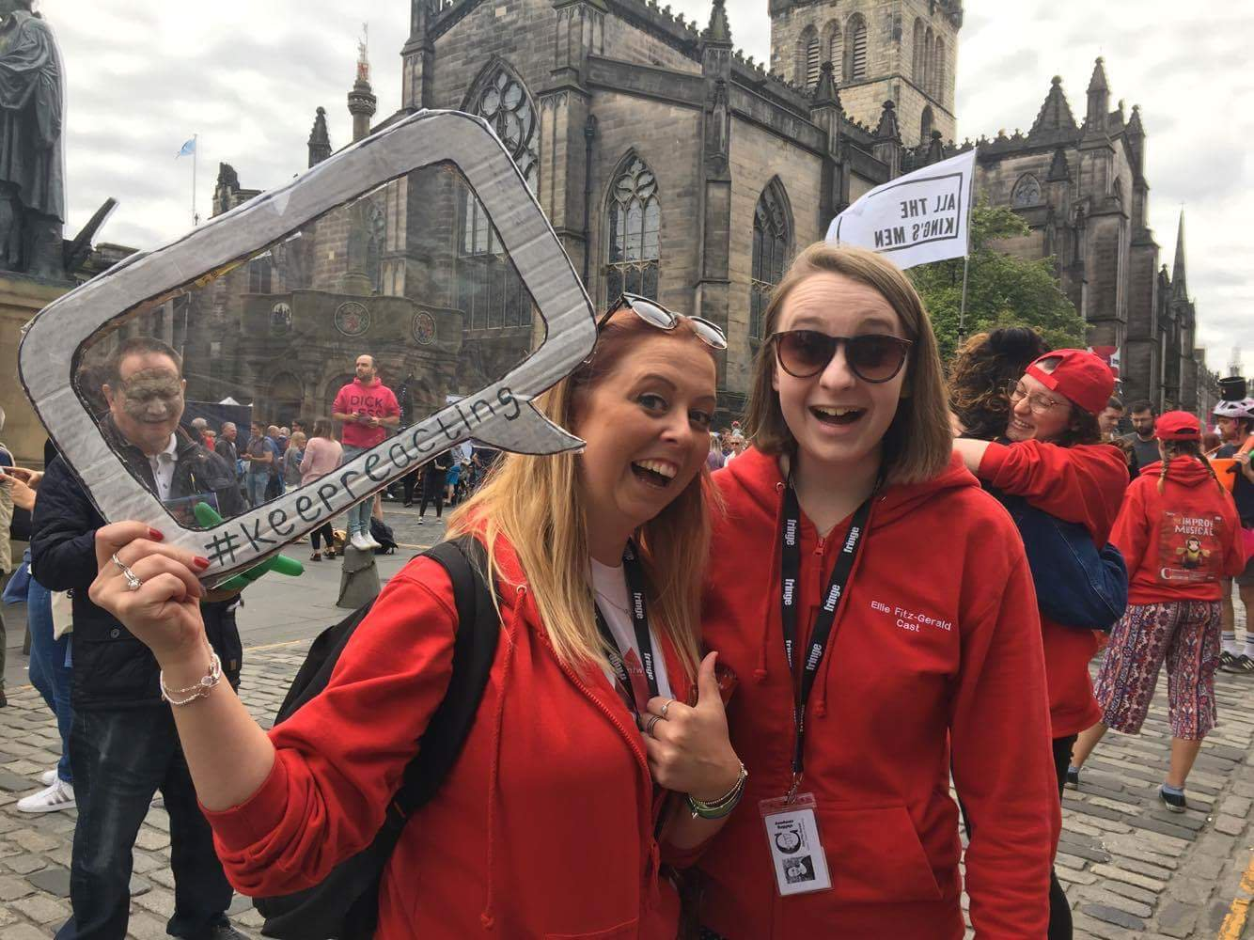

(Musical Theatre Warwick’s Freya Jeffries and Ellie Fitz-Gerald on the Royal Mile)

ii. Online
We wanted to have a large online presence as this is often a strong way of reaching a wider audience. We have both a Facebook and Twitter page where we used #keepreacting to connect all our publicity. This is also where we did the majority of our networking by contacting other companies and connecting with fellow performers at the Fringe. This was crucial to begin conversations about our show.
We also began a blog which can be found at the following link: https://reactivists.wordpress.com/
The blog was updated weekly throughout July with all members of the companies writing a small blog about something that had interested them that week. This was also updated throughout the run with regards to the progress of rehearsals. We also had a vlog which was posted on our YouTube channel with interviews with Helen, the writers and cast.

5. Challenges
One limitation we faced was the challenge of making our production accessible. During the early months of the year, we looked into the options of having our performance Captioned and/ or audio described. After researching the necessary companies and contacting the venues, the cost of either modes of access would’ve been too great for us. We decided to hold two relaxed performances on the 17th and 24th of August.

A relaxed performance is a showing where minimal tech is used, house lights remain on, and audience members are permitted to speak, make noise and leave the room if required. After discussion with the technical team at Jury’s Inn, it was agreed that that specific venue and performance space would not be suitable for a relaxed performance due to its intimate nature and the lack of space for audience members to retreat to if they felt overwhelmed. This wasn’t an ideal situation for us and we were disappointed that we couldn’t offer this to our audience. From this experience, we have learnt that accessibility issues need to be decided upon early in the process so that, when choosing a venue, this can be accounted for and agreed with the venue before confirming with them. After attending the Fringe Central lecture ‘Access on a Budget’, Leanne was able to take note on the variety of accessibility arrangements that can be made at all venues and the company is planning on having more accessible shows when we perform again in the future.

Results
TESTIMONIES AND OPPORTUNITES.

2. THE SCOTSMAN
Edinburgh Festival Fringe: Two earnest young men, clear-voiced and fresh-faced tell us the facts: a suicidal teenager known only as X is in danger of taking her own life if a hospital bed can’t be found for her.
***
The show is part of a series of new plays which the young company write, direct and produce in response to recent news. Each week they will stage a new one. Today’s piece is an old-fashioned, unabashed piece of political theatre in which performers George Brooker and Rishi Soneji also wryly question whether they have any right, as men, to tell an unnamed woman’s story. Ava Davies has written a smart and creative script that may initially feel like an on-the-nose retelling of the facts, but then questions its own legitimacy through a far more interesting exploration of liberal values. Didactic but charming, literal but self-aware, the piece calls for us to remember the unseen people affected by cuts to mental health services and the NHS. At the end a clearly emotional Brooker hugs Soneji – a touching moment that hints at the intense but inspiring process creating a piece this quickly must involve.
(Sally Stott, The Scotsman)

3. FRINGE REVIEW Company B
This premise is simple. Take an event from the past, preferably within living memory and then write a brand new show linking it to a notable news event from the previous week. Then stage it and perform it. This week’s theme is Battleground.
Sounds very simple, but several people here have put in an awful lot of work to deliver a quality piece of theatre from a blank sheet of paper in under a week. Writer Eve Allin chose the Battle of Lewisham as her event from the past and the Unite The Right rally that has dragged Donald Trump through the mire in terms of his reaction to it (or lack thereof) over the past two weeks.
The similarities are, one would hope, pretty obvious. Lewisham saw members of the far-right National Front clash with counter-demonstrators with ensuing violent clashes involving up to 4000 people and police riot shields deployed for the first time in the UK. Charlottesville in North America saw clashes between white supremacists and a crowd of anti-racist and anti-facist protesters leading to the death of Heather Heyer. It was the biggest white supremacist event in recent US history.
But it will never happen again, will it? It will never happen here, will it? That’s the thrust of the polished dialogue between the two actors, Rory Bines-Morris and Caroline Taylor as they mix real quotes from the reaction to events in Charlottesville with their scripted text. The former were nicely chosen polemics too, with the slants from the Daily Mail and The Guardian sitting in juxtaposition to those from the embattled President Trump himself.
With the contrasting yet somehow similar events recounted from the point of view of Mr and Mrs Joe Public, it rammed home the message, if it were needed, of how intolerant society is in danger of becoming, how it repeats mistakes through a failure to learn from history and how apathy is the friend of the extremist.
A simple message, delivered with conviction and empathy by two talented and committed actors, this was a timely reminder that theatre has a role in generating a reaction, a response and a discussion about current affairs. Well worth a look.
(Tim Wilcock, The Edinburgh Fringe Review)
Company Testimonies:
Rishi Soneji, Performer of Company A:
This was the first time I had been to the Edinburgh Fringe Festival, and it was a highly intense but incredibly rewarding experience.

Firstly, the atmosphere in Edinburgh was like none I had experienced before. There was an open, motivated, and exciting buzz in the air, and this never faded during those three weeks. I believe it was with this that the Reactivists took as wind in their sails. The first week was spent devising and discussing the news from the week. Realistically, the news of the week was not as eventful as we have come across in the past. There was no general election, no Brexit, nor worldwide tragedy. This, however, didn’t stop us from finding a topic that was both personally and theatrically challenging. Our piece was based on the ‘Girl X’ case, thus exploring mental health, its relationship with the NHS, and personal struggles. The first few days spent discussing and workshopping were invaluable. It was an open and safe space for all involved to have a say and have their input respected. Rehearsals started shortly afterwards. We were lucky enough to have space in two venues, Fringe Central and Out of the Blue which really gifted us a physical performance space where we could put the writing on its feet. The devising and rehearsal process seemed to pass extremely quickly. Days were spent, rather than wasted, and by Thursday we had a script thanks to Ava Davies whose writing still affects me positively. Helen Morley was a fantastic director, she was non-judgmental and handled a tricky topic extremely well and effectively. Leanne Ward was not only exceptional in producing two shows quickly, but was alert to the sensitive issues at hand and was always willing to check each member of the company was comfortable and happy.
Performance week also went very quickly. We had mixed audiences in terms of age, but this was a great thing I believe. Each day we had people come to speak to us at the end to tell us how they found our piece, and this was exclusively positive. There is no greater reward than to hear that your work has moved somebody; and it was this feeling that has inspired me to write and perform my own show. From my perspective, each show was different. The emotional charge of each scene seemed to escalate with every day, and this was fascinating. The set was limited exclusively to a stool, and lighting was kept very basic - this complemented Ava’s writing and accentuated the political and emotional message of discussion and openness well. Performance was of course challenging, but I am grateful to say I have not only gained confidence in my ability to perform, but confidence in speaking about difficult topics in the forum of theatre; something I hope to pursue this year and the next.
The festival itself was wild, fast-paced, and emotional. I saw some exceptional theatre. I saw some of it twice. I saw some theatre that didn’t work, and some theatre that changed my perspective on life and its meaning. I do not believe there is another place where so much varied and experimental work can be seen, and this was a blessing. I have learnt what works on stage, how theatre as an industry functions, and how nurturing theatre as an art form can be. It would not be an understatement to suggest the Fringe changed my path and my ambitions. Working with the Reactivists was just invaluable. The thought and time put into creating our pieces was unassailable, and I believe the final result was equally as poignant and meaningful.

Conclusion and Outcome
Individually, our confidence, competence and creativity within our specific fields (be that writing, directing, producing, or performing) flourished and developed enormously over the course of the process.
The critical and audience reception to the show was highly positive, we engaged in several really interesting discussions with audience members after the two shows and it certainly felt like we had developed a platform for discussion and debate. The ability to convert this discussion into positive action through our charity donations and packs was really exciting and helped establish our commitment to embedding activism within theatre.
The positive audience and critical reception – and the considerable audiences we amassed - suggests that theatre can engage and rapidly respond to current affairs, although the fast-paced nature of 24hr News does admittedly make this very difficult, as our experiences rehearsing Company B highlight.
A couple of opportunities were offered to us following our run at the festival. Whilst flyering, a member of the Sky Arts team approached us to discuss an opportunity called SkyArts50. This initiative was created by Sky Arts to explore the identity of Britain following Brexit. Submissions open within the next month, and this is an opportunity that we, as a company, are hoping to explore.
http://www.skyartsart50.tv/
We also wish to attend Edinburgh Fringe Festival 2018 with a show of a different format. This will hopefully begin conception in January 2018. Following this years festival, every member of the company feels that they have developed within their individual crafts and would be challenged by another trip to the festival, hopefully in a different venue to explore different theatrical spaces and capacities. We are really excited about the opportunities that Edinburgh has provided for us and cannot wait to see what we as a company do next.

Final Budget
Venue | Space hire | £1,500 (including VAT)
 | Edinburgh Fringe Brochure Fee | £393.60
 | Staffing | £0.00
 | EdFringe.com advert | £0.00
 | Insurance | £126.60
 | Rehearsal Room Booking | £208.50
Production Costs:
Props | Chair (Argos) | £15.00
 | Table (Argos) | £11.49
 | Printing Costs | £15.30
 | Crockery Set (Cancer Research) | £11.00
 | Buckets (Pound Savers) | £7.96
Press and Marketing | Venue Marketing | £0.00
 | Ad Design | £0.00
 | Posters | £56.99
 | Audition Flyers | £29.72
 | Flyers | £161.95
 | Print Distribution | £56.88
 | Outdoor Advertising | £60.00
 | Company T-shirts | £204.60
 | Publicity Photos | £0.00
Accommodation | Rent and Utilities | £4,592.64
 | Food | £0.00
Travel | To and from Edinburgh | £500.00
 | Around Edinburgh | £0.00
Total (not including accommodation) |  | = £3,359.59
Total (including accommodation) |  | = £7,952.23

 | Box Office | Edinburgh Fringe | Ed Fringe Commission | VAT | Total (minus Ed Fringe commission)
14th-19th | £183 | £316 | £12.64 | £2.53 | £483.83
21st-26th | £155.40 | £230 | £9.20 | £1.84 | £374.36
Total |  |  |  |  | = £858.19
Ticket Sales Breakdown

Individually sourced.

