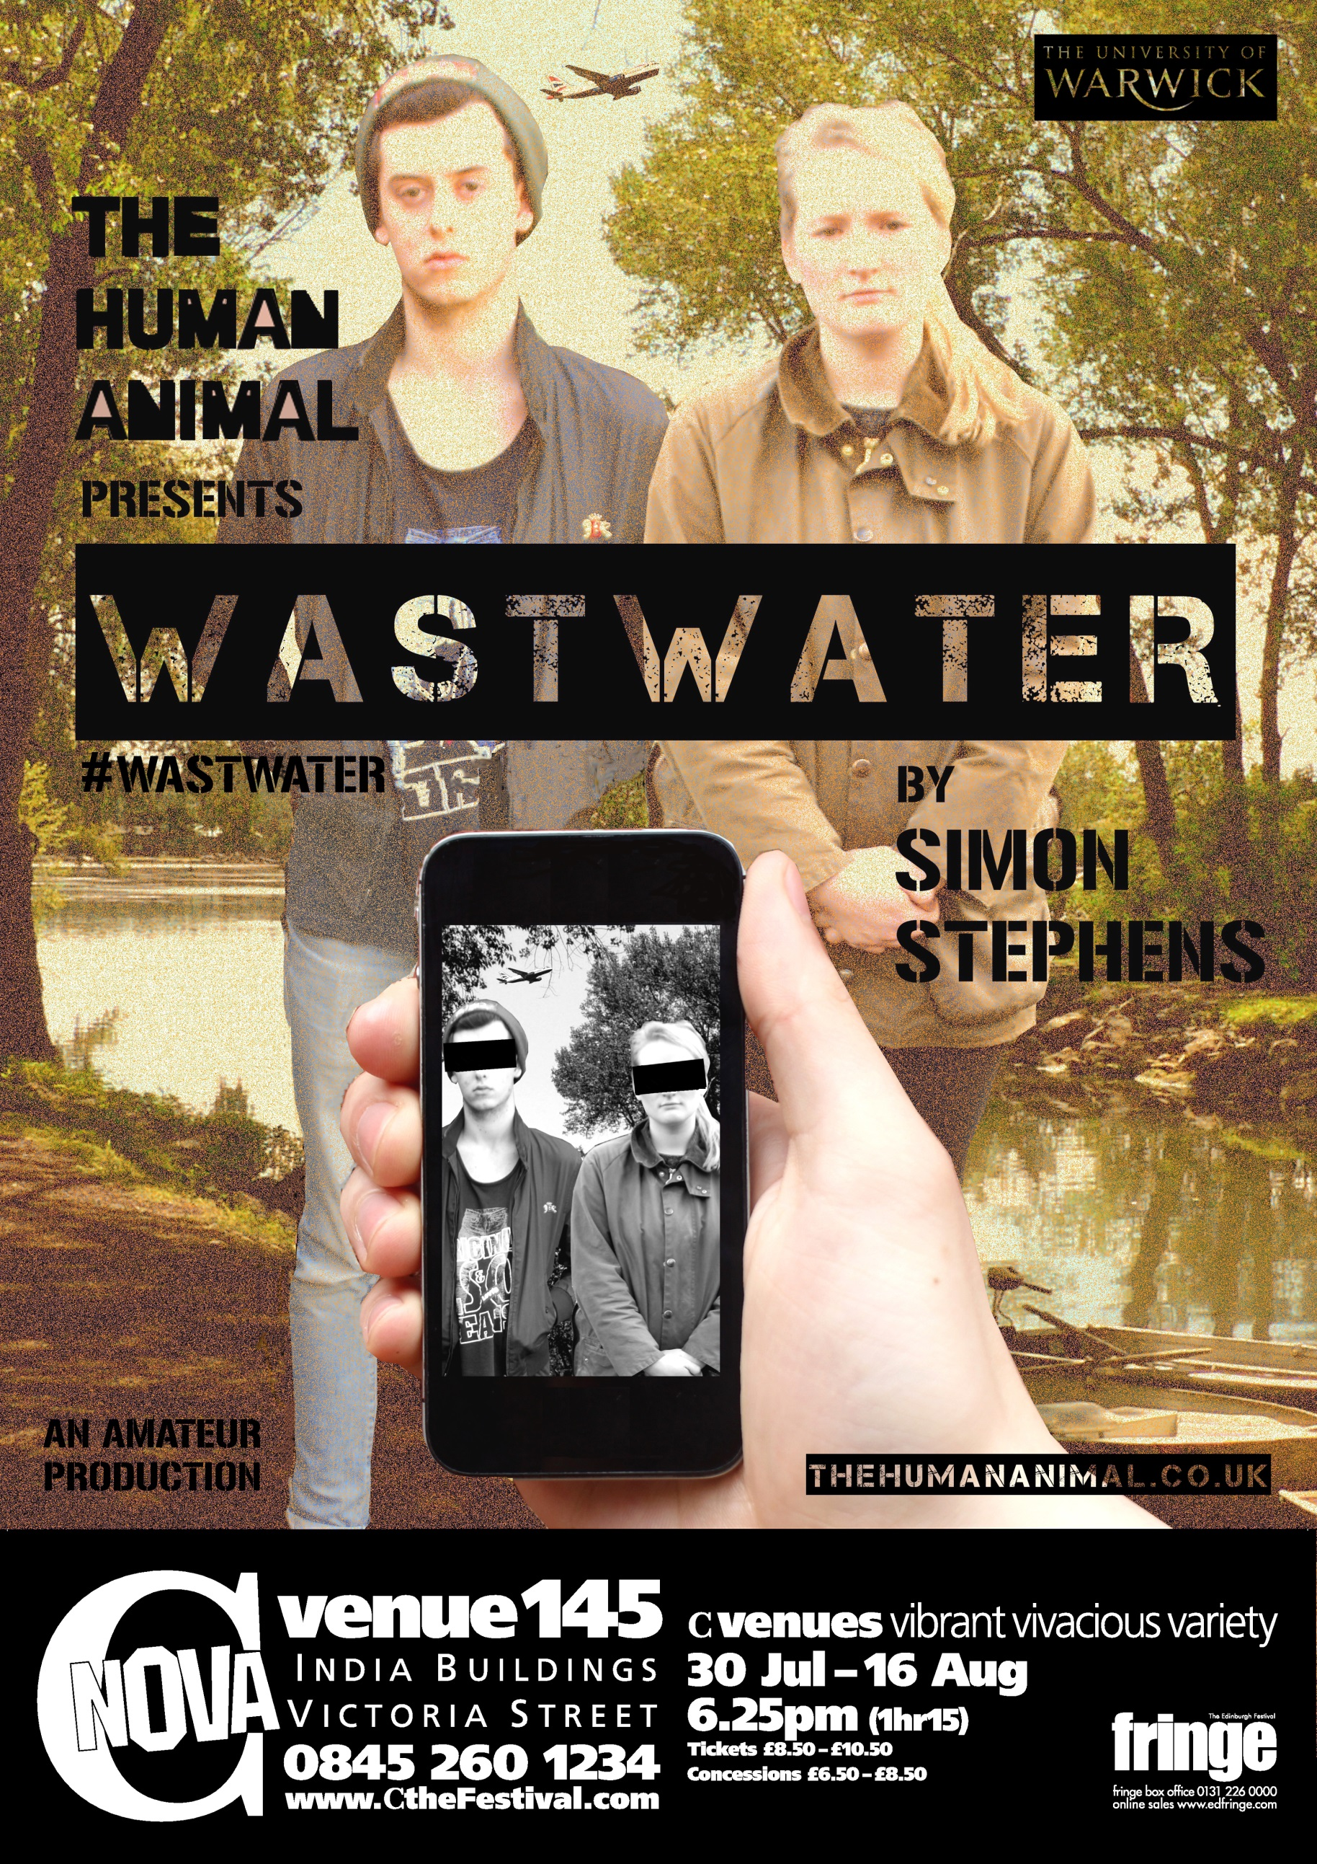
PERFORMANCE FESTIVAL BURSARY REPORT
WASTWATER
EDINBURGH FESTIVAL FRINGE 2014.
WASTWATER AT THE EDINBURGH FESTIVAL FRINGE 2014
IATL FESTIVAL BURSARY AWARD REPORT

In August 2014, the fledgling theatre collective The Human Animal performed their promenade production of Simon Stephens’ ‘Wastwater’ at the Edinburgh Festival Fringe in C Nova, Flexi Studios. The production ran from the 30th July to the 16th of August for a total of eighteen performances, achieving admirable recognition from top reviewers such as Lyn Gardner from The Guardian newspaper, Three Weeks and EdFringeReview.com.
The Festival:
2014 set the record for the largest Fringe Festival to date since its opening in 1947, with over three thousand productions being performed over the month of August. The annual Festival Fringe showcases an entire spectrum of the arts industry from across the globe; ranging from theatre to comedy, dance, circus, performance poetry, solo works, music and cabaret, the fringe has more than enough variety to suit every need.
The Human Animal carved-out their corner of the fringe through their promenade production of Simon Stephens’ ‘Wastwater’:
A mother and son. A pair of lovers. A supplier and her client.
On the edges of Heathrow Airport, six lives threaten to blow apart. Upon closer inspection, these seemingly conventional relationships will tilt our understanding of human interaction in a world pervaded by technology. Written by one of the UK’s leading playwrights, Simon Stephens’ Wastwater is an episodic portrait of the individual on the brink of monumental change. In this promenade production, The Human Animal invite you to explore, touch and trace the world of Wastwater, guiding you through airport security in promise of a flight that will never take off…
The promenade design of the production was used to reflect the isolated and highly contained style of the play itself. The audience were required to move around three separate spaces, each enclosing a different scene. This style of performance required a huge amount of careful planning and organisation to ensure a smooth transition from black-box rehearsal studios on campus to the dramatically different performance spaces at the fringe; as well as making the transition from an isolated rehearsal room to the performance that required a great deal of audience interaction.

Benefits, Opportunities and Connections:
One of the first things we had to consider when planning to take our production of Wastwater to the Edinburgh Festival Fringe was, why Edinburgh? The Edinburgh Fringe offers a unique opportunity to see and be seen other creatives in a professional, competitive environment. The connections made to other companies and professionals within the arts industry are crucial for young, emerging companies to collaborate with and learn the tricks of the trade in a practical, working environment. Whilst in Edinburgh we are able to invite industry professionals and peers to experience and give feedback about our production. In turn we were also able to experience other performances and open dialogues with new and established companies, creating a supportive and constructive network that will enable The Human Animal to develop our work in the future.
A key discovery we made during our time at the Festival Fringe was the vital role that social media, mainly Facebook and Twitter, play to create connections between fellow artists and the arts media. Through the use of social media hashtags such as #edfringe and #unbored we were able open running dialogues with audiences, reviewers and other companies to discuss and support and other performances, whilst at the same time promoting our own production. This encouraged us as a company to continuously evaluate our relationship with technology and rethink our image as an online performer in contemporary society.
After arriving in Edinburgh, the company had to adapt extremely quickly to the three performance spaces that we had been allocated, a few dimensions and details significantly different to what we had initially been expecting. Due to the complicated, promenade-style of our production, the entire company doubled as performers and technical crew to ensure smooth transitions of audience movement from studio space to studio space. The experience has therefore provided each company member with a new technical skillset and practical production knowledge for any production which shall allow us greater flexibility as a company to work as an independent unit in any performance arrangement.

Reviews:
Laura Gavin – Three Weeks
‘Wastwater’ certainly keeps you on your toes. It’s a promenade piece; we are ordered from room to room to visit a series of often uncomfortable scenes. The throbbing soundtrack and projected scenery make an evocative backdrop to the three interconnected dramas, which all take place within earshot of Heathrow. They deal with everything from complex family ties to a tense, sinister transaction. The last scene is dominated by an edgy performance by actor Bryony Davies, but it is Lisa, a character in another, more intimate bedroom scene, who sums up the underlying point: we have no idea what’s going on in the next street, the next household, the next hotel room. A provocative though certainly not relaxing 75 minutes.

Xavier Greenwood – EdfringeReview.com

‘Wastwater’, set on the fringes of Heathrow Airport, consists of a triptych of scenes, which – in the dying summer evening of 23rd June 2011 – give snapshots of the unsettling underbelly of contemporary society. Intense, voyeuristic and interminably bleak, ‘Wastwater’ is named after the deepest lake in Britain, but it must be questioned whether the show, despite its resonant despondency, explores beyond its banks.
The audience are seated and standing around the room; a projection of the play’s surroundings is beamed onto the walls; the noise of jet engines moans overhead; the doors are shut; the scene begins. Between each tableau, the audience are escorted from one room to the next via a middle space in which they are ordered to walk along the yellow tape on the floor. There is no question as to whether the play immerses us: with an unnervingly small distance between the audience and the characters we are too close to turn our eyes away, and indeed this is made impossible by the grim scenes before us.
Each scene contains a new couple, including a foster mother, a police officer and two teachers – alongside these characters in their respected professions are themes which include heroin addiction, torture, and child abuse. The close of each scene ends in medias res, leaving an unnerving residue of obliqueness. It is truly comfortless viewing.
This unceasing pessimism is only amplified by the actors, who perform with manifest intensity; the sinews of deformation which have worn away each character to their brittle selves are made minutely visible by the complete absorption of the actors within their respective roles. The show intensifies as the scene moves from garden to hotel room to warehouse. The acting intensifies too, particularly on the female side; we end with the terrifying megalomaniac Sian (Bryony Davies), who has a penchant for torture.
It is clear that the play succeeds in its goal of depicting the darkest recesses of 21st century society, but, one must only ask, to what end? Whilst it seems to be missing the point to criticise the performance for its lack of plot, it is difficult to identify what is the actual point. Amid the emotional dismemberment of the characters, no mutual tipping point, from which any kind of message can be extracted, can be identified.
Nevertheless, though ‘Wastwater’ does not contain enough depth of meaning to be a five-star production, it is a truly memorable show, which powerfully evokes the hidden nadirs of humanity.

BillyBarrett.com

A few months ago, I criticised the top-down organisation and dearth of originality that I argued characterises so much student drama – so I was heartened to hear about the Human Animal’s production of Simon Stephens’ Wastwater at C venues, whose three couples of the tripartite form directed each other’s sections, and also designed and produced the show. This horizontal organisation, I think, really came through in the piece’s cohesive and collaborative feel.

Like Nothing, Stephens’ 2011 play follows fragmented, seemingly disconnected strands, also centring around individuals’ experiences of abuse, estrangement and commodified sex in a globalised culture – which we’re invited to piece together through a series of musical recurrences and strained narrative connections. The Human Animal’s production is sort-of-promenade, meaning we’re moved from one room to another between each scene, but seated on chairs, crates and the floor throughout. The conceit works beautifully; we’re spared watching the logistics unfold of transforming one space from a field to a hotel room and a derelict house, and given the voyeuristic guilt of walking in – and intruding – on interactions midway through.

The company also uses projection – not in the twee, sketchy OHP way like so many “low-fi” shows, but proper photographic projection right over the set and the cast’s faces, giving the whole piece an eerily still, over-layed collage aesthetic like a crime-scene reconstruction. It seems unfair to single out actors in an ensemble piece, but Bryony Davies and Alex Welsh put in some terrifically tense performances from among the strong cast.

Thank you
After our first stint as the Festival Fringe, the future for The Human Animal is looking very promising. The sheer magnitude of the festival has taught us a great deal about the competitive nature of the arts industry, requiring a great deal of patience, stamina and flexibility. As a company we endeavour to cultivate the connections we have made during the festival to enable the The Human Animal to collaborate on further projects with new artists and individuals, continuing to reimagine our interests and ideas about theatre and performance both at Warwick, Edinburgh and beyond.
To conclude we would most importantly like to thank IATL for their very generous donation towards The Human Animal’s production of ‘Wastwater’. IATL’s support ensured the company were kept afloat in the vast oceans that formed the Edinburgh Festival Fringe, and has allowed us to now have the opportunity to set sail into new waters.
