‘Where The Heart Is’ Final Report

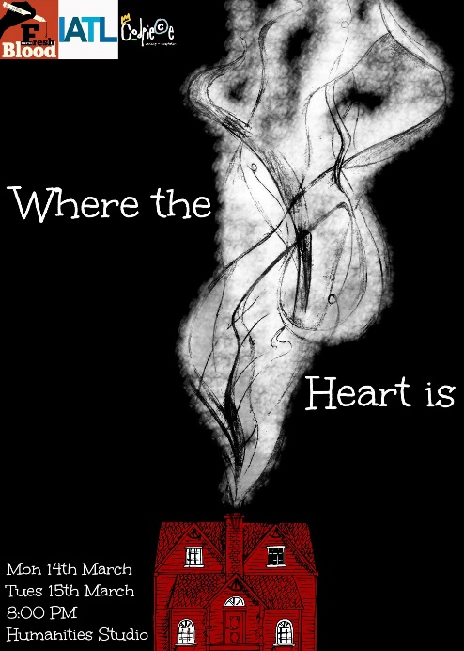
Innovation and interdisciplinarity were at the core of our aims for ‘Where The Heart Is’. We were satisfied with the writing process we developed, providing various layers of feedback to the writers. They began by writing drafts that were workshopped using naturalistic script-work techniques such as units and objectives and actioning, improvisations designed to open up character backstories and Uta Hagen exercises designed to clarify the structure and intentions of scenes. The writers attended these rehearsals, and wrote second drafts, which we then did more in-depth script work with and staged as if in performance, allowing the writers to make adjustments to the actor’s voices and iron out any more problems. The cast acted as dramaturges, discussing improvements with the writers and editing the scripts together, largely in rehearsals in which scenes would be interwoven.

Rather than looking at blending theatre with another single discipline, the system of three writers and the extensive planning meetings between them, the director and the producer were designed to create a melting pot of disciplinary influences. For instance, the 1940s section was inspired by the experiences of the writer, Kier Heath-Griffiths, with his History & Politics degree, looking at undersides of British actions during World War Two, but also by films such as The Enigma by another writer – Carmella Lowkis – and her experience with the LGBTQ movement. This allowed the story to take diverse and unlikely twists, and the post-show talk saw a lot of people comment on the unusual conspiracy-style narrative and the groups and ideas it moved through.

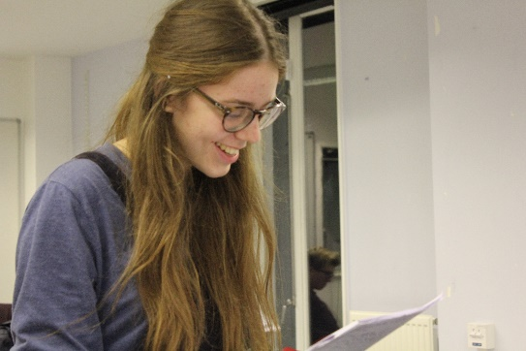
The auditions were able to reach out to a number of different groups partially through our inter-society collaboration, but also through the way we used the diverse backgrounds of our team to share auditions with a variety of audiences. We collaborated on the performance with Codpiece and Freshblood theatre societies, which extended our reach to a lot of people involved in the Warwick Drama movement, but we also got team members to share auditions on society and academic Facebook pages, such as Writing Society, first year Maths, and St John’s Ambulance society. This was extremely effective in getting a variety of students to audition for the production, and our cast included students from Law, Film, Theatre, English and Maths.

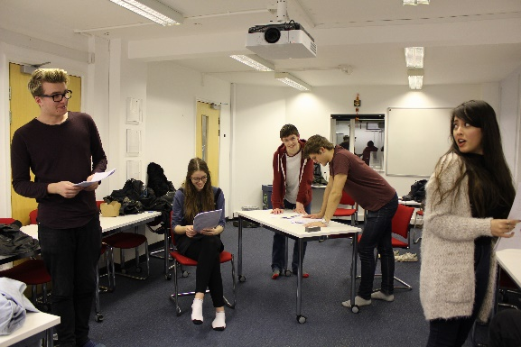
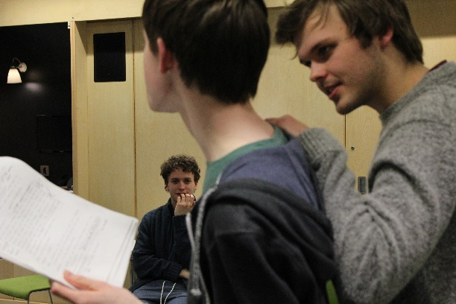
As well as allowing us to test out the scripts, the long rehearsal process helped in developing complex characters and getting used to the unusual use of three-quarter thrust staging, which provided an intimate relationship with the audience. For the former, we would frequently spend at least two hours a week on character-driven improvisations and script work, both working inside-out with Stanislavskian-inspired exercises, and outside-in with Labon and Uta Hagen-inspired workshops. The actors were encouraged to take control of their own scenes, with the director and producer asking for their feedback on how well they felt scenes went first, and allowing them to run their own exercises and control rehearsals when this felt particularly important. The unusual staging also required the large rehearsals rooms that IATL were able to provide, and both director and producer ensured that the actors were constantly aware of the need to play to audiences on all sides, not just at the front of the stage.

The IATL award allowed us to take risks with the set and costume that we wouldn’t otherwise have been able to, and this made a great difference to the final production. Some of the most effective moments of the performance were provided by the interactions of the three different time periods in which the piece was set; the characters occasionally felt the presence of a character from another time period in the room with them. The award meant that we were able to source records, walking sticks, prop guns, military uniform and have a dedicated designer, Lucie Walker, who attended multiple rehearsals (from the History of Art department). The sourcing of historically accurate props from different time periods meant that the aesthetics of the show were strong, reflecting the diversity of different time periods rather than relying on an actor’s own possessions and wardrobes, as is so often the case with student shows. Furthermore, the lighting and sound equipment allowed us to absorb the audience into the world of the performance to a greater degree, with the lighting being used subtly to suggest the passing of a day, which would have been impossible without the IATL facilities and support of the technician.

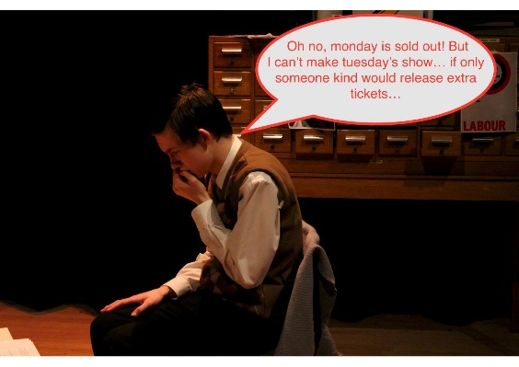
Both performances were well received by audiences, who commented on how well blended the narratives were and the effectiveness of the blends of style and subject matter. The first performance was better received in terms of humour, but the second performance was performed with greater confidence. Both performances ‘sold out’ of seats and had an audience of between 40 and 50, from a variety of university demographics, with Writing Society, History & Politics, Warwick Drama and Maths all having noticeably large audience contingents. From this respect, along with the diversity of disciplines in the cast, we felt that we broadly achieved the outreach aims of the project.

However, the post-show talks and audience reception also helped us think about the ways in which the project could have been improved. Although the cohesion between the scripts was strong, it was suggested that workshops in the previous term could have allowed us to work on careful interweaving of key moments to a greater degree, as audiences responded well to this, with similar comments made about the music composed for it. There were also comments that the politics were somewhat simplistic, with not enough sympathy being given to characters who adopted morally dubious positions. Again, a longer workshopping process would have allowed us to consider the impact we wanted to have on the audience more clearly, or perhaps a trial performance of the first/second draft of the scripts.
