M4C Mid-Year Review 2025/26 Guidance
On the M4C VPP, this academic year’s Mid Year Review process will be listed Year 2025 (even though the reviews take place in 2026)
General Guidance:
- The mid-year review takes place in January-March to enable students to receive feedback in good time and in order to review progress at a key stage in their research programme.
- All M4C funded students must complete the online Mid-Year Review form by the 2 February 2026.
- The mid-year review is an opportunity to discuss your research and professional development training, any requirement for extended funding to enable fieldwork or specialist training, including a placement.
- Once your M4C award has finished you are not required to complete a Mid-Year review but will need to comply with any requirements at your home University.
Timeline:
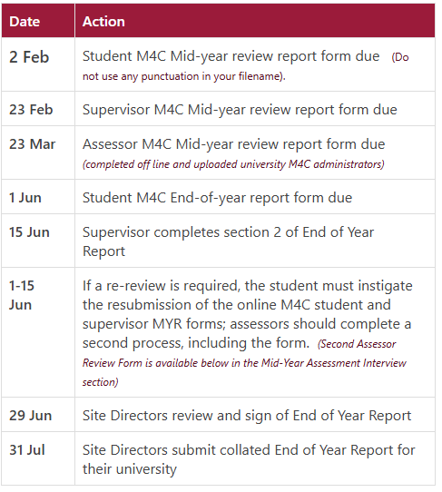

Full Time Student Requirements

Year 1
- A research statement of 1500-2000 words indicating the scope of your thesis, and outlining the key research questions, research context and methodology (include details of any key texts, materials or case studies you intend to use).
- A 5000-word example of your written work ie a chapter or a section of discursive prose from your thesis, or equivalent output for practice-based PhDs.
- For M4C award holders in year one of your PhD (or part-time equivalent), requests for extended funding can be made where there is a rationale for complex or extended training, skills acquisition, extended archival visits, fieldwork or placement needs. An M4C award can be extended up to a maximum of 6 months full-time or 12 months part-time. If applicable please complete the Award Extension Request Form by 31 March 2026.

Year 2
- An updated 1500-2000 word research statement. This should build on your first-year statement and provide details of how the research has developed, any changes in scope, content and direction.
- if required a 5000-word example of your written work (ie a chapter or a section of discursive prose from your thesis) or equivalent output for practice-based PhDs.

Year 3
- An updated 1500-2000 word research statement. This should build on your first-year statement and provide details of how the research has developed, any changes in scope, content and direction.
- if required a 5000-word example of your written work (ie a chapter or a section of discursive prose from your thesis) or equivalent output for practice-based PhDs.
Year 4
- If your end date remains on or before 31st of March and you have completed 3 MYRs you do not need to complete a mid-year review but if your award end date has been extended for any reason beyond 31st of March you must complete a light touch mid-year review (as long as you have already completed 3 MYRs) using the usual form on the VPP and submit a brief statement outlining how you are on track to submit your PhD.

Part Time Student Requirements
Part time students will undertake an assessment review in years 2, 4 and 6. In years 1, 3 and 5 they will be reviewed by their supervisory team using the student mid-year report form

Year 2

A research statement of 1500-2000 words indicating the scope of your thesis, and outlining the key research questions, research context and methodology (include details of any key texts, materials or case studies you intend to use).

A 5000-word example of your written work ie a chapter or a section of discursive prose from your thesis, or equivalent output for practice-based PhDs.

For M4C award holders in year one (or part-time equivalent) requests for extended funding can be made where there is a rationale for complex or extended training, skills acquisition, extended archival visits, fieldwork or placement needs. An M4C award can be extended up to a maximum of 6 months full-time or 12 months part-time. If applicable please complete the Award Extension Request Form by 31 March 2026.

Year 4

An updated 1500-2000 word research statement. This should build on your first-year statement and provide details of how the research has developed, any changes in scope, content and direction.
If required a 5000-word example of your written work (ie a chapter or a section of discursive prose from your thesis) or equivalent output for practice-based PhDs.

Year 6
An updated 1500-2000 word research statement. This should build on your first-year statement and provide details of how the research has developed, any changes in scope, content and direction.
If required a 5000-word example of your written work (ie a chapter or a section of discursive prose from your thesis) or equivalent output for practice-based PhDs.

Mid-Year Assessment Interview
All students must meet with their supervisors for a review meeting and the supervisory team need to complete the Supervisor Section in the online Mid-Year Report form. This must be submitted via the VPP by 23 February 2026. (Please note that the supervisor form will be automatically created on completion of the student section of the form).
Assessment Review Interviews
- All full-time students in year 1 and part-time students in year 2 have an assessment review interview with two assessors from outside of the supervisory team. (NB this does not preclude assessors from subsequently acting as internal examiners on final submission of the thesis).
- All students in Year 2 and 3 have an assessment review interview with one assessor outside of the supervisory team (although two assessors are recommended if the student has been asked to provide a further writing sample or practice-led equivalent by their supervisors).
- The student review materials and supervisor report form the basis of the interview. The assessors will read all the materials submitted and interview the student to assess and document progress.
- The structure and conduct of the meeting with the assessors should follow the pattern of the home university and students must be offered the opportunity to talk to the assessors alone if they wish to do so.
Assessment reviews should take place before 23 March 2026 and the review interview should allow students the opportunity to clarify points or to raise issues with the assessors.
Review interviews may vary between 30 minutes and one hour but should not normally exceed one hour.
Assessors must complete the M4C Mid-Year Monitoring Form (offline) and return it electronically to their M4C Administrator who will upload this to the VPP.
Possible outcomes of the Annual Review process are:
- that the student's progress is satisfactory, and they may proceed to the next year of their studies
or
- that the student's progress is not satisfactory and as a result supportive or corrective action points will be agreed by the assessors which will result in a further review of the student's progress in June. If, after the second June review, progress is not deemed satisfactory, a student's M3C and AHRC funding can be terminated.

