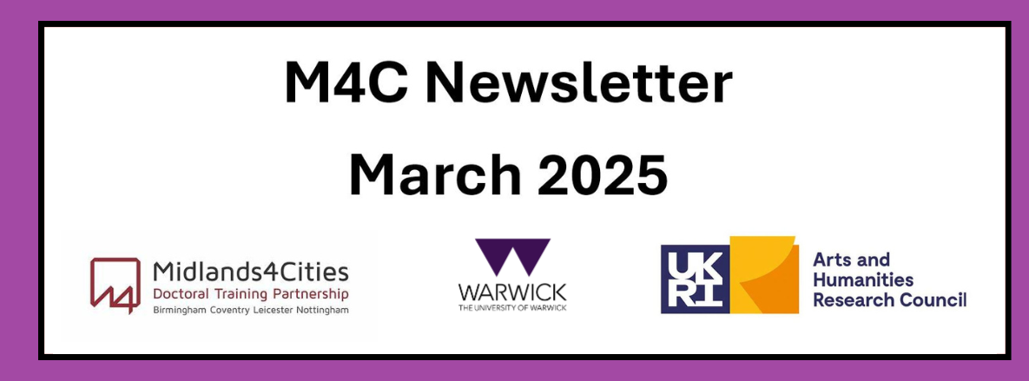

Content
Welcome
EF and RDF Deadlines
Monash-Prato Workshop 2025
Placement Session with M4C
Postgraduate Research Experience Feedback - Now open
Updated Project Titles
Festival of Postgraduate Research


Welcome
Welcome to the first newsletter for M4C students at Warwick. This monthly newsletter will include information about upcoming events, aspects specific to M4C such as RDF / EF’s and we would like to include news about what you are getting up to. If you have been on a placement, attended a conference etc and would like to share that with you fellow M4C students, we would love to hear from you!
If you have any items that you would like us to include in the next newsletter, please email them to M4C@warwick.ac.uk and mark the subject as ‘Newsletter Item’.
EF and RDF Deadlines
If you are planning to apply for an EF or RDF, please ensure that you are aware of the current application deadlines (listed below). The dates of the activity should take place at least 2 months after your application date, for example if you submit your application in the March round (by 29th March) then travel should not take place until at least May. When applying ensure you are allowing enough time between applying and when you intend to go.
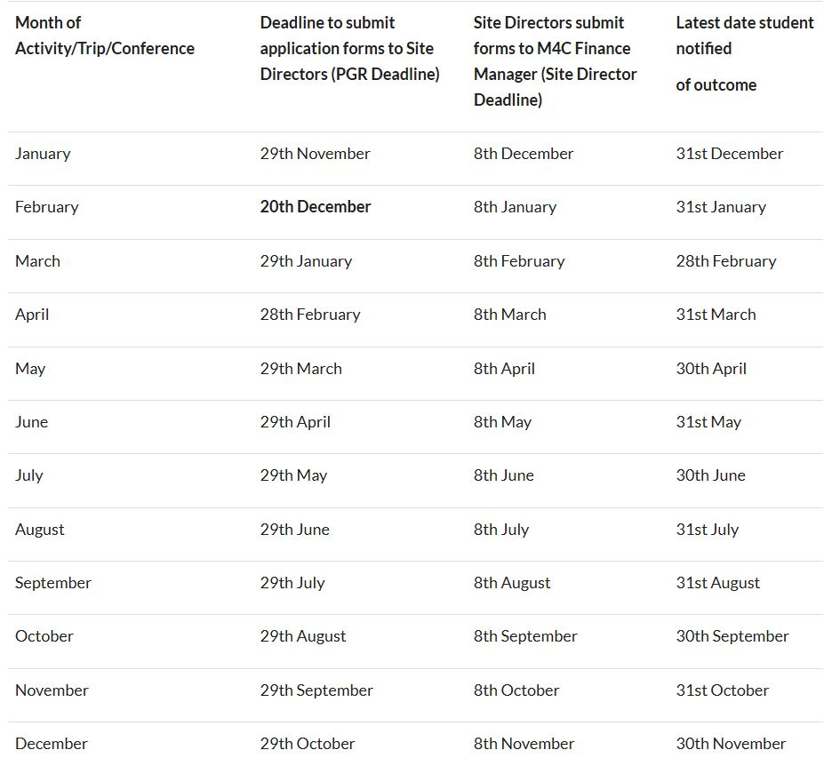
End of Year Report
We want to make you aware that your End of Year Report will soon be coming up with a June deadline. This will need to be completed by yourself, and your supervisor. Further information will be emailed out closer to the time so please keep an eye out for this.
Monash-Prato Workshop 2025 – Applications close 1st April 2025 at 12pm
We warmly invite you to join the 2025 Monash Graduate Research Writing and Publishing Workshop, from Tuesday 3rd June 2025 – Friday 6th June 2025. The four-day workshop is held at the Monash University Prato Centre, Italy, aiming to enhance PGR students’ skills in writing and preparing for publications. The deadline to submit your full application is Tuesday 1st April 2025 at 12pm. No late applications will be accepted.
To be eligible, applicants must:
- Be current PGR students from the Faculty of Arts at Warwick (please see link of eligible departments).
- Have successfully completed their upgrade.
- Be able to travel to Italy to attend the workshop.
- Outline a developed and achievable writing proposal for a journal article or quality book chapter with a recognised quality commercial or university press publisher, which must be submitted by the end of 2025 (successful candidates will be required to complete a 500-word report).
- Have the support of their Warwick supervisor/s.
- Have not attended this workshop previously.
To apply for this opportunity, you will need visit the link below and:
- Download and complete an application form
- Ask your supervisor to sign this
- Submit via the website
- LINK: Graduate Research Writing & Publishing Workshop
- Should you have any queries or require further information, please contact us at CADRE@warwick.ac.uk.

Placement Session with M4C
On Thursday 8th May Dr Jade Jenkinson, the Partnerships and Placements specialist from M4C, will be visiting Warwick to run a session on Placements.
There will be a short talk and the opportunity for 1:1 session with Jade to discuss placement in more detail and food will be provided. We will be looking for a PGR volunteer to reflect on their own placement and how they found it – details to follow.
You will be sent an email invitation for the session shortly so please can you accept if you will be able to attend or decline if not. More information about the 1:1s will be sent closer to the time.
Postgraduate Research Experience Feedback - Now open
If you haven’t already done so, we would encourage you to take 10 minutes to complete the Postgraduate Research Experience Feedback (PREF) survey. It is a good opportunity to contribute to the improvement of the postgraduate research student experience at Warwick, in particular how PGRs experience supervision and training opportunities.
Your responses will be anonymous. You’ll have received an email about completing the PREF directly to your inbox, but you can also access the survey here.
Updated Project Titles
Just a quick reminder that if you have not yet let us know your current Project Title, please can you do so by completing this quick form: https://forms.office.com/e/3WqPnNQs19 by Thursday 27th March. Thank you!
Festival of Postgraduate Research
The Festival of Postgraduate Research will return on Monday 12th May 2025.
The day will include:
- Celebrations of postgraduate research at the Research Showcase and Research Out-of-the-Box
- Sessions on resilience, compassion, and the supervisory relationship
- Opportunities to socialise with PGRs and staff across the university
- Want to get involved? Present your work in 3 minutes or less at the Research Showcase or tell us your idea for Research Out-of-the-Box.
Book now to secure your place at the event: Registration


With our best wishes,

M4C-Warwick Team | University of Warwick | M4C@warwick.ac.uk
Professor David Lambert - CADRE Director & M4C Site Director | Dr Ross Forman - M4C Site Director | Lisa Millard - Doctoral Training Manager | Emily Hardy - Doctoral Training Programmes Co-ordinator

