

Content
Welcome
News from our M4C Warwick Students
RDF and EF Deadlines
End of Year Report
Placement Session
Upcoming Events: British Library Doctoral Open Days / Festival of Postgraduate Research
SPIN Call for Papers
Welcome
Welcome to the April edition of the M4C Warwick newsletter. We hope you are well and enjoying the warmer weather. The M4C Admin Team shall be closed from Friday 18th to Monday 21st April for the Easter bank holiday so we shall respond to any emails when we are back on Tuesday 22nd April.
News from our M4C Warwick Students
Chris Waite
Chris Waite had one of the winning articles for The Interdisciplinary Research Society and Culture Spotlight for the PGR/ECR writing competition last year which is now published: https://warwick.ac.uk/research/spotlights/society-culture/pgrcompetition/2024publishedentries/society_and_culture_pgr_booklet_digital_final.pdf
Congratulations Chris!
RDF and EF Deadlines
If you are planning to apply for an EF or RDF, please ensure that you are aware of the current application deadlines (listed below). The dates of the activity should take place at least 2 months after your application date, for example if you submit your application in the April round (by 29th April) then travel should not take place until at least June. When applying ensure you are allowing enough time between applying and when you intend to go.
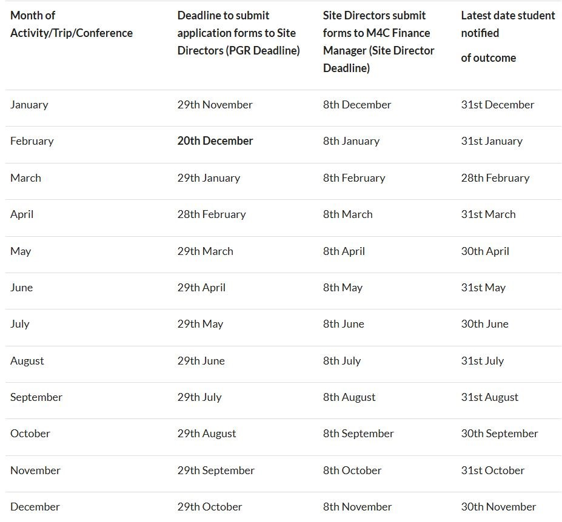
End of Year Report
Just a quick reminder that your End of Year Report will soon be coming up with a June deadline. This will need to be completed by yourself, and your supervisor. Further information will be emailed out closer to the time so please keep an eye out for this.
Placement Session
Just a reminder that on Thursday 8th May Dr Jade Jenkinson, the Partnerships and Placements specialist from M4C, will be visiting Warwick to run a session on Placements. There will be a short talk and the opportunity for 1:1 session with Jade to discuss placement in more detail and food will be provided.
Please accept the email invitation if you will be able to attend or decline if not.
Upcoming Events
British Library Doctoral Open Days
Doctoral Open Days offer current and prospective research students the opportunity to learn about the British Library’s collections and how to access them, as well as meet collection curators and fellow students.
There are two dates coming up, the first focusing on our music, sound and vision, and visual arts collections and the second on our digital collections:
- Not Just Books: Music, Sound and Vision, Friday 25th April 2025 - https://events.bl.uk/events/not-just-books-music-sound-and-vision
- Not Just Books: Digital Collections and Resources – Friday 23rd May 2025 - https://events.bl.uk/events/not-just-books-digital-collections-and-resources
Festival of Postgraduate Research
The Festival of Postgraduate Research will return on Monday 12th May 2025. The day will include:
- Celebrations of postgraduate research at the Research Showcase and Research Out-of-the-Box
- Sessions on resilience, compassion, and the supervisory relationship
- Opportunities to socialise with PGRs and staff across the university
- Want to get involved? Present your work in 3 minutes or less at the Research Showcase or tell us your idea for Research Out-of-the-Box.
Book now to secure your place at the event: Registration
SPIN Call for Papers
The Secrecy Power and Ignorance Network (SPIN) are producing an edited volume (OUP) on the state of Secrecy Studies.
To propose a chapter contribution to the edited volume, please submit the following to secrecyresearch@gmail.com by Sunday 1 June 2025:
- A provisional title and chapter abstract of no more than 250 words
- A brief bio for each author
- 3-5 suggested keywords for your chapter
- And, if interested, indicate whether an A-Z entry will also be proposed and the concept/term under consideration
Please refer to the post in the M4C Teams channel post on the 7th April for more information on this call for papers.

With our best wishes,
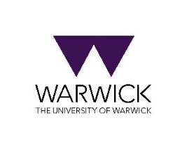

M4C-Warwick Team | University of Warwick | M4C@warwick.ac.uk
Professor David Lambert - CADRE Director & M4C Site Director | Dr Ross Forman - M4C Site Director | Lisa Millard - Doctoral Training Manager | Emily Hardy - Doctoral Training Programmes Co-ordinator

