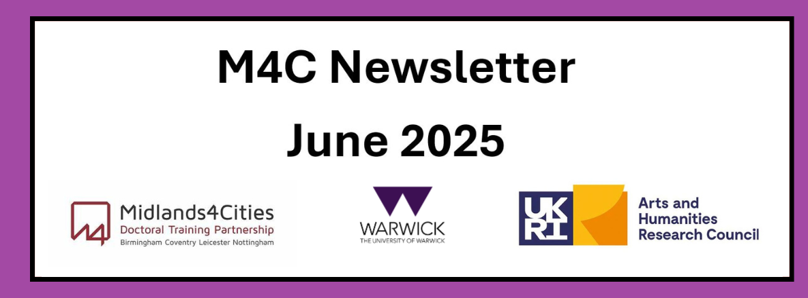
Content
Welcome
End of Year Report
RDF and EF Deadlines
Upcoming Events: Is a Better World Possible? - Solidarity as a Conversation across Temporalities / Sustainability Forum 2025
Wellbeing - Managing Low Mood
Welcome
Welcome to the June edition of the M4C Warwick newsletter. If you have any items that you would like us to include in the next newsletter, please email them to M4C@warwick.ac.uk and mark the subject as ‘Newsletter Item’. If you have been on a placement, attended a conference, had work published etc and would like to share that with you fellow M4C Warwick students, we would love to hear from you!
End of Year Report
Just a quick reminder that the student form for the End of Year Report was due to be completed by Monday 2nd June. If you have not yet completed your report (and are still within funding) then please can you complete this as a matter of urgency – thank you.
RDF and EF Deadlines
If you are planning to apply for an EF or RDF, please ensure that you are aware of the current application deadlines (listed below). The dates of the activity should take place at least 2 months after your application date, for example if you submit your application in the July round (by 29th July) then travel should not take place until at least September. When applying ensure you are allowing enough time between applying and when you intend to go - RDF/EF

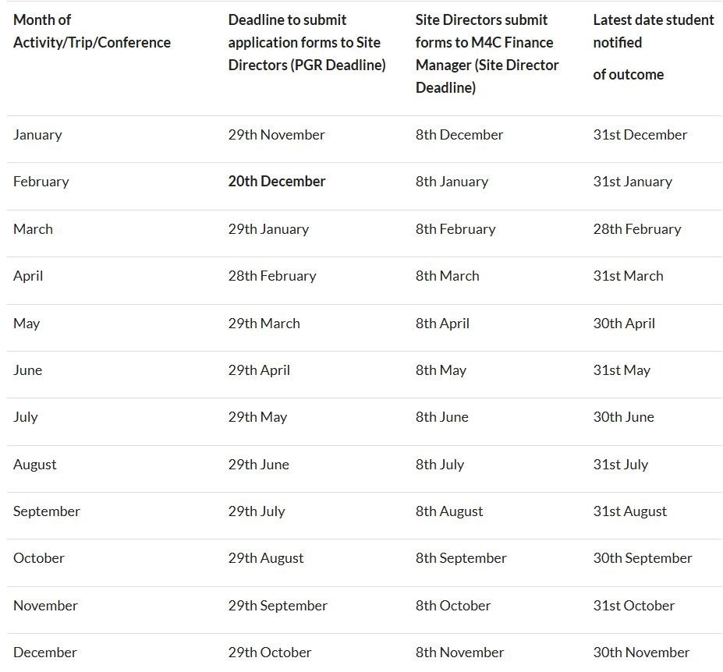
Upcoming Events
Is a Better World Possible? - Solidarity as a Conversation across Temporalities
A one-day interdisciplinary hybrid conference at the University of Warwick (An HRC Doctoral Fellowship Conference) on Saturday 29th November 2025. Is a Better World Possible?
Confirmed Keynote speaker: Dr Anna Bernard (King's College, London)
We live in an age where lives and livelihoods are constantly rendered precarious due to various crises in the form of war, political and economic instabilities, gender disparities, racial exploitation and climate change. Our times have therefore seen calls for solidarities oriented toward making a better world possible- a world built around principles of social justice and equality. ‘Is a Better World Possible?’ will be a one-day hybrid and interdisciplinary conference exploring solidarity and its relationship with temporality. This conference aims to excavate the many forms, meanings and approaches attached to the idea of solidarity, spanning historical manifestations such as anticolonial national liberation struggles to more contemporary movements such as ‘Black Lives Matter’ in the US, the feminist ‘Ni Una Menos’ movement across Latin America, and the ongoing Palestine solidarity and BDS movement. While solidarity has been approached in different ways within academia in recent years, the temporality of solidarity remains an underexplored territory. Discussing the temporality of solidarity, Nowak (2020) argues that solidarity is simultaneously a historical condition, a contemporary action and a future aspiration.
Sustainability Forum 2025
We’re excited to invite you to the Sustainability Forum 2025, hosted by Sustainability | Research Spotlights. This event brings together researchers, practitioners, and partners to explore innovative approaches to sustainability challenges across disciplines.
- Date: 3rd July 2025
- Location: Roof Terrace (FAB)
- Please visit the website to sign up and learn more about the programme.
We hope to see you there! The IDR Spotlights Team
Wellbeing - Managing Low Mood
From the Wellbeing Team: This term is always busy with exams, deadlines, dissertations. It can take a toll on our mental health, so we want to bring attention to looking after yourself. There are times when our mood fluctuates, and this is a natural response to difficult circumstances. We all need to prioritise our health; both physical and mental.
The good news is there is lots that can be done to boost mood. Remember you are not alone, and you can do something about it; taking time to do things that you know help your wellbeing is vital.
If you are living with a mental health problem, or are supporting someone who is, having access to the right information and support is vital. Have a look at our webpages where you will find a range of support options: https://warwick.ac.uk/services/wss/topics

With our best wishes,
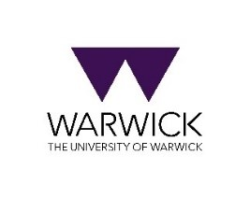
M4C-Warwick Team | University of Warwick | M4C@warwick.ac.uk
Professor David Lambert - CADRE Director & M4C Site Director | Dr Ross Forman - M4C Site Director | Lisa Millard - Doctoral Training Manager | Emily Hardy - Doctoral Training Programmes Co-ordinator

