

Content
Welcome
Student News: 2025 Monash Workshop
End of Year PGR Arts BBQ
RDF and EF Deadlines
Wellbeing - Productivity and procrastination
Welcome
Welcome to the July edition of the M4C Warwick newsletter. If you have any items that you would like us to include in the next newsletter, please email them to M4C@warwick.ac.uk and mark the subject as ‘Newsletter Item’.
If you have been on a placement, attended a conference, had work published etc and would like to share that with you fellow M4C Warwick students, we would love to hear from you!
Student News
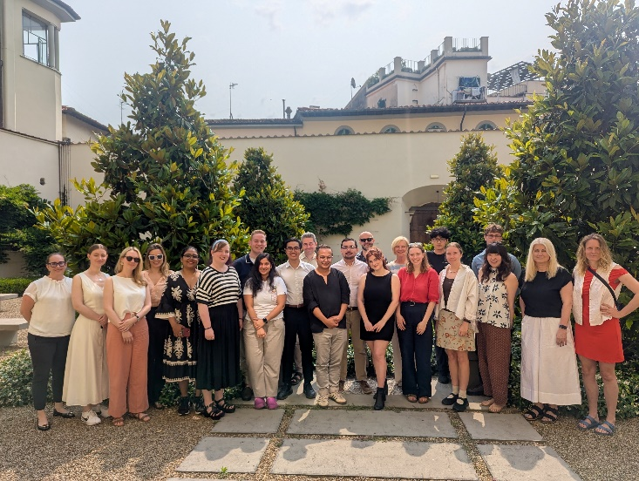
2025 Monash Workshop
Some of our M4C students recently attend the Monash Graduate Research Writing and Publishing Workshop in Prato. Led by Monash University, the workshop’s aim was to mentor PGR students to enhance their skills in preparing, writing, and getting an article published in a major academic journal or a chapter published in a with a recognised quality commercial or university press publisher.

End of Year PGR Arts BBQ
As we approach the end of the academic year, we wanted to invite you to an End of Year Faculty of Arts PGR BBQ, hosted by colleagues from CADRE/Engaging Research Cultures Project!
This will take place on Thursday 31st July 2025 1pm-3pm, on the grassy area outside the Oculus Building on campus.
If you are free and would like to come along, can you complete the sign-up form by Monday 21st July 2025, including any dietary requirements please: https://forms.office.com/e/SuvUkmmW4s
We hope you can make it 😊
RDF and EF Deadlines
If you are planning to apply for an EF or RDF, please ensure that you are aware of the current application deadlines (listed below). The dates of the activity should take place at least 2 months after your application date, for example if you submit your application in the August round (by 29th July) then travel should not take place until at least October. When applying ensure you are allowing enough time between applying and when you intend to go - RDF/EF
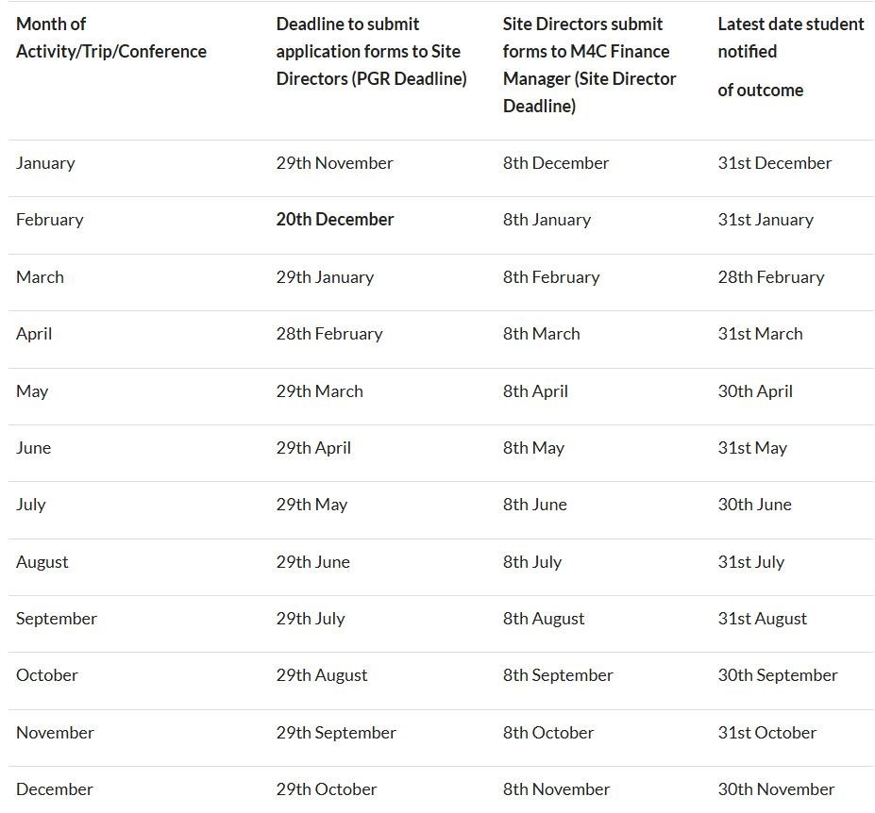

Wellbeing - Productivity and Procrastination
As our undergraduates look to the end of term, our postgraduates have some more studying ahead and maintaining your productivity over the summer can feel challenging. To start addressing issues with productivity, think about why you are struggling to get work done. Maybe the work feels too challenging or perhaps you feel overwhelmed by the amount you need to do, or you feel so exhausted that you don’t have any energy left to give.
The pressures of academic life can mean that to be more productive we forget to maintain our self-care; concentrating on the Foundations of Wellbeing can help to create a balance that allows you to maintain focus and increase productivity.
Visit our self-help pages to learn more about some solutions including focussing on Self-Care, making sure you practice regular Relaxation and trying to find a healthy Work-life Balance.
If you would like to speak to someone at Wellbeing, you can have a brief consultation with a Wellbeing Adviser. Please access the Wellbeing Portal to join a queue for a brief consultation with an Adviser, Monday to Friday from 10am to 3pm. Consultations can be face to face in Senate House, or online. They both require you to join the queue online when you are available.

With our best wishes,

M4C-Warwick Team | University of Warwick | M4C@warwick.ac.uk
Professor David Lambert - CADRE Director & M4C Site Director | Dr Ross Forman - M4C Site Director | Lisa Millard - Doctoral Training Manager | Emily Hardy - Doctoral Training Programmes Co-ordinator

