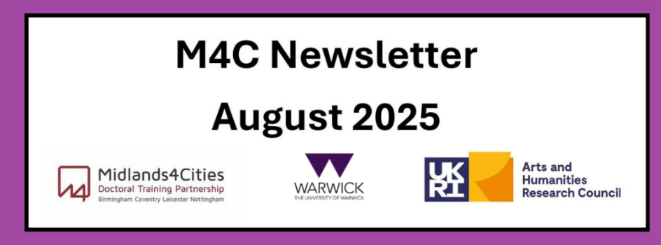

Content
Welcome
M4C Admin Staff News
Placements
RDF and EF Deadline
Events Calendar
Welcome
Welcome to the August edition of the M4C Warwick newsletter. If you have any items that you would like us to include in the next newsletter, please email them to M4C@warwick.ac.uk and mark the subject as ‘Newsletter Item’.
If you have been on a placement, attended a conference, had work published etc and would like to share that with you fellow M4C Warwick students, we would love to hear from you!
M4C Admin Staff News
We wanted to let you know that Emily will be moving to a new role in the University in August within the School of Education, Learning and Communication Science so her last day with M4C will be Friday 8th August. Please can you ensure that any emails are sent to M4C@warwick.ac.uk where they will be picked up by Lisa. We wish Emily the best of luck in her new role!
Placements
As part of your studentship, you can apply to undertake an employability skills focused placement. These placements allow you to spend up to 3 months with a host organisation (up to 6 months if the placement will have a direct impact on your PhD thesis). The organisation is of your choice providing the opportunity to try out a potential future career, expanding your network of contacts and developing new skills. This can be with one of M4C partners or you can create your own placement in collaboration with any organisation where you will help them respond to a genuine business need.
Find out more and how to apply here: Placement
RDF and EF Deadlines
If you are planning to apply for an EF or RDF, please ensure that you are aware of the current application deadlines (listed below). The dates of the activity should take place at least 2 months after your application date, for example if you submit your application in the September round (by 29th September) then travel should not take place until at least November. When applying ensure you are allowing enough time between applying and when you intend to go - RDF/EF
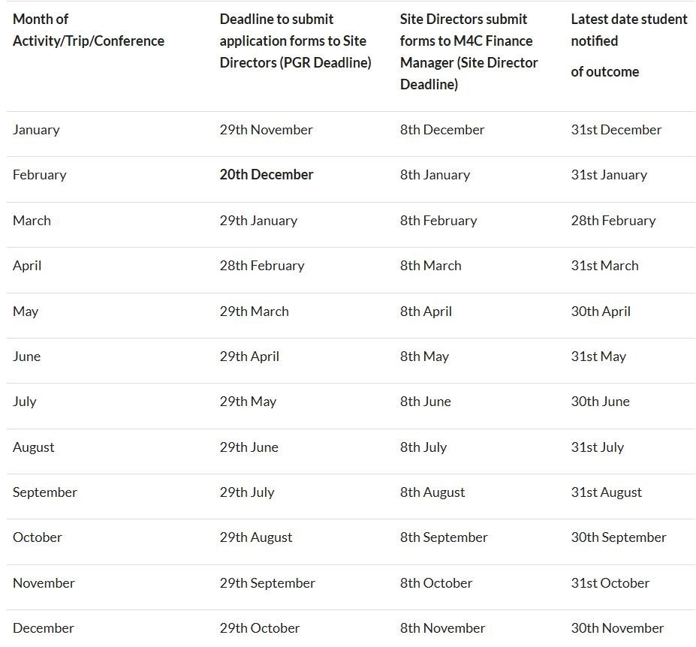

Events Calendar
We have added an event calendar to the M4C webpages - Events Calendar. You will find information on upcoming events here.

With our best wishes,
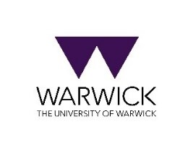
M4C-Warwick Team | University of Warwick | M4C@warwick.ac.uk
Professor David Lambert - CADRE Director & M4C Site Director | Dr Ross Forman - M4C Site Director | Lisa Millard - Doctoral Training Manager | Emily Hardy - Doctoral Training Programmes Co-ordinator

