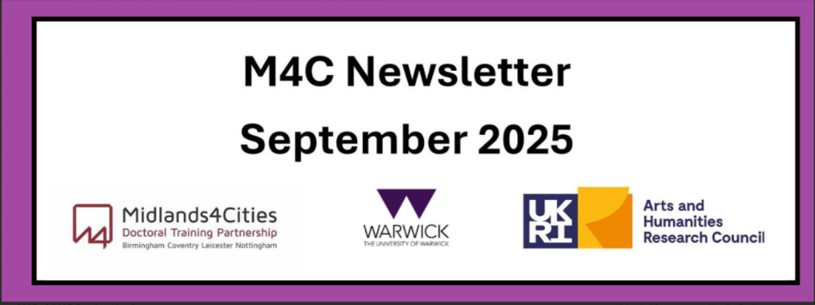

Content
Welcome
M4C Admin Staff News
News from our M4C Warwick PGRs
Placements
RDF and EF Deadline
CDF Applications
CADRE Workshop Series 2025/2026
M4C Warwick New Starters
Student Advisory Forum Representatives
Events Calendar

Welcome
Welcome to the September edition of the M4C Warwick newsletter. If you have any items that you would like us to include in the next newsletter, please email them to M4C@warwick.ac.uk and mark the subject as ‘Newsletter Item’.
If you have been on a placement, attended a conference, had work published etc and would like to share that with you fellow M4C Warwick students, we would love to hear from you!

M4C Admin Staff News
To update you on M4C Warwick Admin staffing news, Emily has now moved onto her exciting new role, however we are very happy to share that our Doctoral Training Programmes Coordinator role has been filled by Dr Yangzi Zhou! Yangzi completed her PhD in 2024 and has recently held an Early Career Teaching Fellowship at IATL and IAS here at Warwick. Yangzi will also be one of our CADRE Workshop Facilitators for 2025/26. I’m sure you will benefit from her knowledge and experience in the coordinator and facilitator role; we are very happy to have her.
In addition, Lisa Millard our Doctoral Training Manager will be heading off on maternity leave on 17th October 2025 – cover is currently being recruited for, and we will keep you posted on this.
Regardless, any queries at all please send to m4c@warwick.ac.uk – your query will always be picked up if it comes into our shared inbox rather than individuals.

News from our M4C Warwick PGRs
Thanks for those who have sent in their news stories about upcoming PGR organised events for this month.

Chloe Challender
M4C 'History of Gender in the Long Nineteenth Century Peer-Led Writing Workshop' co-organised by Chloe at Gladstone’s Library, Wales. This will be held 20-22 Sept 2025. Places have closed: an application process was run in June, and seven M4C PhD researchers from across Warwick, Coventry and Birmingham were successful in getting a place.
Gladstone's Library was chosen as the location partly due to the 19th century collections available within its Reading Rooms. There will also be dedicated writing sessions and other scheduled slots for peer-review and reflection.

Evie Nash
Conference: Dialogues of Nonconformity Across the British Atlantic World, 1500-1800
Date: Friday 12th September 2025
Registration and Info: Dialogues of Nonconformity

The Conference, co-organised by Evie, will take place at the University of Birmingham on 12 September 2025, and is supported by the Birmingham Centre for Reformation and Early Modern Studies, the Warwick Early Modern and Eighteenth Century Centre, and the Doctoral Training Partnership AHRC-Midlands4Cities.
From Jesuits priests who scorned Protestants for not being able to ‘maintain their doctrine in disputation’, to the sectaries of the mid-seventeenth century, such as Quakers, Baptists, and Independents, who disputed each other publicly, early modern nonconformist groups and people posed a challenge to each other as much as they did to the wider societies in which they lived. We are interested in examining how different forms of nonconformist beliefs, ideas and practices spoke to each other in the British Atlantic World. We aim to explore the interactions between religious, social, and political dissent, and examine what it meant to be nonconformist in the early modern British Atlantic. We define ‘nonconformist’ in its broadest meaning and encourage papers from across the whole field of arts and humanities. Papers from researchers of all career stages are welcome.

For more information email:
Jacob Hyde (JMH854@student.bham.ac.uk) & Evie Nash(Evie.Nash@warwick.ac.uk)

Placements
As part of your studentship, you can apply to undertake an employability skills focused placement. These placements allow you to spend up to 3 months with a host organisation (up to 6 months if the placement will have a direct impact on your PhD thesis). The organisation is of your choice providing the opportunity to try out a potential future career, expanding your network of contacts and developing new skills. This can be with one of M4C partners or you can create your own placement in collaboration with any organisation where you will help them respond to a genuine business need.
Find out more and how to apply here: Placement

RDF and EF Deadlines
If you are planning to apply for an EF or RDF, please ensure that you are aware of the current application deadlines (listed below). The dates of the activity should take place at least 2 months after your application date, for example if you submit your application in the September round (by 29th September) then travel should not take place until at least November. When applying ensure you are allowing enough time between applying and when you intend to go - RDF/EF
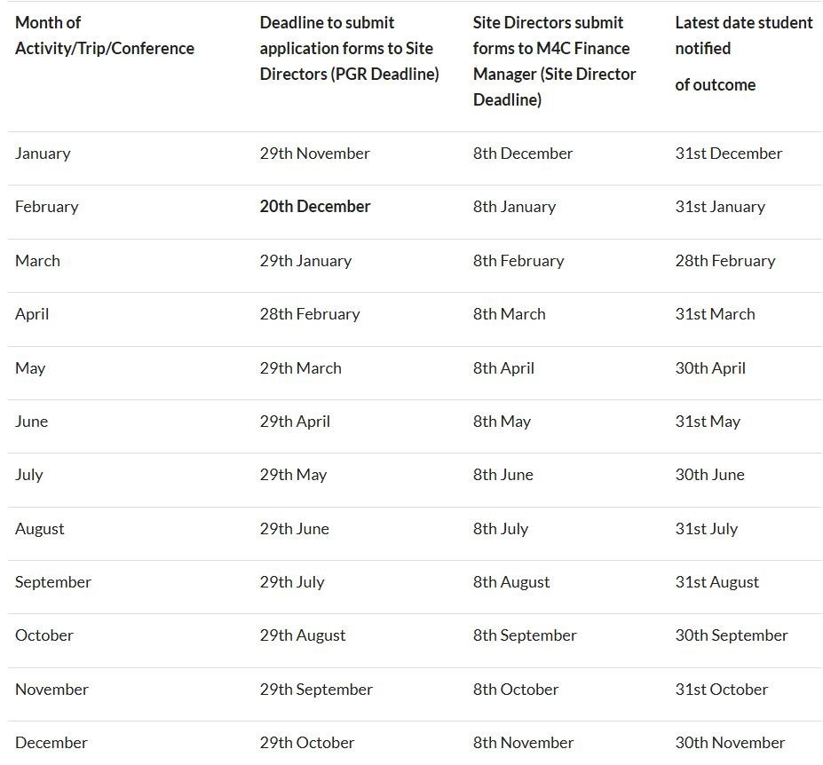

CDF Applications
We have had a number of recent enquiries about CDF Applications, including what to include in your application. The Cohort Development Fund (CDF) is designed to fund groups of students and to support training, development and research activities for the cohort of DTP students and to include Arts and Humanities students outside the DTP wherever possible. All applications to a CDF must include a minimum of 2 M4C students from at least 2 institutions. For more details on activity ideas, and how to apply, please visit the VPP site on CDFs. The application form is linked here. All CDF applications are managed by M4C Nottingham, but we are happy to advise where we can.

CADRE Workshop Series 2025/26
You should have received an email from us with information on the CADRE Workshop Series for 2025/26 – please take a look and sign up to any that appeal to you at your stage in the PhD. We have tweaked our programme this year, adding more support and information on Presenting Papers and Conference Attendance, Public Engagement, Wellbeing and Writing for Others/Getting Published. Please take a look and sign up!
Our CADRE Facilitators this year are Dr Yangzi Zhou and Dr Maialen Maugars. Maialen was a fellow M4C PGR, and both facilitators are looking forward to attending and supporting at each workshop.
2025/26 Schedule - CADRE workshops 2025/26
Sign Up Link - CADRE Workshops sign up

M4C Warwick New Starters – our final new cohort
As the start of the new academic year approaches, we welcome our final new cohort of M4C funded PhD students in October 2025. We have 21 new starters at Warwick who will be starting their PhD or continuing under M4C funding. We will welcome them formally at Warwick from the CADRE/M4C perspective at our induction on 21st October 2025, and I’m sure you will see many at CADRE workshops over the year, at our M4C socials and our monthly online drop-ins. We’re excited to welcome and to add to our M4C Warwick PGR population!

Student Advisory Forum Representatives (SAF Reps)
As we start the new academic year, we are looking for any volunteers who would like to take up the position of SAF Representatives for 2025/26! There is further information about the role here.
From a Warwick perspective generally, we ask our SAF reps to participate in the below, where possible, to engage with our M4C cohort:
- come along to our M4C socials and events at Warwick to support our Warwick cohort
- attend the wider M4C SAF Rep Meetings (in link above)
- attend our CADRE New Starter Induction
It will be a great professional development and networking opportunity, as well as way of helping to ensure that M4C policy is responsive to the needs of PGRs here and across the partnership.
Please email m4c@warwick.ac.uk to register your interest if you are interested and want to be considered by Monday 6th October 2025 by 5pm.
Any questions of course, please get in touch.

Events Calendar
We have added an event calendar to the M4C webpages - Events Calendar. You will find information on upcoming events here.
With our best wishes,
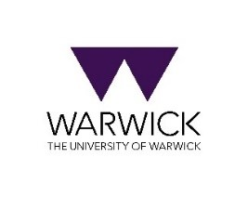
M4C-Warwick Team | University of Warwick | M4C@warwick.ac.uk
Professor David Lambert - CADRE Director & M4C Site Director | Dr Ross Forman - M4C Site Director | Lisa Millard - Doctoral Training Manager | Dr Yangzi Zhou - Doctoral Training Programmes Co-ordinator

