

Content
Welcome
End of Term and Winter Break
News from our M4C Warwick PGRs
Mid Year Review 2025/26
RDF and EF Deadlines
Upcoming Events

Welcome
Welcome to the December edition of the M4C Warwick newsletter. If you have any items that you would like us to include in the next newsletter, please email them to M4C@warwick.ac.uk and mark the subject as ‘Newsletter Item’.
If you have been on a placement, attended a conference, had work published, passed your viva etc and would like to share that with you fellow M4C Warwick students, we would love to hear from you!

End of Term and Winter Break
We hope you are looking forward to a well-earned break over the next few weeks. Due to the university closure (24th December to 1st January) and staff leave replies from us may take longer than usual over the next few weeks.
If you’re staying in Warwick over the festive season, the Chaplaincy will be open every day with tea, coffee, toast, and board games: https://warwick.ac.uk/services/chaplaincy/christmasvacationarrangements/
Information regarding opening hours across the university (including the wellbeing team) can be found here: https://warwick.ac.uk/students/news/christmas/opening-hours/
The Residential Community Team are available throughout the break and Togetherall are available for support 24/7: https://warwick.ac.uk/services/rescommunity/contact/

News from our M4C Warwick PGRs
Faye Claridge
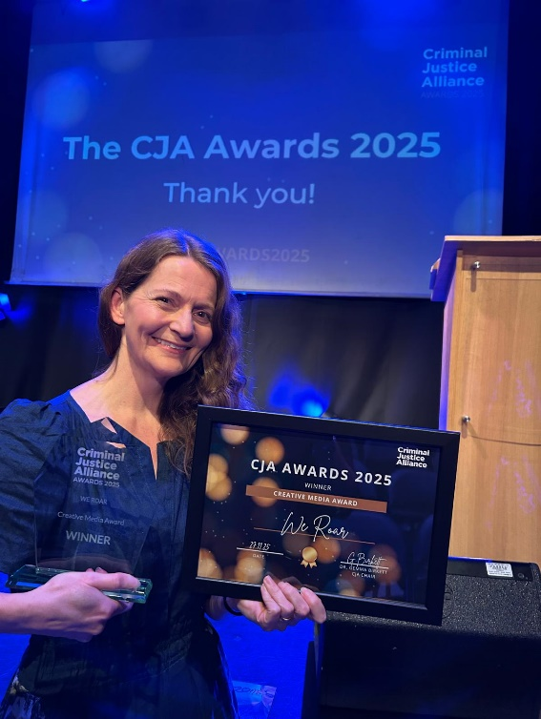
National Creative Media Award

Warwick PGR Faye Claridge has won the national Criminal Justice Alliance Creative Media Award 2025 for an arts project central to her research. We Roar is an exhibition of poetry and artwork made by men and women in 20 prisons in the UK and USA, devised by Faye in 2023. It became the first creative exhibition ever to tour 10 prisons in the UK and is currently continuing on tour in public libraries in England. Its combination of named US and anonymous UK exhibitors founded Faye's M4C research project into the impacts of enforced anonymity in exhibiting artworks made in prison.

Our congratulations to Faye!

Mid Year Review 2025/26
We have emailed you with the following information on the Mid Year Review process which you will be undertaking in the new year.
If you would like to know the MYR requirement for the year and mode of study you are in, including information on if an MYR would be required for those close to their funding end date, please check the Warwick info page. We will email again in the new year with reminders.

- Complete the student MYR on the VPP by 2 February 2026. This includes uploading your research statement and deliverable (as per the guidance in the FT and PT MYR Requirements – please do read the guidance carefully).

*Remember to answer/move the Yes/No questions, the default will be No if you don't update the answer.*

- Let your supervisor know you have completed your mid-year review on the VPP.

- Supervisors to complete MYR report by 23 February 2026. Assessor(s) will be identified by supervisors.

- MYR Meeting to take place between student, supervisor and assessor(s) (March)

- Assessor Report to be submitted by Assessor by 23 March 2026.

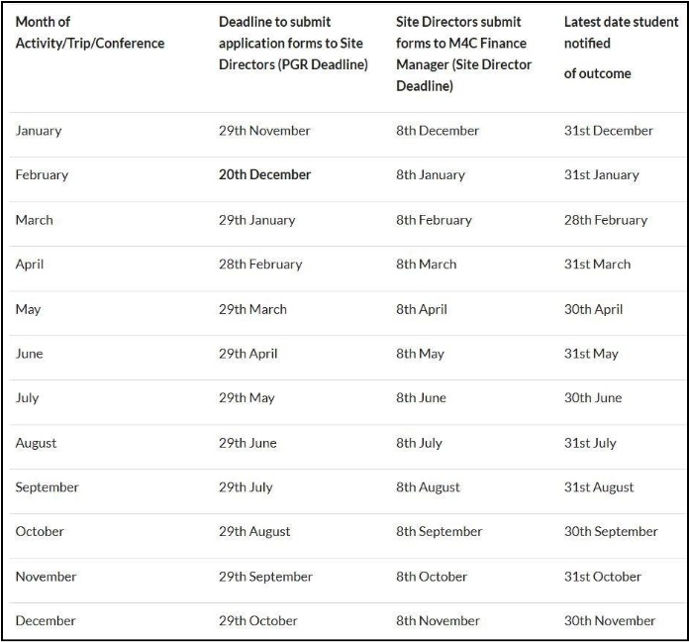
RDF and EF Deadlines
If you are planning to apply for an EF or RDF, please ensure that you are aware of the current application deadlines. The dates of the activity should take place at least 2 months after your application date, for example if you submit your application in the September round (by 29th September) then travel should not take place until at least November. Late application will not be accepted by M4C. When applying ensure you are allowing enough time between applying and when you intend to go - RDF/EF
Earlier this term, the M4C Central Team approved several retrospective RDF/EF applications for the 2025/26 cohort. They have confirmed that they are no longer accepting retrospective applications.

Upcoming Events
Warwick Institute of Engagement
Warwick Institute of Engagement are offering some training on public engagement:
Evaluating Public Engagement: One-Day Workshop
Monday 15 December, Faculty of Arts Building, 10am-3:30pm
Hands on Engagement
Tuesday 16 December 2025, Oculus, 9:30am-12:30pm
Impact through Engagement
Thursday 12 February, Online, 9:30am - 12:30pm

CADRE Workshops Term 2
There are 5 more CADRE workshops coming up in the Spring Term, including sessions on wellbeing, writing, and the final stages of the PhD journey. Registration is via this link.
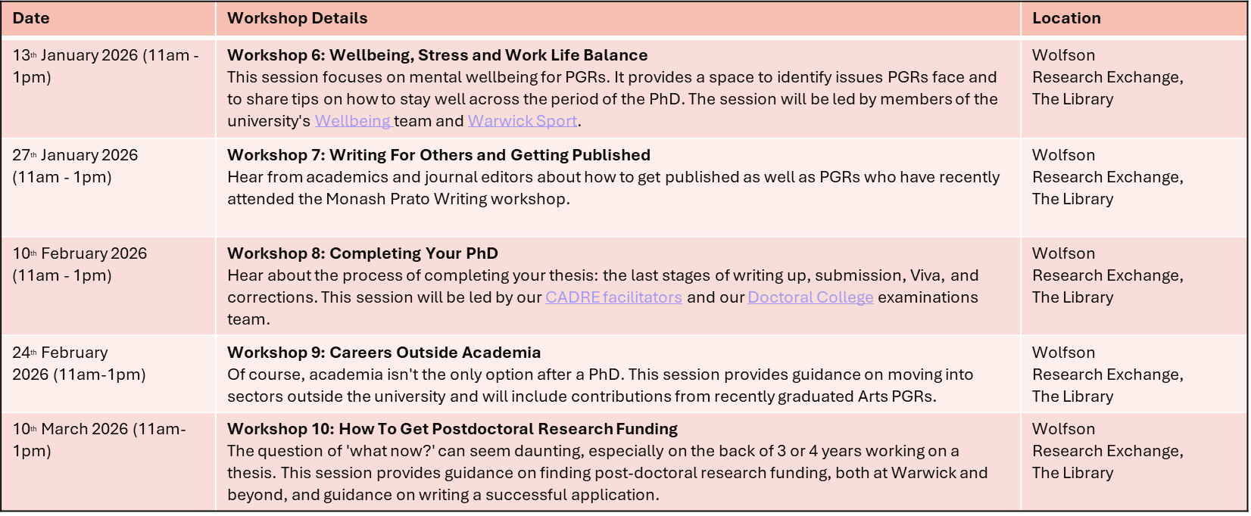
Happy Holidays! We look forward to catching up with you all in the new year.
🎄 🎁 ❄️
M4C-Warwick Team | University of Warwick | M4C@warwick.ac.uk
Professor David Lambert - CADRE Director & M4C Site Director | Dr Ross Forman - M4C Site Director | Kay Jones - Doctoral Training Manager | Dr Yangzi Zhou - Doctoral Training Programmes Co-ordinator

