

Content
Welcome
News from Warwick M4C PGRs
Travel, Subsistence and Other Staff Related Expenses – Change to Policy
RDF/EF Deadlines
Call for Abstracts: Warwick Graduate Conference in Political and Legal Theory
Call for Participants: Developing Effective and Sustainable Partnerships between Researchers and Third-Sector Organisations
Upcoming Events: How to Organise Activities at the Warwick Venice Centre; Social Media Workshops

Welcome
Welcome to the first newsletter for M4C students at Warwick in 2026. We hope everyone has enjoyed a lovely festive break! If you have been on a placement, attended a conference etc and would like to share that with you fellow M4C students, we would love to hear from you!
We typically send out the call for newsletter items at the start of each month. If you have any items that you would like us to include in the next newsletter, please email them to M4C@warwick.ac.uk and mark the subject as ‘Newsletter Item’.
Just a reminder to copy in our email (m4c@warwick.ac.uk) for any M4C-related queries to M4C Central, the Doctoral College, and Site Directors, so that we can help whenever we can!

News from M4C Warwick PGRs
Shaoyu Yang (SMLC)
Shaoyu has passed her viva on 15 December 2025, with a thesis entitled ‘Translating Traumatic Memor y of Twentieth-Century China: Diasporic Literary Works of the 1937 Nanjing Massacre and Their Translations’. Shaoyu is now an Early Career Fellow at the Institute of Advanced Study.
Our congratulations to Shaoyu!

Polina Zelmanova (Film and TV Studies)
Polina, whose research focuses on sex on screen in the #MeToo era, will chair a panel discussion after a special screening of How to Have Sex at the Warwick Arts Centre on Tuesday the 27 January at 5:30pm. Polina will be joined by the film's Intimacy Coordinator Jen Odell whose film and TV work includes Dune Part 2 and 3, Sex Education series 2 and 3, and Black Mirror.

Shy Tara (Mia McKenna-Bruce) and her more confident friends are seeking drinks, sun and sex at a Cretan resort. But when a night of hedonism turns sour, she starts to question her experiences, her friendships and her future, even as the partying continues around her. Powerful, evocative and unsentimental, How to Have Sex is a tremendous calling card for both Manning Walker and the award-winning McKenna-Bruce.

Use the code CARE4 for a £4 ticket, available for University of Warwick students.
https://www.warwickartscentre.co.uk/whats-on/q88-care-bts-how-to-have-sex-panel-discussion/

Travel, Subsistence and Other Staff Related Expenses – Change to Policy
As of 1st December 2025 the University of Warwick expenses policy has been revised. We recommend that you check this link (FP16) and liaise with your departmental contacts before claiming expenses from an RDF or EF award.
Rail: should be the default mode of transport for all UK & European journeys of up to 6 hours, even if the financial cost is higher than other forms of transport. Employees should travel Standard Class. The option to request First Class travel for journeys exceeding two hours has been removed and should not be selected even if the system offers it as an option.
Car hire: Road journeys exceeding 100 business miles per day should only be considered where travel by train is not a viable option, and a hired vehicle, rather than a private one, should be the preferred option. Your car must be insured for business use before you can claim mileage expenses.
Mileage Expenses: Under the new policy, if you wish to claim for mileage from your normal place of residence (home address) to another destination, the distance between these two locations must be more than 10 miles than the distance from your home address to the University of Warwick. If this is not the case, then you will be ineligible to claim mileage expenses. If the distance is greater than 10 miles, then you are permitted to claim the mileage expenses, however, this will be the lower mileage of a) Home address to the destination or b) University of Warwick to the destination. In all applications for funding, please provide the postcode of where you will be commuting from, as well as the postcode of your destination. For further information, please see FP16.3.3. It has been confirmed that PhD students are subject to the revised policy.

RDF/EF Deadlines
If you are planning to apply for an EF or RDF, please ensure that you are aware of the current application deadlines (listed below). The dates of the activity should take place at least 2 months after your application date, for example if you submit your application in the January round (by 29th Jan) then travel should not take place until at least March. When applying ensure you are allowing enough time between applying and when you intend to go.
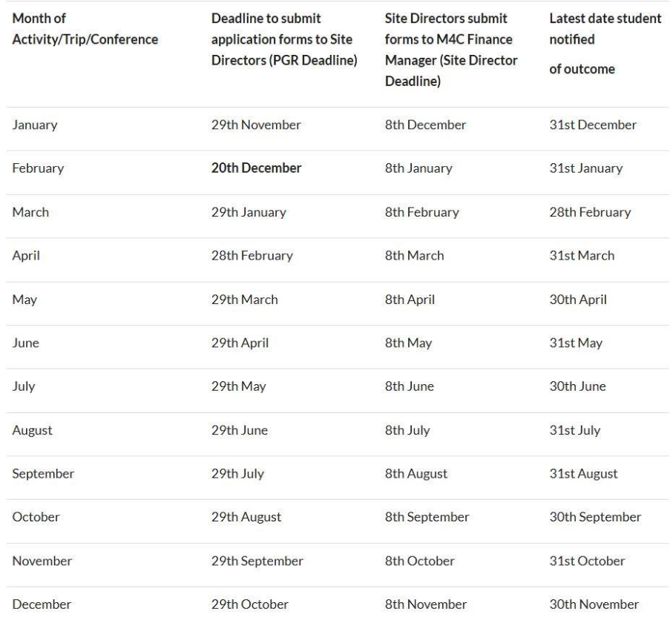

Call for Abstracts: Warwick Graduate Conference in Political and Legal Theory
Please join the Department of Politics and International Studies (PAIS), School of Law, and the Centre for Ethics, Law and Public Affairs (CELPA) at the University of Warwick for their annual conference for postgraduate students working in political and legal theory. This conference is co-organised by Tom Geeson (Law).
Conference Date: 21 February 2026
Location: The University of Warwick, Social Sciences Building
Plenary sessions:
Professor Jeff McMahan (University of Oxford)
Professor Simon Caney (University of Warwick)

The aim of the conference is to provide an opportunity for graduate students to receive useful feedback on works in progress. Papers may deal with any area of contemporary political theory, political philosophy, legal theory, or the history of political thought, and should take no more than fifteen minutes to present.

Graduate students interested in presenting papers should send anonymised abstracts (no more than 750 words) to PLTGradConf@warwick.ac.uk by 18 January 2026. Please indicate in your submission whether you require an early decision for funding or travel reasons.

Graduates are also welcome to attend the conference without presenting; please register via this link no later than 6 February 2026. Attendance is free of charge. Lunch and refreshments will be provided.

For any enquiries, please feel free to contact the conference organisers at PLTGradConf@warwick.ac.uk. More information is also available from: https://philevents.org/event/show/143329

Call for Participants: Developing Effective and Sustainable Partnerships between Researchers and Third-Sector Organisations
Laura Woolley-Nunez (SMLC) is running two surveys as part of her M4C-funded placement in collaboration with The Stephen Spender Trust .
➡️ Public Engagement Partnerships: Academic Perspectives
👥 Aimed at research and/or teaching staff in the Arts and Humanities at universities in the UK or Ireland at any stage of their career, who are interested in partnering with a third-sector organisation on a public engagement project
🔗 https://warwick.co1.qualtrics.com/jfe/form/SV_cUw4n3Cizzo3wq2%20
➡️ Training, Support, and Public Engagement at PhD/ECR Level
👥 Aimed at PhD students and early-career researchers within three years of a doctoral award at universities in the UK or Ireland. A current affiliation with a university in the UK or Ireland is not required.
🔗https://warwick.co1.qualtrics.com/jfe/form/SV_cShz96oJmEpMn4O
Participants will contribute to the understanding of what support is needed at different career stages and how institutions can facilitate meaningful and sustainable public engagement. The research will develop good practice guidelines for how the Stephen Spender Trust and other third-sector organisations (e.g., charities) collaborate with universities in the future.
Each survey takes around 10 minutes to complete.

Upcoming Events
How to Organise Activities at the Warwick Venice Centre
Wednesday 11th February, 12.00 – 14.00, Oculus 0.04
Would you like to learn more about the Warwick Venice Centre? The WVC Academic Director, Dr Bryan Brazeau and the WVC Administrator, Chiara Croff will be hosting an event on 11th February to provide an overview of what we offer, how to get started, and our admin processes. If you’d like to get involved with the WVC – whether by offering something through our new Venice Short Courses programme (launching in 26-27), organising a research event/workshop, or putting on a public-facing/impact-related event, please come along. Members of the ISR team shall also be there and will be able to advise on funding possibilities

If this something which you would be interested in attending, please register here.

Social Media Workshops 2026
The Research Communications team and the Social Media team are hosting workshops to help promote and disseminate your research.
In these workshops, they will explore the Social Media Playbook and the Social Media Guidance for Academic Staff, and have opportunities for Q&A and insight into social media.
Also, learn how the Research Communications team use different channels to disseminate research news and how you can get involved.
Please select your preferred date/time in the sign-up page. (Note: all workshops are the same, you will only need to attend one):
You can send in your questions in advance here.

With our best wishes,

M4C-Warwick Team | University of Warwick | M4C@warwick.ac.uk
Professor David Lambert - CADRE Director & M4C Site Director | Dr Ross Forman - M4C Site Director | Kay Jones - Doctoral Training Manager | Dr Yangzi Zhou - Doctoral Training Programmes Co-ordinator

