

Content
Welcome
RDF/EF Deadlines
End of Year Report
Additional paid work/volunteering
Call for Participants: Student Carers
Upcoming Events: MSCA Postdoctoral Fellowship Information Webinar/ Interdisciplinary in Health Research Event at Warwick/ CPD course for researchers

Welcome
Welcome to the M4C Warwick Newsletter. This monthly newsletter will include information about upcoming events, aspects specific to M4C such as RDF / EF’s and we would like to include news about what you are getting up to. If you have been on a placement, attended a conference etc and would like to share that with you fellow M4C students, we would love to hear from you!

If you have any items that you would like us to include in the next newsletter, please email them to M4C@warwick.ac.uk and mark the subject as ‘Newsletter Item’.

EF and RDF Deadlines
If you are planning to apply for an EF or RDF, please ensure that you are aware of the current application deadlines (listed below). The dates of the activity should take place at least 2 months after your application date, for example if you submit your application in the April round (by 29 April) then travel should not take place until at least June. When applying ensure you are allowing enough time between applying and when you intend to go: RDF/EF

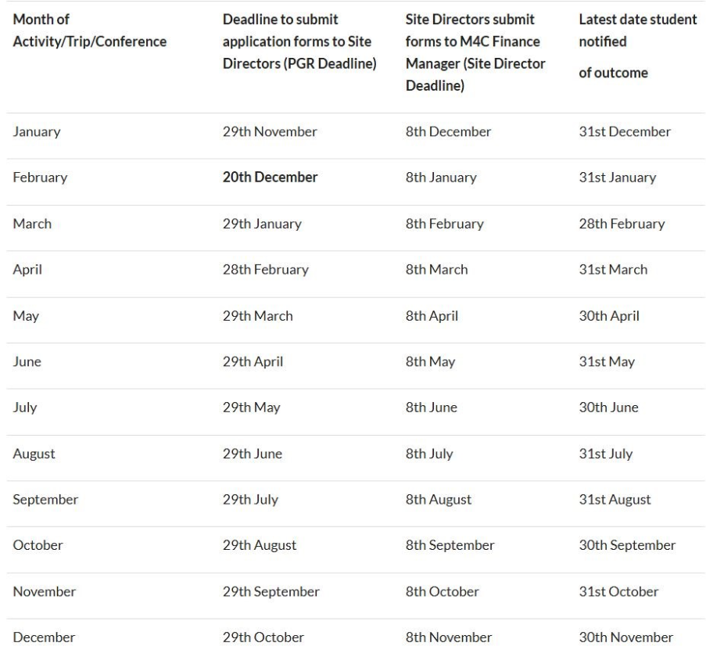

End of Year Report
Just a quick reminder that your End of Year Report will soon be coming up with a June deadline. This will need to be completed by yourself, and your supervisor. Further information will be emailed out closer to the time so please keep an eye out for this.

Additional paid work/volunteering
At the last CADRE workshop we had a question from a PGR regarding the M4C rules regarding Additional Paid Work and Volunteering. We have had the following information from the central team:

As per the information on the VPP regarding additional paid work (section 5): A student may undertake teaching or demonstrating work when this is compatible with their training and provided their supervisors approve. The total time spent (including preparation and marking) should not interfere with the progress of the PhD. This work should not normally exceed six hours in any week. Students who hold a part-time award can carry out up to 20 hours of other paid work

This 6 hours stipulation is a recommendation from the UKRI, but under some cases the M4C will approve aggregating the hours for more intense bursts of activity. The M4C also confirmed that there are no set limits on volunteering, but would always recommend that any hours spent away from the thesis should be agreed with the supervisory team and noted in the supervision records, and must not detract from timely completion of their thesis.

If volunteering plus paid work come to more than 14 hours per week, the student might like to consider going part-time, since they’re not available for full-time study. No stipend extensions are available to students who’ve chosen to spend time volunteering rather than doing the work they are paid to do.

Call for Participants: Student Carers
We are inviting undergraduate (UG), postgraduate taught (PGT) and postgraduate research (PGR) students with caring responsibilities to take part in a research project led by the University’s Gender Engagement Group.
The project explores the experiences of student carers, with particular attention to challenges around funding, childcare access, financial precarity, and expectations around progression and productivity.
We are currently recruiting participants for online focus groups to be held in late April and early May. Participation is entirely voluntary, and all data will be treated confidentially. To thank participants for their time, a £20 Eden Red shopping voucher will be provided to each participant who takes part in a focus group.
Who can take part?
- UG, PGT or PGR students
- With caring responsibilities*
If you are interested, please follow the link below to read more about the study and register your interest:
https://forms.cloud.microsoft/Pages/ResponsePage.aspx?id=vc-6Ce9HZUSSZTVG8ur2vKCxvnN7MaJNqgPky01NIDlUMU9VREowTTlWWVBIQ0VaUFoxSExQWTRZSi4u
If you have any questions, please feel free to contact the research team at:
Cagla.Karatepe@warwick.ac.uk
*Caring responsibilities are defined as the provision of regular or ongoing unpaid care or support to a dependent or loved one. This includes, but is not limited to, parenting and childcare, as well as short-term or long-term care for disabled children, disabled adults, elderly relatives, or family members with chronic illness or additional support needs.

MSCA Postdoctoral Fellowship Information Webinar
The UK National Contact Point for the Horizon Europe Marie Skłodowska-Curie Actions (MSCA) is holding an information webinar for organisations and individuals interested in applying to the MSCA Postdoctoral Fellowships 2026 call (opening date: 9 April 2026, and deadline: 9 September 2026). It will take place online on 14 May 2026.
More information and sign up is available at https://www.ukro.ac.uk/events/msca-postdoctoral-fellowships-2026-call-information-webinar/?utm_sour…
The webinar will cover the following topics:
Overview and Eligibility Rules
Funding
Novelties 2026-2027 Work Programme
Submission and Evaluation Criteria
Question and Answer Session

Interdisciplinary in Health Research Event at Warwick – 20 May 2026
The Health Spotlight team are organising an interdisciplinary health event focused on early career researchers. The event is focused on understanding why interdisciplinary matters in health research, methods to use and experiences in working within an interdisciplinarity framework.
The event is free to attend and will take place on Wednesday 20th May 2026, in the Oculus building (main campus) from 12:00 – 16:00.
If you are interested, the registration link is here: https://warwick.ac.uk/research/spotlights/health/news-events/whyinterdisciplinarityinhealth/

CPD course for researchers
Are you currently designing a research study or preparing an application for ethics approval? Warwick Medical School is hosting a one-day, online CPD course in Research Ethics on Wednesday 8th July 2026. This course will help PhD students and early career researchers across all disciplines to understand the ethical principles underpinning your work and how to satisfy Research Ethics Committees. The course covers both the history and theoretical perspectives of ethics, as well as practical, contemporary issues and problems.
Key Details:
- Date: Wednesday 8th July 2026
- Format: Online (via Microsoft Teams)
- Cost: £200 (includes an electronic University of Warwick certificate for your portfolio).
- Course Director: Dr Simon Jenkins
You can find the full schedule and registration link here: Research Ethics Course Webpage
For any specific enquiries, please contact the Warwick Medical School Continuing Professional Development team at wmscpd@warwick.ac.uk.

With our best wishes,

M4C-Warwick Team | University of Warwick | M4C@warwick.ac.uk
Professor David Lambert - CADRE Director & M4C Site Director | Dr Ross Forman - M4C Site Director | Kay Jones - Doctoral Training Manager | Dr Yangzi Zhou - Doctoral Training Programmes Co-ordinator

