Content
Welcome
M4C Warwick Summer Social - Sparkling cream tea!
End of Year Report
RDF and EF Deadlines
From Screen to Classroom: Understanding Misogyny in Young People

Welcome
Welcome to the June edition of the M4C Warwick newsletter. If you have any items that you would like us to include in the next newsletter, please email them to M4C@warwick.ac.uk and mark the subject as ‘Newsletter Item’. If you have been on a placement, attended a conference, had work published etc and would like to share that with you fellow M4C Warwick students, we would love to hear from you!

M4C Warwick Summer Social - Sparkling cream tea!
We are holding a Summer Meet-up on Wednesday 24 June from 3-5pm. A sparkling cream tea of scones, cream and jam will be served with prosecco (non-alcoholic prosecco, tea and coffee will also be provided) outside the Faculty of Arts building. The Agora in FAB has been booked in case of poor weather.
M4C Site Directors David Lambert and Ross Forman will attend to answer questions for M4C students in an informal setting.
You should have received an email invite with further details and a link to RSVP. Please can you confirm your attendance before midday 17th June – thank you.

End of Year Report
Just a quick reminder that the End of Year Report was due to be completed by both the student and your supervisors before Monday 15th June. If you or your supervisors have not yet completed the report, then please can you complete it on the VPP. This is required for all students who have received M4C funding since the last EYR in June 2025, as your successes and outputs will feed into the Site Director Report to AHRC – thank you.

RDF and EF Deadlines
If you are planning to apply for an EF or RDF, please ensure that you are aware of the current application deadlines (listed below). The dates of the activity should take place at least 2 months after your application date, for example if you submit your application in the July round (by 29th July) then travel should not take place until at least September. When applying ensure you are allowing enough time between applying and when you intend to go - RDF/EF

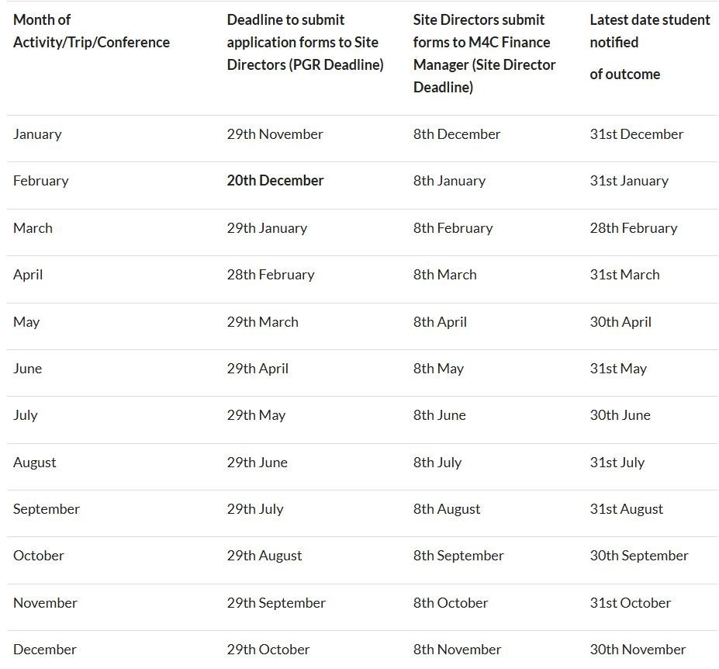
From Screen to Classroom: Understanding Misogyny in Young People
The University of Warwick, in collaboration with its partners at University College London: Institute of Education, Philosophy of Education Society of Great Britain, and Violence Against Women and the Education of Voice, is hosting a one-day interdisciplinary seminar on Thursday 2 July that brings together teachers, school leaders, and experts across education, psychology, philosophy of education and policy to confront the threat of misogyny in schools.

Through expert insight, policy discussion, and practical strategies, the event will explore the roots of rising misogyny, the role of social media, and its impact on both girls and boys. Crucially, the session will aim to develop a forum exchange - an open culture of conversation - connecting Adolescence, education, and the challenge of misogyny.

- Date: Thursday 2 July 2026
- Time: 10:00 - 15:00
- Location: University of Warwick, Coventry (Room TBC)

For more information please visit the event webpage. Please register your attendance here.

With our best wishes,
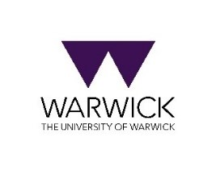
M4C-Warwick Team | University of Warwick | M4C@warwick.ac.uk
Professor David Lambert - CADRE Director & M4C Site Director | Dr Ross Forman - M4C Site Director | Kay Jones - Doctoral Training Manager | Dr Yangzi Zhou - Doctoral Training Programmes Co-ordinator

