Content
Welcome
Student News
Post-PhD Successes – Keep Us Updated
Change to M4C Warwick Staff
RDF and EF Deadlines
Annual Leave

Welcome
Welcome to the July edition of the M4C Warwick newsletter. If you have any items that you would like us to include in the next newsletter, please email them to M4C@warwick.ac.uk and mark the subject as ‘Newsletter Item’. If you have been on a placement, attended a conference, had work published etc and would like to share that with you fellow M4C Warwick students, we would love to hear from you!

Student News
Fridolin Neumann (Philosophy)
Fridolin’s paper has been published in the European Journal of Philosophy, one of the leading journals in Philosophy research. The paper focuses on Heidegger’s conception of idle talk (Gerede) and argues against pragmatist interpretations that idle talk should be understood as referring to a misguided form of ontological discourse that misconstrues the distinctive features of things. The paper is available Open Access here: http://doi.org/10.1111/ejop.70106.

Post-PhD Successes – Keep Us Updated
As you may know from the End of Year Report emails, we are currently preparing the annual report to AHRC. We would like to hear from final-year M4C students who have succeeded in getting academic and non-academic positions. We are particularly interested in hearing from those of you who won the Institute of Advanced Study Early Career Fellowship in recent rounds (April 25/26 and October 26/27). Many thanks for keeping the M4C team updated!

Change to M4C Warwick Staff
We wanted to make you aware of an upcoming change in the M4C Warwick Team: Yangzi will be moving to a new department within the University at the end of July.
Due to these staff changes and annual leave plans throughout the summer, there will be delays in processing RDF/EF applications, Concur claims, and queries throughout late July to early September.
*We would therefore kindly advise you to plan accordingly for this and consider submitting RDF and EF applications well in advance during this period. Because the M4C Warwick Office will be mostly closed from 24th July to 4th August, for the July around with the official deadline on the 29th, please aim to submit your application before 22nd July, especially if complicated travel plans are involved. This will allow sufficient time for you to receive feedback and revise the application. Please note that submissions between the 23rd and 29th of July will not be rejected, though it is strongly recommended that you send in your application early.

Annual Leave
Hopefully over the summer period you will be able to take some time out. A reminder that PGR students are entitled to take annual leave as per the PGR Annual Leave Policy.

RDF and EF Deadlines
If you are planning to apply for an EF or RDF, please ensure that you are aware of the current application deadlines (listed below). The dates of the activity should take place at least 2 months after your application date, for example if you submit your application in the July round then travel should not take place until at least September. When applying ensure you are allowing enough time between applying and when you intend to go - RDF/EF

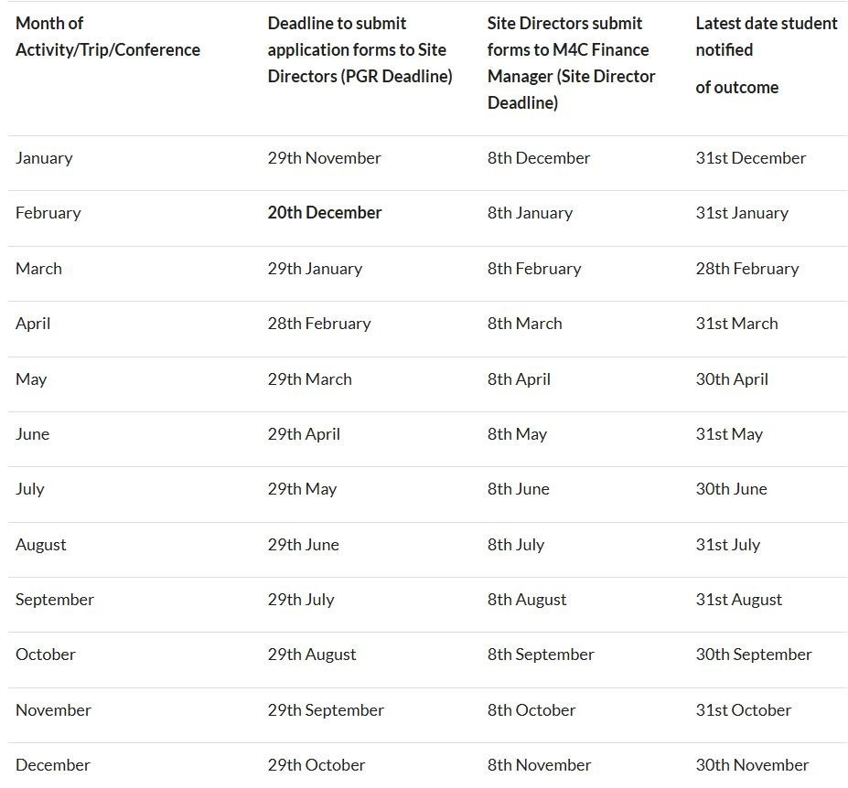

With our best wishes,
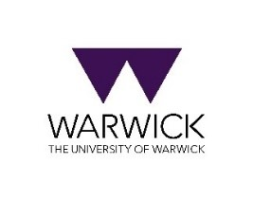
M4C-Warwick Team | University of Warwick | M4C@warwick.ac.uk
Professor David Lambert - CADRE Director & M4C Site Director | Dr Ross Forman - M4C Site Director | Kay Jones - Doctoral Training Manager | Dr Yangzi Zhou - Doctoral Training Programmes Co-ordinator

