AHRC Doctoral Landscape Award Scholarships - Research Training Support Grant Application

AHRC Training Grant awards include a Research Training Support Grant (RTSG) which may be used to support study visits and conference attendance, as well as other research costs which are necessary for the student’s primary research, for example, consumables or exhibition costs. Students can apply for up to £5000.00 over the course of their funded registration.

All spending needs to comply with the guidelines in the PGR Funding Policy and University Financial Regulations

An application cannot be considered if it is not within required timeframes and retrospective applications will not be considered.

Budget Management
The RTSG for AHRC Doctoral Landscape Awards is fixed at £5000.00 and cannot be extended. Whilst within Warwick’s Financial Regulations, PGR can claim expenses for subsistence (food and drink), we would encourage award holders to focus on using their RTSG funds to cover travel, accommodation, and any fees associated with their research or conference costs. Award holder should be mindful to think about long-term budgeting for the duration of the course and carefully plan what can be covered from the award.

Application Checklist | Confirm Y/N
Ensure that your supervisors support and have signed your application
Ensure your application is attached to the online form in docx or odt format (please do not send documents as PDFs) with a clear file name including your name and student ID number.
With your application, ensure to attach quotes for all expenses you expect to incur (including, for example, travel to and from your UK airport).
Accommodation should be comfortable and safe without being opulent. The current overnight accommodation rates for UK hotels are shown on the Payroll website: Subsistence Allowances.
Note: The University requires that all overseas accommodation MUST be booked via the University Travel Agent, Key Travel. If the combined cost of travel and accommodation for any trips within the UK/EU is over £1000.00, Key Travel must be used.
For train travel, aim to use the standard class ticket option from Key Travel or the train provider’s website for all quotes (rather than Trainline, which adds a booking fee). Try to avoid travelling at peak times where possible. Students should not quote for advance rail tickets, due to rapid price fluctuations, however advance saver tickets should be purchased where possible once the funding award is confirmed.
Please consider purchasing a 16-25 or 26-30 railcard, which will allow you to book UK rail trips at a lower cost (https://www.railcard.co.uk/). Students should also consider booking rail tickets via Key Travel to avoid having to claim expenses.
For air travel, please provide quotes via Key Travel, and in all cases, look to minimise flight costs.
Note that the University requires that all overseas flights, and UK/EU bookings where the combined cost of travel and accommodation is over £1000.00 must be booked via the University Travel Agent, Key Travel. See Expenses for full details.
Please ensure that all quotation screenshots are embedded into the application in Section 4, and not included as separate attachments/emails. Note that URL links to quotes are not acceptable – please use screenshots of web or email quotes, or invoices.
Please ensure that your application and all your planned expenditure conform to the Warwick University Expenses Guidance.
If you are travelling abroad, please confirm that you have completed your Departmental Travel Declaration Process, and if required, an Overseas Travel Risk Assessment form. This is required for the University’s Travel Insurance to cover your trip.
Once you have been awarded the RTSG funds, please follow the University Expenses Guidance when making purchases or claiming back any expenses.
The University requires that all overseas flights, and UK/EU bookings where the combined cost of travel and accommodation is over £1000.00 must be booked via the University Travel Agent, Key Travel. See Expenses for full details.

Personal Details
Surname:
Forename(s):
Student ID:
Email address:
Current Funding End Date:
Please contact CADRE@warwick.ac.uk if you are unsure of your funding end date
Approval
- Have you obtained the relevant ethical approval for the proposed activity? Please evidence Departmental or HSSREC Ethical Approval as required.
- Have you obtained approval to travel from your Department; and followed all their relevant internal procedures? Approval must be obtained before you can make an application for funding. Please evidence Departmental Travel approval, signed Overseas Travel Risk Assessment, Fieldwork Risk Assessment as required.
Proposed activity
An application cannot be considered if it is not submitted within required timeframes and retrospective applications will not normally be considered.
1. Please provide a brief description of your proposed project/activity, including duration and location. The proposed activity should be essential to the completion of your PhD thesis (100 words)
2. How will this funding be used to support your doctoral research. Please complete this section in as much detail as possible (300 words maximum)
3. Provide the dates of the event and travel. Please note your application may not be considered if you do not adhere to the advertised deadlines.

Budget
Provide an itemised budget for each item that will be included in your trip. Screenshots of indicative costs must be provided, and screenshots should be copied into this section. If flight/train price increases are a concern, 10% may be added to the advertised costs.
Add more rows to the table below as required.
4. Itemised expenses | Expected cost
EXAMPLE: RTN train Coventry to London:  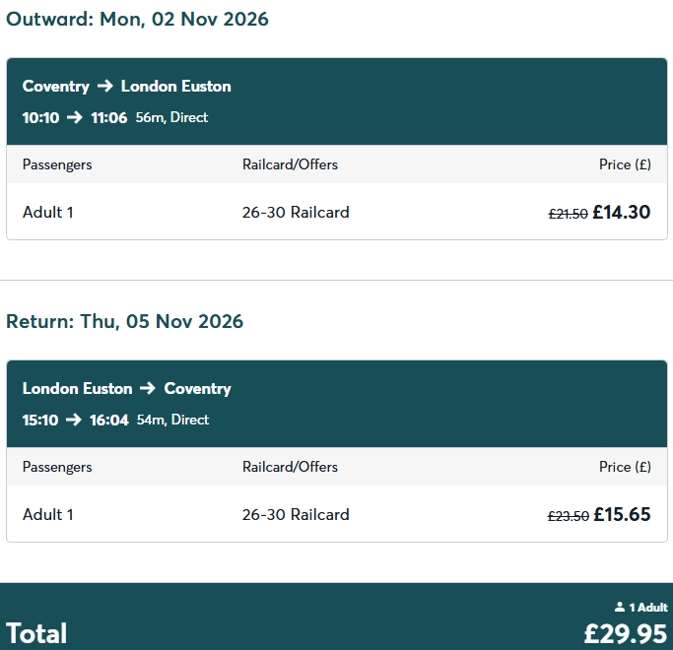 | £29.95

5. Is there any additional information that you would like to include in the application? For example:
- You are planning to stay with a friend or relative and therefore have not costed for accommodation;
- A more costly route has been selected for specific reasons;
- Are there certain uncosted elements of this trip that you will be applying for on a future application, and why can these not be costed now?
- If you have Disabled Student Allowance (DSA) support in place, please indicate costs here that will be charged to the DSA in line with your needs assessment and the UKRI DSA Framework.

Declaration
I declare that all information provided is true to the best of my knowledge:
Signature: | Date:

Approvals
6. Supervisors’ comments in support of the application. These must include discussion of the significance of the activity to the successful completion of the project:
Supervisor Name: | Signature: | Date:

Once completed, this form should be submitted to the AHRC RTSG Application Online Form. The application will be checked by the CADRE manager/coordinator and submitted to Site Directors for consideration. Students should expect to receive an outcome to their application within no longer than 2 weeks (note that responses may be longer outside of University Term time).
Site Director Sign-Off
7. Comments:
Site Director(s) Name: | Signature(s): | Date:

