Thomas Glave
Scenes from a Jamaican Childhood

Thursday 22 November, Ramphal Building R.0.14, 5.30 pm

This presentation will journey through meditations on coming of age, social class, gender, sexuality, and relationships with the dead in Jamaica, by way of the author's personal reflections.

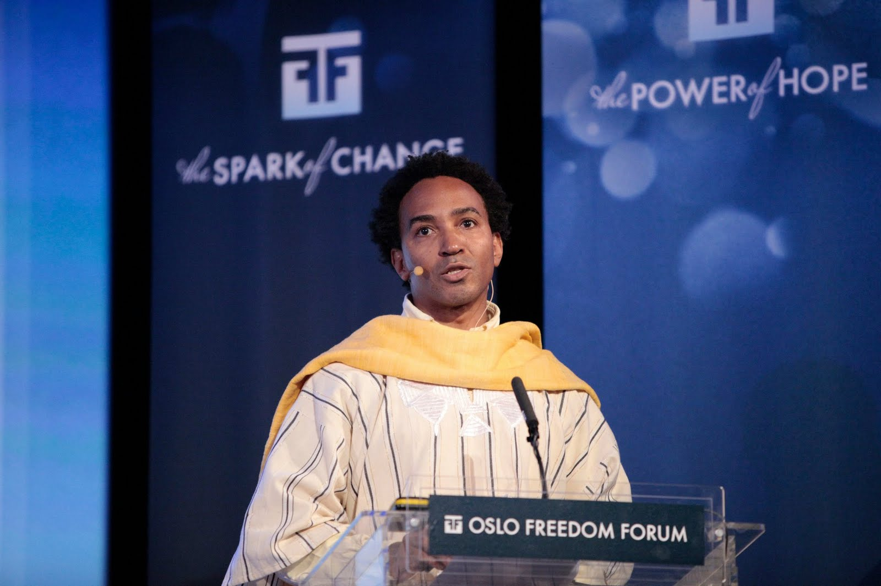
Thomas Glave’s most recent work appears in The New York Times, The Kenyon Review, Callaloo, and in several anthologies, including Kingston Noir and Why Are Faggots So Afraid of Faggots?: Flaming Challenges to Masculinity, Objectification, and the Desire to Conform, both published in 2012. Glave has been Martin Luther King, Jr. Visiting Professor at MIT, and is a 2012 Visiting Fellow at Clare Hall, University of Cambridge.

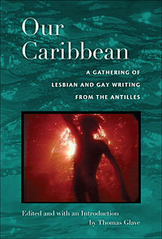 | 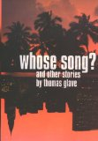 | 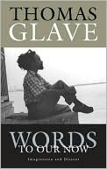 | 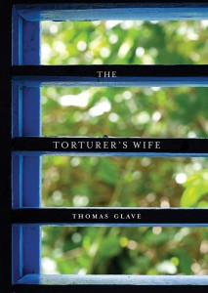
Thomas Glave is editor of the anthology Our Caribbean: A Gathering of Lesbian and Gay Writing from the Antilles (Lambda Literary Award, 2008).

He is the author of Whose Song? and Other Stories; Words to Our Now: Imagination and Dissent (Lambda Literary Award, 2005), and The Torturer’s Wife (Dayton Literary Peace Prize finalist, 2008). Among the Bloodpeople: Politics and Flesh is forthcoming from Akashic Books in summer 2013: http://www.akashicbooks.com/amongthebloodpeople.htm

This event is free and open to all.
For any inquiries, please contact Fabienne Viala: F.Viala@warwick.ac.uk

