Professional Development Planning

Engaging with your own professional development will enable you to expand your range of skills and better understand the ways in which you work. As a doctoral research student you are expected to spend three days per year developing transferable skills outside your research programme. This will enable you to:
- Learn new skills
- Be a more effective researcher
- Navigate ethical frameworks
- Build extensive networks
- Maximise your employability in an increasingly competitive job market.
Warwick has a substantial range of opportunities for professional development, including training workshops, events and courses. These are offered by multiple providers from across the institution. To help you to choose which opportunities would be most appropriate for you, they have been categorised under six themes:
 | 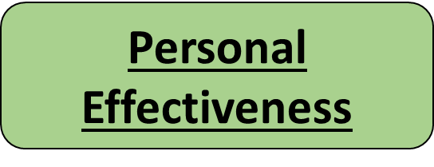 | 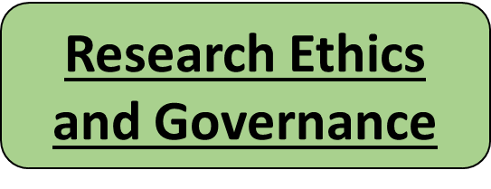
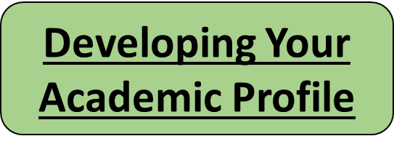 | 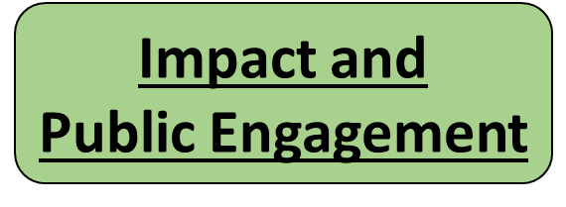 | 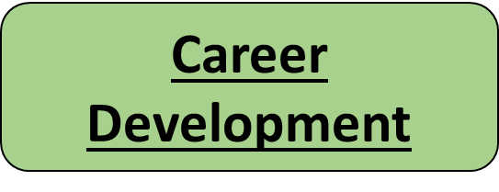

The six themes represent a simplified version of Vitae’s Researcher Development Framework.

This form provides a space for you to reflect upon your skills across each of the six themes. For each theme, consider:
- How strong are your skills currently?
- How important is it for you to develop these skills
  - …to succeed in your research project?
  - …to demonstrate to employers?
- Which skills do you need to work on developing?
Use the spaces provided to write notes or lists, or create diagrams or mind maps to organise your thoughts- whatever works for you. You are encouraged to discuss this with your supervisor. However, it is up to you whom you feel comfortable sharing this form with.

Once you have identified the specific areas you would like to focus on, you can use the doctoral college and SkillsForge to find the professional development opportunities which meet your needs. You can filter the opportunities listed by theme, skill or stage of study.
Academic Skills  Argument construction, Communication, Critical thinking, Decision making, Digital literacy, Entrepreneurship, Equality and diversity, Evaluating, Information seeking, Languages, Practical research skills, Project planning, Team working, Writing | Personal Effectiveness  Communication, Equality and diversity, Global citizenship, Influence and leadership, Project planning, Self-confidence, Self-reflection, Time management, Working with others

Research Ethics and Governance  Ethics and integrity, Equality and diversity, Information management, Income generation, Policy, Professional conduct, Publishing and dissemination | Developing Your Academic Profile  Career development, Digital identity, Digital literacy, Equality and diversity, Evaluating, Global citizenship, Influence and leadership, Networking, Publishing and dissemination

Impact and Public Engagement  Communication, Communication to non-experts, Enterprise, Equality and diversity, Evaluating, Global citizenship, Income generation, Influence and leadership , Innovation, Networking, Professional conduct, Publishing and dissemination, Public engagement, Teaching, Writing | Career Development  Career development, Communication, Communication to non-experts, Critical thinking, Digital identity, Digital literacy, Enterprise, Equality and diversity, Networking, Self-confidence, Self-reflection, Teaching

Personal Development Plan
You can use this section to identify a number of specific goals to work towards to enhance your professional development. This should be revisited regularly, for example every term, to assess progress. Please use www.warwick.ac.uk/pgrdevelopment for information, workshops and events that can help you enhance the skills or themes you have identified. You can use the space below to plan which opportunities you engage with.

Identified skill area for development | Planned Activity | Success criteria (how will you know you’ve achieved your goal?) | Deadline (when do you want to achieve it by?)

