Coinage of Greece and Rome 2020/21

Module convenor and tutor:
Prof. Suzanne Frey-Kupper S.Frey-Kupper@warwick.ac.uk

Why did Ancient states strike coins?
Topics
- Money before coinage?
- The challenge of understanding the beginnings of coinage: dating, locating and function of electrum coinage
- Minting authority and historical context: ‘The State’?

Pre-monetary exchange, objects in silver from Cisjordan, c. 1200-600 BC

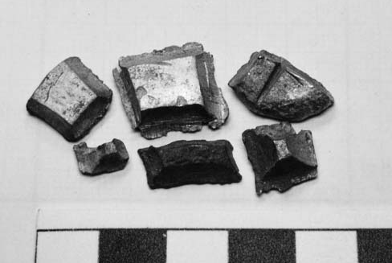
Chocolate bar ingots of silver from Akko, ninth to eight century BC
(Thompson 2003, p. 72, fig.

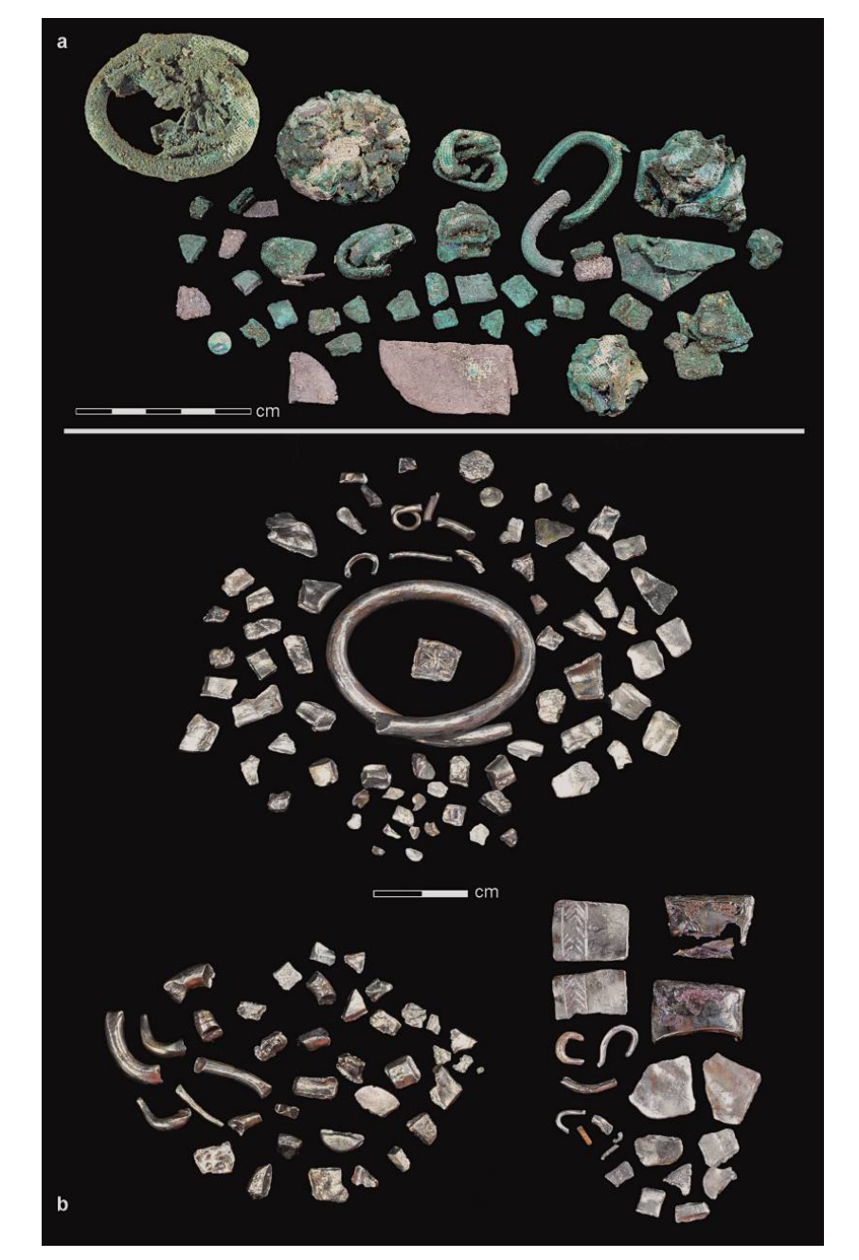
a: Closed bundles and loose objects from the Tell Keisan hoard;
b: Bundles 2, 6 and 8 after cleaning (Eshel et al. 2018, p. 205, fig. 4)

‘…bundling gradually replaced by the practice of hacking silver ingots to verify their quality.
In Iron Age II, during every transaction, the hacked items were weighed using miniature silver items to balance the scales. We conclude that the ‘hacked silver’ economic system was not based on ‘pre-weighing’ and therefore cannot be defined as heralding the use of coins’

(Eshel et al. 2018, p. 197).
Beth Shean, chiselled jewellery (Thompson 2003, p. 77, fig. 10)

Electrum Coinage, the earliest coinage, introduced from c. 640 BC
While the metal from the rivers is generally rather pure, of varying mixing ratio, the coin metal must be an artificial alloy since consistently of 55% gold, 43-44% silver, 1-2% bronze

- the Lydians were able of separating gold and silver and produce high-quality coinage by:
- segregating the metal and composing the new mint metal.
If they had just diluted the natural metal, they would not have achieved such a stable alloy.

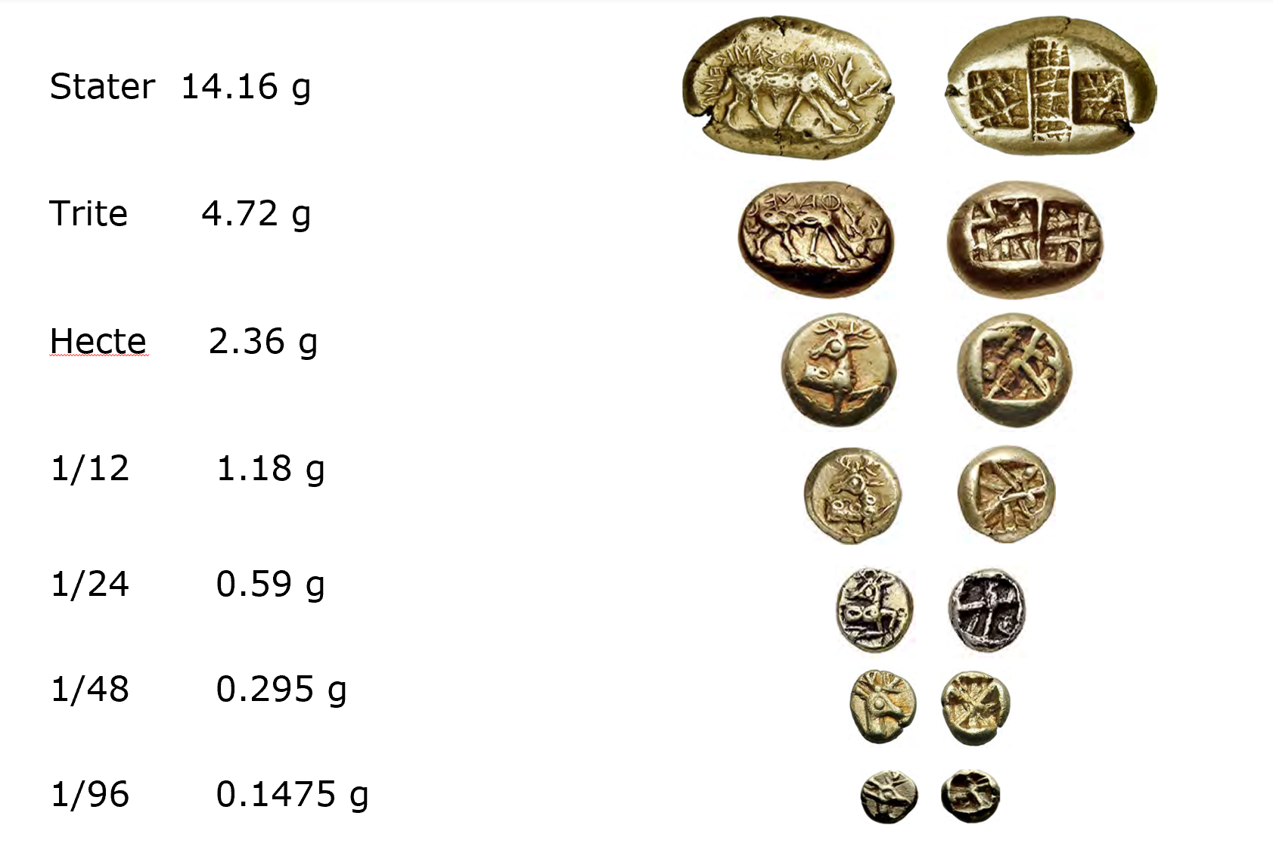
Denominations based on the Lydo-Mileasian weight standard unit, the stater.
Here the coinage of Phanes, stater and fractions, c. 625-600 BC (Fischer-Bossert 2020)
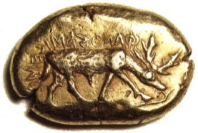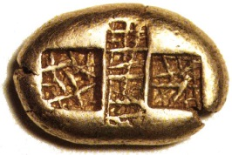

Stater of Phanes, c. 625-600 BC
Retrograde legend ΦΑΝOΣ ΕΙΜΙ ΣΗΜΑ, ‘I am the the badge of Phanes’
14.30 g ‘from the coast of Asia Minor, not far from Ephesus’
(R.-Alföldi 1978, p. 76)
Frankfurt, Bundesbank, inv. 0346/74
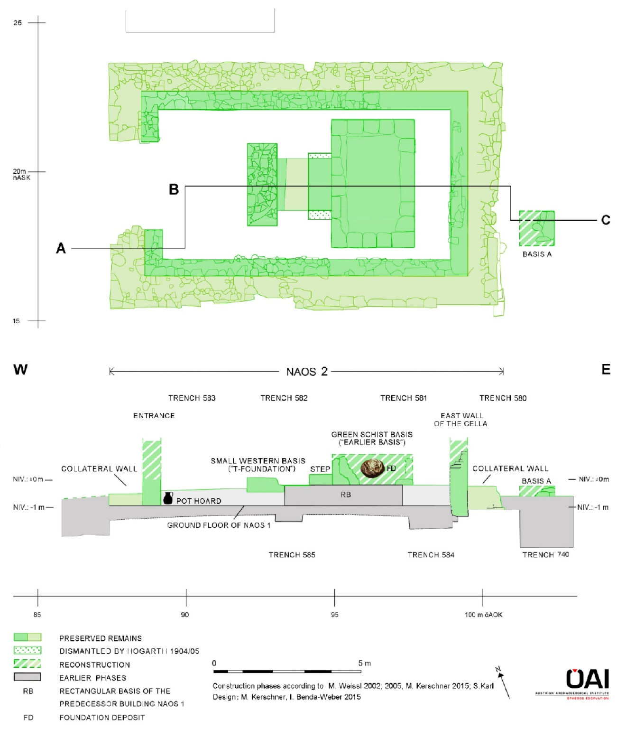
Ephesus, Artemision, naos 2 (temple 2), plan and cut, with ‘central basis’ and floor with pot hoard, archaeological contexts dating coins c. 640-620
(Kerschner and Konuk 2020, p. 117, fig. 12)
Bibliography

Reasons for coining
Crawford, M.H. (1970) ‘Money and exchange in the Roman world’, Journal of Roman Studies 60: 40–48

Howgego, C. (1990) ‘Why did ancient states strike coins ?’ Numismatic Chronicle 150: 1-25 (a response to @Crawford, M. (1970) ‘Money and exchange in the Roman World, Journal of Roman Studies 60: pp. 40–48 (general introduction, useful for the module in general)

Lo Cascio, E. (1996) ‘How did the Romans view their coinage and its function?’ in Coin Finds and Coin Use in the Roman World. The Thirteenth Oxford Symposium on Coinage and Monetary History, 25.-27.3.1993. A NATO advanced Research Workshop (Studien zu Fundmünzen der Antike 10) eds. C.E. King and D.G. Wigg (Berlin: Mann) 273–287

@Melville Jones, J.R. (2006) ‘Why did the Ancient Greeks strike coins?’, Journal of the Numismatic Association of Australia 17: 21–30 http://www.numismatics.org.au/pdfjournal/Vol17/Vol%2017%20Article%204.pdf

Pre-monetary transactions
Balmuth, M.S. ed. (2001) Hacksilber to Coinage. New Insights into the Monetary History of the Near East (New York: American Numismatic Society) [CJ 208.H2]

@Eshel, T., Yahalom-Mack, N., Shalev, S., Tirosh, O., Erel, Y., and Gilboa, A. (2018) ‘Four Iraon Age Silber hoards from Southern Phoenicia: From bundles to Hacksilber, American Schools of Oriental Research, BASOR 379: 197–228 (essential to question 1)

@Thompson, C.M. (2003) ‘Sealed Silver in Iron Age Cisjordan and the 'Invention' of Coinage’, Oxford Journal of Archaeology 22: 67–107 (essential to question 1)
https://0-onlinelibrary-wiley-com.pugwash.lib.warwick.ac.uk/doi/epdf/10.1111/1468-0092.00005

The beginning of coinage
@Fischer-Bossert. W. (2018) ‘Electrum Coinage of the Seventh Century BC’, in O. Tekin (ed.), Second International Congress on the History of Money and Numismatics in the Mediterranean World, 5-8 Jan. 2017 Antalya. Proceedings (Istanbul: AKMED), 15–23 (overview for all three topics)

@Fischer-Bossert. W. (2020) ‘Phanes’, in (eds) Wartenberg U., van Alfen, P. Fischer-Bossert, W., Gitler, H. Konuk, K. Lorber, K., White Gold. Studies in Early Electrum Coinage (New York and Jerusalem: American Numismatic Society and The Israel Museum), 423–476

@Haselgrove, C. and Krmnicek (2012) ‘The Archaeology of Money’, Annual Review of Anthropology: 235–250

@Kerschner, M. (2020) ‘The Archaic temples in the Artemision and the archaeology of the “Central Basis”’, in (eds) Wartenberg U., van Alfen, P. Fischer-Bossert, W., Gitler, H. Konuk, K. Lorber, K., White Gold. Studies in Early Electrum Coinage (New York and Jerusalem: American Numismatic Society and The Israel Museum), 191–262

@Kerschner, M. and Konuk, K. (2020) ‘Electrum coins and their archaeological context. The Case of the Artemision in Ephesus’ in (eds) Wartenberg U., van Alfen, P. Fischer-Bossert, W., Gitler, H. Konuk, K. Lorber, K., White Gold. Studies in Early Electrum Coinage (New York and Jerusalem: American Numismatic Society and The Israel Museum), 83–190 (essential to question 2)

Kim, H. (2001) ‘Archaic Coinage and the Use of Money’, in Money and it's Uses in the Ancient Greek World eds. A. Meadows and K. Shipton (Oxford: Oxford University Press) 13–19.

Kraay. C.M. (1976) Archaic and Classical Coinage (London: Methuen)

@Kroll, J.H. (2008) ‘The monetary use of weighed bullion in Archaic Greece’, in The monetary systems of the Greeks and Romans ed. W.V. Harris (Oxford: Oxford University Press) 12–37

Kroll, J.H. (2012) ‘The monetary background of early coinage’, in The Oxford Handbook of Greek and Roman Coinage ed. W.E. Metcalf (Oxford: Oxford University Press) 33–42 (overview for all three topics)

@ Schaps, D.M. (2004) The Invention of Coinage and the Monetization of Ancient Greece (Ann Arbor: University of Michigan Press) [CJ 335.S2]

@Schaps, D.M. (2007) ‘What was money in Ancient Greece?’ in The Monetary Systems of the Greeks and Romans ed. W.V. Harris (Oxford: Oxford University Press) 38–48

@van Alfen, P.G. (2004-2005) ‘Herodotus' "Aryandic" Silver and Bullion Use in Persian-Period Egypt’, AJN 16-17: 7–46

@van Alfen, P. (2020) ‘The role of “The State” and early electrum coinage’, in (eds) Wartenberg U., van Alfen, P. Fischer-Bossert, W., Gitler, H. Konuk, K. Lorber, K., White Gold. Studies in Early Electrum Coinage (New York and Jerusalem: American Numismatic Society and The Israel Museum), 547–567 (essential to question 3)

