First Year Excursion to the Ashmolean Museum, 12 May 2026

Itinerary

Departure 10am: Please arrive at 10am at Carpark P19 next to Bluebell 1 (map below). The coach will depart at 10.15am.

The Ashmolean will not allow people to wear large backpacks etc in the museum. We recommend you bring a small sized canvas bag or similar.

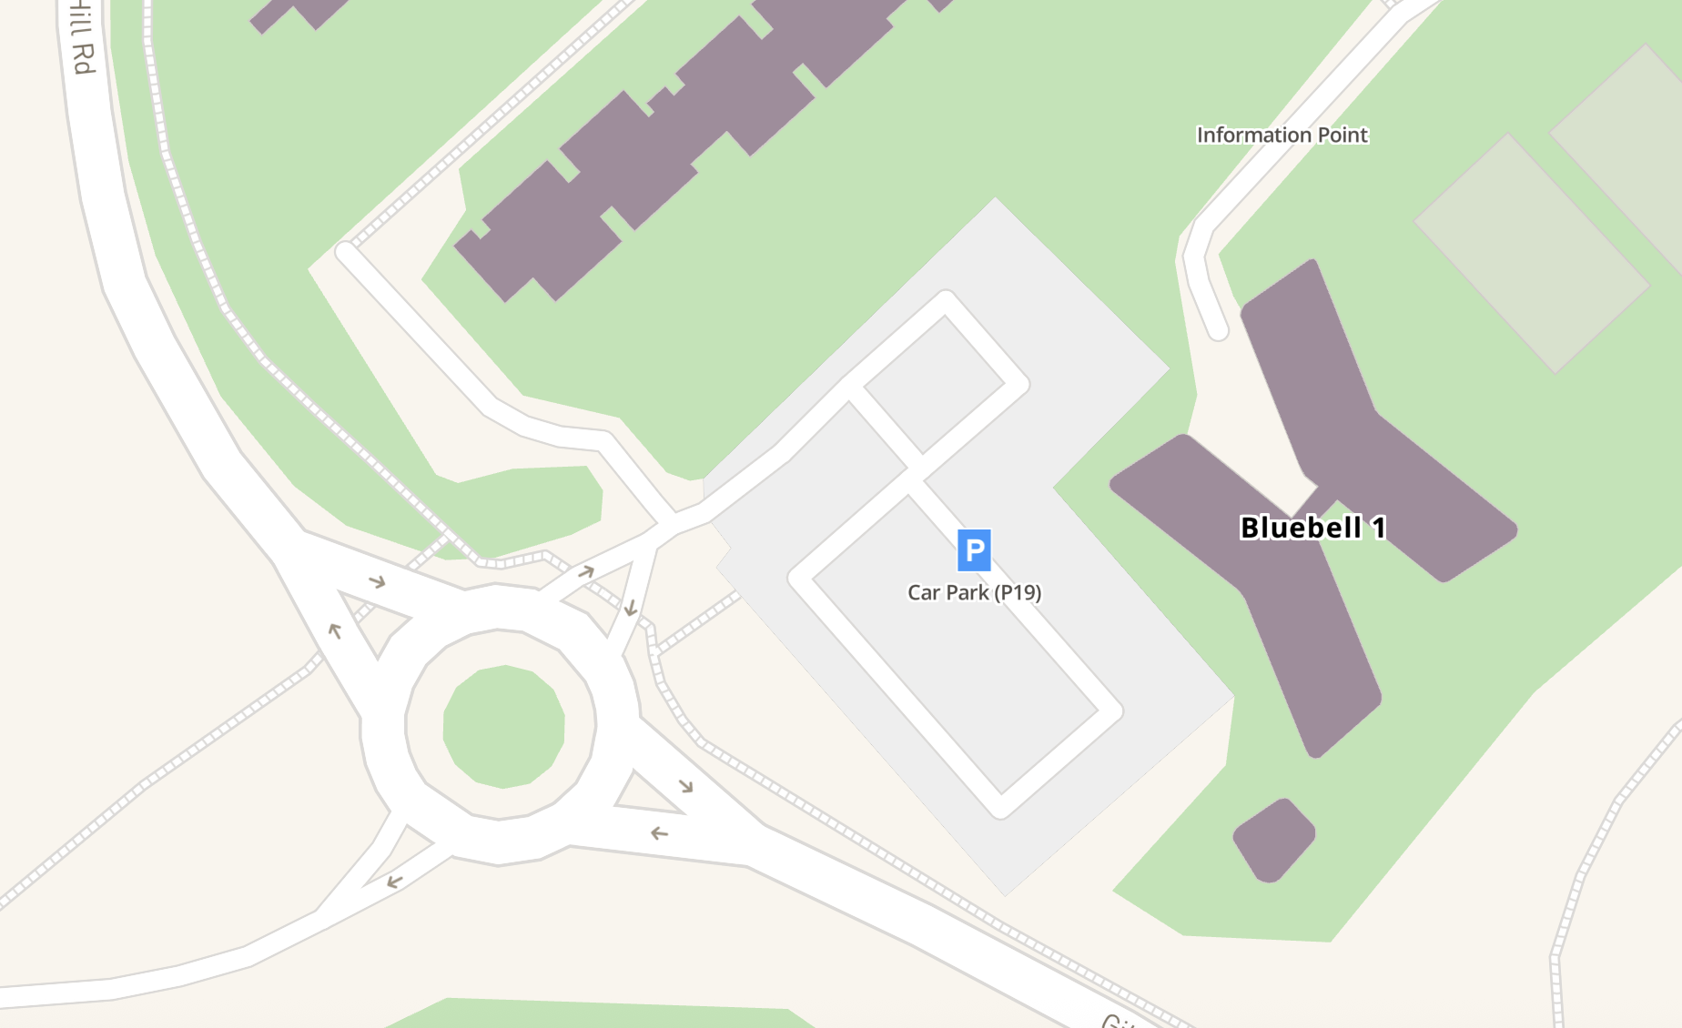

Arrival at Ashmolean Museum by 11.45am.
We will need to enter in staggered groups, and there will be time for the bathroom etc before our formal sessions begin.

You will be divided into 5 groups – please find the list of groups at the end of this document. Each group will spend 30 minutes in each gallery.

12.10-12.40pm
Group 1: The Greek World Gallery (Chris)
Group 2: Rome Gallery (Carlos)
Group 3: Cast Gallery (Zahra)
Group 4: Money Gallery (Clare)
Group 5: Free time (feel free to explore other areas of the museum!)

12.45-1.15pm
Group 1: Rome Gallery (Carlos)
Group 2: Cast Gallery (Zahra)
Group 3: Money Gallery (Clare)
Group 4: Free time (feel free to explore other areas of the museum!)
Group 5: The Greek World Gallery (Chris)

1.15-2pm: lunch. You are free to bring your own lunch and eat it outside the museum in the front courtyard; there is also a café in the basement of the museum and a Tesco express close by.

2.05-2.35pm
Group 1: Cast Gallery (Zahra)
Group 2: Money Gallery (Clare)
Group 3: Free time (feel free to explore other areas of the museum!)
Group 4: The Greek World Gallery (Chris)
Group 5: Rome Gallery (Carlos)

2.40-3.10pm
Group 1: Money Gallery (Clare)
Group 2: Free time (feel free to explore other areas of the museum!)
Group 3: The Greek World Gallery (Chris)
Group 4: Rome Gallery (Carlos)
Group 5: Cast Gallery (Zahra)

3.15-3.45pm
Group 1: Free time (feel free to explore other areas of the museum!)
Group 2: The Greek World Gallery (Chris)
Group 3: Rome Gallery (Carlos)
Group 4: Cast Gallery (Zahra)
Group 5: Money Gallery (Clare)

3.45-4.00pm: final comfort break, please meet outside the main entrance to the museum by 4pm; we will walk to the coach from there.

4.15pm: coach departs

5.45pm: arrival back onto campus.

Group 1
Dania Ali
Ellie Barlow
Alex Blakeman
Finn Cahill
Margot Cowling
Priyasha Dutta
Sam Griffiths
Rhianna Hodgson
Mary Kehoe
Raadhikhaa Kumaarr
Megan Mannall
Davide Paolacci
Eliza Price
Florence Sallin
Megan Strange
Amy Whitefield

Group 2
Alejandro Donnai Jessop
Eleanor Barrett
Jake Bowen
Zoe Chesterman
Tom Daly
Ciara English
Emily Guess
Ellie Horbury
Addy Kelly
Kit Langdon
Olivia McCreath
Amelia Parkin
Holly Quinton
Enaysha Sehgal
Emily Tayloe
Mack Wood

Group 3
Ottilie Horler
Grace Barry
Madeleine Brown
Jane Clark
Sophie Davey-Adam
Seren Finch
Issy Harper
Mathilda Houghton
Elizabeth Khan
Luca LaPlaca
Olivia Mills
Arianna Pellisari
Harry Reynolds
Blaise Shah
Isaac Teague
Ayra Zangie

Group 4
Alice Suffield
Izzy Beales
Beth Clough
Libby Davis
Nicky Denham
Rosie Finlayson
Liam Henry
Anna Jaeger
Jemima Knapper
Joseph Latimer
Cait Mitchell
Lavinia Pellisari
Michelle Rigotti
Mia Simcox
Rory Tune

Group 5
Lucy Bell
Freddie Benton
Greta Bullmann
Clara Costa
Isabelle Dickens
L Gibbons
Mariana Herrera Gomez
Freddie Jones
Dominik Kopczynski
Robert Leveson
Evie Mossop
Autumn Post
Leon Rudak
Conor Snape
Patrick Weston

