Department of Classics and Ancient History
Style Guide

General points
Use Microsoft Word.
Page numbers: include a page number in the header of your essay.
Fonts and spacing: use a 12-point clear font (such as Times New Roman); 1.5 or double line spacing; and clearly delineate paragraphs. Use the same font type and size throughout.
Quotations: the use of quotations from primary sources is strongly encouraged, whilst direct quotations from scholarship should be used sparingly and preferably only if necessary to your argument. Paraphrasing scholarship with acknowledgement given in a footnote is preferable. Quotations may be given within a sentence and must always be enclosed by quotation marks “like this”.
Latin words: these should be given in italics.
Greek words: if written in Greek, the use of unicode is recommended, e.g. παρθένος. If Greek is transcribed in Latin letters, these should be given in italics, e.g. parthenos.
Greek names in English: Be consistent in translating Greek names, preferably using Latinised forms of names, e.g. Aeschylus or Dyrrachium (no italics here).
Use of ibid.: this is not recommended.
Word Count: This includes text and footnotes, but not captions, list of figures or bibliography. Please refer to module tutors for advice on word limits for particular assignments.

Footnotes
Footnotes and their associated bibliography are used to show where the information you use comes from and are vital to avoid plagiarism. They acknowledge all primary source material and ideas taken from scholarship, and are used to give accurate references to whichever ancient or modern works you have quoted from or have used. Footnotes may include more than one work and both ancient and secondary sources (see examples below) and all works cited in footnotes should appear in a full bibliography (see section on Bibliography).
Formatting: insert the footnote at the end of a sentence after the full stop like this.¹ Footnotes should not be given mid-sentence even if a quotation is used. A full stop should also be put at the end of the footnote.

Referring to sources in footnotes

Primary sources - classical texts:
These should be given as the original classical author’s name, title of work in italics, and finally book/chapter/section/line numbers. Use the Loeb Classical Library (available online via the library) to find accurate references.
Examples: Tacitus, Annals 13.39 (this refers to Book 13, chapter 39)
Homer, Iliad 22.131-135 (this refers to Book 22, lines 131 to 135)
Horace, Odes 3.2.1-4 (this refers to Book 3, poem 2, lines 1 to 4)

Primary sources – inscriptions:
If you include any published inscriptions in your work, these also need to be correctly referenced, by giving the abbreviation for the corpora to which they belong and their individual number. An entry would appear for the abbreviation of the corpora (RIB) in the List of Abbreviations for Standard Reference Works and Catalogues (see separate section for this under Bibliography).
The following example is for the translation of an inscription from the corpora of Roman Inscriptions of Britain:
Inscription in text: “To the spirits of the departed (and to) Regina, his freedwoman and wife, a Catuvellaunian by tribe, aged 30, Barates of Palmyra (set this up).”
Footnote: A footnote would be inserted after the second quotation mark and would include the following: RIB 1065.

Primary sources - coins:
If referring to a coin in a footnote, simply refer to the standard catalogue abbreviation (e.g. RIC III Marcus Aurelius 574 or RIC III, p. 260, no. 574, RRC 433/1, RPC I 1305). It is likely that in referring and discussing coins, you will wish to include an image, and the following information should therefore be included: Minting authority (the state and/or its representative: Roman Republic, emperor, city state etc.), mint, denomination, date and standard reference as well as the Museum and the accession no. If possible, the scale should be 1:1 or otherwise be indicated (e.g. 1:2). If a find place is known, this should also be given.
This should also appear in the List of Illustrations with further information (see separate section) and the abbreviation for the corpus should also appear in the Abbreviations of Standard Reference Works and Catalogues (again see separate section).
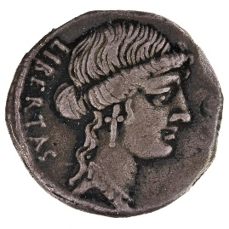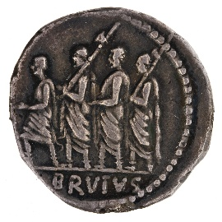
Fig. 1. Denarius of the Roman Republic, Brutus as moneyer, mint of Rome, 54 BC, RRC 433/1;
American Numismatic Society, 1976.999.24 (scale 1.5:1).
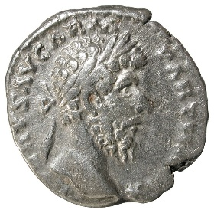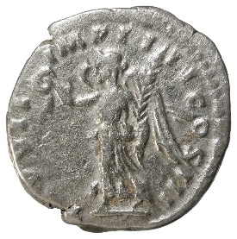
Fig. 2. Denarius of Marcus Aurelius, Rome, AD 166-167, RIC III, p. 260, no. 574;
Valencia Museum of Prehistory, Inv. 39441; from the Llíria Hoard.

Secondary sources:
These should be given in this format: author’s surname (date) page number(s).
The following provides examples for a single-authored book, a multi-authored book, a chapter from an edited volume, a journal article, and online sources. Please see the Bibliography section for how these same examples should be given therein.
Single-authored book: Bowman (1994) 93-95.
Multi-authored book: if two authors: Cooley and Cooley (2014) 67-80.
if more than two authors: Morford et al (2011) 110.
Chapter from edited volume: it is important to acknowledge the author of the specific chapter used, rather than the editors of the work (this is also true of encyclopaedia/dictionary entries where the author of the individual entry should be cited). The footnote then appears in the same format as the single-authored book, and the editors of the book will be credited in the bibliographic entry.
Example: Purcell (1995) 150-79.
Journal articles: Author plus date, as for single-authored book. E.g. Rowan (2016) 30-35.
Online sources: For books and journal articles which you have accessed online, please reference as above. For references to materials only available online you should provide the URL in the footnote and in bibliography, along with a title if given and the date accessed:
Example: British Museum, “Explore: the Rosetta Stone”: www.britishmuseum.org/collection/egypt/explore-rosetta-stone. Accessed 06 June 2022.

Multiple sources in a footnote:
Citing numerous sources, both ancient and secondary, in a footnote is normal practice as necessary. Each work should be separated by a semi-colon, with any classical text being given first, followed by secondary material in descending date order (earliest first, most recent last).
Example: Tacitus, Annals 13.39; Bowman (1994) 93-95; Cooley and Cooley (2014) 67-80.

Bibliography
All sources which are cited in footnotes must be given in full in the bibliography, which should be set out on a new separate page at the end of the essay document. The bibliography should be separated into the following sections and the relevant sources included in alphabetical order (by author) in the appropriate section. If there are multiple entries for the same author, arrange them by date order, with the earliest first:
Primary Sources, Internet Sources and Secondary Sources.
The following provides examples of how these should appear and correlates with the examples given in the footnote section above. Please note that you should provide page ranges for journal articles and chapters in books.
Primary sources (texts): Homer, Iliad, trans. R. Fagles (Harmondsworth: Penguin Classics 1990).
Horace, Odes and Epodes, ed. and trans. N. Rudd, Loeb Classical Library 33 (Cambridge, MA: Harvard University Press, 2004).
Tacitus, Annals, Books 13-16, trans. J. Jackson, Loeb Classical Library 322 (Cambridge, MA: Harvard University Press 1937).
Secondary Sources
(see below for examples of single and jointly authored books, a chapter in an edited volume, and a journal article)
Bowman, A.K. (1994) Life and Letters on the Roman Frontier (London: British Museum Press).
Cooley, A.E. and Cooley, M.G.L. (2014) Pompeii and Herculaneum: A Sourcebook (Abingdon: Routledge).
Morford, M. P. O., Lenardon, R. J. and Sham, M. (2011) Classical Mythology (Oxford: Oxford University Press).
Purcell, N. (1995) “The Roman villa and the landscape of production”, in Urban Society in Roman Italy, eds. T. J. Cornell and K. Loman (London: UCL Press), 150-179.
Rowan, C. (2016) “Ambiguity, Iconology and Entangled Objects on Coinage of the Republican World”, Journal of Roman Studies 106: 21–57.

Online sources: British Museum, “Explore: the Rosetta Stone”, online at: https://www.britishmuseum.org/collection/egypt/explore-rosetta-stone Accessed 06 June 2022.

List of Abbreviations for Standard Reference Works and Catalogues
If this needs to be included then it is preferable to place it first in the Bibliography with a subheading as here; it is used to provide details of any standard reference works and catalogues used. This is most likely to be required when coins or inscriptions. Examples are given here from the inscription and coin included above:
RIB Roman Inscriptions of Britain, Volume 1. Online at: https://romaninscriptionsofbritain.org/ 2022.
RRC Roman Republican Coinage. Online at: http://numismatics.org/crro/ 2022.

Images and captions

Images are often useful to illuminate discussions and support arguments, and these can be placed either within the body of the text or as a separate series of figures at the end of the essay. When used they should be referenced in text as (Fig. 1.) given a caption, see examples below, and included in a separate List of Illustrations (see next section).
Captions should include information as to what the image is and give museum numbers where possible.
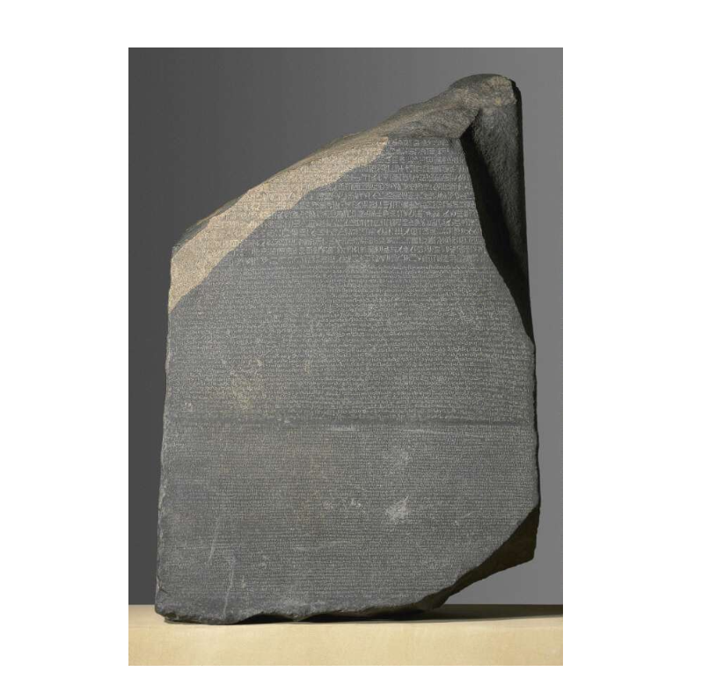
Fig. 3. The Rosetta Stone, British Museum No. EA24.

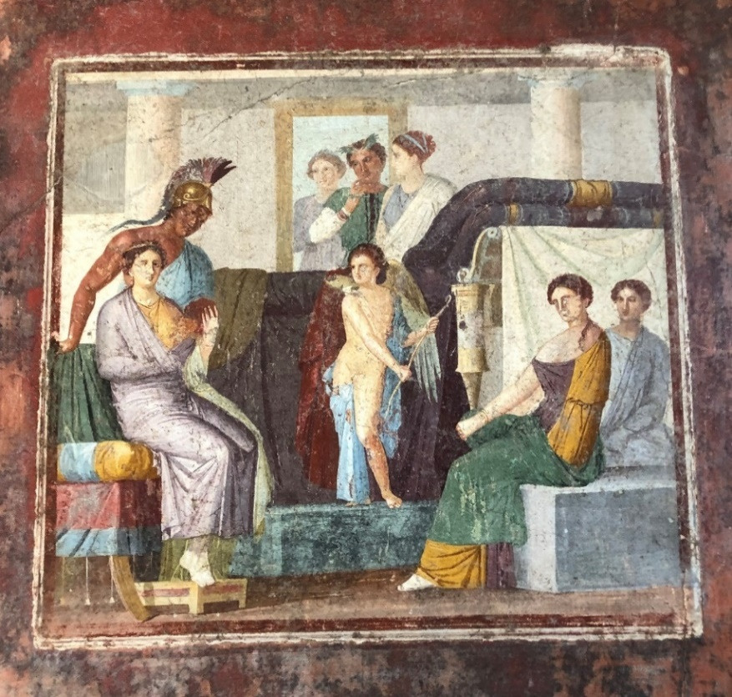

Fig. 4. Wall painting, Mars and Venus, in situ in the House of M. Lucretius Fronto, Pompeii V 4 a.

List of Illustrations
The List of Illustrations is used to give further information about any coins/images included and should appear at the end of the essay, either before or after the Bibliography.
It should repeat the caption but also give information on where the image has come from (student’s own photograph; website details; Wikimedia Commons; book).
Examples:
Fig. 1. Denarius of the Roman Republic, Brutus as moneyer, mint of Rome, 54 BC, RRC 443/1.
Obv.: LIBERTAS (at left); head of Libertas right; border of dots..
Rev.: BRVTVS (in exergue); L. Junius Brutus walking left, between two lictors carrying fasces and preceded by an accensus; border of dots..
AR, 3.53 g, 5 h; American Numismatic Society, 1976.999.25
http://numismatics.org/crro/id/rrc-433.1 (accessed 06 June 2022).
Fig. 2. Denarius of Marcus Auelius, Rome, AD 166-167, RIC III, p. 260, no. 574.
Obv.: L [VE]RVS AVG ARM PARTH [MA]X; Head of Lucius Verus, laureate, right: border of dots.
Rev.: T[R] P VII IMP IIII COS III; Victory, winged, draped, advancing left, holding wreath in extended right hand and palm, sloped over left shoulder, in left hand.
AR, 3.24 g, 12 h; Valencia Museum of Prehistory, Inv. 39441; from the Llíria Hoard
https://www.mupreva.org/nomisma/id/es/39441 (accessed 28 Aug. 2023).

Fig. 3. The Rosetta Stone, British Museum No. EA24 (from British Museum: https://www.britishmuseum.org/collection/object/Y_EA24 accessed 06 June 2022).
Fig. 4. Wall painting, Mars and Venus, in situ in the House of M. Lucretius Fronto, V 4 a, Pompeii (author’s own photograph).

Referencing and layout of essays can be puzzling! If you are uncertain about how to reference something or have questions on how to present your work, please contact your module tutor. Any constructive feedback on this document will also be welcomed.
Please note that this guide is only a reference to recommended presentation of essays and does not cover marking criteria, and general essay writing advice. For those, please see the Departmental Handbook and the webpage: https://warwick.ac.uk/fac/arts/classics/intranets/students/essaywritingresources.
Revised, 18 Aug. 2023

