CX-235

UNIVERSITY OF WARWICK

Summer examinations 2014

DEMOCRACY AND IMPERIALISM IN CLASSICAL ATHENS
Time allowed: 2 hours

All questions carry equal weighting.

Candidates should answer QUESTION 1 and TWO other questions.

Students will not be given credit for substantial repetition of material between questions on the examination paper.

Read carefully the instructions on the answer book and make sure that the particulars required are entered on each answer book.
==========================================================

1. Discuss TWO of the following (ONE picture, ONE text) and comment on any points of interest or difficulty they contain.

a)
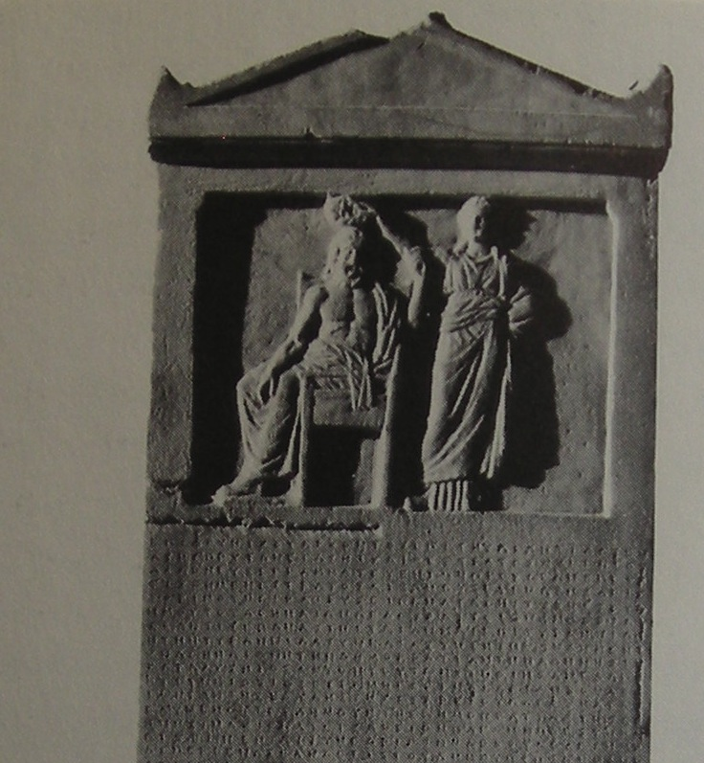

b)
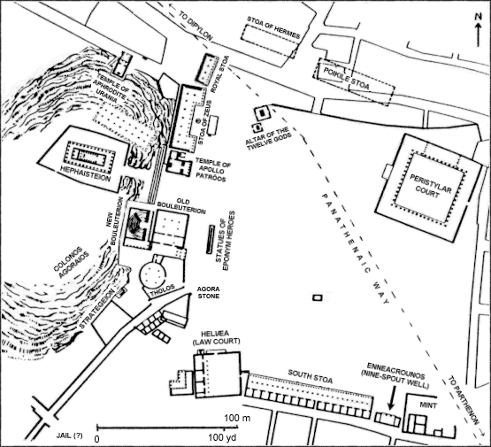

____________________________________________________________________________
CX235 continued
CX235
_____________________________________________________________________________

c) ‘In short, I say that as a city we are the school of Hellas; while I doubt if the world can produce a man, who where he has only himself to depend upon, is equal to so many emergencies, and graced by so happy a versatility, as the Athenian. And that this is no mere boast thrown out for the occasion, but plain matter of fact, the power of the state acquired by these habits proves. For Athens alone of her contemporaries is found when tested to be greater than her reputation, and alone gives no occasion to her assailants to blush at the antagonist by whom they have been worsted, or to her subjects to question her title by merit or rule. Rather, the admiration of the present and succeeding ages will be ours, since we have not left our power without witness, but have shown it by mighty proofs; and far from needing a Homer for your panegyrist, or other of his craft whose verses might charm for the moment only the impression which they gave to melt at the touch of fact, we have forced every sea and land to be highway of our daring, and everywhere, whether for evil or for good, have left imperishable monuments behind us. Such is the Athens for which these men, in the assertion of their resolve not to lose her, nobly fought and died….

Thucydides, History of the Peloponnesian War, 2.41-2

d) ‘For the good fortune of the Athenians and the allies of the Athenians. So that the Spartans shall allow the Greeks to be free and autonomous, and to live at peace occupying their own territory in security [and so that the peace and friendship sworn by the Greeks and the King may be in force and endure in accordance with the agreements] be it decreed by the people that: If any of the Greeks or of the barbarians living in Europe or of the islanders, who are not the King’s, wishes to be an ally of the Athenians and their allies, he may be – being free and autonomous, being governed under whatever form of government he wishes, neither receiving a garrison nor submitting to a governor nor paying tribute, on the same terms as the Chians and the Thebans and the other allies.’

IG II² 43 (Rhodes and Osborne 2003 22); 378/7 BC
e)
‘The common people have subverted those who spend their time in gymnasia or who practise music, poetry and drama; they consider that it is not a good thing because they know that they cannot practise these pursuits themselves. In the case of providing financial support for festivals, for athletics in the gymnasia and for manning triremes, they know that the rich pay for athletics and for triremes, while the common people are paid to row in triremes and take part in athletics. The common people think that they deserve to take money for singing and running and dancing and sailing in the ships, so they they get more and the rich beome poorer. And in the lawcourts they put their own self-interest before justice.’

The Old Oligarch Constitution of the Athenians 1.13

_____________________________________________________________________________
CX235 continued
CX235
_____________________________________________________________________________

2. What made democracy possible in ancient Greece?

--------------------------------------------------------------------------------------------------------------------

3. ‘Solon was no democratic’ Discuss

--------------------------------------------------------------------------------------------------------------------

4. To what extent was Athenian democracy always afraid of the individual?

--------------------------------------------------------------------------------------------------------------------

5. What degree of interest do you think the average Athenian had in their democracy?

--------------------------------------------------------------------------------------------------------------------

6. ‘Without the empire, Athenian democracy would have collapsed much more quickly’ Do you agree and why?

--------------------------------------------------------------------------------------------------------------------

7. In what ways was the democracy of 4th century Athens better than that of the 5th century?

--------------------------------------------------------------------------------------------------------------------

8. ‘Democracy is mob-rule’. Discuss

--------------------------------------------------------------------------------------------------------------------

9. In what ways does the picture of Athenian democracy and empire that emerges from the ancient literary sources differ from that presented through the epigraphic sources?

--------------------------------------------------------------------------------------------------------------------

CX235 END

