CX-235/ CX-335

UNIVERSITY OF WARWICK

Summer examinations 2016

DEMOCRACY AND IMPERIALISM IN CLASSICAL ATHENS
Time allowed: 2 hours

All questions carry equal weighting.

Non Q800 candidates should answer QUESTION 1 and TWO other questions from questions 3-10.

Q800 candidates should answer QUESTION 2 and ONE other question from questions 3-10.

Students will not be given credit for substantial repetition of material between questions on the examination paper.

Read carefully the instructions on the answer book and make sure that the particulars required are entered on each answer book.
==========================================================

1. Discuss TWO of the following (ONE picture, ONE text) and comment on any points of interest or difficulty they contain.

a)
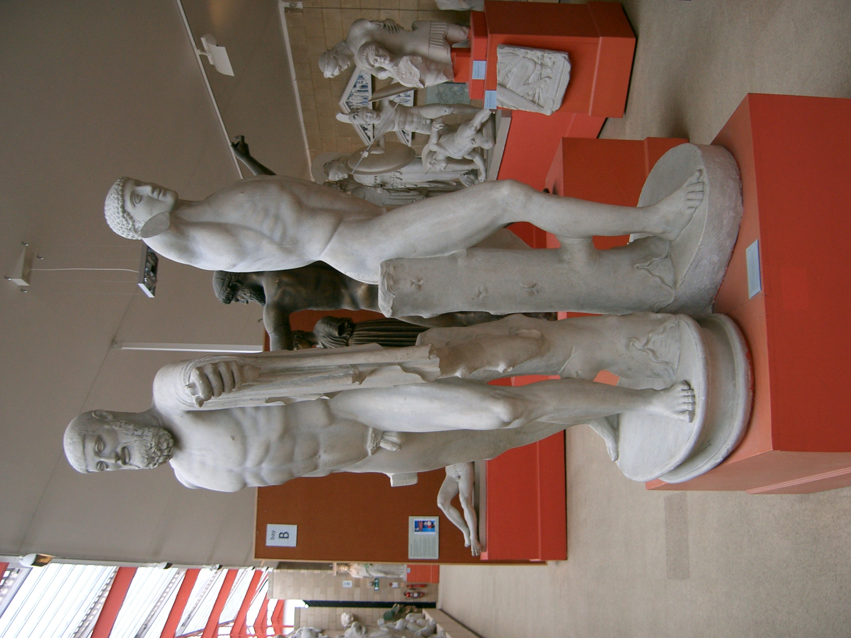

b)

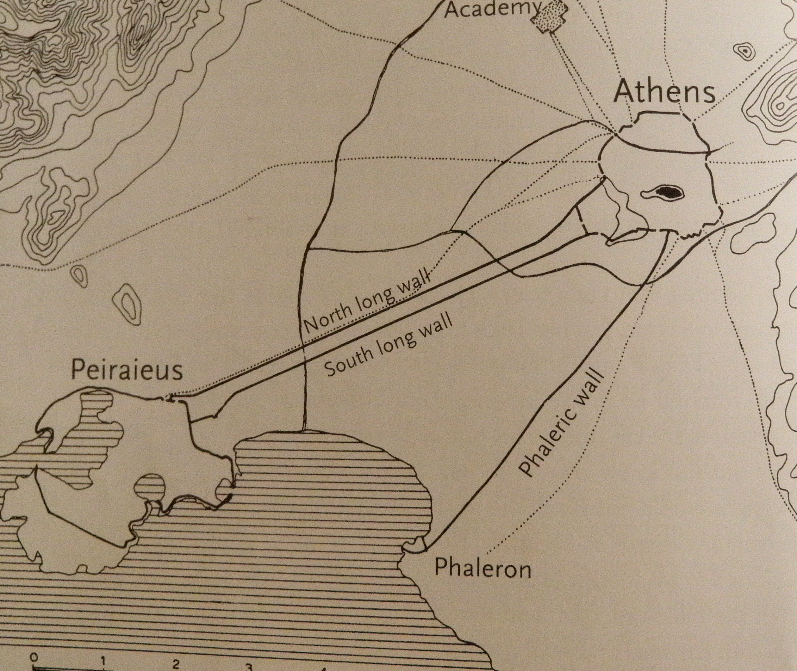
____________________________________________________________________________
CX235 / CX 335 continued

CX235 / CX 335
_____________________________________________________________________________

c) ‘In all that Otanes has said to persuade you to put down monarchy’ he observed ‘I fully concur; but his recommendation that we should call the people to power seems to me not the best advice. For there is nothing so void of understanding, nothing so full of insolence as the unwieldy rabble. It were folly not to be borne, for men, while seeking to escape the insolence of a tyrant, to give themselves up to the insolence of a rude unbridled mob. The tyrant, in all his doings, at least know what he is about, but a mob is altogether devoid of knowledge; for how should there be any knowledge in a rabble, untaught and with no natural sense of what is right and fit? It rushes wildly into state affairs with all the fury of a stream swollen in the winter, and confuses everything. Let the enemies of the Persians be ruled by democracies, but let us choose out from the citizens a certain number of the worthiest, and put the government in their hands.’
Herodotus, The Histories, 3.81

d) “If anyone rises up against the people for a tyranny or joins in setting up the tyranny of overthrows the people of Athens or the democracy at Athens; whoever kills the man who has done any of these things shall be undefiled. And it shall not be permitted for any of the councillors of the Council of the Areopagus, if the people or the democracy at Athens is overthrown, to go up to the Areopagus or to sit together in the meeting or to deliberate about anything at all; and if when the people or the democracy at Athens has been overthrown any of the councillors of the Areopagus does go up to the Areopagus or sit together in the meeting or deliberate about anything, he shall be without rights, both himself and his descendents, and his property shall be made public and the tithe given to the Goddess. This law shall be written up on two stone stelai by the secretary of the council, and placed one at the entrance to the Areopagus as you enter the council house and the other in the Assembly….”

Law Against Tyranny (IG II³ 1 320/ Rhodes and Osborne 2003 79); 337/6 BC

e)
Chorus: ‘Demos, you have a fine way, since all mankind fears you like a man with tyrannical power. But you’re easily led astray, you enjoy being flattered and thoroughly deceived, and every speechmaker has you gaping. You’ve a mind, but its out to lunch.
Demos: There’s no mind under your long hair, since you consider me stupid; but there’s purpose in this foolishness of mine. I relish my daily pap, and I pick one thieving political leader to fatten; I raise him up and when he’s full, I swat him down.
Chorus: In that case you’ll do well, and your character does really contain, as you claim, very deep cunning, if you deliberately fatten these men, like public victims, on the Pnyx, and then when you chance to lack dinner, you sacrifice one who’s bloated and have yourself a meal.

Aristophanes Knights 1110-1140
____________________________________________________________________________
CX235 / CX 335 continued

CX235 / CX 335
_____________________________________________________________________________

2. Translate TWO of the following and comment on any points of interest or difficulty they contain.
(Translation 50%, comment 50%).

a) Old Oligarch 1.1-1.3
Περὶ δὲ τῆς Ἀθηναίων πολιτείας, ὅτι μὲν εἵλοντο τοῦτον τὸν τρόπον τῆς πολιτείας, οὐκ ἐπαινῶ διὰ τόδε, ὅτι ταῦθ᾿ ἑλόμενοι εἵλοντο τοῦς πονηροὺς ἄμεινον πράττειν ἢ τοὺς χρηστούς. διὰ μὲν οὖν τοῦτο οὐκ ἐπαινῶ· ἐπεὶ δὲ ταῦτα ἔδοξεν οὕτως αὐτοῖς, ὡς εὖ διασῴζονται τὴν πολιτείαν καὶ τἆλλα διαπράττονται ἃ δοκοῦσιν ἁμαρτάνειν τοῖς ἄλλοις Ἕλλησι, τοῦτ᾿ ἀποδείξω.
Πρῶτον μὲν οὖν τοῦτο ἐρῶ, ὅτι δίκαιοι αὐτόθι καὶ οἱ πένητες καὶ ὁ δῆμος πλέον ἔχειν τῶν γενναίων καὶ τῶν πλουσίων διὰ τόδε, ὅτι ὁ δῆμός ἐστιν ὁ ἐλαύνων τὰς ναῦς καὶ ὁ τὴν δύναμιν περιτιθεὶς τῇ πόλει, […] οὗτοί εἰσιν οἱ τὴν δύναμιν περιτιθέντες τῇ πόλει πολὺ μᾶλλον ἢ οἱ ὁπλῖται καὶ οἱ γενναῖοι καὶ οἱ χρηστοί. ἐπειδὴ οὖν ταῦτα οὕτως ἔχει, δοκεῖ δίκαιον εἶναι πᾶσι τῶν ἀρχῶν λέγειν ἐξεῖναι τῷ βουλομένῳ τῶν πολιτῶν. ἔπειτα ὁπόσαι μὲν σωτηρίαν φέρουσι τῶν ἀρχῶν χρησταὶ οὖσαι καὶ μὴ χρησταὶ κίνδυνον τῷ δήμῳ ἅπαντι, τούτων μὲν τῶν ἀρχῶν οὐδὲν δεῖται ὁ δῆμος μετεῖναι
b) Aristotle Athenian Constitution 22 (Cleisthenes)

Τούτων δὲ γενομένων δημοτικωτέρα πολὺ τῆς Σόλωνος ἐγένετο ἡ πολιτεία· καὶ γὰρ συνέβη τοὺς μὲν Σόλωνος νόμους ἀφανίσαι τὴν τυραννίδα διὰ τὸ μὴ χρῆσθαι, καινοὺς δ᾿ ἄλλους θεῖναι τὸν Κλεισθένη στοχαζόμενον τοῦ πλήθους, ἐν οἷς ἐτέθη καὶ ὁ περὶ τοῦ ὀστρακισμοῦ νόμος. πρῶτον μὲν οὖν ἔτει πέμπτῳ μετὰ ταύτην τὴν κατάστασιν ἐφ᾿ Ἑρμοκρέοντος ἄρχοντος τῇ βουλῇ τοῖς πεντακοσίοις τὸν ὅρκον ἐποίησαν ὃν ἔτι καὶ νῦν ὀμνύουσιν. ἔπειτα τοὺς στρατηγοὺς ᾑροῦντο κατὰ φυλάς, ἐξ ἑκάστης φυλῆς ἕνα, τῆς δὲ ἁπάσης στρατιᾶς ἡγεμὼν ἦν ὁ πολέμαρχος.

____________________________________________________________________________
CX235 / CX 335 continued

CX235 / CX 335
_____________________________________________________________________________

ἔτει δὲ μετὰ ταῦτα δωδεκάτῳ νικήσαντες τὴν ἐν Μαραθῶνι μάχην, ἐπὶ Φαινίππου ἄρχοντος, διαλιπόντες ἔτη δύο μετὰ τὴν νίκην, θαρροῦντος ἤδη τοῦ δήμου, τότε πρῶτον ἐχρήσαντο τῷ νόμῳ τῷ περὶ τὸν ὀστρακισμόν, ὃς ἐτέθη διὰ τὴν ὑποψίαν τῶν ἐν ταῖς δυνάμεσιν ὅτι Πεισίστρατος δημαγωγὸς καὶ 4στρατηγὸς ὢν τύραννος κατέστη. καὶ πρῶτος ὠστρακίσθη τῶν ἐκείνου συγγενῶν Ἵππαρχος Χάρμου Κολλυτεύς, δι᾿ ὃν καὶ μάλιστα τὸν νόμον ἔθηκεν ὁ Κλεισθένης, ἐξελάσαι βουλόμενος αὐτόν.

c) Polybius 6.44

τὸ δὲ παραπλήσιον καὶ περὶ τῆς Ἀθηναίων πολιτείας διαληπτέον. καὶ γὰρ αὕτη πλεονάκις μὲν ἴσως, ἐκφανέστατα δὲ τῇ Θεμιστοκλέους ἀρετῇ συνανθήσασα ταχέως τῆς ἐναντίας μεταβολῆς ἔλαβε πεῖραν διὰ τὴν ἀνωμαλίαν τῆς φύσεως. ἀεὶ γάρ ποτε τὸν τῶν Ἀθηναίων δῆμον παραπλήσιον εἶναι συμβαίνει τοῖς ἀδεσπότοις σκάφεσι. καὶ γὰρ ἐπ᾿ ἐκείνων, ὅταν μὲν ἢ διὰ πελαγῶν φόβον ἢ διὰ περίστασιν χειμῶνος ὁρμὴ παραστῇ τοῖς ἐπιβάταις συμφρονεῖν καὶ προσέχειν τὸν νοῦν τῷ κυβερνήτῃ, γίνεται τὸ δέον ἐξ αὐτῶν διαφερόντως· ὅταν δὲ θαρρήσαντες ἄρξωνται καταφρονεῖν τῶν προεστώτων καὶ στασιάζειν πρὸς ἀλλήλους διὰ τὸ μηκέτι δοκεῖν πᾶσι ταὐτά, τότε δὴ τῶν μὲν ἔτι πλεῖν προαιρουμένων, τῶν δὲ κατεπειγόντων ὁρμίζειν τὸν κυβερνήτην, καὶ τῶν μὲν ἐκσειόντων τοὺς κάλους, τῶν δ᾿ ἐπιλαμβανομένων καὶ στέλλεσθαι παρακελευομένων, αἰσχρὰ μὲν πρόσοψις γίνεται τοῖς ἔξωθεν θεωμένοις διὰ τὴν ἐν ἀλλήλοις διαφορὰν καὶ στάσιν, ἐπισφαλὴς δ᾿ ἡ διάθεσις τοῖς μετασχοῦσι καὶ κοινωνήσασι τοῦ πλοῦ· διὸ καὶ πολλάκις διαφυγόντες τὰ μέγιστα πελάγη καὶ τοὺς ἐπιφανεστάτους χειμῶνας ἐν τοῖς λιμέσι καὶ πρὸς τῇ γῇ ναυαγοῦσιν.

____________________________________________________________________________
CX235 / CX 335 continued

CX235 / CX 335
_____________________________________________________________________________

d) Plutarch Life of Solon 13.

Οἱ δ᾿ Ἀθηναῖοι τῆς Κυλωνείου πεπαυμένης ταραχῆς καὶ μεθεστώτων, ὥσπερ εἴρηται, τῶν ἐναγῶν, τὴν παλαιὰν αὖθις στάσιν ὑπὲρ τῆς πολιτείας ἐστασίαζον, ὅσας ἡ χώρα διαφορὰς εἶχεν, εἰς τοσαῦτα μέρη τῆς πόλεως διαστάσης. ἦν γὰρ τὸ μὲν τῶν Διακρίων γένος δημοκρατικώτατον, ὀλιγαρχικώτατον δὲ τὸ τῶν Πεδιέων· τρίτοι δ᾿ οἱ Πάραλοι μέσον τινὰ καὶ μεμιγμένον αἱρούμενοι πολιτείας τρόπον, ἐμποδὼν ἦσαν καὶ 2διεκώλυον τοὺς ἑτέρους κρατῆσαι. τότε δὲ τῆς τῶν πενήτων πρὸς τοὺς πλουσίους ἀνωμαλίας ὥσπερ ἀκμὴν λαβούσης παντάπασιν ἐπισφαλῶς ἡ πόλις διέκειτο, καὶ μόνως ἂν ἐδόκει καταστῆναι καὶ παύσασθαι ταραττομένη τυραννίδος γενομενης. ἅπας μὲν γὰρ ὁ δῆμος ἦν ὑπόχρεως τῶν πλουσίων. ἢ γὰρ ἐγεώργουν ἐκείνοις ἕκτα τῶν γινομένων τελοῦντες, ἑκτημόριοι προσαγορευόμενοι καὶ θῆτες, ἢ χρέα λαμβάνοντες ἐπὶ τοῖς σώμασιν ἀγώγιμοι τοῖς δανείζουσιν ἦσαν, οἱ μὲν αὐτοῦ δουλεύοντες, οἱ δ᾿ ἐπὶ τὴν ξένην πιπρασκόμενοι. 3πολλοὶ δὲ καὶ παῖδας ἰδίους ἠναγκάζοντο πωλεῖν (οὐδεὶς γὰρ νόμος ἐκώλυε) καὶ τὴν πόλιν φεύγειν διὰ τὴν χαλεπότητα τῶν δανειστῶν.

3. Why would any ancient Greek community consider democracy for its political system?

--------------------------------------------------------------------------------------------------------------------

4. Why could Athenian democracy never resolve the problem of the power of the individual?

--------------------------------------------------------------------------------------------------------------------

5. “In Athenian democracy, equality was more important in theory than in practice’ Discuss.

--------------------------------------------------------------------------------------------------------------------

_____________________________________________________________________________
CX235 / CX 335 continued

CX235 / CX 335
_____________________________________________________________________________

6. ‘The Empire showed the Athenian democracy at its best’. Discuss?

--------------------------------------------------------------------------------------------------------------------

7. To what extent was Athens a good influence on 4th century Greece?

--------------------------------------------------------------------------------------------------------------------

8. When did democracy in the Greek-speaking world end?

--------------------------------------------------------------------------------------------------------------------

9. Do literary sources give us a different picture of 4th century BC Athenian democracy than that presented in epigraphic sources?

--------------------------------------------------------------------------------------------------------------------

10. Is it worth relating today’s democracies to ancient Greek democracy?

--------------------------------------------------------------------------------------------------------------------

CX235 / CX 335 END

