The University of Warwick
Department of Classics and Ancient History

CX 120/220/320 – Greek Language
2020/21

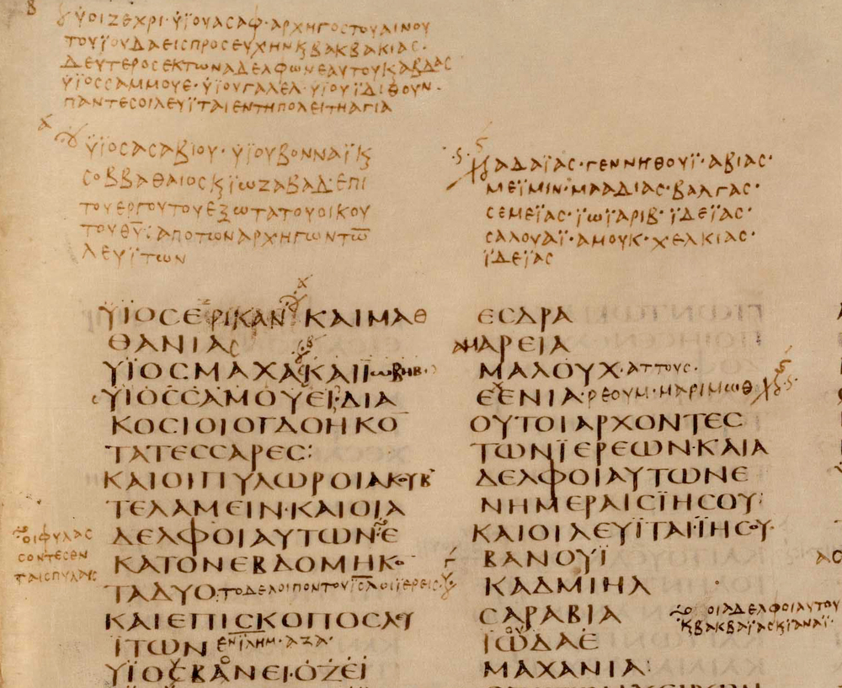
detail from Codex Sinaiticus, fourth century C.E.

Module Convenors:
Term 1: Clive Letchford C.A.Letchford@warwick.ac.uk
Drop-in hours: Tuesdays 9-10, Fridays 12-1

Terms 2 and 3: tba

Introduction
This module offers the opportunity to learn the basics of the classical Greek language and is designed for students who have little or no previous experience of the language. The department believes that language is at the heart of the discipline and all students should, at the minimum, have a basic knowledge of one of the classical languages.

This module will be taken by:

- 1st Year Q800 students who have no qualification in Greek.
- 2nd year students who want to add to try Greek after a year of Latin, or begin Greek alongside further study of Latin. Students will need to have completed the Latin Language module in a satisfactory manner with a minimum of 70% overall.
- First year students who can demonstrate that they are likely to be able to learn Greek successfully or Latin . Evidence might be an A level in a classical or modern language or Latin GCSE. Otherwise, first year students generally take Latin which provides a better foundation for taking up Greek in their second year
- Third (or fourth) year students who have been studying Latin for two years and who have done well in both years.

Before arriving at Warwick, all students proposing to take this course need to have learnt the alphabet and practiced reading passages of Greek out loud with confidence, available on the module website. They will be tested on their fluency in the first week of the academic year.

The department welcomes enquiries from students outside the Classics Department. Potential non-classicists should email the module convener to signify their interest. Because Classical Greek is a demanding language, we will need to see evidence that you will be able to meet the demands of the course so we will discuss your previous language learning experience.

Main points
For 2020/21, we have one group with three hours of tuition: on campus twice a week on Mondays and Fridays and a live on-line class on Wednesdays. We will use the course book Greek for Beginners by Wilding.
The course uses a very traditional approach to the language with translation both ways. You ned to develop strategies to memorise new vocabulary and a significant number of endings. The classes need to be backed up by a significant amount of independent study, for which extensive materials are available on-line.
You should expect to:
- spend 2-3 hours between each class on independent study
- revise for exams over the Christmas and Easter vacations,
- set aside time for 300 hours of study over the year in total

Attendance is required at all classes, unless there is a very good reason you cannot attend. If you have appointment you cannot miss, please discuss this in advance. If you are ill, you should email as soon as possible (on the day) giving a brief explanation of why you could not attend. In the absence of any such email, attendance will be noted as unauthorised in the register. Our experience is that regular attendance is the single most important factor for success on this module.
In the event that you have to miss classes for more than one week due to illness, university regulations usually require you to submit a medical certificate from your GP or similar healthcare professional to the departmental office. You will be informed if there are different arrangements for 2020/21.
More importantly, you should be in email contact with the module tutor and your personal tutor since it is easy to fall behind in such a situation and catching up becomes progressively harder.
Drop-in sessions
Drop-in sessions are an important part of the module, offering students the opportunity to sort out areas of uncertainty as the module progresses. Often a quick, well-directed question can sort things out quickly and put your mind at rest. Drop-in sessions are particularly important where you have missed a class. You are expected to do the work which is always set out on-line, but you should use a drop-in session to check on anything you have not understood.
I have a dedicated session for Greek on Fridays 12-1 , and another general session on Tuesdays 9-10.

Exams
This is a core module for first years, and so must be passed.
There are two formal exams during the course:
- Week 1, term 2 30%
- Summer – main exam period 70%
These will be on-campus, unless the university needs to go entirely on-line again, in which case they will be held on-line.
In addition, you will sit interim exams in Week 6 of term 1 and term 2: these will be diagnostic to make sure that you are on-track, and that you are consolidating the material covered in a timely way.

Greek Language: Aims and objectives

This module aims to introduce a complete beginner to the main elements of the structure of Classical Greek in a logical and systematic way and so enable them to read and translate passages of adapted Greek with accuracy and confidence.

By the end of this module, all students should expect to:

- know the designated vocabulary, accidence and syntax
- have developed considerable translation skills, involving an appreciation of the different linguistic structure of this inflected language
- have cultivated their capacity for analytical and logical analysis
- have improved their understanding of English grammar
- appreciate the continuing influence of Greek on the English language

Students are encouraged to use the help that is always available to sort out any points of difficulty that arise and not get behind.

This module provides the necessary basis for those who continue their study of the language in 2020. Many students go on to the module Greek Language and Literature and read classical authors such as Xenophon, Euripides and Homer.

Organisation

Classes
There are three classes per week, two face-to-face and one on-line, throughout the 23 weeks of teaching. Please note that classes continue through Week 6 in the Autumn and Spring terms.

Text books
The course uses the course Greek for Beginners by Wilding, published by Bloomsbury. You will be required to have printed copy and also a copy of Greek Grammar by Morwood.

Assessment
January exam
This one hour exam will contain a short passage for translation into English and some questions requiring you to demonstrate your knowledge of grammar and vocabulary, using questions of a type we have been used to during your first term. It will form 30% of the module.

Summer exam
The two hour exam will contain one or more passages for translation which have not been seen previously, and questions actively testing knowledge of grammar and vocabulary. Words that cannot be deduced from the context will be glossed. It will form 70% of the module.
Passing the module
For first year students, this is a core module. If you do not achieve a mark of 40% overall then you will be required to resit an examination in the first week of September. Your mark will be capped at 40% in your university record. If you do not pass the resit in September, you will be required to withdraw from your degree.
Non-first years cannot resit but carry the mark that they gain. Translations will be marked on the university's 20 point scale.

Independent working

The module represents 300 hours of study over the year. Students are expected to do the majority of their work for this module outside classes. Class time will be devoted to introducing new concepts via reading, vocabulary and grammar work. Students are advised that they should reckon on spending an average of 2 to 3 hours of private study between each class and will also need to spend some time during vacations to consolidate material in preparation for an exam on the first day of the next term.

Independent learning will typically involve:
- written exercises set on topics introduced in the session
- translating passages of Greek
- learning vocabulary
- learning new endings and sentence structures
- consolidation of recent material.

Reading List

Essential:

Greek for Beginners by Wilding
Oxford Grammar of Classical Greek by Morwood

Useful:
If you want to look at other explanations, the following are useful:

Taylor, J. (2016) Greek to GCSE Part 1
Taylor J. (2016) Greek to GCSE Part 2

(Copies in the library. You can probably pick up earlier editions very cheaply second-hand: these are fine.)

History of the language:

If you are interested in the language and want to find out more about it, the following are a good place to start.

Colvin, S. A (2014) A brief History of Ancient Greek [e-book]
Horrocks, S. (2010) Greek: A History of the Language and Its Speakers [e-book]
Allen, W.S. (1987) Vox Graeca (Third Edition)

Word-processing in Greek

You should be able to word-process in Greek. This must include the facility to input breathings which are integral to classical Greek (but not modern Greek). You will have to investigate a bit, but it is generally straightforward, more so on Apple products.

There are two aspects: having the right characters installed, and getting your keyboard to know you want to input Greek characters rather than English ones.

- Font. You must use a Unicode font which includes a full set of Greek characters (‘Polytonic Greek’). Fonts installed on Windows systems include Lucida Sans, Palatino Linotype, Tahoma and Arial Unicode MS. Macs also have Lucida Grande, Helvetica and Times.

- Input. You also need to have a way of inputting the text. If you have an Apple, it is a just matter of changing the keyboard layout, done via ‘country’ options. Be careful to use Polytonic Greek, not ‘Greek’ (‘polytonic’ refers to the accents and allows breathings, which is essential). Life is a little more complicated in Windows, where Polytonic Greek needs to be enabled using Control Panel/Regional and Language Options/ and setting input language and keyboard to Polytonic Greek.

Advice on studying

Learning a classical language requires regular memorisation not just of new vocabulary but also the way the endings of the words change (accidence) and the ways in which sentences are constructed (syntax). This is a skill that not all students have developed confidently at school and so emphasis is given in the early stages to developing good working habits and training the mind to become better at doing this.

Experience has shown that the following are useful tips.

- Find yourself a study buddy. Not only can you test each other on new vocabulary and noun and verb endings, but it is also very revealing to see how well you can explain a topic to someone else.
- Investigate flash cards: make your own using index cards or look on the web. Quizlet is probably best, but some like others – memrise and cram.com and these can be used on your phone. Better still is the Greek Project, hosted by Eton College, which has up to section 7. You should reckon on spending about three ten minute sessions per day on vocabulary and noun and verb endings.
- In addition to getting on top of new material, EVERY DAY you should devote a small amount of time on going over previous material. Be methodical about this. Keep a record of what you have looked back on and how secure it is.
- Vocabulary: you should keep a note book or equivalent list for words that you have forgotten.
- Noun and verb endings: make sure you can write them out quickly and accurately.
- When you come across an area which is not as secure as you thought, spend time rereading the explanation in the text and look over your notes again. Rework the associated exercises and check your answers from when you did them the first time.
- If you are still unclear seek help from the course tutor. Usually, confusion can be sorted out very quickly on a one-to-one basis.

It is important that vocabulary and grammar are learnt thoroughly and at the time of setting – not left to the last minute – and that material is consolidated on a weekly basis.

