The University of Warwick
Department of Classics and Ancient History

CX 101/201/301 – Latin Language and Literature

2020/21

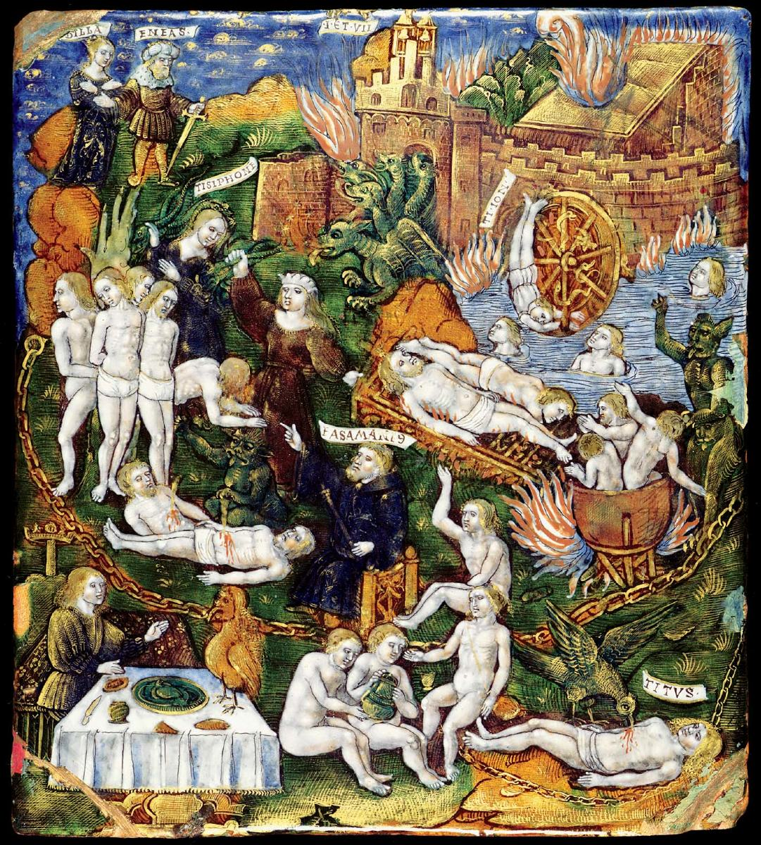

Module convenors:
Term 1: Clive Letchford c.a.letchford@warwick.ac.uk
Drop-in sessions : Tuesdays 9-10, Thursdays 11-12

Term 2: Victoria Rimell V.Rimell@warwick.ac.uk

Introduction
This module builds upon Latin Language CX115 module and gives the opportunity to read continuous extracts from original authors. Students need to have a sound basis to enrol on the module: second year students will need to have completed the Latin Language module in a satisfactory manner, generally with at least 70% or with a decent showing in a placement test.

This module is also studied by first year undergraduates on the Classical Civilisation or Ancient History courses who have studied Latin at A level but did not achieve the A grade necessary for the module Latin Literary Texts. Anyone else who is interested should discuss their position with the module tutor. A placement test may be required.

Main points
For 2020/21, we have one group with three hours of tuition a week: on campus twice a week on Mondays and Fridays and an asynchronous class. We will complete the course book Familia Romana by Ørberg in the first term, and read original Latin in the second term.
The course uses innovative communicative techniques and classes are an integral part of the course. These need to be backed up by a significant amount of independent study, for which extensive materials are available on-line.
You should expect to:
- spend 2-3 hours between each class on independent study
- revise for exams over the Christmas and Easter vacations,
- set aside time for 300 hours of study over the year in total
Attendance is required at all classes, unless there is a very good reason you cannot attend. If you have appointment you cannot miss, please discuss this in advance. If you are ill, you should email as soon as possible (on the day) giving a brief explanation of why you could not attend. In the absence of any such email, attendance will be noted as unauthorised in the register. Our experience is that regular attendance is the single most important factor for success on this module.
In the event that you have to miss classes for more than one week due to illness, university regulations usually require you to submit a medical certificate from your GP or similar healthcare professional to the departmental office. You will be informed if there are different arrangements for 2020/21.
More importantly, you should be in email contact with the module tutor and your personal tutor since it is easy to fall behind in such a situation and catching up becomes progressively harder.

Drop-in sessions
Drop-in sessions are an important part of the module, offering students the opportunity to sort out areas of uncertainty as the module progresses. Often a quick, well-directed question can sort things out quickly and put your mind at rest. Drop-in sessions are particularly important where you have missed a class. You are expected to do the work which is always set out on-line, but you should use a drop-in session to check on anything you have not understood.
I have a dedicated session for Latin on Thursdays 11-12 , and another general session on Tuesdays 9-10.

Exams
There are two formal exams during the course:
- Week 1, term 2 20%
- Summer – main exam period 80%
These will be on-campus, unless the university needs to go entirely on-line again, in which case they will be held on-line.
In addition, there is no teaching in Week 6 of term 1 and term 2, but there will be an informal interim assessment to inform your progress.

Aims and objectives
The aims of the course are to finish learning the structures of the language and to read some Latin by classical authors of a reasonable length. By the end of this module, students should expect to have:

- completed an introduction to the syntax of the language;
- developed a good working Latin vocabulary;
- read unadapted Latin; and
- started to develop an awareness of different literary styles.

To continue to the next level, Latin Literary Texts, the Department recommends a minimum of 70% in this module.

Organisation

There are three hours of tuition per week, two face-to-face, one asynchronous on-line. In the event that face-to-face teaching has to stop, these will be replaced by on-line synchronous classes

Students will need to have their own copy of:

- Familia Romana - Orberg
- Latin dictionary
- Oxford Grammar of Latin – James Morwood (OUP)

The first two you should still have from last year. The third is available from the campus bookshop
If you have not got a dictionary, I recommend The Bantam New College Latin and English Dictionary by John Traupman; or Pocket Oxford Latin Dictionary. (Note: a very small dictionary will not be sufficient at this level.)

In the second term, you may want to use an on-line dictionary for some of the time. The only on-line dictionaries you should consider using are:

- Logeion – online dictionary, linked to texts, based on but more user-friendly than
- Perseus – on-line texts

You should be aware that Perseus uses out of date editions of texts, and that where the text is critical, you should be using TLL) which can be accessed through the Library via the electronic databases. This is particularly relevant for post-graduate students.

Assessment
This module is assessed through two examinations, as follows:

- Term 2, Week 1
1 hour exam (worth 20%) based on Familia Romana, including analysis and manipulation of grammatical forms.

- Term 3
2 hour exam (worth 80%). Questions on the two set texts (25% each), including analysis and manipulation of grammatical forms, discussion of content and scansion where relevant. These may be on any part of the texts studied. There will also be a passage for unseen translation.

Passing the module
Non-first years carry the mark that they gain. The summer examination will be marked according to the University’s 20 point scale.

For first year students, this is a core module and needs to be passed. If you fail, then you will be required to re-sit that summer exam in the first week of September. Your mark will be capped at 40% in your university records. If you do not gain 40%, you will be required to withdraw from the course.

Overview of the year

Term 1
The rest of basic Latin accidence and syntax is studied and the vocabulary widened to around 1800 words: this is done by reading chapters 28-33 of Familia Romana.

Term 2
The first set text is read in weeks 1-5 and the seccond set text is substantially finished by the end of the term. Work begins on preparation for unseen translation in the summer examination.

Term 3
The set book is finished in the first week; the rest of the time is devoted to revision and exam technique.

Texts
The texts for 2020-21 are to be confirmed.
The examination can be on any portion of the text studied in class and will include questions on grammar and content.

Study skills
Students are expected to do significant work outside classes, and are advised that they should reckon on spending between 2 and 3 hours in private study between each class, and will also need to spend some time during vacations to consolidate the new material. In total, the module will require around 300 hours of work.

Study will typically be divided between:

- working on vocabulary
- revising and refining accidence (endings) and syntax (sentence construction)
- pre-paring text for the next class
- post-paring text from the previous class

For the set texts, students prepare by annotating a copy of the text but not writing out a full translation. The class will consist of checking students’ understanding of the Latin and discussion of grammatical content and style. Students will need to go write additional notes and comments in class and then go over the text again immediately after each class to consolidate their work.

Advice on studying for this module

- At the start of the year, identify gaps in your knowledge and sort them out, quickly. Some loss is to be expected. An important part of learning a language is how you manage your consolidation.

- Make a habit of looking at vocabulary every day – both new vocabulary and revision of vocabulary previously learned. Have a vocabulary book or list and carry it around for odd moments (bus?) that you can usefully fill.

- Get used to using a proper dictionary, especially with set texts. Virtually now words have a one-to-one correspondence with English.

- Get comfortable with the terminology for the various constructions – purpose, clause, result clause etc. Be able to explain how they work at any time. The exams will ask you to do this.

- Use published translations sparingly.

- Team up on a regular basis with someone else: both for language and set text work. You both learn from each other, and it’s double the fun.

- Don't be afraid to make mistakes. To get good in a language, you need to develop a model of various features in your own mind, which works for you (a 'personal grammar'). Your model will need to go through several iterations and can only be tested by trying - and failing!

- I am always very keen to help clarify your understanding in my office hours.

Plagiarism
The purpose of set books is to enable the student to get to grips with idiomatic Latin. While translations can be helpful in getting to understand trickier phrases, lifting sentences wholesale is not acceptable, whether in class or in exams.

On-line dictionaries

- Logeion - very detailed, but easy to use. Based on Lewis and Short
- Forcellini: Totius Latinitatis Lexicon. Very extensive - much more so than the Oxford Latin Dictionary (which has a mere 2,386 pages).

Syntax summary

Major types of constructions:

Indirect Speech
Indirect Statement | accusative plus infinitive | verba dicendi et sentiendi
Indirect Command | ut/ne + subjunctive verb | verba postulandi
Indirect Question | question word + subjunctive verb | verba rogandi
2 other frequent ut
i Purpose clause | ut/ne + subjunctive  'because they wanted to ...'
ii Result clause | signpost word + ut + subjunctive
Conditionals | si/nisi  plus either 2 indicatives  or 2 subjunctives

Less frequent/tricky types:

Seeing to it that  Verbs of Fearing | ut/ne + subjunctive  NE + subjunctive | verba curandi  verba timendi
Time clauses | cum + subjunctive or indicative  dum + present indicative or subjunctive
Purpose clause (2) | qui + subjunctive
Ablative absolute | noun + participle in the ablative
Gerunds  and gerundives | verbal nouns  purpose (ad, causa)  obligation (needing to be done) with esse + dative
Independent subjunctive | jussive subjunctives  wishes - if only  jussive - 'let them eat cake'

Illustration on front cover:
Aeneas and the Sibyl (at upper left) in the Underworld, c.1530 (a plaque with enamel and gold on copper)
Image from the Fitzwilliam Museum, University of Cambridge

