CX209-30/309-30

UNIVERSITY OF WARWICK

Sample examination paper

THE ROMAN NEAR EAST
Time allowed: 2 hours

All questions carry equal weighting.

Candidates MUST answer question ONE and any TWO others.

Students will not be given credit for substantial repetition of material between questions on the examination paper.

Read carefully the instructions on the answer book and make sure that the particulars required are entered on each answer book.

1. Comment on points of interest in any TWO of the following:

a) For the well-being, victory and eternal preservation of our lords Gaius Julius Verus Maximinus and Gaius Julius Verus Maximus Caesar his son, Augusti, under the imperial legatus propraetore Pomponius Iulianus, in the consulship of Maximinus and Africanus, the villagers constructed with their own funds (this building) for the community and thanks to the generosity of those whose names follow, during the strategeia of Ulpius Scaurianus: Iunius Bassianus, veteran, 300 denarii; Flavius Ulpius, veteran, 400 denarii; Ulpius Rufinus, veteran, 330 denarii.
Inscription from the village of Kafr Laha in the Hauran, Waddington 2399

b) There was no actual man-made statue of the god, the sort Greeks and Romans put up; but there was an enormous stone, rounded at the base and coming to a point at the top, conical in shape and black. This stone is worshipped as though it were sent from heaven; on it are some small projecting pieces and markings that are pointed out, which people would like to believe are a rough picture of the sun, because that is how they see them.
Herodian 5.3.2-5.

c) As a census of Arabia is being conducted by Titus Aninius Sextius Florentinus, legatus Augusti pro praetor (i.e. governor), I, Babatha daughter of Simon, of Maoza in Zoarene of the Petra administrative region, domiciled in my own private property in the said Maoza, register what I possess (present with me as my guardian being Judanes son of Elazar, of the village of Engedi in the district of Jericho in Judaea, domiciled in his own private property in the said Maoza), that is, within the boundaries of Maoza a date orchard called Algiphiamma.
P. Yadin no. 16, from the Babatha archive

d) For it happened one day at Antioch, when the city was in perfect tranquillity, a comic actor being on the stage with his wife, acting some common scene from daily life, while the people were delighted with his acting, his wife suddenly exclaimed: ‘Am I dreaming or are the Persians here?’ The audience immediately turned round and then fled in every direction while trying to avoid the missiles which were showered upon them. The city was burnt and a number of her citizens killed, who, as is usual in time of peace, were strolling about carelessly, and all the places in the neighbourhood were burnt and laid waste. The enemy, loaded down with plunder, returned without loss to their own country after having burnt Mareades who had wickedly guided the Persians to the destruction of his fellow citizens. This event took place in the time of Gallienus.
Ammianus Marcellinus 23.5.3

e) Monument in Palmyra.
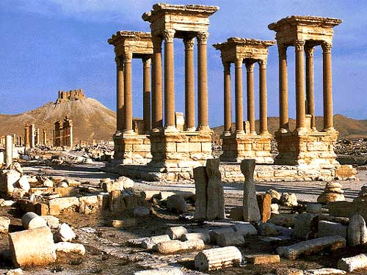

f) Basalt relief in Gaziantep Museum, Turkey.
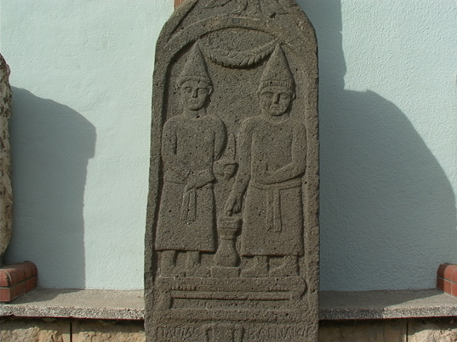

g) Sarcophagus from Tyre.
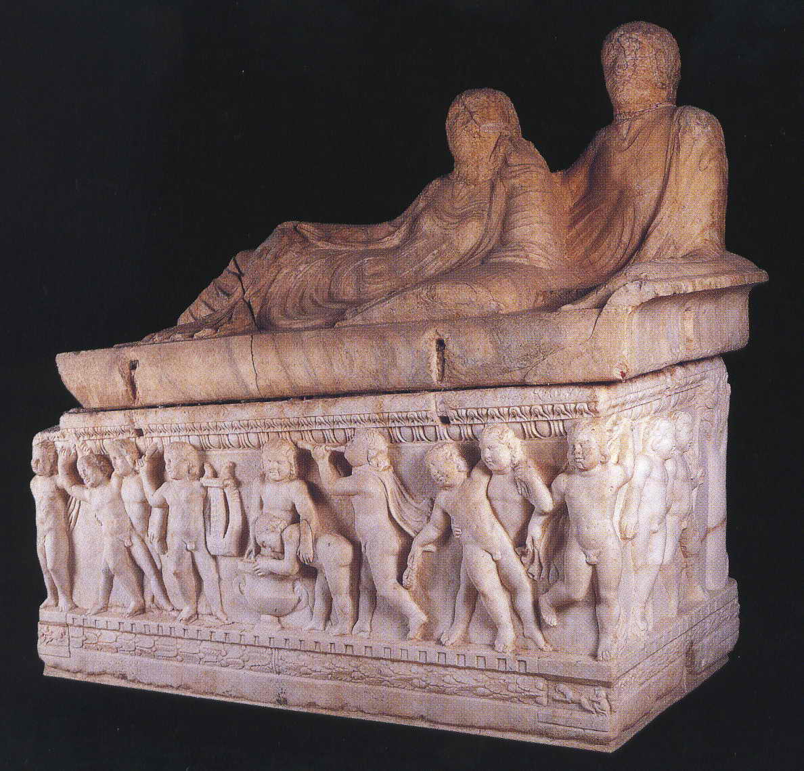

h) Funerary relief from Palmyra
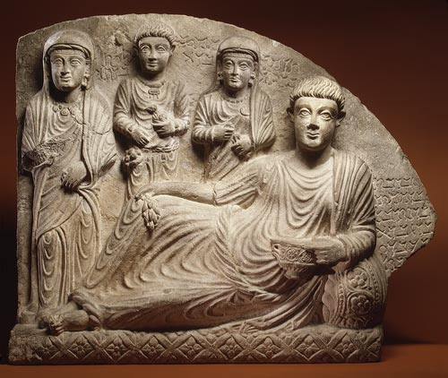

2. What sort of information about the countryside can we gain from studying the ‘Dead Cities’ of the limestone massif of northern Syria?

3. What was the function of the so-called ‘Strata Diocletiana’?

4. ‘A social and economic history of the Near East in the Roman period cannot be written’ (Fergus Millar). Do you agree with this statement?

5. To what extent was Hellenism in Roman Syria the product of elite culture?

6. Did the presence of the Roman army contribute to the cultural and economic development of the Syrian provinces?

7. Do the architectural designs and features of temples in the Near East differ greatly from those of ‘classical’ temples? Give examples.

8. How does the study of coinage contribute to our understanding of the economy of the Roman Near East?

