Art of the Ancient World 2015/16

Dr Suzanne Frey-Kupper, Associate professor (Reader) S.Frey-Kupper@warwick.ac.uk

T 2-2 Greek and Roman Pottery- Extended Bibliography

1. Classes of pottery
Fine ware
Plain (or coarse) ware
Amphorae
Lamps
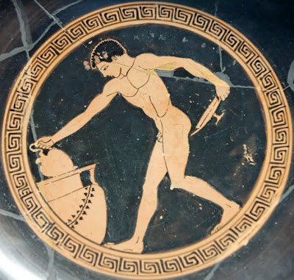
Cup, c. 500 B.C., Paris, Louvre G 133.
Shapes

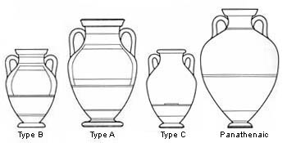
Amphorae

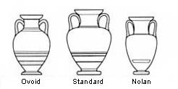
Neck Amphorae
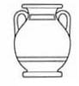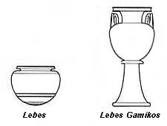
Pelike Lebes or Dinos
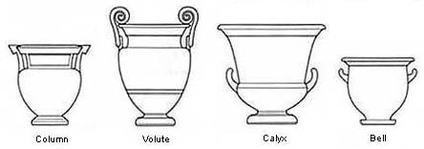
Kraters

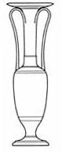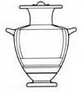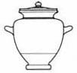
Loutrophoros Hydria Stamnos

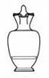
Oinochoe Olpe Chous

Cups or kylikes

Komast cup
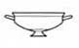The earliest type of Athenian black-figure cup, adapted from Corinthian potters. Its lip is narrow and sharp
ly angled from the body ('offset'). The foot is short-stemmed and flaring. The name derives from its regular decoration with representations of komasts, who also can be found on earlier Corinthian vessels.

Siana cup
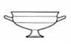Named after a site on Rhodes where examples were found, Siana cups can be distinguished from Komast cups by their taller feet and lips. They are decorated on the interior (the tondo), another difference from Komast cups, and there are two schemes for decorating the exterior. The 'double-decker' type involves two friezes on each side, one on the lip (usually floral), and a figured scene on the body. The 'overlap' type uses a single frieze on each side to cover the total height of the body and lip. Aspects of the form and decoration of Siana cups appear to be indebted to East Greek models.

Little Master cup
The term 'Little Master cup' is a translation of the German Kleinmeisterschale, alluding to the small scale of the decorative elements. It has a high-stemmed foot and an offset concave lip. Examples are divided into two categories; lip-cups and band-cups.
Although there are differences of shape - the lip is more obviously offset on a lip-cup than on a band-cup - the most obvious distinction is in the scheme of decoration. Band-cups are painted black save for the handle zone, which contains a decorated frieze, whereas lip-cups are largely plain save for the line that divides the lip and the body. In the handle-zone there is often an inscription and occasional decorative elements, while the lip may carry a single figure (often a bust) or a small group.

Type A cup
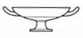Developed in the third quarter of the sixth century, Type A cups do not have an offset lip, and their profile runs smoothly from the rim to a fillet at the junction between the bowl and the short flaring foot. Examples are decorated in both black- and red-figure, and some are 'bilingual', but production ceases by the early fifth century.

Type B cup
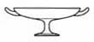Like those of Type A, Type B cups lack the offset lip, but also the fillet at the top of the stem. The resulting profile is a flowing curve.

Type C cup
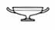Less common than Type B cups, these sometimes have an offset lip. There is a moulding low down on the stem. They are frequently painted entirely black or decorated only on the interior.
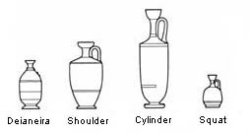
Lekythoi Aryballos Alabastron Pyxis

All shapes are from the Beazley Archive.

Bibliography and electronic resources

General
CVA Corpus Vasorum Antiquorum
@Mannack, T. (2012) ‘Greek Decorated Pottery I: Athenian Vase-Painting’, in A Companion to Greek Art, ed. T. J. Smith and D. Plantzos (Malden, MA and Oxford: Wiley-Blackwell): pp. 39-61
@Paspalas, S.A. (2012) ‘Greek Decorated Pottery II: Regions and Workshops’, in A Companion to Greek Art (Malden, MA and Oxford: Wiley-Blackwell): pp. 62-104
Hayes, J.W. (1997) Handbook of Mediterranean Roman Pottery (London: British Museum Press) [NK 3850.H2]
Orton C., P. Tyers, and A. Vince (1993), Pottery in Archaeology (Cambridge: Cambridge University Press)
Fine ware
Greek, Archaic to Hellenistic

General
Cook, R. M. (1997) Greek Painted Pottery (New York: Routledge) Third edition [NK 3840.C6]
Rasmussen, T. and Spivey, N. (1991) Looking at Greek Vases (Cambridge: Cambridge University Press) [NK 4645.L6]
Sparkes, B.A. (1991) Greek Pottery. An introduction (Manchester; New York: Manchester University Press; New York) [NK 3840.S65]
Vickers, M. (1999) Ancient Greek Pottery (Oxford: Ashmolean Museum) [NK 3840.V4]

Mycene and Crete
Coldstream, J. N. (2001) Knossos Pottery Handbook: Greek and Roman (London : British School at Athens) [NK 3840.C6]
Mountjoy, P.A. (1986) Mycenaean decorated Pottery. A guide to Identification (Göteborg: Paul Åströms Förlag) [ NK 3843.M6]

Geometric
Coldstream, J. N. (1977) Geometric Greece 900-700 BC (London: E. Benn) [DF 221.8.C6]
Cook, R. M. and Dupont, P. (1999) East Greek Pottery (London : Routledge) [NK 3840.C6]

Corinth
Dehl, Ch. (1984) Die korinthische Keramik des 8. und frühen 7. Jhs. V. Chr. In Italien. Untersuchung zu ihrer Chronologie und Ausbreitung (Mitteilungen des Deutschen Archäologischen Institutes. Athenische Abteilung, 11. Beiheft) (Berlin: Gebrüder Mann)
Payne, H. (1931) Necrocorinthia. A Study of Corinthian Art in the Archaic Period (Oxford ; Clarendon Press)
Payne, H.G. (1933) Protokorinthische Vasenmalerei (Berlin: Verlag heinrich Keller)

Attica
Beazley, J.D. (1965) Attic Black-Figure Vase Painters (Oxford: Clarendon) [NK 4649.B3]
Beazley, J.D. (1963) Attic Red-Figure Vase Painters, 2nd edition (Oxford: Clarendon) [NK 4649.B3]
Beazley, J.D. (1971) Paralipomena: Additions to Attic Black-Figure Vase-Painters and to Attic Red-Figure vase-painters, 2nd edition (Oxford: Clarendon) [NK 4648.B3]
Beazley, J.D. and Ashmole, B., Greek Sculpture & Painting to the End of the Hellenistic Period (Cambridge 1932).
http://www.beazley.ox.ac.uk/index.htm
Boardman, J. (1974) Athenian Black Figure Vases. A Handbook (London: Thames and Hudson) [NK 4648.B6]
Boardman, J. (1975) Athenian Red Figure Vases. The Archaic Period. A Handbook (London: Thames and Hudson) [NK 4648.B6]
Boardman, J. (1989) Athenian Red Figure Vases. The Classical Period. A Handbook (London: Thames and Hudson) [NK 4648.B6]
Boardman, J. (2001) The History of Greek Vases. Potters, Painters and Pictures (London: Thames and Hudson) [NK 4645.B6]
Richter, G.M.A. and Milne, J.M. (1935) Shapes and Names of Athenian Vases (New York)
Sparkes, B.A. (1996) The Red and the Black. Studies in Greek Pottery (London: Routledge) [NK 4649.S7]
Sparkes, B.A. and Talcott, L. (1970) Black and Plain Pottery of the 6th, 5th and 4th Centuries B.C. (The Athenian Agora XII) (Princeton, New Jersey: The American School of Classical Studies at Athens)

South Italy and Sicily
@Cambitoglou, A. and Trendall, A.D. (1961), Apulian Red-Figured Vase-Painters of the Plain Style (Rutland, Vt. : Archaeological Institute of America)
http://0-quod.lib.umich.edu.pugwash.lib.warwick.ac.uk/cgi/t/text/text-idx?c=acls;idno=heb06131
Greene, K. (1976) Gnathia Pottery in the Akademisches Kunstmuseum Bonn (Mainz: Zabern) [NK 4650.G6]
Morel, J.-P. (1981) Céramique campanienne: les formes (Bibliothèque de l’École Française de Rome 244) (Rome : École Française)
Trendall, A.D. (1967) The Red-Figured Vases of Lucania, Campania and Sicily (Oxford: Clarendon) [NK 4649.T7]
Trendall, A.D. (1987) The Red-Figured Vases of Paestum (London: British School at Rome) [NK 4649.T7]
Trendall, A.D. (1989) Red Figure Vases of South Italy and Sicily. A handbook (London: Thames and Hudson) [NK 4649.T7]

Etruscan
Rasmussen, T.B. (1979) Bucchero pottery from southern Etruria (Cambridge and New York: Cambridge University Press) [NK 3845.R2]
Spivey, N. (1991) ‘Greek vases in Etruria’, in: Looking at Greek Vases ed. T. Rasmussen and N. Spivey (Cambridge: Cambridge University Press): 132-150 [NK 4645.L6]

Roman
De la Bédoyère, G. (2000) Pottery in Roman Britain (Princes Risborough: Shire) [NK 3850.D3]
Ettlinger, E., Hedinger, B., Hoffmann, B. et al. (1990) Conspectus Formarum Terrae Sigillatae Italico modo confectae (Römisch-Germanische Kommission des Deutschen Archäologischen Institutes zu Frankfurt a.M. Materialien zur Römisch-Germanischen Keramik 10) (Bonn: Habelt)
Greene, K. (1992) Roman Pottery (London: Published for the Trustees of the British Museum by British Museum Press) [NK 3850.G7]
Hayes, J.W. (1972) Late Roman Pottery (London: The British School at Rome)
Hayes, J.W. (1980) Supplement to Late Roman Pottery (London: The British School at Rome)
Hayes, J.W. (2008) Roman Pottery: Fine-Ware Imports (The Athenian Agora XXXII) (Princeton, New Jersey: The American School of Classical Studies at Athens)
Hedinger, B., Die frühe Terra sigillata vom Monte Iato, Sizilien (Ausgrabungen 1971-1988) und frühkaiserzeitliche Fundkomplexe aus dem Peristyhaus 1 (Studia Ietina VIII) (Lausanne, 1999).
Peña, J.T. (2007) Roman Pottery in the Archaeological Record (Cambridge: University Press)
Peacock D.P.S. (1982) Pottery in the Roman World: An Ethnoarchaeological Approach (London and New York: Longman) [DG 107.P3]
Peacock D.P.S. ed. (1977) Pottery in Early Commerce: Characterization and Trade in Roman and Later Ceramics (London: Academic Press Incl.)
Robinson, H.S. (1959) Pottery of the Roman Period. Chronology (The Athenian Agora V) (Princeton, New Jersey: The American School of Classical Studies at Athens)
Tyers, P. A. (1996) Roman Pottery in Britain (London: Batsford) [ NK 3850.T9]
Webster, P. (1996) Roman Samian Pottery in Britain (York [England]: Council for British Archaeology) [NK 3850.W3]

Plain (or coarse) ware
Rotroff, S.I. (2003) Hellenistic Pottery: The Plain Wares (The Athenian Agora XXXIII) (Princeton, New Jersey: The American School of Classical Studies at Athens)

For Roman fine and coarse ware (with typologies) see also:
http://potsherd.net/atlas/types/sigillata/gallery

Amphorae
Typology, chronology, bibliography

Roman Amphorae: a digital resource:
University of Southampton, 2005
By S. Keay and D. Williams

Roman Amphorae: a digital resource: University of Southampton, 2005:
http://archaeologydataservice.ac.uk/archives/view/amphora_ahrb_2005/cat_amph.cfm?CFID=52282&CFTOKEN=671E9B3B-09AE-498D-9DDD106B0220AE90
with excellent bibliography

Provenance Studies on Pottery: Fabrics of the Central Mediterranean
University of Vienna, 2011-
By V. Gassner and D. Williams
http://facem.at/project/papers.php with excellent bibliography
@Bechtold, B. (2010) ‘Amphorae Production in Punic Sicily (7th–3rd/2nd Centuries B.C.E.). An overview’, http://facem.at/img/pdf/Amphorae_in_Punic_Sicily_06_06_2011.pdf
@Grace, V., ‘The Middle Stoa dated by Amphora Stamps’, Hesperia 54 (1985), pp. 1-54.
@Lawall, M.L., ‘Early Excavations at Pergamon and the Chronology of Rhodian Amphora Stamps’, Hesperia 71 (2001), pp. 295-324.
Lamps
Bailey, D.M. (1975) A Catalogue of the Lamps in the British Museum. Vol. 1. Greek, Hellenistic and Early Roman Pottery Lamps (London, British Museum)
Bailey, D.M. (1980) A Catalogue of the Lamps in the British Museum. Vol. 2. Roman Lamps made in Italy (London, British Museum)
Bailey, D.M. Bailey (1988) A Catalogue of the Lamps in the British Museum. Vol. 3. Roman Provincial Lamps (London, British Museum)
Bailey, D.M. (1996) A Catalogue of the Lamps in the British Museum. Vol. 4. Lamps of Metal and Stone and Lampstands (London, British Museum)
Techniques
Noble, J.V. (1988) The Techniques of Painted Attic Pottery (London: Thames and Hudson) [NK 3840.N6]
Hemelrijk, J.M. (1991) ‘A closer look at the potter’, in: Looking at Greek Vases ed. T. Rasmussen and N. Spivey (Cambridge: Cambridge University Press): 233- 256 [NK 4645.L6]
Trade
Johnston, A. (1991) ‘Greek vases in the marketplace’, in: Looking at Greek Vases ed. T. Rasmussen and N. Spivey (Cambridge: Cambridge University Press): 203-232 [NK 4645.L6]
Spivey, N. (1991) ‘Greek vases in Etruria’, in: Looking at Greek Vases ed. T. Rasmussen and N. Spivey (Cambridge: Cambridge University Press): 132-150 [NK 4645.L6]
Terracotta figurines
Higgins, R. (1963) Greek Terracotta Figures (London, British Museum) [NK 3840.H4]
Higgins, R. (1976) Greek Terracottas (Methuen's Handbooks of Archaeology) (New York: Methuen)
Iconography
@Mitchell, A.G. (2009) Greek Vase Painting and the Origins of Visual Humour (Cambridge: Cambridge University Press) [NK 4645.M62 and e-resource]
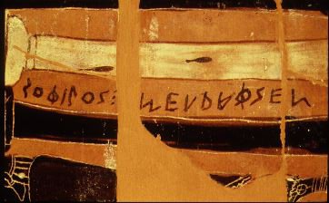
Signature (written retrograde), c. 570 BC.
SOΦΙLOS MEΓΡΑΦSEN (Sophilos megraphsen - ‘Sophilos drew me’)
British Museum, GR 1971.11-1.1 (Wikimedia Commons).

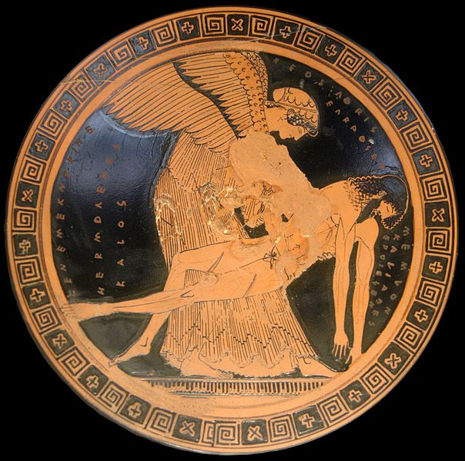
The so-called ‘Memnon pieta’, Attic cup, c. 490–480 BC, from Capua. Inscriptions on the left:
ΕΕΝΕΜΕΚΝΕRΙΚΕ (‘this inscription doesn't make sense’), HERMOΓΕΝΕS KALOS (Hermogenes
kalos – ‘Hermogenes is beautiful’). Inscriptions on the right: HEOS (‘Eos’), ΔΟRIS EΓRAΦSEN
(Doris Egraphsen - Douris painted). Inscription on the right:
MEMNON (Memnon), KALIAΔES EΠOIESEN (Kaliades epoiesen – ‘Kaliades made’). Paris,
Louvre, G 155 (Wikimedia Commons).
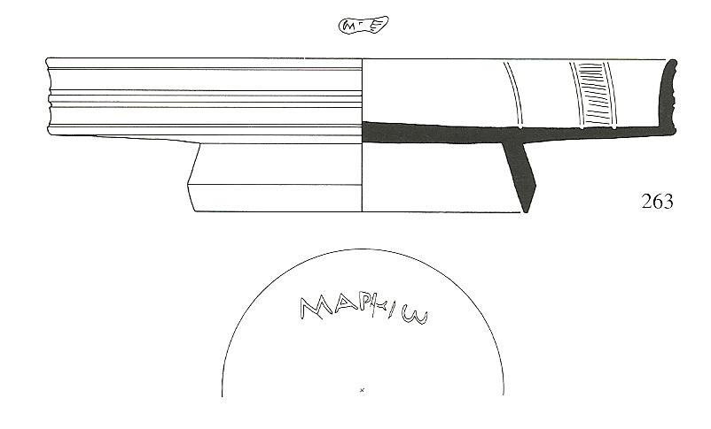
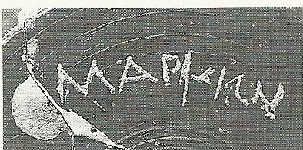

Terra sigillata plate from Sicily 40/50 AD with graffito in Greek (‘Markio’, belongs to Marcios) (Hedinger 1999, p. 347, pls 22.and 140).

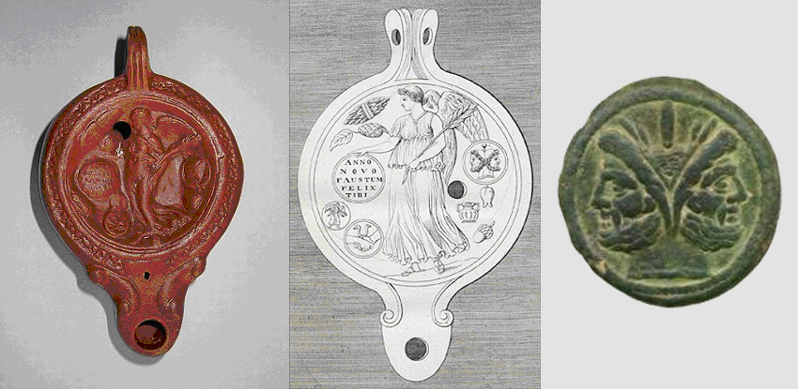
Roman new year lamp, first half of 1st c. AD (in trade (November 2011))
Victoria with inscribes shield: ANNO NOVO FAVSTVM FELIX TIBI, In the field strenae.
Strenae: connected with the name of a Sabine tutelary goddess, Strenia, who corresponds to the Roman Salus, and from whose precinct beside the Via Sacra at Rome consecrated branches were carried up to the Capitoline at the New Year. The strenae consisted of branches of bay and of palm, sweetmeats made of honey, and figs or dates, as a good omen that the year might bring only joy and happiness [Ovid, Fasti, 1.185-190]. The fruits were gilded [Martial 8.33.11] as they are now in Germany; and the word, as well as the custom, survives in the French étrennes. coins, especially the ancient as, with the image of Janus, who was specially honoured on this day, were also sent as presents, as well as small lamps of terracotta or bronze stamped with a motto and with minute representations of the usual gifts. Clients in particular were in the habit of complimenting their patrons with such presents; and, during and after the time of Augustus, the emperors benefited considerably by this custom, which lasted until the 5th c., although abolished several times [Suetonius, Oct. 57 and 91, Calig. 42].

