Coinage of Greece and Rome 2018/19

Module convenor:
Professor Suzanne Frey-Kupper S.Frey-Kupper@warwick.ac.uk

T 1-4 Republican coinage – Roman banking and business
Themes
- The beginnings: cast and struck, and other coinages in Italy: Where are the origins?
- The denarius coinage: what made it successful?
- Production, administration, control
- How do Roman bankers work
- Sources to understand the question above?
- Iconography
- And again: What is money?

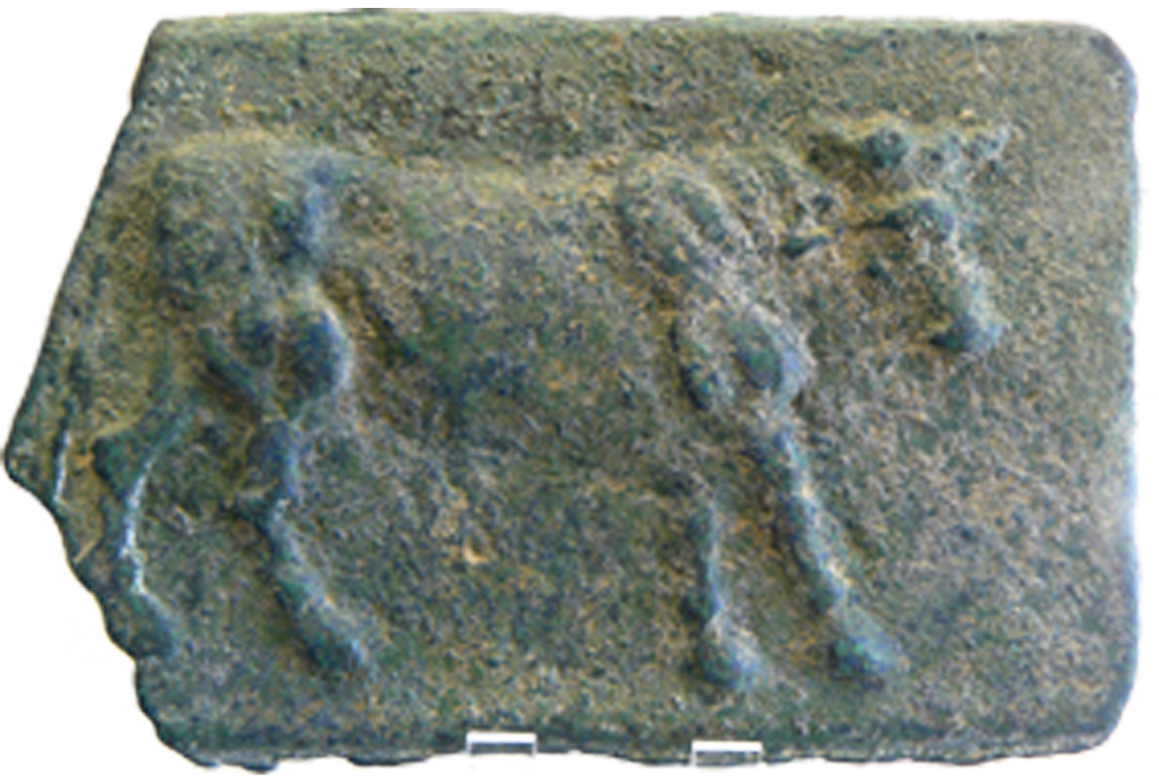

Cast bronze bar or ingot, 280-242 BC. RRC, p. 132, no. 5/1.
Length, c. 15 cm, c. 1.4 kg.
Paris, Bibliothèque Nationale, Cabinet des Médailles.
http://fr.wikipedia.org/wiki/Fichier:Aes_Signatum_C_des_M.jpg
Wikimedia Commons

The denarius system:
Denomination | Value mark | in asses | types | Metal
Denarius | X | 10 | Head of Roma / Dioscuri riding r. | AR
Quinarius | V | 5 | Head of Roma / Dioscuri riding r. | AR
Sestertius | IIS | 2¹/₂ | Head of Roma / Dioscuri riding r. | AR
Victoriatus | none | not given | Head of Jupiter / Victory and trophy | AR
As | I | 1 | Head of Janus / prow r. | AE
Semis | S | ¹/₂ | Head of Saturn / prow r. | AE
Triens |  | ¹/₃ | Head of Minerva / prow r. | AE
Quadrans |  | ¹/₄ | Head of Heracles / prow r. | AE
Sextans |  | ¹/₆ | Head of Mercury / prow r. | AE
Uncia |  | ¹/₁₂ | Head of Roma / prow r. | AE
Semuncia | none | ¹/₂₄ | Head of Mercury / prow r. | AE

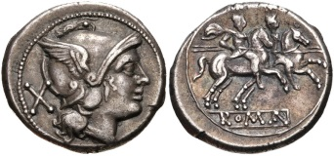 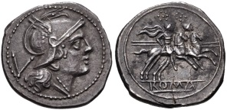 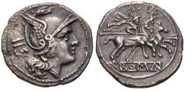
Rome, denarius, quinarius, and sestertius, from 211 BC, RRC, p. 155, nos 44/5-7.

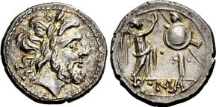
Rome, victoriatus, from 211 BC, RRC, p. 154, no. 44/1.

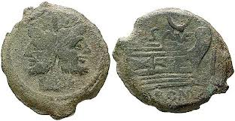

Struck as of the moneyer L. Saufeius, 153 BC. RRC, p. 248, no. 203/2.
Bibliography

Overviews
*@ Burnett, A. (2012) ‘Early Roman coinage’, in The Oxford Handbook of Greek and Roman Coinage ed. W.E. Metcalf (Oxford: Oxford University Press) 297-314 [CJ339.O]
Crawford, M.H. (1985) Coinage and Money under the Roman Republic (London: Methuen) [CJ833.C73]
*@ Woytek, B.E. (2012) ‘The denarius Coinage of the Roman Republic’, in The Oxford Handbook of Greek and Roman Coinage ed. W.E. Metcalf (Oxford: Oxford University Press) 315-34 [CJ339.O]

Useful collection of articles
Bland, R. and Calomino, D. eds (2015) Studies in Ancient Coinage in Honour of Andrew Burnett (London: Spink) [CJ75.B53]
van Alfen, P.G., Bransbourg, G. and Amandry, M. eds (2015) Fides. Contributions to Numismatics in Honor of Richard B. Witschonke (New York: American Numismatic Society) [CJ809.F544]

Catalogues and fundamental works on chronology
Crawford, M.H. (1969) Roman Republican Coin Hoards (Royal Numismatic Society. Special Publication 4) (London: Royal Numismatic Society) [CJ 909.C7]
@ Crawford, M.H. (1974, 2001 reprint with corrections) Roman Republican Coinage (Cambridge: Cambridge University Press) (= RRC) [CJ 909.C7]
@ Hersh, C.A. (1953) ‘Overstrikes as Evidence for the History of Roman Republican Coinage’, Numismatic Chronicle 13: 33-68
King, C.E. (2007) Roman Quinarii from the Republic to Diocletian and the Tetrarchy (Oxford: Ashmolan Museum)
Woytek, B.E. (2003) Arma et nummi : Forschungen zur römischen Finanzgeschichte und Münzprägung der Jahre 49 bis 42 v. Chr. (Wien: Verlag der Österreichischen Akademie der Wissenschaften) [CJ833.W6].

The beginnings and coinages in Italy
*@ Burnett, A. (1977) ‘The Coinages of Rome and Magna Graecia in the Late Fourth and Third Centuries B.C.’, Schweizerische Numismatische Rundschau 56: 92-121 (online by retroseals of the Swiss Academy of Humanities and Social Sciences/Swiss Numismatic Review)
Burnett, A. (2000) ‘The Silver Coinage of Italy and Sicily in the Second Punic War’, in Metallanalytische Untersuchungen an Münzen der Römischen Republik (Berliner Numismatische Forschungen. Neue Folge 6), ed. W. Hollstein (Berlin: Mann) 102-13
Crawford, M.H. (1985) Coinage and Money under the Roman Republic (London: Methuen) [CJ833.C73]
Thomsen, R. (1957-61) Early Roman Coinage, vols 1-3 (Copenhagen: Nationalmuseet) [CJ 935.T4]
Thurlow, B.K. and Vecchi, I.G. (1979) Italian Cast Coinage, Italian Aes Grave (London: V.C Vecchi & Sons, B. & H. Kreindler) [CJ 937.T4]

The denarius coinage
Buttrey, T.V. (1957) ‘On the retariffing of the Roman denarius’, American Numismatic Society. Museum Notes: 57-65
@ Woytek, B.E. (2012) ‘The denarius Coinage of the Roman Republic’, in The Oxford Handbook of Greek and Roman Coinage ed. W.E. Metcalf (Oxford: Oxford University Press) 315-34 [CJ339.O]

Coin production, administration and control
@ Burnett, A.M. (1977) ‘The Authority to Coin in the Late Republic and Early Empire’, Numismatic Chronicle: 37-63
Buttrey, T.V. (1976) ‘The Denarii of P. Crepusius and Roman Republican Mint Organization’, American Numismatic Society. Museum Notes 21: 67-108
Woytek, B.E. (2012) ‘System and products in Roman mints form the late Republic to the high Principate. Some current problems’, Revue Belge de Numismatique et de Sigillographie 158: 85-122 [PDF available]

Iconography
@ Burnett, A. (1986) ‘The iconography of Roman coin types of the third century BC’, Numismatic Chronicle: 67-75
@ Meadows, A. (1998) ‘The Mars/Eagle and Thunderbolt Gold and Ptolemaic Involvement in the Second Punic War’, in Coins of Macedonia and Rome: Essays in Honour of Charles Hersh eds. A. Burnett, U. Wartenberg and R. Witschonke (London: Spink and Son): 125-34 [CJ 233.C6] [also on academia]

Overstrikes
@ Hersh, C.A. (1953) ‘Overstrikes as evidence for the History of Roman Republican Coinage’, Numismatic Chronicle 13: 33-68

Banking and business in the Roman World ̶ Roman Money
*Andreau, J. (1999) Banking and business in the Roman World (Cambridge: Cambridge University Press) [HG 188.R75.A5313], see especially chapter 3, pp. 30-49 (Banks and bankers); chapter 4, pp. 50-63 (Other categories of financiers), chapter 6, pp. 71-79 (The tablets of Murecine); chapter 8, pp. 90-99 (The interest rate).
*@ Harris, W.V. (2006) ‘A revisionist view of Roman money’, Journal of Roman Studies: 1-24
Lo Cascio, E. (2003, ed.) Credito e moneta nel mondo romano. Atti degli incontri capresi di storia dell’economia antica (Capri 12-14 ottobre 2000) (Bari: Edipuglia) [HG 188.R75.153] [with many articles in English]

