Engaging With Ancient Coinage

Clare Rowan (C.Rowan@warwick.ac.uk)

Terms used to describe a coin:

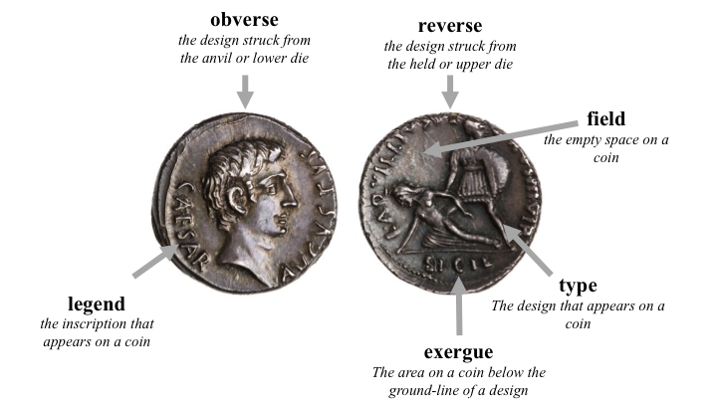

denomination | metal | value in asses
aureus | gold | 400 ( = 25 denarii)
denarius | silver | 16
quinarius | silver | 8
sestertius | silver | 4
as | bronze | 1
semis | bronze | 1/2
triens | bronze | 1/3
quadrans | bronze | 1/4
sextans | bronze | 1/6
uncia | bronze | 1/12

Table 1: Main denominations of the denarius system after c.141/140 BC

denomination | metal | value in asses
aureus | gold | 400 ( = 25 denarii)
gold quinarius | gold | 200 (= ½ an aureus)
denarius | silver | 16
silver quinarius | silver | 8
sestertius | orichalcum (brass) | 4
dupondius | orichalcum (brass) | 2
as | copper | 1
semis | orichalcum (brass) | 1/2
quadrans | copper | 1/4

Table 2: Main denominations of the Roman monetary system under Augustus.

Latin Numismatic Abbreviations

Coins often carried the name of the magistrate, and magistracies are often followed by Roman numerals to indicate the number of times the position has been held (e.g. COS III means consul for the third time).

IIIVIR moneyer (tresvir)
III VIR R P C triumvir for confirming the Republic with consular power (III vir Rei
Publicae Constituendae Consulari Potestate)
III VIR AAA FF the three men for casting and striking of gold, silver and bronze
(tresviri auro argento aere flando feriundo)
ARMEN Armenia
AVG augur (Republican period), Augustus (imperial period). AVGG refers to two
emperors, AVGGG three.
COS consul
COS DES consul designate
DAC Dacicus (i.e. conqueror of Dacia)
DEVICTA having been conquered
DICT dictator
DIVI F son of the god/divus
EID MAR Ides of March
F son of
GER Germanicus (i.e. conqueror of Germany)
HS sestertii
IMP imperator
ITER a second time
LEG legatus or legion
LEG F C legatus fisci castrensis
MAG, or MGN the great (magnus)
MAX Maximus
N grandson of
(IN) PERPETVO in perpetuity
OPTIMO PRINC optimus princeps (the best of emperors)
PARTH Parthicus (i.e. conqueror of Parthia)
P M pontifex maximus
PONT pontifex
PONT MAX pontifex maximus
P P pater patriae
PR praetor (more rarely prefect)
PRO COS proconsul
PRON grandson
PRO PR propraetor
Q quaestor
QVART a fourth time
QVINC a fifth time
REX king
S C, or EX S C by decree of the Senate (ex senatus consultum)
S P Q R the senate and people of Rome (Senatus populusque Romanus)
TER a third time
TR POT tribunician power

Finger Counting Latin Style!

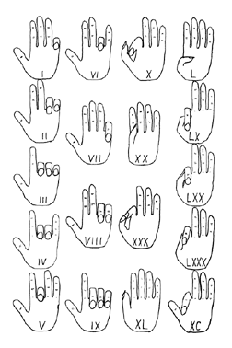
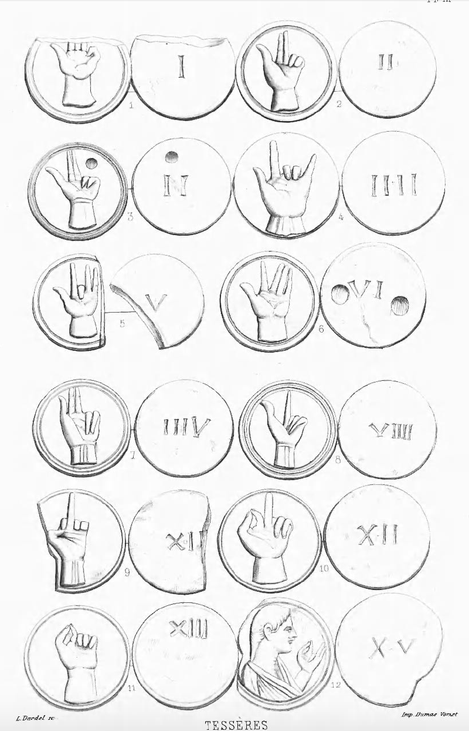

Online Resources

Roman Republican Coinage Online
http://numismatics.org/crro/

Online Coins of the Roman Empire
http://numismatics.org/ocre/

The Coinage of Julius Caesar
http://www.humanities.mq.edu.au/acans/caesar/Home.htm

Coins at Warwick Blog
http://blogs.warwick.ac.uk/numismatics/

Numiswiki
https://www.forumancientcoins.com/numiswiki/view.asp

Electronic Versions of the Powerpoint and Handout are available at:
www.warwick.ac.uk/go/tokens/resources

(password is TokensImpact)

