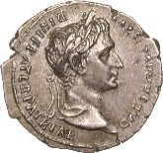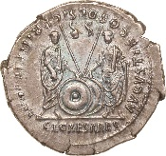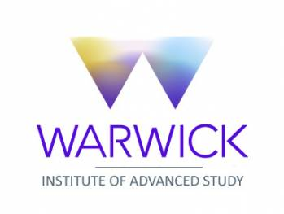
Interdisciplinary Workshop on Coinage, Money & Economy
jointly with the annual Numismatics Day
University of Warwick
Department of Classics and Ancient History
Thursday 17 May 2018, Oculus 0.04
This workshop involves the Centre for Interdisciplinary Methodology with Dr Nathaniel Tkacz and the Department of Politics and International Studies with Dr James Brasset and Ruben Kremers.
Introduction Suzanne Frey-Kupper

10.00-10.30 am Bernhard Woytek Sub-groups of the Augustan CL CAESARES denarii: new metallurgical analyses
10.30-11.00 am Suzanne Frey-Kupper Phoenix from the ashes — Coin finds post 146 BC to Claudius from recent excavations in Carthage
11.00-11.30 am Coffee break
Chair Clare Rowan
11.30 am-12.00 Mairi Gkikaki Coin circulation in Roman Imperial Athens
12.00-12.30 pm Kevin Butcher On the so-called six-assaria coins of Pompeiopolis
12.30-1.00 pm Dario Calomino Arma et nummi along the Danube in the first half of the 3rd century AD
1.00-2.00 pm Lunch
Chair Bernhard Woytek
2.00-2.30 pm Richard Abdy The coin clipping phenomenon in Sub-Roman Britain
2.30-3.00 pm David Wigg-Wolf Rome's shadow: Some thoughts on coins beyond the frontier in Germany
3.00-3.30 pm Tea break
Chair Nathaniel Tkacz
3.30-4.00 pm Nino Crisà Railways, authorities, museums and Modern coins: the 'Cerda Hoard' in context (Palermo, 1869)
4.00-4.30 pm James Brassett, Digital coins, cryptographic tokens: The social life of
Ruben Kremers virtual monies
Chair Kevin Butcher
4.30-5.00 pm Final Discussion

