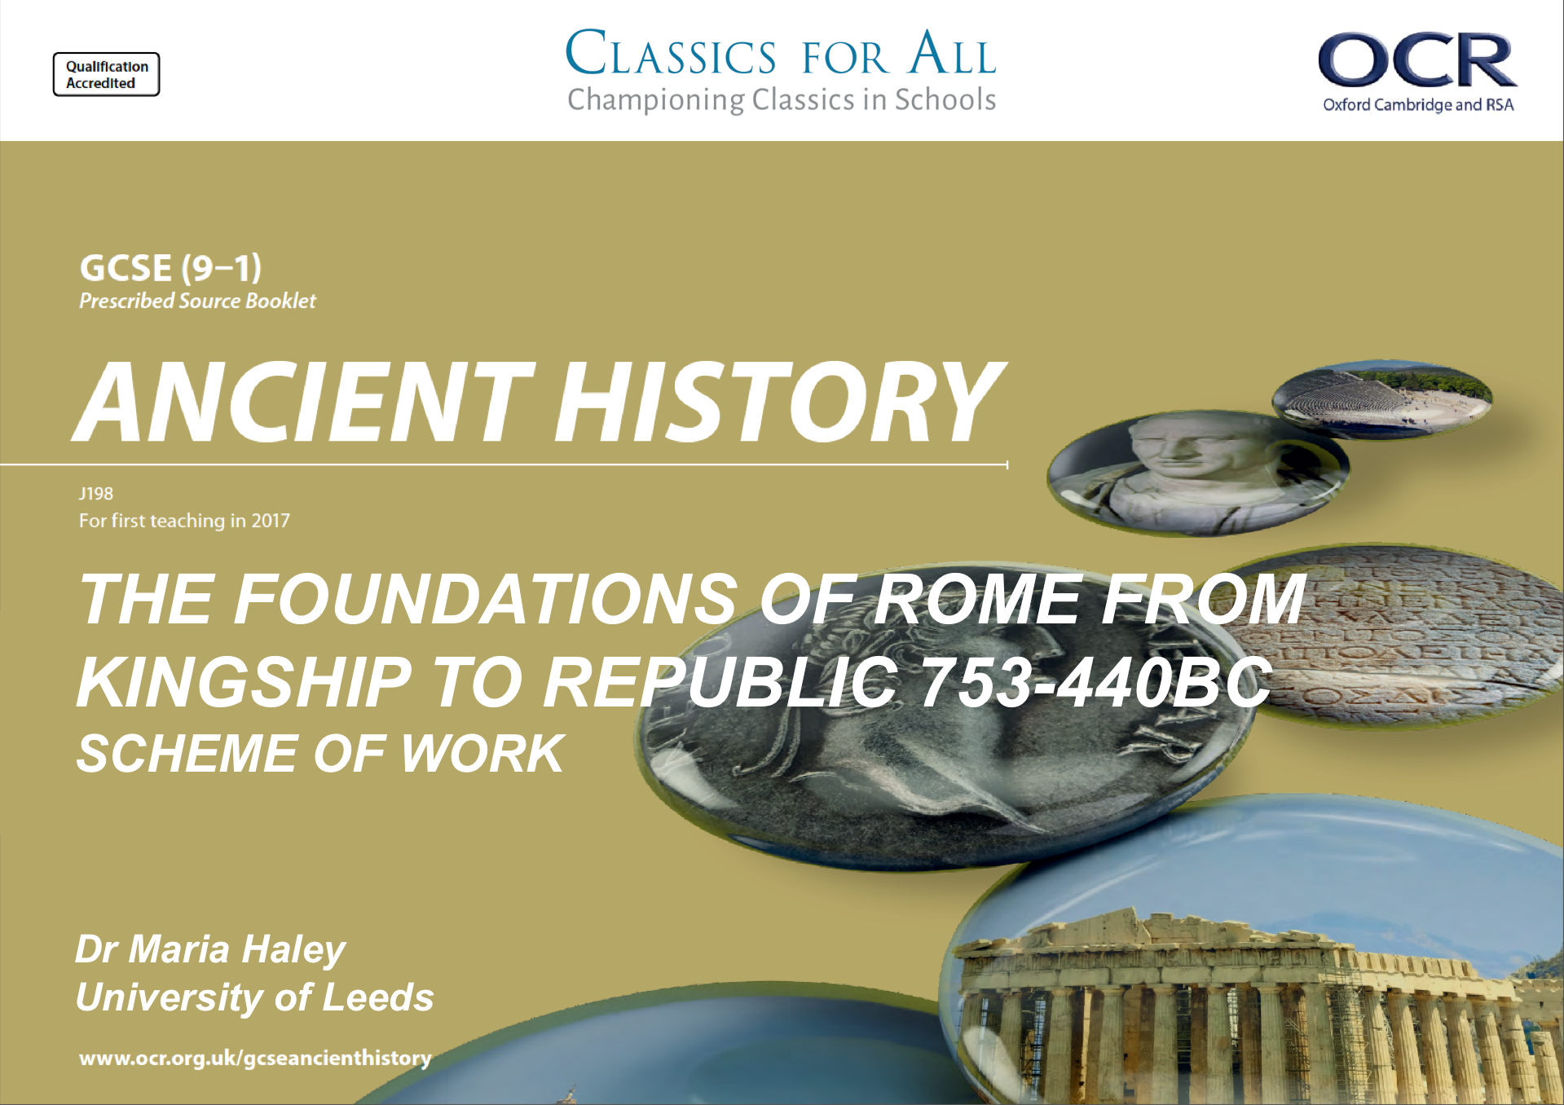
The Foundations of Rome; from Kingship to Republic – GCSE - Scheme of Work

LESSON TITLE | LESSON OBJECTIVES | RESOURCE AND PRESCRIBED ANCIENT SOURCES
INTRODUCTION TO THE UNIT

- Intro to the Unit | - To define key terms and sources for the unit.  - To understand key themes and events during the time period. | P. 3-4 textbook.
THE LEGENDARY KINGS AND THE ORIGINS OF ROME. 753-617BC.

- Usefulness of Roman foundation myths; role of Aeneas | - To understand the myths surrounding the foundation of Rome.  - To assess the place of the character of Aeneas in these myths.  - Analyse the use of ancient sources. | P. 6-8 textbook.  Optional extra: Livy, The History of Rome, preface.
- How was Rome founded | - To understand the legends surrounding the foundation of Rome.  - Compare and analyse competing versions of the foundations of Rome. | P. 9-10 textbook  Dionysius, Roman Antiquities, 1.85-88
- What the foundation myths tells us about development of Rome; Political, Religious and military initiatives. | - What the foundation myths tells us about development of Rome; Religious and Military initiatives.  - To assess the different interpretations from the ancient sources. | P. 12-16 textbook  P. 14-16. textbook  Livy, 1.7, 8 10, 12 and 16
- ‘Rape’ of the Sabine women. | - To understand the early challenges facing the city of Rome.  - To explain Romulus’ actions in helping populate the city.  - Assess the impact this action had on alliances. | P. 16-17.  Livy 1.9-10, 1.13
- The appointment of Numa as 2nd Legendary King and his religious initiatives/ acts of diplomacy. | - To understand the process of Numa’s appointment as King.  - To explain and assess his religious initiatives.  - To assess how successfully Numa brings peace to Rome. | P. 17-19  Livy 1.17-18  Livy 1.19-20 religious initiatives
- 3rd Legendary King, Tullus Hostilius. | - To understand and explain Tullus’ legal and political initiatives.  - To assess the significance of his war with Alba. | P. 20-21  Livy 1.22-1.25, 1.2
- 4th Legendary King, Ancus Marcius | - To understand Ancus’ character  To assess his political, military and religious achievements.  - to compare and contrast the 4 legendary Kings. | p.21-22  Livy 1.32-33.
- Assessment; Legendary Kings and the Origins of Rome. | - Potentially use practise questions in textbook, and create an additional source-based questions to test as much as possible.
- Assessment feedback and improvement lesson.

The Etruscan Kings. 616-509BC.

- 5th legendary King, Tarquinius Priscus | - To understand the events around TP’s succession.  - To understand TP’s political, social, religious and military reforms.
- 6th legendary King, Servius Tullius. | - To understand the events around Servius’ succession.  - To understand the changes Servius Tullius made; politically, socially and religiously. | p. 30-33.  Livy. 1.39-1.41. .42, .43, .48. 1.44-1.45  Dionysius
- 7th Legendary King, Tarquinius Superbus. | - To understand the events around Superbus’ succession.  - To assess his political, social and military changes. | p. 34.-37.  Livy. 1.47-.48. 1.50-.56
- Assessment; The Etruscan Kings. | Practise questions from the book, as well as added factual recall questions.
- Assessment feedback and improvement lesson
Origins of the Republic

- Downfall of the Roman Kings | - To understand the different social orders of the Republic.  - To assess the significance of the Rape of Lucretia.  - To understand Brutus’ role in creating the Republic. | p. 41-43.  Livy 1.56-59.
- The Tarquin Conspiracy | - To understand the main features of the new Republic.  - To assess the significance of the Tarquin Conspiracy. | p. 44-45.  Livy 1.59-60. 2.1-2.
- The early Republic’s Wars of Independence. | - To understand the events of the Wars of independence  - To analyse the significance of key individuals in the wars.  - To assess the consequences of the Wars of Independence. | p. 45-49.  This will HAVE to be split into two lessons. Compensate by setting at least one lesson to be covered as halfterm homework.
- Assessment; Origins of the Republic. | Practise questions in the book, as well as two additional source questions.
- Assessment feedback and improvement.

Securing the Republic. 494-440BC
- The Conflict of Orders and Plebeian Unrest | - To understand and explain what the Conflict of Orders was.  - To analyse the causes of Plebeian unrest, and how this is connected to the CoO. | p. 51-54.  Livy 2.21.
- The First Secession; impact of the battle of Lake Regilius and the role of Publius Servilius and Appius Claudius. | - To understand the explain the events at the battle of Lake Regilius.  - To assess the role of key individuals in the First Secession. | p. 54-56.  Livy 2.23-27.
- The First Secession;  Dictator Valerius and Sicinius. | - To understand Livy’s presentation of Rome during the First Secession.  - To assess the role of key individuals in the First Secession. | p. 56-58.  Livy 2.28-31.
- Why had the Tribunes failed to improve the lives of the Plebeians by 462BC? | - To understand and explain the roles of key individuals in the First Secessions.  - To assess the impact of the First Secession on Plebeian lives. | p. 59-60.  Livy 2.55-58. 2.61
- The First and Second Decemvirate. | - To identify and explain the creation and role of the Decemvirate.  - To analyse opposition to the Decemvirate. | p. 61-63.  Livy 3.33. 3.36-37.
- The Second Secession: Verginius and the impact of the Second Secession. | - To understand the role of individuals in the second secession.  - To analyse the impact of the second secession. | p. 64-65.  Livy 3.53-3.54
- The Second Secession: Valerio-Horatian Laws and the Twelve Tables. | - To understand the compromises Rome came to after the Second Secession.  - To assess the significance of the Twelve Tables. | p. 64-65.  Livy 3.53-3.54
- Legal changes in Rome to 440BC. | - To understand and explain the final changes made to Roman law in our study.  - To assess the extent to which division still existed between the Plebeians and the Patricians. | p. 66.  Livy 4.1-4.6
- Assessment: Securing the Republic | Practise questions from the book, and additional factual recall questions.
- Assessment Feedback and improvement

