Putting it all together! Wevideo training
Week 7, Tuesday 1-3pm, Teaching Grid

What you need to do before this session:
- You need to record your story as a mp3 file and have it saved. You are free to borrow/use the microphone in my office (please email to make an appointment), or else use your own!
- You need to have the appropriate images you are going to use to illustrate your story saved as jpeg files. Try and get higher quality images wherever possible (i.e. 300dpi or above).
- A plan (on paper or whatever form works) of the types of special effects you think might be useful.
- The first hour of the session will be focused on learning the software, so everyone will need an account for Wevideo (free) for their group (make sure you click on the link on the digital storytelling page to access the departmental account):
https://www.wevideo.com/invite/?code=eyJwcm9tbyI6IkVTNVhJTDUzWU1VNyIsImpvaW4iOnRydWUsInJvbGUiOjI1ODU1OTl9
Tips for Audio Recording
- Think about where you want to record your story: in a quiet place or somewhere with background noise. Sometimes a particular venue can create a sense of place or ambience (e.g. Alison has recorded her voice overs in the Ashmolean when discussing objects in the Ashmolean).
- Imagine you are talking to someone – not your computer!
- Look at the video and/or pdf guidelines on using audacity on the module webpage if you want more information.
- If you are using Audacity on your own computer make sure you download the LAME encoder before you start recording. Otherwise you will not be able to export your file as a mp3.

 | Script | Image | Notes
1 | Title slide | Text: The image and the thunderbolt
 | Fade to Black
2 | This is not your average story, since it’s the story of an image. Images lead unusual lives because they exist in different forms: they can be mental or verbal, imagined or real. | Dreamer, Talking, Science-Fiction, Artwork | Appear on screen as word is mentioned
3 | They can move between objects, people and cultures, generating new meanings and ways of seeing. | Full of fun, then mona lisa overdrive, mona lisalollipo, artsy new beetle | Images appear on the screen slowly
 | Dip to black
4 | Our story begins in Ptolemaic Egypt, when the image of an eagle standing on a thunderbolt makes its first significant appearance | Ptolemaic birth house at Dendera
5 | It appears on coins, adorning the coinage of the Ptolemies for more than 250 years. The eagle and the thunderbolt refer to the god Zeus, but its appearance here means our image becomes the symbol of Ptolemaic currency, Ptolemaic economic power, and representative of the Ptolemies themselves. Its an image of Zeus, and the Ptolemaic dynasty. | Gold coin of the Ptolemaic Dynasty | Text saying coin of Ptolemy II and date (?) – 277-276 BC
 | Dip to black
6 | In the third century BC, the eagle and the thunderbolt appears on Roman coinage. What did this movement mean? Many today think that the eagle on the thunderbolt on the gold coin is a reference to the Ptolemies, that it references an alliance between Rome and the Ptolemaic dynasty. | Copper coin Romans  Gold coin Romans | Dates in text adjacent to images – c. 264 BC, from 211 BC
7 | it references an alliance between Rome and the Ptolemaic dynasty. | Ptolemy II  Bronze portrait bust | Bronze portrait bust, then image of Ptolemy II appears next to it
 | Dip to black
8 | But when images move, their meanings change. Our image referred to Zeus, and then to the Ptolemies. So when it comes to Rome perhaps it came to signify Rome, and Roman power. The eagle and the thunderbolt marks Rome as a Hellenistic power, Rome as a dominant force to be reckoned with, just like the Ptolemies. | Gold coin Romans
9 | By moving and being placed in a new context, this small image generates new ways of seeing the world, and of seeing Rome. |  | Text: a new way of seeing this as that  Wittgenstein, Philosophical Investigations
10 | The eagle on the thunderbolt continued to move between mediums, minds and worlds. We later find it on local coins in Sicily. What does it mean here? Images and their meanings can be slippery to pin down. This city was under Roman control and used Roman coinage. So I think the eagle and thunderbolt here is a reference to Roman power, an understanding of Rome as a Hellenistic power. This is the Roman Empire before Rome ever had an emperor. | Bronze coin of Panormos | Text says: Panormos, , c. 130/120-30/20 BC
11 | And perhaps also the Roman Empire once she had an emperor. | Bronze coin of Panormos under Augustus | Text says: coin of Panormus under the emperor Augustus, 28 BC – AD 14
12 | Text: The eagle and the thunderbolt, by Clare Rowan |  | Fade out
13 | Credits  Last line –with thanks to IATL and the students of the Hellenistic World 2014/15

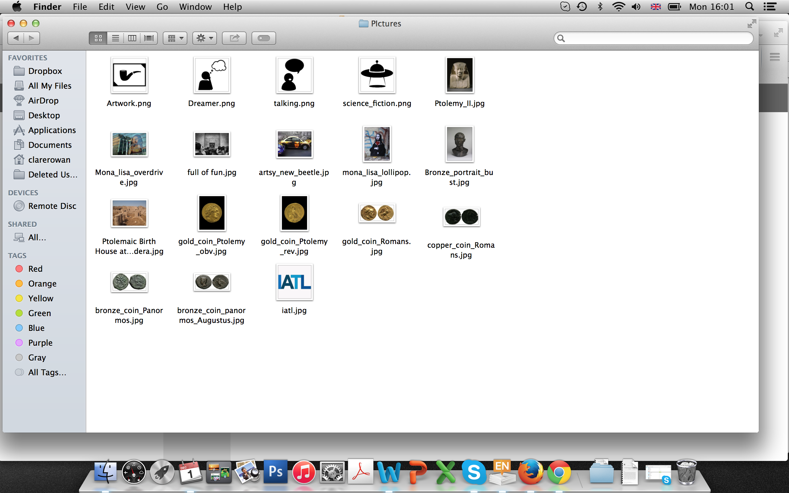

IMAGE CREDITS:

You need to credit EACH image or sound file you use!

CC attribution guidelines:
Creator
Title
URL
Type of licence
(see https://creativecommons.org/licenses/)

These are for cc commons images, but differing websites will have differing requirements – you need to check the requirements for each image used (in the same we as academics we need to request or obtain permission for each image we use in a publication). If you do not do this, your video will be unable to be published online.

A sample of image credits is below.

Image credits

1.) Artwork, designed by Dan Lowenstein,
http://www.thenounproject.com
cc-by 3.0

2.) Dreamer, designed by Claire Jones,
http://www.thenounproject.com
cc-by 3.0

3.)Talking, designed by Ed Gray,
http://www.thenounproject.com
cc-by 3.0

4.) Science Fiction, designed by Yi Chen,
http://www.thenounproject.com
cc-by 3.0

5.) Mona Lisa Overdrive by Ciro Cattuto
https://flic.kr/p/BsqL
cc –by-nc-sa

6.) Full of fun by Kateryna Zavhorodnya
https://flic.kr/p/inw2XZ
cc-by-nc 2.0

7.) Artsy New Beetle, Wolfsburg, Germany. Volkswagen Museum. By p_d_s
https://flic.kr/p/6SE6r
cc by-nc-nd 2.0

8.) Kreibel Mona Lisa Lollipop Tart by bixentro
https://flic.kr/p/4FRqqX
cc-by 2.0

9.) Ptolemaic Birth House at Dendera (I) by Institute for the Study of the Ancient World
https://flic.kr/p/dMta7y
cc-by 2.0

10.) Gold coin of the Ptolemaic Dynasty. BM 1964,1303.1
© The Trustees of the British Museum

11.) Copper coin of the Roman Republic, BM TC,p18.8.Rom
© The Trustees of the British Museum

12.) Gold coin of the Roman Republic, BM 1844,1008.57
© The Trustees of the British Museum

13.) Brooklyn Museum: Ptolemy II
Charles Edwin Wilbour Fund, 37.37E
cc-by
http://www.brooklynmuseum.org/opencollection/objects/3946/Ptolemy_II/image/8732/image

14.) Bronze portrait bust of man, Metropolitan Museum of Art, New York
Bequest of Benjamin Altman, 1913, 14.40.696
http://www.metmuseum.org/collection/the-collection-online/search/248852

15.) Bronze coin of Panormos, Sicily
Reproduced courtesy of Classical Numismatic Group Inc., (www.cngcoins.com)
Electronic Auction 224, lot 32

16.) Bronze coin of Panormos, Sicily, under Augustus.
Reproduced courtesy of Classical Numismatic Group Inc., (www.cngcoins.com)
Electronic Auction 130, lot 276

