Non-Assessed gobbets practice
Please email to Zahra by Mon 24th October.
Comment on points of interest in each of the TWO images. C. 500 words each.
(in the exam this would make up 50% of Qu 1; and you’d have 20 mins for each)

1)
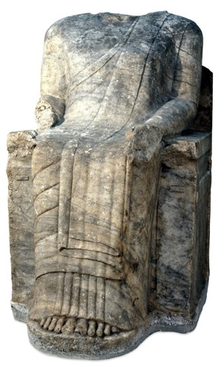Statue dedicated by Chares, British Museum

2)

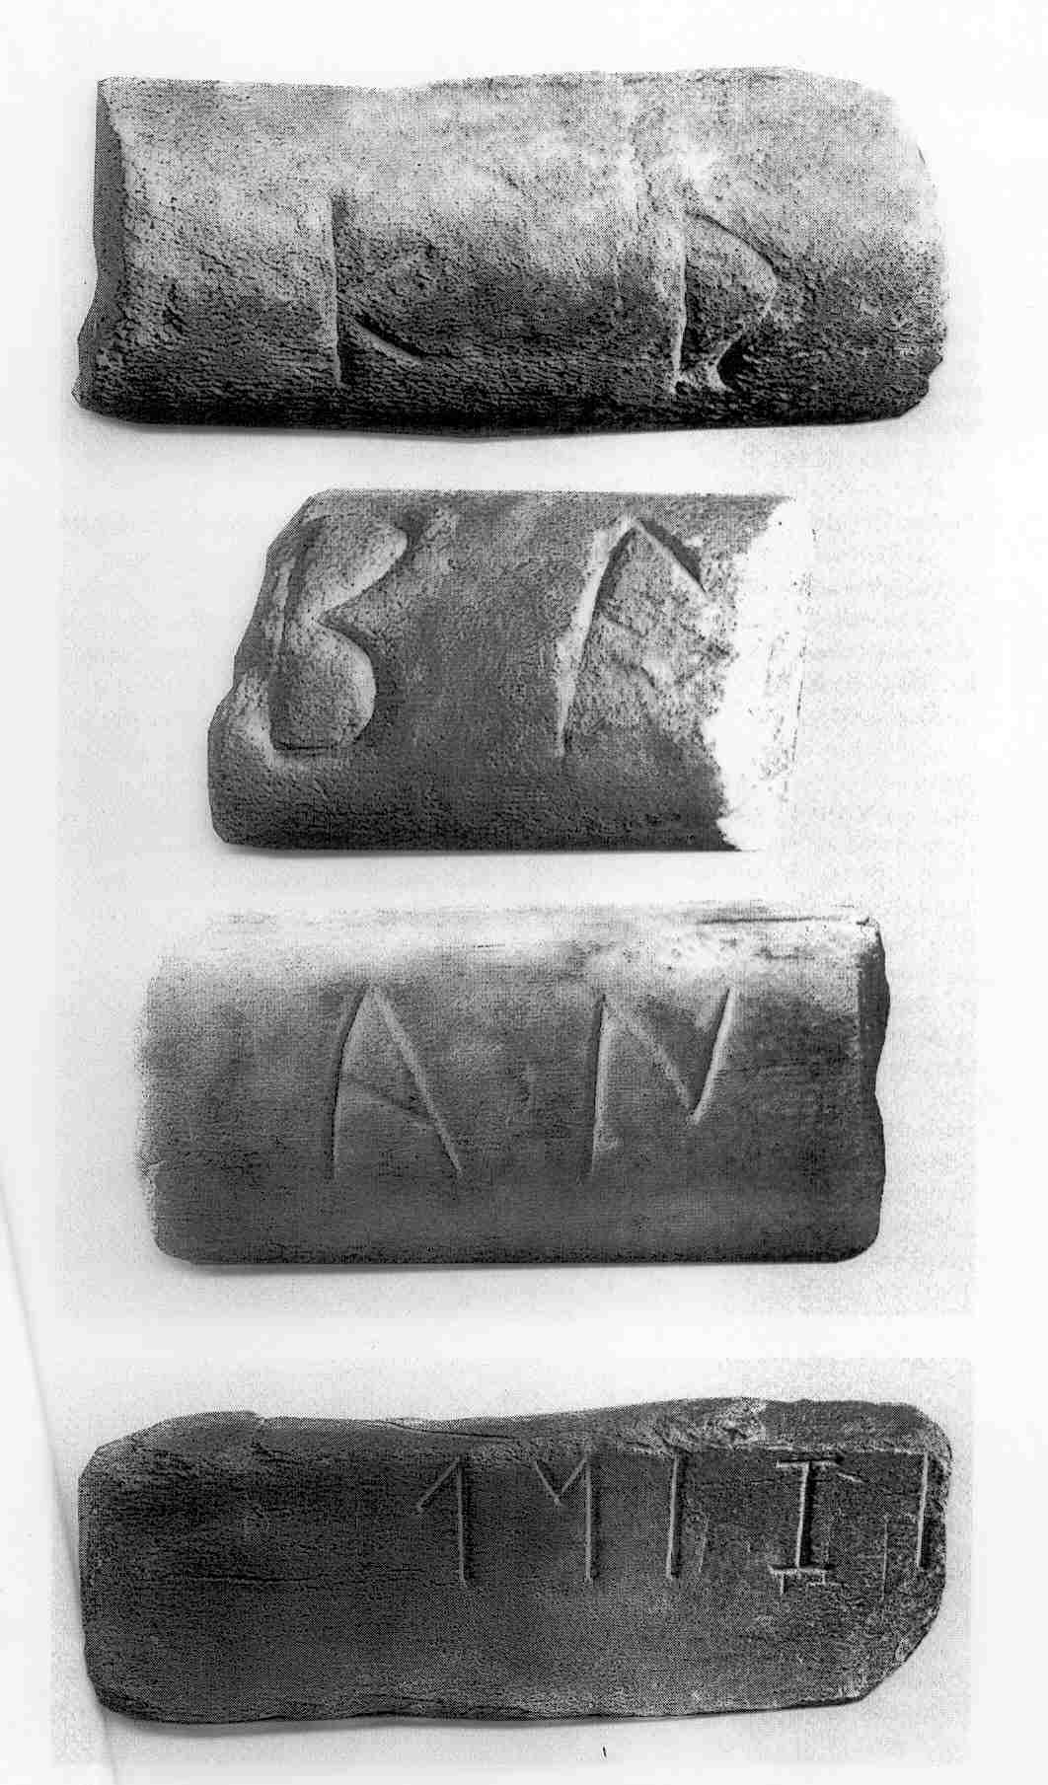
Inscribed torus from column bases, Ephesus. British Museum

