The University of Warwick
Department of Classics and Ancient History

CX 105/205/305 – Greek Language
2018/19

Module Convenor: Clive Letchford, Room H.2.39
C.A.Letchford@warwick.ac.uk

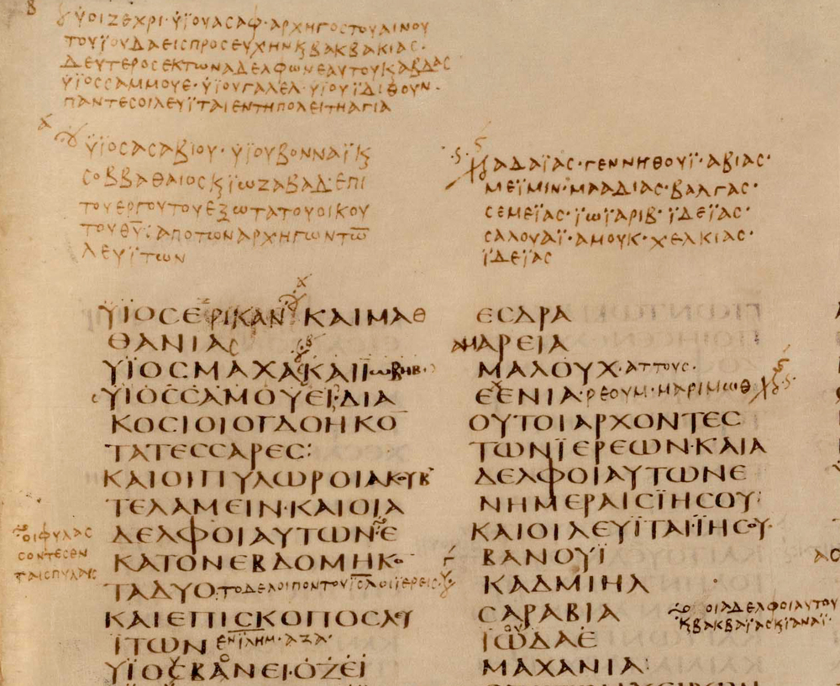
detail from Codex Sinaiticus, fourth century C.E.

Office Hours
Tuesdays, 12-1, Wednesdays 12-1
during teaching weeks
The module
This module offers the opportunity to learn the basics of the classical Greek language and is designed for students who have little or no previous experience of the language. The department believes that language is at the heart of the discipline and all students should, at the minimum, have a basic knowledge of one of the classical languages.
This module will be taken by:
- 1st Year Q800 students who have no qualification in Greek.
- 2nd year students who want to add to try Greek after a year of Latin, or begin Greek alongside further study of Latin. Students will need to have completed the Latin Language module in a satisfactory manner with a minimum of 70% overall.
- First year students who can demonstrate that they are likely to be able to learn Greek. Evidence might be an A level in a modern language or a good GCSE in Latin. Otherwise, first year students generally take Latin which provides a better foundation for taking up Greek in their second year
- Third (or fourth) year students who have been studying Latin for two years. Students will need to have completed the Latin Language module in a satisfactory manner with a minimum of 70% overall.
Before arriving at Warwick, all students proposing to take this course need to have learnt the alphabet and practiced reading passages of Greek out loud with confidence. They will be tested on their fluency in the first week of the academic year. Please drop in to my office to get a copy of suitable materials and guidance.
The department welcomes enquiries from students outside the Classics Department. Potential non-classicists should email the module convener to signify their interest. Because Classical Greek is a difficult language, we will need to see evidence that you will be able to meet the demands of the course so we will discuss your previous language learning experience.
Attendance
There are three hours of teaching each week. They are an integral part of the course and so attendance is required at all classes. If you have an appointment you can't miss, please discuss this in advance, If you are ill, you should email as soon as possible giving an indication of why you could not be expected to attend. In the absence of any such email, your absence will be noted as unauthorised. Our experience is that regular attendance is the single most important factor for success on this module.
If your illness means that you have to miss classes for more than one week, we require a medical certificate from your GP. More importantly, you should be in email contact with the module tutor and your personal tutor since it is easy to fall behind in such a situation and catching up becomes progressively harder.
There are four exams during the course (worth 10% each) and one at the end worth 60%. The exams during the course are held in Week 6 of Term 1, in Weeks 1 and 6 of Term 2, and Week 1 of Term 3. These are generally held on a Monday morning. Precise details will be given early on in the first term.
Please note the following:
- If you do not sit the exam at this time, you cannot sit it at a later date and you get 0%.
- If you are too ill to sit the exam, university regulations require you to provide a medical note from your GP confirming that you were unfit to sit the exam on that day. Suitable allowance will be made in calculating your module score.
- All exams require you to bring your university card to confirm your identity.
- It is inadvisable to travel back on the morning of an exam.

Office Hours
Office Hours are an important part of the module, offering students the opportunity to sort out areas of uncertainty as the module progresses. My Office Hours are as stated on the front page of the module handbook. Outside these times you are welcome to drop in, but you may well find I am teaching. Alternatively , you can email me with any queries.

Aims and objectives

This module aims to introduce a complete beginner to the main elements of the structure of Classical Greek in a logical and systematic way and so enable them to read and translate passages of adapted Greek with accuracy and confidence.

By the end of this module, all students should expect to:

- know all the designated vocabulary, accidence and syntax
- have developed considerable translation skills, involving an appreciation of the different linguistic structure of this inflected language
- have cultivated their capacity for analytical and logical analysis
- have improved their understanding of English grammar
- appreciate the continuing influence of Greek on the English language

Students are encouraged to use the help that is always available to sort out any points of difficulty that arise and not get behind.

This module provides the necessary basis for those who continue their study of the language in 2019. Many students go on to the module Greek Language and Literature and read classical authors such as Thucydides Euripides and Homer.

Organisation

Text book
The course uses the course Reading Greek (second edition), published by Cambridge University Press. You will be required to have printed copies of both volumes (Text and Vocabulary; Grammar and Exercises) from the first class of the year. Experience has shown that the ebook versions are unsatisfactory. You will not need a lectionary.

Classes
We usually run two groups in parallel. Students are assigned to a group at the start of an academic year, taking into account any other commitments. Each group has three classes per week throughout the 23 weeks of teaching. Please note that classes continue through Week 6 in the Autumn and Spring terms, unlike some other modules in the Department. 2nd and 3rd years are expected to attend throughout Week 6 even though it is a reading week.

Assessment
Four interim exams
There will be four interim exams of 40 minutes. These will focus on (but not be restricted to) the vocabulary and grammar introduced since the previous exam. Students should be aiming to achieve upwards of 70% in these exams.

Final exam
The two hour exam will contain passages for translation and/or comprehension which have not been seen previously, and a separate section with questions actively testing knowledge of accidence and syntax. Words that cannot be easily deduced will be glossed.

Passing the module
For first year students, this is a core module. If you do not achieve a mark of 40% overall in the five exams, then you will be required to resit an examination in the first week of September. If you do not pass in September, you will be required to withdraw from the University.

Non-first years cannot resit but carry the mark that they gain. Their unseen and/or comprehension questions will be marked on the university's 20 point scale.

Independent working

Students are expected to do the majority of their work for this module outside taught classes. Class time will be devoted to introducing new concepts and to addressing areas where students have encountered difficulty. Students are advised that they should reckon on spending an average of at least 2 hours of private study between each class and will also need to spend some time during vacations to consolidate material.

Independent learning will typically involve:
- written exercises set on topics introduced in the session
- learning vocabulary
- learning new endings and sentence structures
- consolidation of recent material.

Word-processing in Greek

You may also wish to word-process in Greek. If so, you must have the facility to input breathings which are integral to classical Greek (but not modern Greek). You will have to investigate a bit, but it is generally straightforward, more so on Apple products.

There are two aspects: having the right characters installed, and getting your keyboard to know you ant Greek characters rather than English ones.

- Font. You must use a Unicode font which includes a full set of Greek characters (‘Polytonic Greek’). Fonts installed on Windows systems include Lucida Sans, Palatino Linotype, Tahoma and Arial Unicode MS. Macs also have Lucida Grande, Helvetica and Times.

- Input. You also need to have a way of inputting the text. If you have a Mac, it is a just matter of changing the keyboard layout, done via ‘country’ options. Be careful to use Polytonic Greek, not ‘Greek’ (‘polytonic’ refers to the accents and allows breathings, which is essential). Life is a little more complicated in Windows, where Polytonic Greek needs to be enabled using Control Panel/Regional and Language Options/ and setting input language and keyboard to Polytonic Greek.

Advice on studying

Learning a classical language requires regular memorisation not just of new vocabulary but also the way the endings of the words change (accidence) and the ways in which sentences are constructed (syntax). This is a skill that not all students have developed confidently at school and so emphasis is given in the early stages to developing good working habits and training the mind to become better at doing this. Experience has shown that the following are useful tips.

- Find yourself a study buddy. Not only can you test each other on new vocabulary and noun and verb endings, but it is also very revealing to see how well you can explain a topic to someone else.
- Investigate flash cards: make your own using index cards or look on the web – memrise and cram.com are liked, and can be used on your phone. Better still is the Greek Project, hosted by Eton College, which has up to section 7. You should reckon on spending about three ten minute sessions per day on vocabulary and noun and verb endings.
- In addition to getting on top of new material, EVERY DAY you should devote a small amount of time on going over previous material. Be methodical about this. Keep a record of what you have looked back on and how secure it is.
- Vocabulary: you should keep a note book or equivalent list for words that you have forgotten.
- Noun and verb endings: make sure you can write them out quickly and accurately.
- When you come across an area which is not as secure as you thought, spend time rereading the explanation in the text and look over your notes again. Rework the associated exercises and check your answers from when you did them the first time.
- If you are still unclear seek help from the course tutor. Usually, confusion can be sorted out very quickly on a one-to-one basis.

It is important that vocabulary and grammar are learnt thoroughly and at the time of setting – not left to the last minute – and that material is consolidated on a weekly basis.

Bibliography

Essential:

JACT (2007) Reading Greek: Text and Vocabulary
JACT (2007) Reading Greek: Grammar and Exercises
(Both should be in printed editions)

Reading Greek should prove all you need to learn Greek this year. If you want to look at other explanations, the following are useful:

Morwood, J. (2001) Oxford Grammar of Classical Greek
Taylor, J. (2016) Greek to GCSE Part 1
Taylor J. (2016) Greek to GCSE Part 2

(You can probably pick up earlier editions very cheaply second-hand: these are fine.)

If you are interested in the language and want to find out more about you, the following are a good place to start.

Colvin, S. A (2014) A brief History of Ancient Greek [e-book]
Horrocks, S. (2010) Greek: A History of the Language and Its Speakers [e-book]
Allen, W.S. (1987) Vox Graeca (Third Edition)

