CX1248

UNIVERSITY OF WARWICK

Summer examinations 2014

CITY OF ROME
Time allowed: 2 hours

All questions carry equal weighting.

Candidates should answer QUESTION 1 and TWO other questions.

Students will not be given credit for substantial repetition of material between questions on the examination paper.

Read carefully the instructions on the answer book and make sure that the particulars required are entered on each answer book.
====================================================================

1. Comment on points of interest in TWO of the following (ONE picture, ONE text) and comment on any points of interest or difficulty they contain.

a). Casa D’Aracoeli, Rome

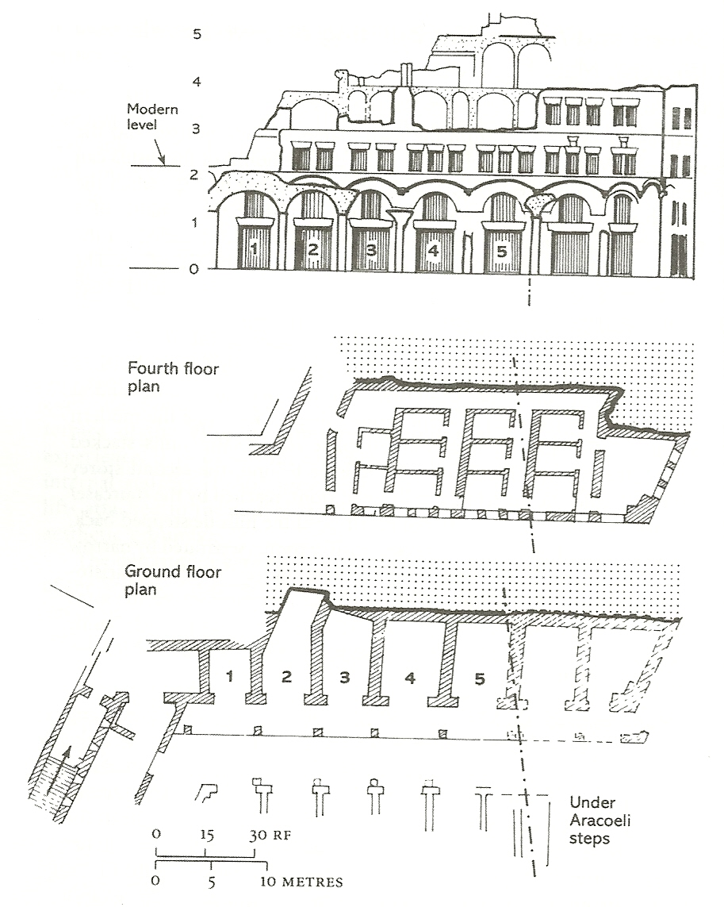
___________________________________________________________________________
CX1248 continued

CX1248
___________________________________________________________________________

b) Porta Maggiore; CIL VI 1256.
([In AD 52] Tiberius Claudius, son of Drusus, Caesar Augustus Germanicus, Pontifex Maximus, with Tribunican power for the 12th time, 5 times consul, 27 times Imperator, Pater Patriae, had the waters of the Claudia brought to Rome from the springs called Caeruleus and Curtius at the 45th milestone, and likewise the Anio Novus from the 62nd milestone, both at his own expense.)

([In AD 71] Emperor Caesar Vespasian Augustus Pontifex Maximus, with Tribunican power for the 2nd time, Imperator 6 times, 3 times consul (4 times designatus), Pater Patriae restored to the city at his own expense the Curtian and Caerulean waters, which had been led to the city by the deified Claudius but had fallen into intermittent use and disrepair for nine years.)

([In AD 81] Emperor Titus Caesar son of the Divine Vespasian Augustus Pontifex Maximus, with Tribunican power 10 times, 17 times Imperator, Pater Patriae, Censor, Cos VIII, at his own expense, had the Curtian and Caerulean waters, introduced by the deified Claudius and afterwards repaired for the city by Titus’s deified father Vespasian, restored with new structures, beginning from its source, after the aqueduct was ruined to its foundations from age.

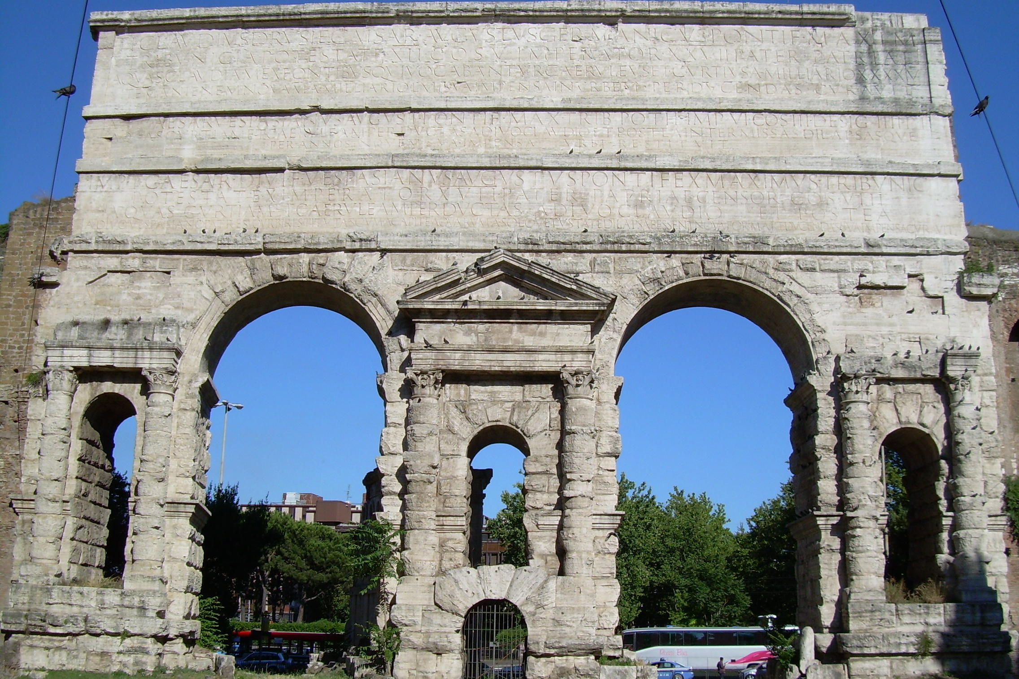

_____________________________________________________________________________CX1248 continued

CX1248

c) Forum Romanum after the Severan reconstruction
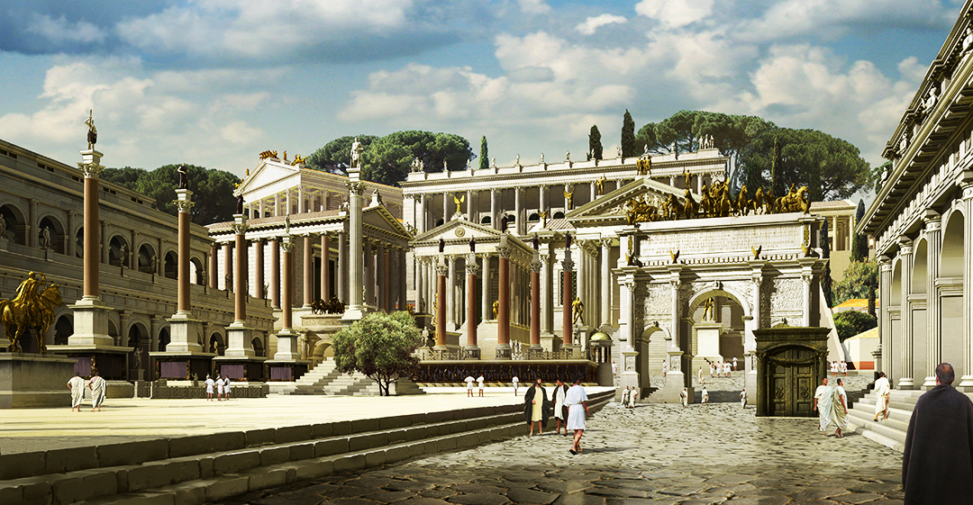
_____________________________________________________________________________d)
…coming to Evander’s humble home, there were cattle everywhere, lowing in the Roman Forum and in the now luxurious district of Carinae “Come into my poor home and do not judge it too harshly” With these words he lead mighty Aeneas under a roof tree of his narrow house and set him down on a bed of leaves covered in the Libyan bear hide.

Virgil, Aeneid VIII. 360-370.

e)
In your search of a lover, don’t neglect the noble race track:
The teeming sands of the Circus are rich with opportunity…
Just sit down next to your lad7, there’s nothing here to prevent it,
Sidle yourself right up and press your hip to hers;
The crowded seating, like it or not, works in your favor,
And regulations compel you to squeeze in tight and touch…
When horses appear, look excited and quickly ask whose,
And whatever racer is her favorite.. amazing!.. he’s yours as well!
If any speck of dirt should land on your lady, be concerned to brush it away,
And even if the dirt is absent, brush it off anyway…
If the folds of her robe should slip and touch the ground,
Gently gather them and rescue the fabric from filth…
You new arrangement of cloth will give you a glimpse of her leg..
Make sure to check behind you as well…
No knee from the bench above will be jabbing her tender back…

Ovid, Ars Amatoria, I. 135-158

CX1248 continued

CX1248

f)
The size of the Campus Martius (North) alone is astonishing. It is spacious enough to allow chariot races and at the same time all other equestrian sports… Nearby are hordes of Wrestlers and others playing ball with hoops, Works of Art adorn all the paths and the lush gardens are in bloom every season.. Nearby[South] many porticoes, sacred groves, lavish temples, three theatres and one amphitheatre are all laid out in semi circle. Here everything is so crowded, one upon the other, that the rest of the city seems only incidental…

Strabo, Geography, V. 3.8

--------------------------------------------------------------------------------------------------------------------

2. Was the city of Rome “Hellenised” in the 3rd -2nd centuries BC?
--------------------------------------------------------------------------------------------------------------------

3. Was Caesar’s vision for the Forum Romanum fundamentally different from that of Augustus?
--------------------------------------------------------------------------------------------------------------------

4. If we take into careful consideration the abundant supplies of water in public buildings, baths, pools, open channels, private houses, gardens and country estates near the city; if we consider the distances traversed by the water before it arrives, the raising of arches, the tunnelling of mountains and the building of level routes across deep valleys, we shall readily admit that there has never been anything more remarkable in the whole world."
(Pliny the Elder: Natural History 36.121 - 123)

Which Rome’s of engineering feats was most important to her sucesss as a city?

--------------------------------------------------------------------------------------------------------------------

5. How do comparative studies of Ostia shape our understanding of everyday life in Rome?
--------------------------------------------------------------------------------------------------------------------

6. How is the plurality of Roman religion reflected in her public buildings?
--------------------------------------------------------------------------------------------------------------------

7. What was Trajan’s most significant monumental undertaking?
--------------------------------------------------------------------------------------------------------------------

8. Is the Arch of Constantine in Rome a Christian monument?
--------------------------------------------------------------------------------------------------------------------
9. Was the role of single Roman emperor a crucial factor in implementing a monumental building scheme? (You can consider Republican, Imperial, OR Post-Imperial (3rd century crisis/ tetrarchy material).

-------------------------------------------------------------------------------------------------------------------
CX1248 END

