
“BUILDING
COMMUNITIES”
SCHOOLS
COMPETITION

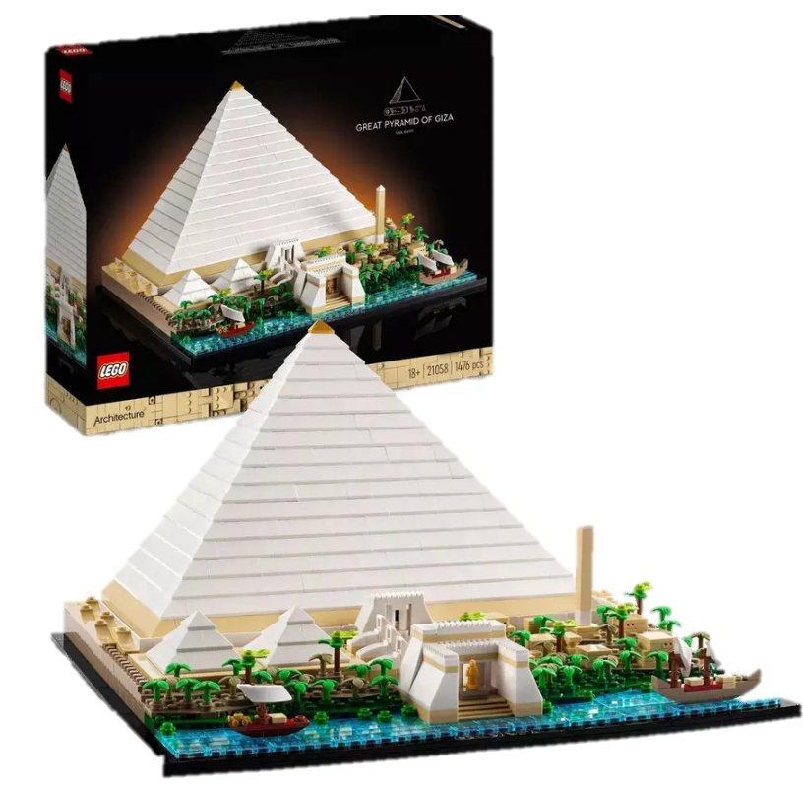

Are you interested in the
ancient world?

We want you to create a piece of art/design/writing which looks at how ancient buildings/spaces were used in the ancient world. There are three categories of entries:

Minecraft (recreate an ancient place using Minecraft)

Creative Design (drawing, painting, digital design, or building with Lego or other materials)

Creative Writing (storytelling, poetry, drama)

Ask your teachers to find out
how to take part

Win a Lego Pyramid for your school!

