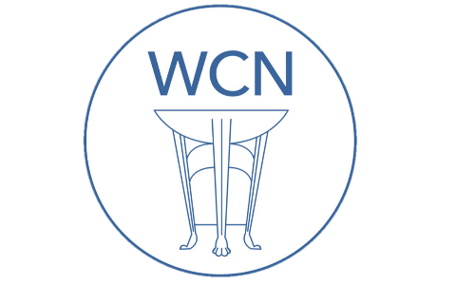
Roman Coventry and Warwickshire Project
Iron Age - Teaching Notes
These teaching notes and the accompanying PowerPoint presentation are designed to give an overview of the Iron Age and its tribes – the people who were here when the Romans arrived.
The lesson is a continuation of ‘Prehistoric Britain’ and can be presented in chronological order after that lesson if required. The emphasis here is on understanding the rich culture (most unknown) of the peoples who inhabited this land before the Romans arrived.
Roman culture in Britain became something of an amalgam of Roman ways and beliefs and what was here before – especially in the sphere of religion.
This lesson includes information on local Iron Age sites at the University of Warwick, and an Iron Age Hillfort in SW Warwickshire at Meon Hill near Stratford upon Avon.
Exercise
As with the Prehistoric material, it is useful to get the pupils to imagine the experience of the Roman invasion from both the perspective of the invaders and the invaded. From a cultural standpoint, what might the Britons have feared they might lose under Roman rule? What might they gain? Why did some resist the Romans and others accept them, and is any one of these attitudes necessarily correct?
These last thoughts can feed in to the lessons to come on those for- and against- Rome: Cartimandua; Caratacus; and Boudica.
Slide 1: Iron Age

Slide 2: Iron Age Britain
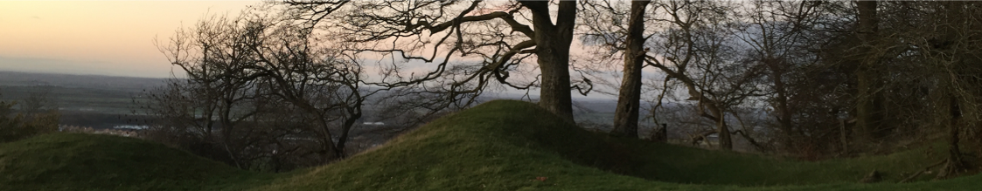
Introduction to the Iron Age
The Iron Age in Britain began around 750BC and lasted until the coming of the Romans in AD43.

Slide 3: Kirkburn Sword
It was the arrival of iron working techniques from southern Europe that brought Britain into the Iron Age. Iron was stronger and more plentiful than bronze and iron working revolutionised many aspects of life, most importantly agriculture. Iron tipped ploughs could turn soil more quickly and deeply than older wooden or bronze ones, and iron axes could clear forest land more efficiently for agriculture. There was a landscape of arable, pasture and managed woodland. There were many enclosed settlements and land ownership was important.

Slide 4: British Tribes and Hillforts
Hillforts were an important part of the Iron Age British landscape, especially in the west. An amazing website, the Oxford Atlas of Hillforts shows us just how many hillforts there were scattered across the countryside. Take a look and see where the nearest hillforts are to you, and then why not go and visit?

Slide 5: Iron Age Britons
Iron Age Britons lived in organised tribal groups, ruled by a chieftain. These groups would have changed and evolved throughout the Iron Age, and their early interactions seem to have been hostile, perhaps as tribal groups and boundaries settled in to place. This inter-tribal warfare was traditionally interpreted as the reason for the building of hill forts, as defensive areas where small communities across the landscape could muster and stand their ground when attacked.
But while this may have been the case in some, some hillforts are sited on the sides of hills with poor defensive value, and so some may best be seen simply as communal gathering places or even strongholds of elites within the groups. Some may even have simply been enclosures for domesticated animals such as cows.

Slide 6: Iron Age Britons (cont.)
Although the first had been built about 1500 BC, hillfort building peaked during the later Iron Age. There are over 2,000 Iron Age hillforts known in Britain. By about 350 BC many hillforts went out of use and the remaining ones were reinforced. Why so many went out of use is not known. Perhaps people had begun to meet together as larger tribal groups in just a few of the most important hillforts. You can find out more about the tribes which had developed by the time of the arrival of the Romans here.

Slide 7: Maiden Castle
One of the most spectacular hillforts is that of Maiden Castle in Dorset. Check out the English Heritage Maiden Castle website for more details of its history, some of which I have adapted below.
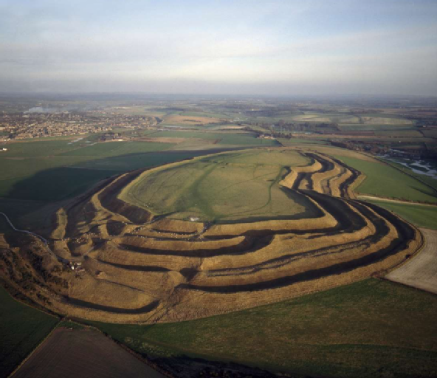
Maiden Castle - a hillfort in Dorset
Maiden Castle is one of the largest and most complex Iron Age hillforts in Britain. Its vast multiple ramparts enclose an area the size of 50 football pitches, and the site was home to several hundred people in the Iron Age (800 BC–AD 43). Excavations during the 1930s and 1980s have unearthed much of its history, from its origins as a Neolithic enclosure over 6,000 years ago, its modifications during the Iron Age, to the construction of a Romano-British temple here.
Slide 8: Maiden Castle (cont.)
The hill was originally inhabited during the Neolithic period when as enclosure was built here on the hill top following the clearing of the woodland on top. Following a period of reduced activity, the first hillfort was constructed in the early Iron Age. Enclosed by a single rampart, it was built on top of the earlier enclosure and was later extended west to enclose more than double the original area. Extra ramparts were added, the inner rampart was heightened and the entrances became increasingly complex as more ramparts were added and gateways were redesigned.

Slide 9: Maiden Castle (cont.)
The same sort of changes must have happened at other hillfort sites as well. Many would have been built where previous settlements had been found and would have become more complex during the Iron Age. This is particularly true for the first few hundred years, because generally - and this is true also of Maiden Castle - in the later Iron Age defences seem to have become less important. As stated already, hill forts more genrally seem to have been less used in this later period, so it seems that the reasons for their occupation changed considerably as the Iron Age progressed.
At the height of its occupation, the Maiden Castle fort was densely populated and there were many roundhouses. These had central hearths, large pits for storing grain and were often circled by drainage gullies. Various finds from the site show that activities such as textile production and metalworking were taking place here.

Slide 10: Maiden Castle (cont.)
In the middle Iron Age, the layout of the interior of the hillfort was reorganised. Once randomly arranged houses were now built in regimented rows, with traffic guided along roads. This reorganisation suggests some control existed over social life within the fort.
Later in the Iron Age, this organised system broke down, and the focus of the settlement became once again the eastern end of the hillfort. At this time, there was increasing trade with the continent, and specialised industries such as metal-working were becoming very important.

Slide 11: Pytheas - a Greek in Iron Age Britain
We know of a traveller named Pytheas, a Greek colonist from Massalia (modern day Marseille in southern France) who wrote an account of his voyages by sea - the Periplus - around Britain and Ireland and even up to the Arctic. The name of his book, Periplus, is Greek for 'sailing around'. Unfortunately his book is lost, but enough ancient authors themselves quoted passages of his book or referred back to it, so we know something of what he saw. He is thought to have lived around in the latter part of the fourth century BC, the time when Alexander the Great lived and was travelling in the opposite direction into Asia.

Slide 12 and 13: Pytheas’ Britons
Pytheas called the Iron Age Britons the "Pretanoi", which is linguistically linked with "Britanni", and was quoted as writing that the Britons were renowned wheat farmers. Large farmsteads produced food in industrial quantities and Roman sources note that Britain exported hunting dogs, animal skins and slaves. Then there was tin. His account of the tin trade in perhaps Cornwall was used by the historian Diodorus Siculus in this account from Book, Chapter 22 of his Library of History:
The inhabitants of that part of Britain which is called Belerion are very fond of strangers and from their interactions with foreign merchants are civilized in their manner of life. They prepare the tin, working very carefully the earth in which it is produced. The ground is rocky but it contains earthy veins, the produce of which is ground down, smelted and purified. They beat the metal into masses shaped like knuckle-bones and carry it off to a certain island off Britain called Ictis. During the ebb of the tide the intervening space is left dry and they carry over to the island the tin in abundance in their wagons ... Here then the merchants buy the tin from the natives and carry it over to Gaul, and after travelling overland for about thirty days, they finally bring their loads on horses to the mouth of the Rhone.
Some people believe that St Michael's Mount in Cornwall (below) is the location of this island Ictis.
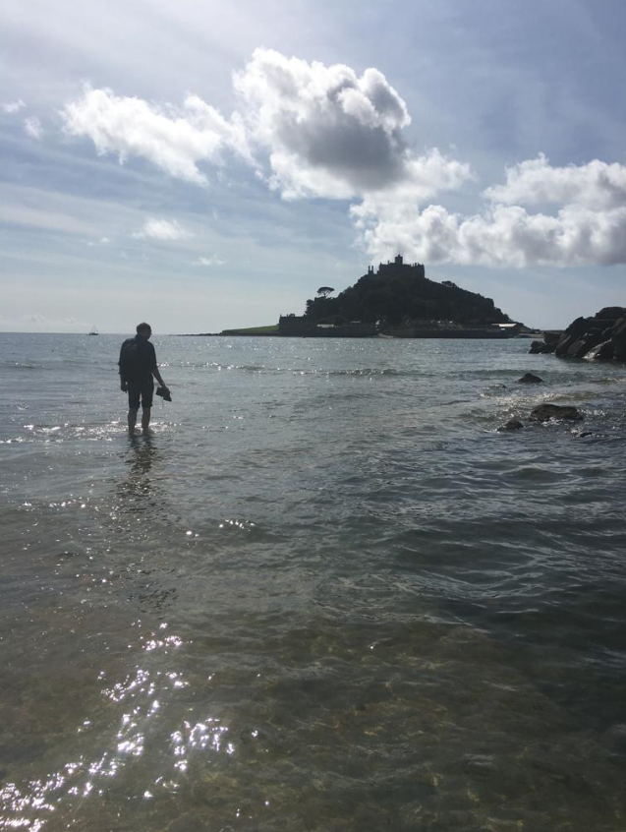
Dr Grigsby walking to St Michael's Mount as the tide comes in and covers the causeway.

Slide 14: What did the iron age Britons call themselves?
What is interesting is that Pytheas' use of the name Pretanoi may reflect the name that all or certain Britons called themselves. This is not always the case (for example the Greeks called themselves Hellenes and it was the Romans who invented that other more familar name). As the archaeologist and author Barry Cunliffe summarises:
"It is quite probable that the description of Britain given by the Greek writer Diodorus Siculus in the first century BC derives wholly or largely from Pytheas. What is of particular interest is that he calls the island "Pretannia" (Greek "Prettanikē"), that is "the island of the Pretani, or Priteni". "Pretani" is a Celtic word that probably means "the painted ones" or "the tattooed folk", referring to body decoration - a reminder of Caesar's observations of woad-painted barbarians. In all probability the word "Pretani" is an ethnonym (the name by which the people knew themselves), but it remains an outside possibility that it was their continental neighbours who described them thus to the Greek explorers."
- Barry Cunliffe, Britain Begins, Oxford University Press, 2021, p.4.

Slide 15: A brief history of Iron Age Tribes in Britain
Iron Age Britons lived in organised tribal groups, ruled by a chieftain. These groups would have changed and evolved throughout the Iron Age, and their early interactions seem to have been hostile, perhaps as tribal groups and boundaries settled in to place. This inter-tribal warfare was traditionally interpreted as the reason for the building of hill forts, as defensive areas where small communities across the landscape could muster and stand their ground when attacked.
Although the first hillforts had been built about 1500 BC, building peaked during the later Iron Age. There are over 2,000 Iron Age hillforts known in Britain. By about 350 BC many hillforts went out of use and the remaining ones were reinforced. Why so many went out of use is not known. Perhaps people had begun to meet together as larger tribal groups in just a few of the most important hillforts.
We will look at these larger tribal groups - those which had developed by the time of the arrival of the Romans in AD43 - below, focusing especially on the tribes who may have lived in the area occupied by present day Warwickshire.

Slide 16: Names of Iron Age Tribes in Roman Times
The names of the Celtic Iron Age tribes in Britain were recorded by Roman and Greek historians and geographers, especially Ptolemy. Claudius Ptolemy (who lived ca. AD100 – ca.170 AD) was a mathematician, astronomer, and geographer from Alexandria in Egypt. His geographical works are one of the main sources for the names and distribution of the British tribes. Information from the distribution of Celtic coins also allows us to map this distribution, but the exact ranges of the tribal territories will always remain speculative.
We should also note that the names that Ptolemy and others gave the British Tribes were not necessarily the names by which the tribes knew themselves. The name "Durotriges" for example may mean "hillfort-dwellers", referring to the fact that hillforts continued to be occupied in this area after they were abandoned elsewhere in the south of Britain. It is unlikely that the Durotriges named themselves after their hillforts. In the same way, the tribal name "Regnenses" is actually Latin and means "inhabitants of the (client) kingdom". You can read more about client kingdoms here.
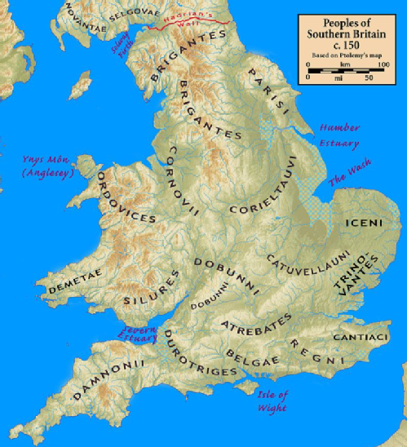
Slide 17: Tribes in Warwickshire
Given our inexact knowledge of the distribution of the tribes in Iron Age and subsequently Roman Britain, it is actually quite difficult to give a definite answer to the question of which tribes inhabited the area which later became Warwickshire. As the map below shows, apart from the Dobunni in the SW, Warwickshire seems to be centrally placed in a sort of no-mans land between the territories of the Corieltauvi and the Catuvellauni.

Slide 18: Tribes in Warwickshire (cont.)
Archaeology helps us somewhat here, for the distribution of Iron Age coins falls broadly into two, with concentrations of Corieltauvian coinage in the north of the county, and Dobunnic coinage in the south. The distributions overlap at sites such as Alcester and Tiddington. As will be discussed below, the tribal capitals of the Dobunni and Corieltauvi also lay closer to us than that of the Catuvellauni, but that does not rule out the possibility that each of these tribes may have had an influence here and that the people of different parts of the region may have thought themselves affiliated to each of these tribes. It is also possible that certain inhabitants of the region imagined themselves affiliated to none of these groups as well. At best, we ought to imagine that the people of Roman Warwickshire at the very least had connections with and shared elements of identity and culture with each of these tribes, and especially perhaps the Corieltauvi.
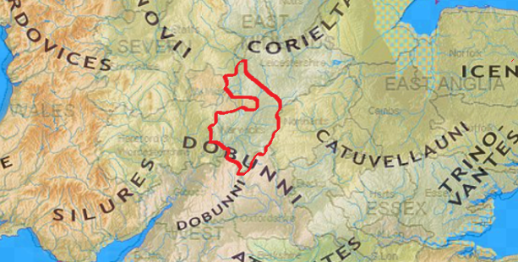
We shall look at each of these tribes in a bit more detail below. But it also worth noting that in the first century AD, the tribes of our region were very much on the periphery of the Romano-British world, whose core lay in the south east. In many ways the people of this region acted as middlemen. As the archaeologist Barry Cunliffe explains, "Beyond the core was a peripheral zone of tribes who traded with the core and through whose territory raw materials and slaves from the north and west of the country passed." (Cunliffe, Britain Begins (2012) page 367).
Slide 19: The Corieltauvi
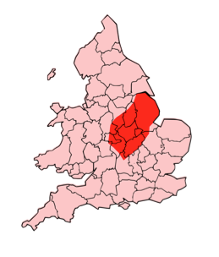
The Corieltauvi (sometimes referred to as the Corieltavi) were a tribe of people living in Britain prior to the Roman conquest, and after the invasion became a client Kingdom, or civitas in Latin, of Roman Britain. Civitates (plural form of civitas) were independent administrative centres, governed by the Britons themselves, though under the supervision of Roman provincial administration based in Londinium (London). You can learn more about the client Kingdoms here.
The territory of the Corieltauvi was in what is now the English East Midlands. They were bordered by the Brigantes to the north, the Cornovii to the west, the Dobunni and Catuvellauni to the south, and the Iceni to the east. Their capital was called Ratae Corieltauvorum, modern day Leicester.
As with most Iron Age tribes, the Corieltauvi were largely an agricultural people. They had only a few strongly defended sites or signs of centralised government, and appear to have been a federation of smaller, self-governing tribal groups.
Slide 20: coins
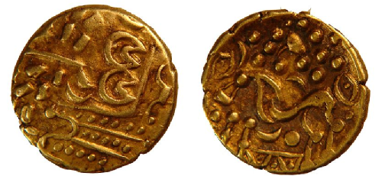
From the beginning of the 1st century BC, they began to produce inscribed coins: almost all featured two names, and one series had three, suggesting they had multiple rulers. The names on the earliest coins are so abbreviated as to be unidentifiable. Right is a gold stater dating to 50-20BC on display at Lincolnshire Museum and produced by the Corieltauvi. Later coins feature the name of Volisios, perhaps the most important king of the region, together with names of three presumed sub-kings, Dumnocoveros, Dumnovellaunus and Cartivelios, in three series minted ca. 45 AD. The Corieltauvi had an important mint, and possibly a tribal centre, at Sleaford.
They seem to have offered little or no resistance to Roman rule. Ratae was captured ca. AD 44, and it may have had a Roman garrison. The Fosse Way, a Roman road which runs through much of south Warwickshire, passed through their territory.

Slide 21: The Dobunni
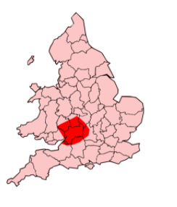
The Dobunni were one of the Iron Age tribes living in the British Isles prior to the Roman invasion of Britain and are known from several references to the tribe in Roman histories and from inscriptions.
The meaning of the name is unclear but some archaeologists such as Miles Russell suggests that their original name may have been "Bodunni", connected with the Celtic word *bouda meaning "Victorious", in the sense of "The Victorious Ones". The name Boudica is also linked to this word meaning victory.
The tribe lived in the area of southwestern Britain coinciding with the modern counties of Bristol, Gloucestershire and the north of Somerset, although at times their territory may have extended into parts of what are now Herefordshire, Oxfordshire, Wiltshire, Worcestershire, and Warwickshire. Their capital was known by the Romans as Corinium Dobunnorum, modern day Cirencester. As for the surrounding peoples, it is thought that they were bordered by the Cornovii and Corieltauvi to the North; the Catuvellauni to the East; the Atrebates and Belgae to the South; and the Silures and Ordovices to the West. But exact ranges for each of these tribes are unknown.
In the Iron Age period, the Dobunni were a large group of farmers and craftsmen, living in small villages concentrated in fertile valleys. Remnants of several fortified Dobunni hillforts can be seen in the Bristol area. In the late Iron Age period, southern Britain saw the development of sites generally referred to as oppida (towns),with an example being Salmonsbury, and Bagendon near Cirencester.

Slide 22: Dobunni coins
Right is a silver Dobunni coin now housed at Salisbury and South Wiltshire Museum, dating from between 50BC and AD43. In the Roman period, like the Corieltauvi the Dobunni became a client Kingdom of the Romans, maintaining good relations with their Roman overseers.
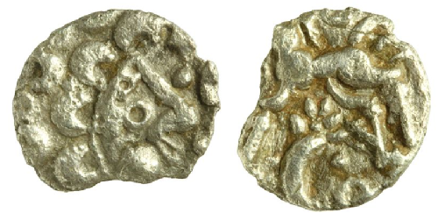
A study of the religion of the Dobunni by Stephen Yeates has shown that there was a focus on the worship of the natural world. It is possible to identify deities associated with the landscape; for example: *Cuda, a mother goddess associated with the Cotswold Hills, and its rivers and springs.

Slide 23: The Catuvellauni
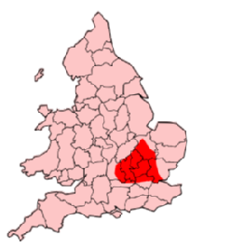
The Catuvellauni (possibly meaning "war-chiefs" in the ancient Gaulish Celtic language) were a tribe or state of south eastern Britain before the Roman conquest, attested by inscriptions into the 4th century AD.
Something of the history and fortunes of the Catuvellauni and their rulers before the conquest can be traced through ancient coins and references in classical histories. They are mentioned, for example, by Cassius Dio, who implies that they led the resistance against the Roman conquest in AD 43. In the 2nd century AD they appear as one of the civitates (client Kingdoms) of Roman Britain in Ptolemy's Geography. In terms of where they were found, they were centred on the town of Verlamion (near modern St Albans) and the surrounding areas of Hertfordshire, Bedfordshire and southern Cambridgeshire. Thus their territory was bordered to the north by the Iceni and Corieltauvi, to the east by the Trinovantes, to the west by the Dobunni and Atrebates, and to the south by the Regnenses and Cantiaci. As such the inhabitants of Warwickshire will at the very least have interacted with these people.
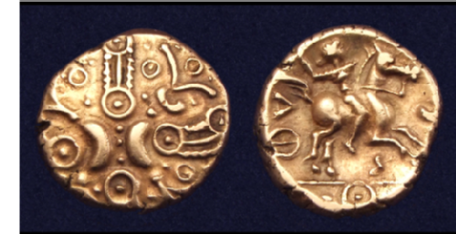
Slide 24: Coins

The story of the rulers of the Catuvellauni and their interactions with Rome is an interesting one, and we shall focus more on this in the section on Interactions.
Left is a coin of the Catuvellauni King Tasciovanus, a so-called "Hidden Faces" gold stater minted at Verlamion near modern day St Albans. On the obverse we see stylized crescents and wreaths with hidden faces. On the reverse is a warrior on horse, carrying a carnyx - a sort of bronze wind instrument with a typical S-shape and often with a stylised animal head.

Slide 25: Iron Age Coventry
An Iron Age village beneath Warwick University
Researchers at the University of Warwick have discovered late iron age roundhouses on the campus. It is the earliest evidence of settlement in Coventry. The discovery of the outline of 15 late iron age roundhouses on the University of Warwick's campus is hugely significant for Coventry. It is the earliest evidence of settlement within the modern boundary of the city. For more information and pictures, visit the site here.
The 15 building outlines uncovered so far appear to be just the edge of a larger complex of Iron Age structures, bounded on side by a small river and leading back to the site of a Neolithic track or pathway.
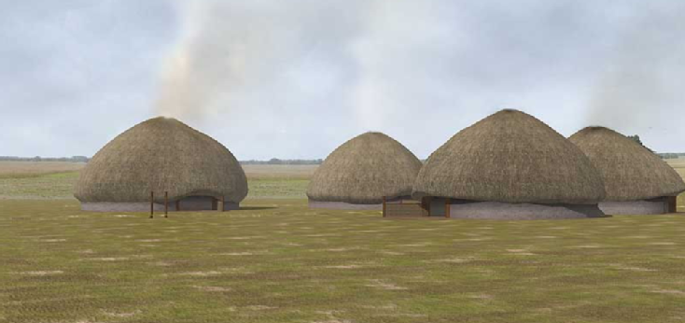
Slide 26: 3D reconstruction of the Iron Age settlement
The number and size of the roundhouses uncovered makes it a significant English Iron Age site and one of the most significant such sites in the West Midlands. Because of its size some of the team involved have dubbed it a housing estate.
The roundhouse outlines uncovered so far are on the large side - the largest being 15 metres in diameter. Dr Stephen Hill, the University of Warwick archaeologist supervising the archaeological dig, believes the site dates from the 1st century BC or the 1st century AD.
Slide 27: massive scale
Click here for 3D animation (1.62mb)
The massive scale of these structures suggests that they may have served public and ceremonial purposes; a suggestion which is supported by the wealth of votive materials (especially horses’ heads and pottery vessels) that were placed in the construction trenches when the round houses were built. The round houses had entrances with porches on their east side away from the prevailing winds. Some of the excavated structures were used for industrial purposes and contained small pottery crucibles for smelting metal. It is likely that domestic houses are yet to be discovered elsewhere within the enclosure.
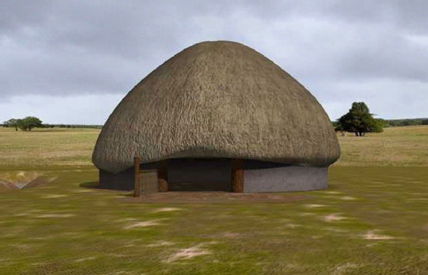

Slide 28: Roundhouses
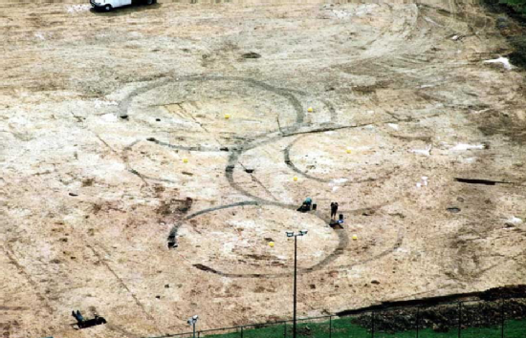
The round houses were impressive structures up to 18 metres in diameter and are likely to have stood about 9 metres tall. They had wattle and daub (mud on hurdle) walls and thick thatched roofs.

Dr Hill has also suggested the inhabitants were probably pushed off the site by the incoming Romans in the first century AD. There is considerable evidence of Roman presence on the University of Warwick site and the Coventry area as a whole.
This point is just inside the northern limit of the extensive Iron Age settlement that extended through the site of University House, as far as the multi-storey car park beside the Warwick Manufacturing Group building. The site here was an excellent one for settlement, consisting of a level clearing with a stream along the south side. The settlement was defended by a substantial ditch and rampart (a section of this can be seen next to the path opposite the entrance to the Westwood Games Hall). An area of the Iron Age settlement was excavated in 2002 at the time of the construction of the all-weather rugby pitch. Although the area had been severely affected by construction work in the 1960s, these excavations uncovered parts of the defensive ditch and rampart and also the construction slots of at least fifteen round houses together with several simple four-post structures which would have served as animal sheds.

Aerial photographs have revealed the existence of a banjo-shaped enclosure on the north side of the Iron Age site, underlying the running track. This structure, which is likely to have been built around a significant burial, may represent the earliest phase of settlement on the site and its presence may explain why large, apparently public, buildings were placed immediately to the south of it.
The excavated structures were arranged in overlapping groups, demonstrating that there were at least three phases of occupation. The implication of this, given the cost and effort involved in constructing buildings from vast quantities of oak, reed and clay, is that the site may have been occupied for a long period in later prehistory.

Slide 29: Meon Hill

Slide 30: Meon Hill Introduction
Meon Hill stands in the southwest corner of Warwickshire, close to the border with Gloucestershire, and forms the northern boundary of the Cotswolds. It is the most northerly of chain of small hills, one of which - Ebrington - is the highest point in all Warwickshire, at 853 ft (about 260m) above sea level. At an elevation of 194m on the flat top of a hill conspicuous for miles around, Meon Hill has great views across the County, especially west across the Vale of Evesham towards Bredon Hill and the Malverns, and north and west towards Stratford and Coventry.

Slide 31 and 32 Meon Hill
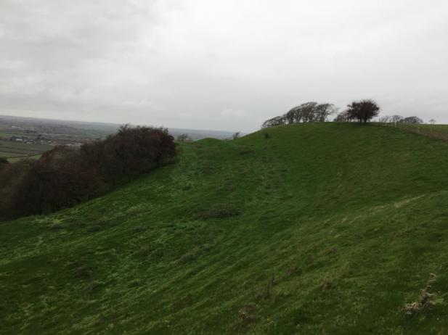
This strategic viewpoint was doubtless one of the reasons why the hill was chosen as the site of an Iron Age hillfort, the remains of which are visible as earthworks (above and blow). As one of only two known examples of large multivallate hillforts (hillforts with two or more ditches) in Warwickshire, Meon hillfort is an example of a rare class of monument in the county. View from the western ramparts of Meon Hill looking North.
Lying within the supposed territory of the Dobunni tribe, this may have been an important tribal gathering place. Finds from the site date from 800BC down to the Roman conquest.

Slide 33: Currency Bars from Meon Hillfort
Meon hillfort was described as a fortification of treble earthworks as far back as the 17th century. The history of archaeological finds at Meon Hill goes back at least to 1824 when a large hoard of 394 iron currency bars was found 1.2m below the surface on the hill possibly just behind the northern rampart. These currency bars were perhaps originally packed into a chest. They appear to be primarily spit-shaped bars (see photo below).The term ‘iron currency bar’ has long been in use to describe these elongated iron objects found in late iron age sites in Britain, and this find on Meon Hill are the earliest finds on record. Some of these are now to be found in Market Hall Museum in Warwick, Oxford, Gloucester, Stratford, Reading, Hereford and Cheltenham.
Iron 'currency bar' from Meon Hill
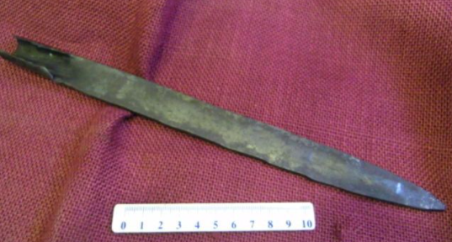

Slide 34: Plan of Meon Hillfort
Excavations and site surveys - beginning in 1906 - recorded the layout of the ramparts and internal features as well as producing a variety of finds. Originally the hill was encircled by a double line of defences which in 1906 were best preserved on the SW and SE. On the E the rampart had been levelled by ploughing and a gap in the W was probably the result of a landslip. These excavations were published in by Hodges in the Transactions of the Birmingham Archaeological Society Vol. 32, (1906), 101-15 as 'Meon Hill And Its Treasures'.

Plan of Meon Hillfort showing landslip (?) gap on the west and flattened/ploughed rampart to the east
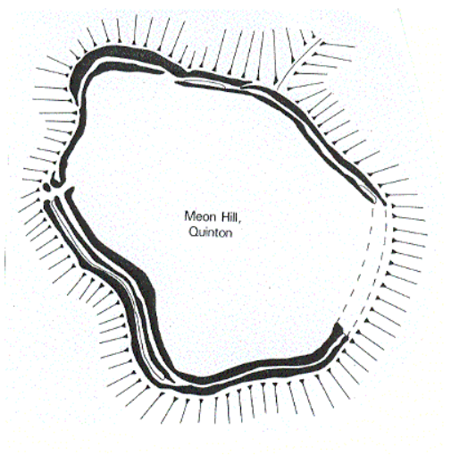
In 1906 the interior was divided up into a northern ploughed field and a southern unploughed field. Excavation by the archaeologist T. R. Hodges uncovered six or so slightly saucer-shaped depressions 4.3m to 6m in diameter on the summit of the hill in undisturbed grassland. One of these was excavated and proved to be a hut. The area of these huts is shown in the photo below, though nothing of the depressions now remains to be seen.

Slide 35: Area of huts on the top of Meon Hill
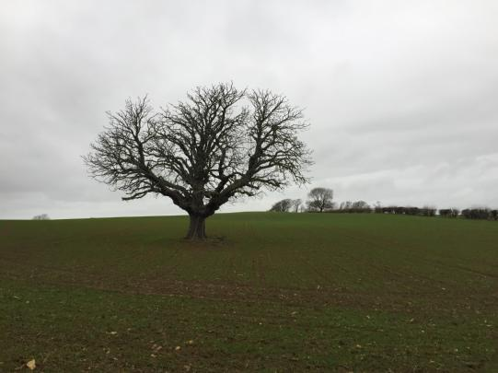
Further excavations were undertaken in 1922 which uncovered Romano-British and earlier pottery, and one or two pieces of bronze and flint. Many artefacts were found in the ploughed interior including Neolithic/Bronze Age finds and fragments of probably Iron Age pottery with three possibly Iron Age whetstones.
Slide 36: View to the west towards Mickleton from the western ramparts
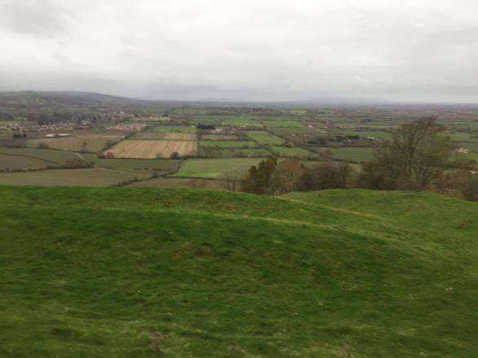
There were two possible entrances on the E and NW, though the latter could be modern. Field walking of the interior produced a sparse scatter of Iron Age pottery, animal bone, fired clay/daub, fire-cracked pebbles and possible sling stones.
In 1957 an Anglo-Saxon inhumation was found within the hillfort. The finds associated with this burial include a shield boss, spearhead and a ferrule (a metal band or ring).
Timetrail record

