
Roman Coventry and Warwickshire Project
Roman Army: Teacher Notes

These teaching notes and the accompanying PowerPoint presentation are designed to give an overview of the Roman army: how it was organised and what a typical soldier was armed with etc. It is a short lesson which might be used in combination with another lesson, such as when studying the Roman Invasion or Boudica’s revolt.
Exercise
More information is given here on the ranks in the army than is found in the PowerPoint. A closer study of these ranks and the organisation of the army based on these notes below might make an interesting lesson for groups particularly interested in the military angle.
Imagining the experience of a Roman soldier based on rank and background will make an interesting exercise for your pupils. Compare for example a rich eques or cavalryman from Rome with a conscripted auxiliary taken from his homeland.
Slides 2-3: The Roman Army

- When considering the Roman invasion of Britain and the battles fought by the Romans and Britons, it is important to bear in mind the military capability of the Roman Army.
- The Roman Army legions under Suetonius Paulinus which marched against Boudicca and the rebels were very well-equipped and well-trained. They were formed of legionaries and auxiliaries.
- The legionaries were the elite soldiers. A legionary had to be over 17 years old and a Roman citizen. Every new recruit had to be fighting fit - anyone who was weak or too short was rejected.
- Legionaries signed up for at least 25 years' service. But if they survived their time, they were rewarded with a gift of land they could farm. Old soldiers often retired together in military towns, called ‘colonia’.
- An auxiliary was a soldier who was not a Roman citizen. He was only paid a third of a legionary’s wage. Auxiliaries guarded forts and frontiers but also fought in battles, often in the front lines where it was the most dangerous.
Slides 5-8: Legionaries’ Equipment

- Shield (scutum): Roman legionaries carried a large rectangular shield known as a scutum. This was curved to help protect the soldier's body and it had a hard iron bulge in the middle for battering their enemies in battle. Soldiers would lift their shields over their heads for protection when fired at from above. They looked like a tortoise, so they called this formation the testudo (Latin for tortoise).
- Sword (gladius): A Roman soldier's trusty sword was called a gladius. It was quite small and light, which made it good for stabbing and slashing in battle. Roman soldiers wore their swords on the right at first. But by the AD300s most Romans wore their swords on the left.
- Helmet (cassis/galea): A Roman soldier's helmet was called a galea. It had special guards to protect their cheeks and neck. Soldiers could also attach a crest made of horse hair to the top of their helmets. However, ordinary legionaries probably didn't wear this in battle. Historians think that it was just used for parades and formal ceremonies.
- Tunic (tunica): Underneath their armour, a Roman soldier wore a woollen tunic. This was probably coloured red or white. The colour may have related to the soldier's rank.
- Armour (lorica segmentata): Body armour was made from overlapping iron plates held together by leather straps and brass clasps. The armour was heavy and very tough so a legionary would wear a tunic underneath for padding. A legionary had to march all day carrying his armour and weapons. Together with his cooking pots and tools, a soldier's equipment could weigh around 35kg.
- Scarf (focale): Soldiers often wore a scarf called a focale too. This protected their neck from rubbing up against their armour.
- Belt (balteus): This is the traditional belt of a Roman soldier/legionary which he used to carry his sword. The balteus is a mark of a soldier — not only that, it's really a status symbol of being a soldier. Worn at all times, even off duty, only soldiers were allowed, by law, to wear this unique belt. It may have helped to protect the soldiers in battle. The belt may represent rank or awards but historians just don't know. Roman objects archaeologists have discovered show that many of these belts were very elaborate. Possibly since Roman soldiers did not have a lot to spend their pay on, they spent it on making their gear fancier. (Baltea): are decorative parts of the belt.
- Boots (Caligae): Roman army boots were called caligae. They were like sandals but much stronger. They were made from leather and had little iron studs on the soles. The iron studs on a Roman soldier's sandals meant that it was easy to slip when running on wet stones! A legionary’s boots were actually the most important piece of his equipment because he had to march across large areas of the Roman World from one fort or camp to another. The legionary had to do all of this on his feet. And so having the right boots was significant for Roman soldiers, including those marching across Roman Britain.
Slides 9-10 The Roman Legion – Structure
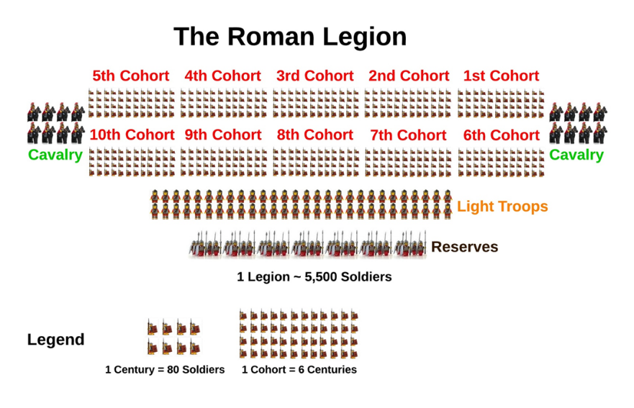
- The basic structure of the army is as follows:
- Contubernium (tent group): consisted of 8 men.
- Centuria (century): was made up of 10 contubernium with a total of 80 men commanded by a centurion.
- Cohorts (cohort): included 6 centuriae or a total of 480 fighting men, not including officers. In addition, the first cohort was double strength but with only 5 centuriae instead of the normal 6.
- Legio (legion): consisted of 10 cohorts.
- Additionally each Legion had a 120 man Alae (cavalry unit) called the Eques Legionis permanently attached to it possibly to be used as scouts and messengers.

Slide 11: Rank Structure
- Just like modern armies, there was a set rank structure for Roman Legions:
- Legatus Legionis: The overall Legionary commander. This post was generally appointed by the emperor, was a former Tribune and held command for 3 or 4 years, although could serve for a much longer period. In a province with only one legion, the Legatus was also the provincial governor and in provinces with multiple legions, each legion has a Legatus and the provincial governor has overall command of them all.
- Tribunus Laticlavius: Named for the broad striped toga worn by men of senatorial rank. This tribune was appointed by the Emperor or the Senate. Though generally quite young and less experienced than the Tribuni Angusticlavii, he served as second in command of the legion, behind the Legate.
- Praefectus Castrorum: The camp Prefect. Generally he was a long serving veteran who had been promoted through the ranks of the centurions and was 3rd in overall command.
- Tribuni Angusticlavius: Each legion had 5 military tribunes of equestrian (knight) class citizens. They were in many cases career officers and served many of the important administrative tasks of the Legion, but still served in a full tactical command function during engagements.
- Primus Pilus: The "First File" was the commanding centurion of the first cohort and the senior centurion of the entire Legion. Service in this position also allowed entry into the equestrian social class upon retirement.
- Centurio: Each Legion had 59 or 60 centurions, one to command each centuria of the 10 cohorts. They were the backbone of the professional army and were the career soldiers who ran the day to day life of the soldiers as well as issuing commands in the field. They were generally moved up from the ranks, but in some cases could be direct appointments from the Emperor or other higher ranking officials.
- The cohorts were ranked from the First to the Tenth and the Centuria within each cohort ranked from 1 to 6, with only 5 Centuria in the First Cohort (For a total of 59 Centuria and the Primus Pilus). The Centuria that each Centurion commanded was a direct reflection of his rank. (Command of the First Centuria of the First Cohort was the highest and the 6th Centuria of the 10th Cohort was the lowest). The 5 Centurions of the First Cohort were called the Primi Ordines, and included the Primus Pilus.
- Pilus Prior: The commander of the first cohort of each Centuria (except the first), with the following titles for the Centurions in sequence throughout each Centuria.
- Pilus Posterior
- Princeps Prior
- Princeps Posterior
- Hastatus Prior
- Hastatus Posterior

- Low-Level Officers in the Roman Legion
- Principales: The Principales would be the equivalent of modern-day non-commissioned officers and had the following rank structures from highest to lowest:
- Aquilifer: A single position within the Legion. The Aquilifer was the Legion's Standard or Eagle bearer and was an enormously important and prestigious position. The next step up would be a post as a Centurion.
- Signifer: Each Centuria had a Signifer (59). He was responsible for the men's pay and savings, and the standard bearer for the Centurial Signum, a spear shaft decorated with medallions and often topped with an open hand to signify the oath of loyalty taken by the soldiers. It was this banner that the men from each individual Centuria would rally around. A soldier could also gain the position of Discentes signiferorum, or standard bearer in training.
- Optio: One for each Centurion (59), they were appointed by the Centurion from within the ranks to act as his second in command.
- Tesserarius (Guard Commander): Again there were 59 of these, or one for each Centuria. They acted in similar roles to the Optiones.
- Cornicen (Horn Blower): They worked hand in hand with the Signifer drawing the attention of the men to the Centurial Signum and issuing the audible commands of the officers.
- Imaginifer: Carried the Standard bearing the image of the Emperor as a constant reminder of the troop's loyalty to him.

- The Rank and File of the Roman Legion
- Immunes: These were trained specialists, such as surgeons, engineers, surveyors, and architects, as well as craftsmen. They were exempt from camp and hard labour duties due to the nature of their work, and would generally earn slightly more pay than the Milites.
- Discens: Milites in training for an immunes position. The word derives from the Latin verb ‘disceo’ meaning ‘I learn’.
- Munifex (or Miles Gregarius): The basic private level foot soldier.
- Tirones: The basic new recruit. A Tirones could take up to 6 months before becoming a full Milites.
Slide 12: The Roman Cavalry
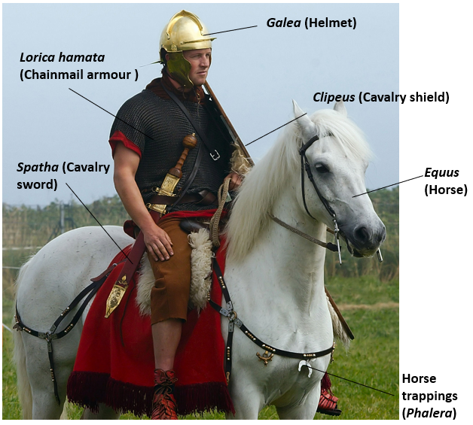
- Roman cavalry from the 1st century BCE most often came from provinces outside Italy and allied states.
- The equites (a high social rank below that of the senatorial class) were required to serve up to 10 years of service in the cavalry between the ages of 17 and 46. The writer Polybius explains that Equites originally provided a legion's entire cavalry contingent. However, from an early stage, when equites numbers had become insufficient, large numbers of young men from the First Class of commoners were regularly volunteering for the service, which was considered more glamorous than the infantry.
- By the time of the Second Punic War, it is likely that all members of the First Class served in the cavalry, since Livy states that members of Class I were required to equip themselves with a round shield (clipeus), rather than the oblong shield (scutum) required of the other classes - and all images of cavalrymen of this period show round shields (Livy I.43). It appears that equites equo privato (i.e. First Class members) were required to pay for their own equipment and horse, but that the latter would be refunded by the state if it was killed in action.
- Cavalrymen in service were paid a drachma per day, triple the infantry rate, and were liable to a maximum of ten campaigning seasons' military service, compared to 16 for the infantry (Polybius II.19, 39).
- Classified as auxilia, these troops formed cavalry wings or alae.
- The alae were divided into cavalry troops (turmae) consisted of 30 men with two officers and commanded by a decurio.
- Command of these units remained in the hands of Roman officers with the title of praefecti but, over the centuries, the difference between auxilia and regular legionaries became less distinct.
- In battle, cavalry were often deployed on the flanks to protect and screen infantry.
- The Romans inherited knowledge of horses from the Greeks, and amassed a large body of knowledge themselves related to which were the best types of horses to employ, which were the best training tactics and tack, and the most effective veterinary practices. The Romans prized stallions from Parthia, Persia, Media, Cappadocia, Spain and Libya
- Horses were fed barley and each cavalryman was allotted six bushels each month. According to Polybius a horse received 3.5 pounds per day. Despite every care taken, horses ran the risk of disease and injury, by far the most common being lameness - largely because horses were unshod. In battle, less serious wounds to the animal could be treated but the biggest threat came from infected wounds.
- For the rider to better control the horse, various tack such as bitting and saddlery were used. The bits placed in the horse's mouth and connected to the reins were often harsh so as to provide an immediate response from the animal, and there is ample evidence that riders wore spurs. Horses could also be muzzled to prevent them biting each other when in close formation. The Roman saddle was made of leather-covered wood and had two front and two rear horns to keep the rider in position, especially important as there were no stirrups. They were also, no doubt, useful for hanging the bits and pieces of a cavalryman's equipment.
- Horsemen wore several important pieces of equipment:
- Horse (equus): a horseman wasn’t a horseman without his horse. Roman cavalry horses were probably smaller than cavalry horses which later armies used in Medieval times.
- Cavalry shield (clipeus): This was an oval wooden shield which was slightly smaller than the legionary’s shield for use on horseback.
- Cavalry sword (spatha): Roman horsemen used a special sword called a spatha. It was longer than the legionary’s sword and so useful for fighting on a horse.
- Helmet (galea): Like the helmet legionaries wore, it had special guards to protect their cheeks and neck. Soldiers could also attach a crest made of horse-hair to the top of their helmets. Some examples archaeologists have found are very decorative and made from gold and silver.
- Chainmail armour (lorica hamata):a type of Roman chain mail formed from hooked rings of bronze or iron.
- Horse tack (bridles/saddle/reins): the Romans used a variety of bridles so that the rider could control the horse. Some types fitted on the horse very tightly. Since stirrups hadn’t been invented in Roman times, horsemen kept themselves in their saddles with horse built into the saddle. There were two at the front and two at the back.

