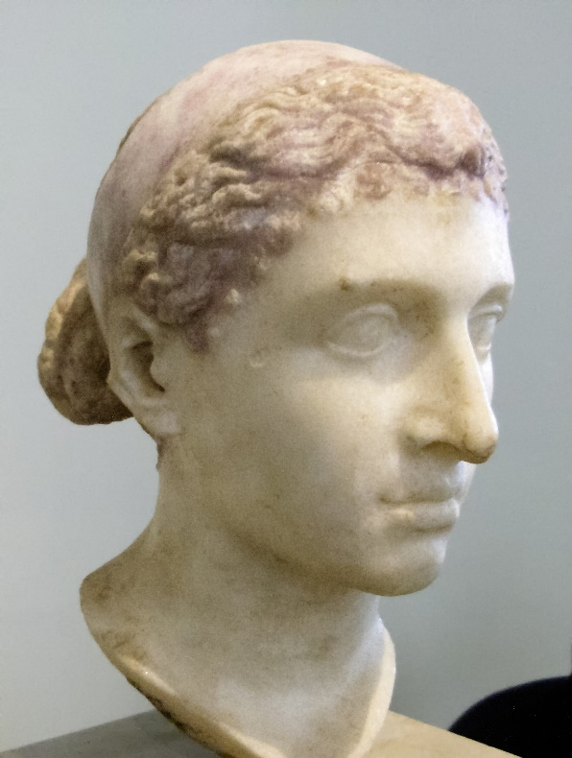
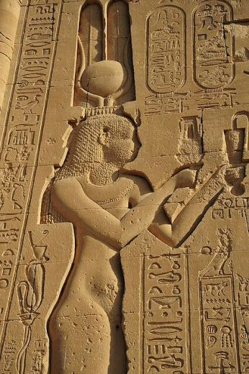
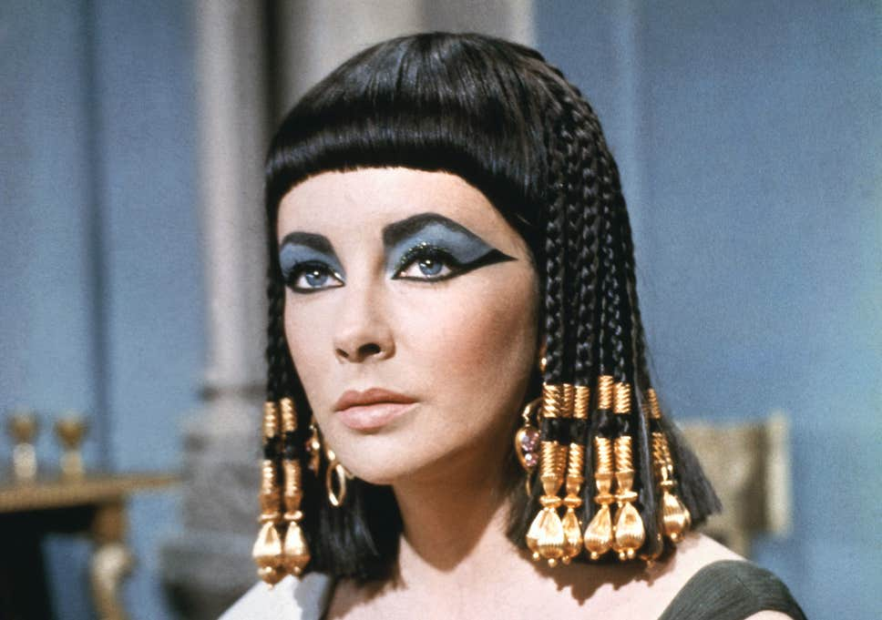
Cleopatra and Rome Revision Booklet

Topic 1 – Cleopatra as Queen of Egypt
We have almost no information about Cleopatra’s childhood, as the interest in her began once she was an adult, but we know that she was born into a complicated family with a father who was seriously in debt to the Romans and mercenaries whom he had paid to support his power in Egypt.
However, we know that once she grew up she was expected to marry one of her own brothers to keep royal power within the family, but that this did NOT lead to positive relationships with her siblings OR an easy first few years in power!
TASK: using past lessons, notes in your workbook and p.154 of the textbook, annotate Cleopatra’s family tree with info on each of the family members, include;
- What we know about their role in Egypt
- What their relationship was like with Cleopatra/ how they challenged her!
- Problems that they might have created in Egypt
- How they eventually died!

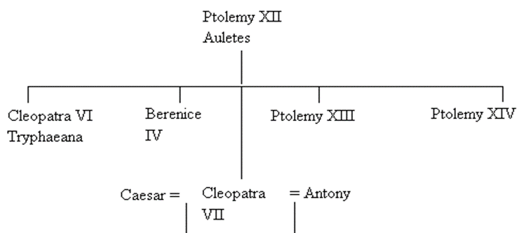

Arsinoe

Cleopatra’s Character and high-quality Education!
We do have a good deal of information on what Cleopatra’s personality and education were like – according to Roman sources at least!
This is a VERY important topic to revise as we can use the positive things we learn about her character to CHALLENGE the negative stereotypes that come from our Roman sources.
TASK: using previous lessons/ notes in your workbooks, p.155-156 & 160-162 and Plutarch, Life of Anthony, 27, complete the diagram summarising the key parts of Cleopatra’s character and education.
6+ work = include a quote from an ancient source for each of the four areas!

EXAM PRACTISE
What can we learn from Plutarch, Life of Mark Anthony 27, about Cleopatra’s personality? (5)
Using details from Plutarch, Life of Mark Anthony 27, evaluate how accurate you think Plutarch’s presentation of Cleopatra is. (5)

Presentation of Cleopatra – in NON-Roman sources!
It can feel frustrating that when we study Cleopatra, we have no writings from her or ever hear her opinion on her own story. However, we do have visual/ archaeological (physical) sources left from around her time that show us how she wanted to look to her people.
In some of the archaeological sources we looks Macedonian, as she had Macedonian heritage through her ancestor Ptolemy, and in some she looks Egyptian, as these were made for her Egyptians subjects to see!
TASK: using previous lessons, your workbook, p. 162-163, annotate the two sources below with the key features from the box. HINT - Try to remember which belong to the Macedonian-style sources, which belong to the Egyptian –style sources, and which work for BOTH!
Diadem/ tiara Tight, cotton sheath dress Head sideways on
Curly hair Strong jawline Uraeus (sacred snake)
Tripartite Wig (wig in three parts) Hook nose Cows horns around a sun disk
Hair in a bun Holding a cornucopia (horn filled with fruits and food)

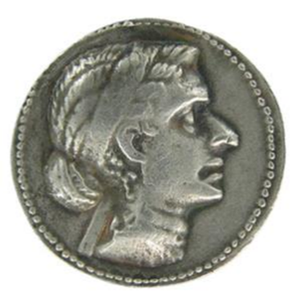
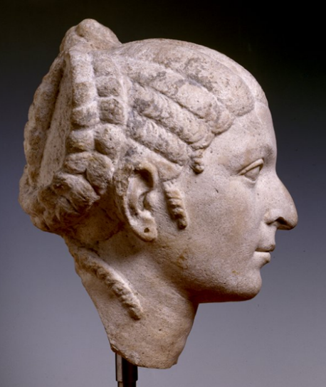
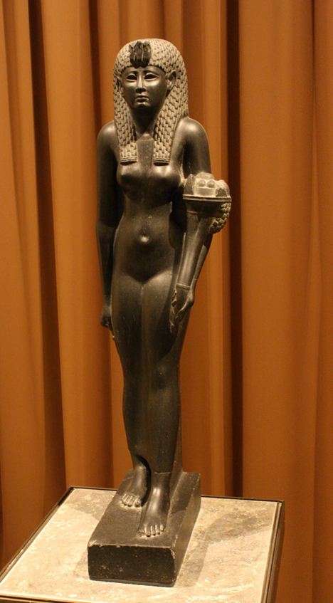

TASK: Give three reasons why it was important for Cleopatra to present images of herself to her public, both Macedonian/ Hellenistic and Egyptian images.
- ………………………………………………………………………………………………………………………………………………………………………………………………………………………………………………………………………………………………………………………………………………………………………………………………………………………………………………………………………………

- ………………………………………………………………………………………………………………………………………………………………………………………………………………………………………………………………………………………………………………………………………………………………………………………………………………………………………………………………………………

- ………………………………………………………………………………………………………………………………………………………………………………………………………………………………………………………………………………………………………………………………………………………………………………………………………………………………………………………………………………
The story of Isis
Cleopatra chose Isis as her patron goddess, this meant that Cleopatra associated herself with the goddess, dressed like her and said that the two of them were connected. One of the benefits of this was that the story of the goddess Isis was oddly similar to Cleopatra’s own life story, which made it easier to justify her life to any Egyptians who might question her relationships and actions against her own brother!
TASK: using previous lesson, your workbook and p. 163-165 of the textbook, summarise the story of Isis in 3 main steps, and then next to each step, explain what part of Cleopatra’s life this was similar too and helped justify.

EXAM PRACTISE
How effective was Cleopatra’s presentation of her own image in helping her secure her rule in Egypt? (10)

Topic 2 – Cleopatra’s relationship with Julius Caesar

Egypt had been involved with Rome since it became a Client Kingdom of the Roman empire in168BC, which meant by the time Cleopatra started her relationship with Julius Caesar – and so became a focus for Rome – Egypt wasn’t new for the Romans. What was new was the fact that there was a Queen who was standing up for herself and her own interest!
TASK: using previous lessons, your workbooks and p. 169-170 of the textbook, list 3 significant points in the History between Egypt and Rome, BEFORE Cleopatra came to the throne.

- ……………………………………………………………………………………………………………………………………………………………………………………………………………………………………………………………………………………………………………………

- ……………………………………………………………………………………………………………………………………………………………………………………………………………………………………………………………………………………………………………………

- ……………………………………………………………………………………………………………………………………………………………………………………………………………………………………………………………………………………………………………………
TASK: using previous lesson, your workbooks and p.168-169 of the textbook, complete the venn diagram summarising the benefits for Rome and Egypt when it came to having/ being client states – consider factors that are benefits for both!

Civil War between Cleopatra and Ptolemy XIII, 48-47BC
In 48BC, Ptolemy XIII and his advisors had successfully driven Cleopatra out of Alexandria/ Egypt. Cleopatra returned to Egypt later on in 48BC, with an army large enough to challenge Ptolemy XIII, and Ptolemy sent his general, Achillas, to meet her forces.
While this civil war was building in Egypt, the Roman civil war was also happening between Julius Caesar and Pompey the Great. Pompey was on the verge of defeat, and headed to Egypt for support. Upon arrival in Egypt, Pompey met his end. It was decided by Ptolemy and his advisors that Caesar was the better ally to have…
TASK: using previous lessons, your workbooks, p.171 of the textbook and Plutarch, Life of Caesar 48, finish the sentences summarising the events when Pompey arrived in Alexandria.
- Pompey had been fighting ……………… for con troll of the ………………………….., but he was losing this fight.
- Pompey fled to the city of ……………………………, where he anticipated he would receive help from the Egyptians because…………………………………………………………………………………………………………………………………
- Ptolemy XIII decided to decapitate Pompey because………………………………………………...............................
- When Caesar arrived in Alexandria, following Pompey, his reaction to learning that Pompey had been killed was……………………………………………………., he felt this way because………………………………………………………………….
- This helped push Caesar and Cleopatra closer because…………………………………………………………………………………
Cleopatra meets Caesar
Ptolemy had hugely offended Caesar by killing his friend and adversary, Pompey. This leads us on to a VERY important moment in the history of Cleopatra; her meeting Julius Caesar. This meeting tends to be remembered through Plutarch’s account where Cleopatra hide herself in a rolled up carpet, but it is worth remembering that Plutarch is the ONLY SOURCE that ever mentions this romantic tale!
TASK: using previous lessons, your workbooks, p.171-173 of the textbook and Plutarch, Life of Caesar, 49, complete the diagram explaining the meeting of Cleopatra and Julius Caesar
6+ work = include a quote from an ancient source for each of the four areas!

Historians debate why it was that Caesa chose to support Cleopatra. Some argue that it was because he hated Ptolemy so much after he killed Pompey, others think it’s because he felt Cleopatra would be a better political ally to have on the throne and some think it was motivated by romantic feelings!
TASK: In your opinion, why did Caesar chose to support Cleopatr as Queen?
CHALLENGE: Read Cassius Dio, Roman History, 44- 45 and see how far you agree with Dio’s answer to this question!
………………………………………………………………………………………………………………………………………………………………………………………………………………………………………………………………………………………………………………………………………………………………………………………………………………………………………………………………………………………………………………………………………………………………………………………………………………………………………………………………………………………………………………………………………………………………………………………………….......................................................................
What lead to Caesar’s decision to support Cleopatra’s claim to the throne in 46BC? (10)
Using details from Cassius Dio, Roman History, 44-45, evaluate how accurate you think Dio’s presentation of Caesar’s motivations in supporting Cleopatra is. (5)
EXAM PRACTISE

Impact of Cleopatra and Caesar’s relationship on Rome
Caesar was the most powerful man in Rome once Pompey was dead, and this made him (basically) the leader of the Roman empire, even though there was still a Senate full of politicians who had ideas of their own! This meant that Caesar’s romantic life and activites in Egypt, affected Rome as well.
TASK: using previous lessons, your workbooks, p.175-176 of the textbook and Cassius Dio, Roman History, 44- 45, list 5 problems Caesar was facing. 2 that he still faced back in Rome, and 3 that he faced now he had made Cleopatra Queen in Egypt.
- ……………………………………………………………………………………………………………………………………………………………………………………………………………………………………………………………………………………………………………………

- ……………………………………………………………………………………………………………………………………………………………………………………………………………………………………………………………………………………………………………………

- ……………………………………………………………………………………………………………………………………………………………………………………………………………………………………………………………………………………………………………………

- ……………………………………………………………………………………………………………………………………………………………………………………………………………………………………………………………………………………………………………………

- ……………………………………………………………………………………………………………………………………………………………………………………………………………………………………………………………………………………………………………………

Personal benefits for Cleopatra and Caesar
This relationship had serious consequences for Rome and Egypt as an empire and a country, but there were also personal benefits that Caesar and Cleopatra had from being together.

TASK: using previous lessons, your workbooks, p.176-177 of the textbook, complete the spider diagram summarising benefits for Cleopatra and Caesar from being in a relationship together.
CHALLENGE: are any of the benefits the same for both people?

Caesar had the problem of being shut off from water, since the canals were dammed up by the Ptolemy and his men. Secondly, when the enemy tried to cut off his fleet, he was forced to resist the danger by using fire, and this spread from the dockyards and destroyed the great library of Alexandria. Thirdly, when a battle arose at Pharos, he jumped from the pier into a small boat and tried to go to the aid of his men in their struggle, but the Egyptians sailed up against him from every side so that he threw himself into the sea and with great difficulty escaped by swimming. It is said that at this time too, he was holding many papers in his hand and would not let them go, but he held them above water with one hand and swam with the other. But finally, after Ptolemy had gone over to the enemy, Caesar marched against him and conquered him in a battle where many died and the king himself disappeared. Then, leaving Cleopatra on the throne of Egypt…
Plutarch, Life of Caesar, 49

EXAM PRACTISE
Using details from passage, what can we learn about Caesar’s relationship with Ptolemy XIII? (5)

………………………………………………………………………………………………………………………………………………………………………………………………………………………………………………………………………………………………………………………………………………………………………………………………………………………………………………………………………………………………………………………………………………………………………………………………………………………………………………………………………………………………………………………………………………………………………………………………………………………………………………………………………………………………………………………………………………………………………………………………………………………………………………………………………………………………………………………………

Using details from passage, evaluate how accurate you think Plutarch’s account of Caesar’s time in Egypt is. (5)

………………………………………………………………………………………………………………………………………………………………………………………………………………………………………………………………………………………………………………………………………………………………………………………………………………………………………………………………………………………………………………………………………………………………………………………………………………………………………………………………………………………………………………………………………………………………………………………………………………………………………………………………………………………………………………………………………………………………………………………………………………………………………………………………………………………………………………………………
What were the consequences of Cleopatra’s relationship with Julius Caesar? (10)

The Birth of Caesarion
Around July or August 47BC, Caesar left for Asia Minor to campaign further into the East. It was around the same time that Cleopatra gave birth to her first child.
She called the boy Ptolemy Caesar, and for the Alexandrians there was little doubt as to his parentage, they quickly took to calling him by his nickname – Caesarion (little Caesar).
As Caesarion was non-Roman, he could never formally inherit from Caesar, but Caesar did indeed recognise his son and others commented on their similarity of appearance. Having his son share the throne with Cleopatra also strengthened Caesar’s power in Egypt.
TASK; using previous lessons, your workbooks, annotate the two sources with evidence that Caesarion was indeed Caesar’s son, and evidence that Cleopatra promoted him has king in Egypt. Explain HOW for each point you make!
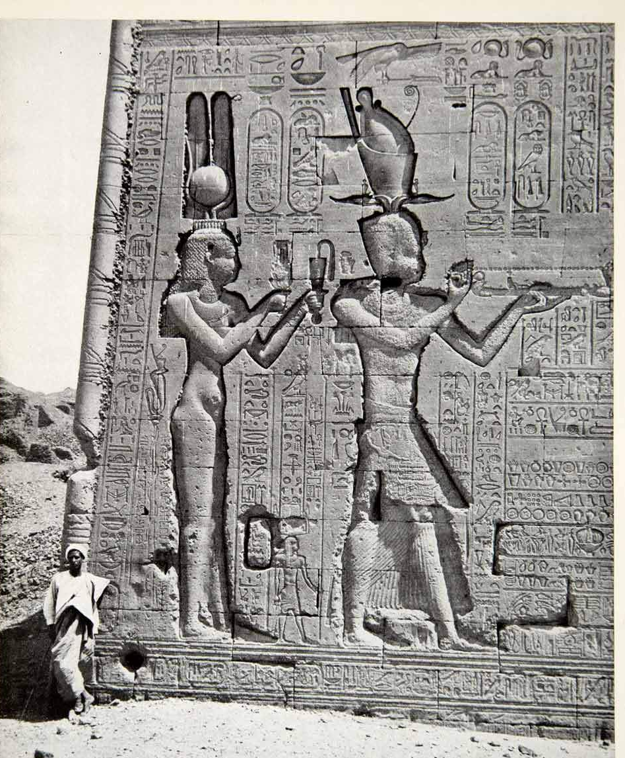
Evidence #1
……………………………………………………………………………………………………………………………………………………………………………………………………………………………..
Evidence #2
……………………………………………………………………………………………………………………………………………………………………………………………………………………………..
Evidence #3
………………………………………………………………………………………………………………………………………………………………………………………………………………………………

He finally summoned her to the city of Rome and sent her back only when she had received the greatest honours and rewards. He allowed her to call her son by him by his own name. Certain Greek writers have reported that he was similar to Caesar in appearance and in his way of walking. Indeed Mark Antony confirmed to the Senate that he had been acknowledged by him and that Caius Matius and Caius Oppius knew this along with the rest of Caesar’s friends.
Suetonius, Life of Divine Caesar, 52,

Cleopatra arrives in Rome
In a step that, arguably, further proves the meaningfulness of the relationship between Cleopatra and Caesar, in 46BC Cleopatra visited Caesar in Rome. She brought both her ‘husband’/ brother Ptolemy XIV and her son Caesarion.
Cleopatra’s arrival was not greeted by a popular welcome, and for many was just MORE evidence that Caesar wasn’t able to rule Rome effectively…
TASK: using previous lessons, your workbooks, p.178-179, Suetonius, Life of Divine Julius Caesar, 52 and Cicero, Letters to Atticus XV.15, complete the flow chart explaining what happened when Cleopatra went to Rome.

Topic 3 – Cleopatra’s relationship with Mark Anthony
The assassination of Julius Caesar threw Rome into chaos. The conspirators insisted that in killing Caesar, they had spared Rome tyranny and corruption, whereas the friends and supporters of Caesar were shocked by the actions and eager for revenge.
The Caesarion-supporters were led by Marcus Antonius, known to us as Mark Anthony, who was Consul of Rome and used his influence to fire up the public during Caesar’s emotive funeral.
Mark Anthony seemed to be the obvious next leader of Rome, but Caesar’s 18yr old Great-Nephew, Octavian, had been adopted as Caesar’s son and was now also in contention for control of Rome….
As part of his work to take control from Octavian, Mark Anthony reconnected with Cleopatra and their love affair began. – It is likely that Cleopatra and Mark Anthony had already met when Cleopatra travelled to Rome to visit Julius Caesar.
Mark Anthony vs. Octavian – the early years
TASK: using previous lessons, your workbooks, and p.182-183 of the textbook, complete the diagram charting the different actions of Mark Anthony and Octavian during the first few years that they both came to power.

Cleopatra in Rome 41-44BC
The uncertainty of Rome’s political situation, the fact that Mark Anthony and Octavian were duelling for power, left Cleopatra in a difficult position. She had left Rome shortly before Caesar’s death, and understood that her main aim must be to stabilise and cement her own power in Egypt.
TASK: : using previous lessons, your workbooks, and p.183 of the textbook. Complete the diagram assessing the problems Cleopatra faced and how she solved these problems.

EXAM PRACTISE
How effective were Cleopatra’s solutions to Egypt’s internal problems 41-44BC? (10)

Cleopatra’s meeting with Mark Anthony at Tarsus
Anthony spent the winter of 42BC in Athens, enjoying his time there and preparing for further excursions East. He quickly endeared himself to the Athenians by taking part in their religious customs and adopting the Greek style of dress.
According to Plutarch, Mark Anthony had a playful nature and he enjoyed the finer things in life. This element of his personality is what would draw him towards the wealth of Egypt, but also earn the scorn of more traditional Romans who didn’t like such traits.
Mark Anthony first met Cleopatra after turning to the wealth of Egypt to fund his campaigns, and aimed to have a positive relationship with Cleopatra.
He summoned her to Tarsus, which she agreed to, and Plutarch believes that her intention to win Anthony over was clear from that moment.
Plutarch’s presentation of Mark Anthony
TASK: using previous lessons, your workbooks, p.185 of the textbook and Plutarch Life of Mark Anthony 24, 25, & 28, fill the spider diagram with examples of what we learn about Mark Anthony’s nature and personality. – for each one, think! Does it make Anthony look good or bad?
CHALLENGE:
Who does the person that Plutarch chooses to compare Mark Anthony to tell us about what Plutarch thinks of Mark Anthony?

Meeting at Tarsus
Cleopatra’s arrival at Tarsus was, supposedly, magnificent. She arrived on one of her huge boats, a pleasure boat of the grandest proportions, and was dressed as the goddess Aphrodite.
Her arrival quickly drew large crowds, but Plutarch reports that Anthony initially missed it as he was receiving other guests at the local market. It would seem as though a connection quickly built between the two figures, and they soon became allies as well as lovers.
TASK: using previous lesson, your workbook and p.186, read the passages below and answer the comprehension questions alongside them. For each answer, include a quote to prove your point!
She received many requests both from Antony himself and from his friends calling for her to visit him; yet, she treated him with such contempt and laughed at him, instead she sailed up the River Cydnus in a barge covered in gold, its purple sails in the wind, its rowers pressing on with silver oars to the sound of flute and pipes. She herself lay back beneath a canopy embroidered with gold, dressed to look like Aphrodite [Venus] in some painting, while on both sides stood boys made up as Cupids in paintings who fanned her… Marvellous strong-smelling perfumes drifted from many burners towards the banks of the river. Some of the people followed her on both banks of the river right up the river from its mouth, while others came down from the city to see the sight.
Finally only Antony himself, seated on his platform, remained. Everywhere there was the rumour that Aphrodite would celebrate with Dionysus [Bacchus] for the good of Asia.
Therefore, Antony sent an invitation to her for dinner; but she thought that it was better for him to come to her. So immediately wishing to show his readiness to accept and his generosity, Antony agreed and went. What met him was a preparation that was beyond any description, but what especially amazed him was the enormous number of lights. We are told that many of these lights were hung from the roof and displayed everywhere at once… in such a way that few sights could have been as beautiful.
Plutarch, Life of Mark Anthony, 26
How does Cleopatra make herself look impressive in front of Mark Anthony?

How does Cleopatra respond to Anthony’s demands to come to him at Tarsus?

How does Anthony respond to Cleopatra’s efforts at Tarsus?

On the next day, Antony supplied the banquet for her; he was eager to surpass her feast in its brilliance and presentation; however, in both of these he was completely defeated and left way behind. He was the first to joke about the squalid and common nature of his efforts.
Cleopatra saw in these jokes that in Antony there was a lot of the soldier and the common man, and used this way of behaving towards him, showing confidence and no restraint now. Her beauty, so we are told, was not itself outstanding; it did not immediately strike those who saw her; yet being with her had an inescapable hold; when talking with her, she was persuasive, and the character which surrounded her whole manner in company had a force to it.
Her voice had a pleasantness of tone; and her tongue, like some musical instrument with many strings, could be turned to whatever language she wished, so that in conversations with barbarians, she rarely spoke through an interpreter, mostly making her own replies on her own regardless of whether they were Ethiopians, Troglodytes, Hebrews, Arabians, Syrians, Medes or Parthians. Indeed, it is said that she had learnt the languages of many other peoples, although the kings of Egypt before her had not even tried to learn the Egyptian language, and some actually had given up speaking their own Macedonian dialect.
Plutarch, Life of Mark Anthony, 27
How is Anthony presented as wanting to please Cleopatra?

Where does it feel like Plutarch is ‘moralising’ in this passage?

How is Cleopatra presented as seductive?

EXAM PRACTISE
Using details from passage, evaluate how accurate you think Plutarch’s portrayal of Anthony and Cleopatra is. (5)

The Perusine War and ‘peace’ between Mark Anthony and Octavian
Anthony spent the winter of 41-40BC in Alexandria with Cleopatra. Plutarch, life of Mark Anthony, 28, continues the negative and moralising view of Anthony, claiming that he ‘let himself be carried off by (Cleopatra) to Alexandria’, and says that the two spent the whole winter at grand leisure – demonstrating their focus on extravagance and spoilt riches.
This winter of leisure would not go on forever, and eventually Anthony had to return to Italy to supress the threat from Pompey’s Son, Sextus, who had taken the Mediterranean in a bid to reclaim his father’s power…This meant he had to, once again, work with Octavian to save Rome, but this lead the Perusine War!
TASK: using previous lessons, your workbook and p.187-188 of the textbook, complete the flowchart summarising the Perusine war. Make sure to include; Sextus taking control of the Mediterranean, The decision of the Triumvirs and marriage of Octavia and Mark, Treaty of Tarentum, Antony sails back to Antioch – last event

Cleopatra and Mark Anthony reunite!
While the Perusine war had been raging, and Anthony and Octavian had seemingly entered a new period of peace, Cleopatra had continued to rule Egypt from 41-37BC with the support of Rome and Anthony.
In the winter of 37BC, Anthony summoned Cleopatra to winter with him in Antioch, for both romantic and political reasons… This, obviously, was a huge insult to his new marriage to Octavia and it was worsened by his decision to recognise the twin boy and girl that he had, had with Cleopatra.
TASK: using previous lessons, your workbook and p.188-190 of the textbook, complete the diagram explaining the consequences of Cleopatra and Mark Anthony reuniting and how this relationship became significant for Rome!
6+ work!:
Make sure to explain how it is significant for BOTH sides, bot just one. Think about benefits and drawbacks for each nation!
……………………………………………………………………………………………………………………………………………………………………………………………………………………………………………………………………………………………………………………………………………………………………………………………………………………………………………………………………………………………..

Relationship between Mark Anthony and Octavian breaks down – is Cleopatra to blame?
By 36BC, Anthony finally headed eastwards into Parthia and was initially successful in his military campaign, with his joint Roman and Egyptian army. However, the campaign soon turned to disaster, with Anthony losing nearly 30,000 men and leaving his army in Armenia, to return to Syria and await the arrival of Cleopatra with reinforcements
Meanwhile, Octavia continued to be the loyal wife, and travelled as far as Athens with resources for Anthony, only to be told by him to stay there but send on the supplies if she wanted. It became clear to her that his true love was Cleopatra, and she returned to Rome, devastated, and Octavian encouraged her to seek a divorce…
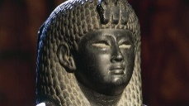
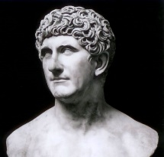
TASK: using previous lessons, your workbook, textbook p.190-191 (stop when you get to The Donations of Alexandria) and Plutarch 51, 53 and Velleius Paterculus 2.82, complete the spider diagram summarising the actions of each of the main characters at this time. For each, summarise; their actions, any mistake they make and their aims in what they’re doing.

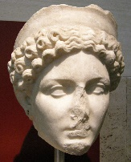

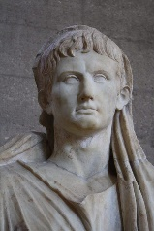

The Donations of Alexandria 34BC
By 34BC, Anthony had cut all contact with Octavia, and following a major military success in Armenia, he returned to Alexandria and put on spectacular celebrations with Cleopatra. Celebrations that seemed a lot like a Roman triumph, which was only allowed to take place in Rome, as a victory FOR Rome.
This was followed a few days later by a staggering ceremony, where Anthony, joined by Cleopatra who was dressed as the goddess Isis, announced that the empire that he controlled would be split between his sons after his death, and that Caesarion was the formal co-ruler alongside Cleopatra.
The formal recognition of Caesarion as Caesar’s son threatened Octavian, and he now actively spoke out against Anthony, claiming he was more of a foreign king than a triumvir of Rome. There was no going back.
TASK: using previous lessons, your workbook, textbook p.191-192, Plutarch life of Mark Anthony, 54 complete the flow chart summarising the Donations of Alexandria by answering the questions in each box.



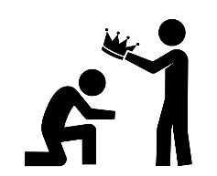



Which parts of the coin may have insulted a Roman audience?
Which parts of the coins emphasise the importance/ power of Cleopatra’s children.
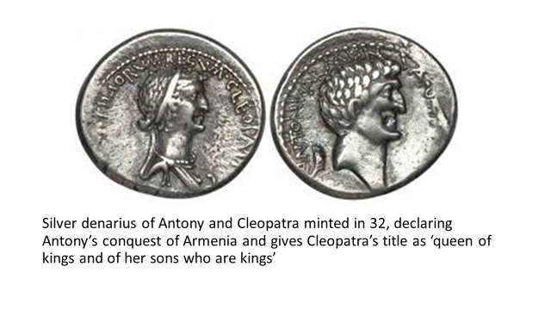
Explain the significance of the Donations of Alexandria for Rome and Egypt . (10).
Using details from coin, evaluate how accurate you think it presentation of Anthony and Cleopatra is. (5)
EXAM PRACTISE
Why would we consider this to be quite an accurate and reliable source when trying to work out the consequences of the Donations of Alexandria?
Which parts of the coin emphasise Anthony’s importance/ power.

Topic 4 – the Battle of Actium and its significance for Egypt and Rome
By 31BC, a range of actions had been taken, by Octavian and Mark Anthony/ Cleopatra, that the relationship was completely beyond repair.
The Donations of Alexandria had confirmed for many that Anthony had become a decadent and dangerous eastern king, weak-willed and ruled by his threatening Egyptian Queen. His decision to split his half of the empire amongst his children, encouraged the belief that he was going to destroy the Roman Empire.
This was made all the worse by Octavian war of propaganda back in Rome, and his active attempts to slander Cleopatra and present her as a danger to the empire.
TASK: using previous lessons, your workbook, textbook p. 195, complete a spider diagram with at least 5 causes of war between Mark Anthony/ Cleopatra and Octavian. – challenge yourself to go as far back through the history as you can! Think about Caesar’s will?
6+ work!:
Select the factor that you think was most SIGNFICANT in causing war. Explain why you chose that one.

Causes of war in 31BC

Mark Anthony and Octavian prepare for war
The two sides, Anthony and Octavian, quickly assembled their armies. Plutarch records that Anthony and Cleopatra had a force of 500,000 ships, 100,000 infantrymen and 12,000 cavalry men. Whereas Octavian had a far smaller force of 250 warships and 80,000 infantrymen, although a similar amount of cavalry men.
Ancient sources tend to inflate the numbers of military forces (e.g. Herodotus’ inflation of figures for Xerxes’ Persian army), but the types of forces makes it clear that a fight was expected at land and sea.
TASK: using previous lessons, your workbook, textbook p. 196-197, Plutarch, Life of Mark Anthony, 60, 62, 63 and 64 from your source booklet, complete the table summarising how both sides prepared for this battle. After reading the sources again, make 3 points about how Plutarch is presenting Mark Anthony’s character here! – it’s not good!
Mark Anthony’s preparations | Octavian’s preparations
How does Plutarch present Mark Anthony in these passages?

How similar is this presentation to how Plutarch has talked about him before? – Think about; meeting Cleopatra, Donations of Alexandria, etc.

The Battle of Actium 31BC
Having prepared for battle against Octavian, Mark Anthony and Cleopatra met his forces on the western coast of Greece. Octavian would win this battle and this victory over Mark Antony would allow him to become the master of the Roman world.
Antony, with 500 ships and 70,000 infantry, made his camp at Actium. Octavian, with 400 ships and 80,000 infantry, arrived from the north and, by occupying the nearby island of Corinth, also managed to cut Antony’s southward communications with Egypt. Desertions by some of his allies and a lack of provisions soon forced Antony to take action.
The following naval battle was fiercely fought, with each side’s squadrons trying to outflank the other, until Cleopatra took her Egyptian galleys and fled the battle. Antony then broke off and with a few ships managed to follow her. The remainder of his fleet became disheartened and surrendered to Octavian, and Antony’s land forces surrendered one week later.
TASK: using previous lessons, your workbook, textbook p. 197-198 and the internet, complete the flow chart timeline of the main events of the Battle of Actium 31BC.

Make sure to include;
Where Octavian’s strategy.
Challenges Anthony faced
The start of the battle
Fighting during it
Cleopatra’s desertion
Anthony’s fleeing

How did the Ancient Sources talk about the Battle of Actium 31BC?
The Roman accounts of the Battle of Actium are all the same. This is likely because the sources and their authors were pro-Octavian, either genuinely preferring him or at least writing when Octavian was incharge.
The sources present the following picture: Antony and Cleopatra met Octavian and Agrippa, fighting was closely matched before Cleopatra fled wit her forces and Anthony followed leaving the battle to be won by Octavian.
In a number of sources the glory of the battle and the role of certain characters and their actions have been exaggerated. You could well be asked an exam question on the accuracy of these sources in terms of people or events at the Battle of Acitum 31BC.
TASK: using previous lessons, your workbook, textbook p.199-200 and Plutarch, Life of Mark Anthony, 68, Velleius Paterculus, The Roman History, 2.82-86, and Aeneid, 8.6675-731.- all in your source packs, summarise how each source spoke about the battle.
Source | How do we know they are on Octavian’s side from their description of the battle? | How do they present Mark Anthony and Cleopatra? | Based on their methods and aims (cheat sheet!), why would they record the battle like this?
Plutarch, Life of Mark Antony, 68.

Velleius Paterculus, The Roman History, 2.82-86

Virgil, Aeneid, 8.6675-731

Impact of the Battle of Actium 31BC on Mark Anthony and Cleopatra
Octavian benefitted hugely from Antony's loss of the battle of Actium, he was able to take over most of Antony’s fighting force and he destroyed what remained of Antony’s fleet. Antony’s flight from the battle had left him reeling, but it had at least meant that he and Cleopatra survived, and Cleopatra’s treasury was still in tact.
According to the sources, however, the reputation of the once great Mark Antony was now in tatters. Cleopatra though, had faired slightly better…
TASK: using previous lessons, your workbook, textbook p..201 of the textbook, and Plutarch Life of Mark Antony 67 and 69, complete the diagram summarising the different experience for Cleopatra and Mark Anthony after their lost the battle. – focus on what it meant for their power and careers!
6+ work!:
Which of the two figures would you argue suffered the most as a result of the defeat at the Battle of Actium?
Explain why!

Mark Anthony’ suicide
Cleopatra, sensing the end, Is reported to have built herself a funeral pyre to burn on, with her riches, if Octavian took the city. Antony won a small skirmish, but then was beset by a range of disastrous events, which lead to his decision to commit suicide.
It seems as though the relationship between Cleopatra and Mark Antony began to weaken during this time.
TASK: using previous lessons, your workbook, and textbook p.201-202 of the textbook and Plutarch Life of Mark Antony 74, 75, and 76, summarise the events leading up to and INCLUDING Mark Anthony’s suicide.

- ……………………………………………………………………………………………………………………………………………………………………………………………………………………………………………………………………………………………………………………

- ……………………………………………………………………………………………………………………………………………………………………………………………………………………………………………………………………………………………………………………

- ……………………………………………………………………………………………………………………………………………………………………………………………………………………………………………………………………………………………………………………

- ……………………………………………………………………………………………………………………………………………………………………………………………………………………………………………………………………………………………………………………

- ……………………………………………………………………………………………………………………………………………………………………………………………………………………………………………………………………………………………………………………
Octavian now arrives in Alexandria
Octavian entered Alexandria in great pomp and show. He was very much the successful conqueror. He spoke to the people of Egypt, before he tackled the issue still presented by Cleopatra and her children. This dispelled any myths still present that Cleopatra was in charge and had been successful at Actium…
Cleopatra had anticipated Octavian’s arrival, and had deliberately locked herself (and her treasury!) away in purpose-built mausoleum, so that she could end her life on her own terms. Octavian wanted her alive so she could be paraded through the streets of Rome at a celebratory triumph, in his honour.
TASK: using previous lessons, your workbook, read p. 202 and Plutarch Life of Mark Antony 79 and 81, explain what problems Octavian faced dealing with Cleopatra and how he solved these problems.

Octavian meets Cleopatra
Now that he had finally managed to secure Cleopatra, Octavian met with her to discuss terms, or so Cleopatra hoped. According to Plutarch, Cleopatra was desperate and dishevelled, but still a beautiful queen who blamed Antony for her actions and hoped to gain some favour from Octavian. Octavian was reportedly unmoved by her pleading and charms, but encouraged her to think positively in case she attempted suicide again.
Read Plutarch’s account of the same event, explain how similar the two accounts are to eachother.

Where has Plutarch presented these characteristics in Cleopatra before?

How is Cleopatra presented in this source? Why do you think she is made to look like this?

Such words she uttered, expecting to move him to pity, but Caesar(Octavian) made no answer to them; fearing, however, that she might kill herself, he begged her again to be of good cheer, and not only did not remove any of her attendants but also took special care of her, that she might add brilliance to his triumph. This purpose she suspected, and regarding that fate as worse than a thousand deaths, she developed a genuine desire to die, and not only addressed many requests to Caesar that she might die in some manner or other, but also devised many plans herself. But when she could accomplish nothing, she feigned a change of heart, pretending to set great hopes in him and also in Livia (his wife). She said she would sail to Rome of her own free will, and she prepared some treasures to use as gifts, in the hope that by these means she might inspire belief that it was not her purpose to die, and so might be less closely guarded and thus be able to destroy herself.
Cassius Dio, Roman History, 51.13 – Cleopatra meets with Octavian

Cleopatra’s Death and the Roman response
Although all sources agree that Cleopatra chose to take her own life rather than be presented as a defeated queen at Octavian’s triumph, there is debate about how exactly she killed herself. Plutarch says that she killed herself with a snake smuggled into her room in a tray of figs, Dio says that the snake arrived in a water jug, or that she killed herself with a poisoned hairpin.
TASK: using previous lessons, your workbook and p.203, Plutarch Life of Mark Antony 85 and Dio, 51.14, complete the table summarising Dio and Plutarch’s different versions of how Cleopatra died.
Plutarch’s version | Dio’s version

Which account of Cleopatra’s death do you believe is most accurate and why?

Why were the suicides of Mark Anthony and Octavian significant for Octavian?
Octavian now had complete access to power, and the path to total control of Rome was now open to him. As we know, Octavian will go on to become Caesar Augustus, the first Emperor of Rome, and usher in a ‘Golden Age’ of Roman Emperors.
The death of Mark Antony eliminated the last major rival to that power, but the death of Cleopatra gave Octavian access to the financial resources he desperately needed to pay off his soldiers, as well as some much needed good PR!
TASK: using previous lessons, your workbook and p.204. complete the diagram summarising the reasons why the deaths were of such importance to Octavian AND Rome!

