Knowledge audit

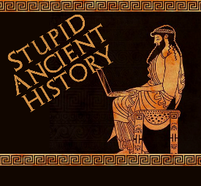
The Persians: 10: Nabonidus Chronicle

Most of these questions can be short answers- the intention is knowledge acquisition and recall rather than
higher level conceptual thinking. Questions marked with a * will require prose answers.

- What century is the Nabonidus chronicle from?
- Where is it from??
- What language is it written in

- Who was Nabonidus?
- Why does Nabonidus seem unpopular with his people??

- Briefly outline what the Chronicle says about Cyrus*

- Why might the Nabonidus chronicle not be 100% reliable when discussing Cyrus?

- Give 3 reasons why the Nabonidus chronicle is important

Extension

- Quickly compare the details in Herodotus and Nabonidus- what are the similarities and differences between the two.

Similarities | Differences

