Knowledge audit

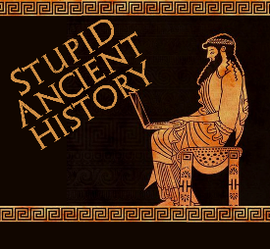
The Persians: 11: Cyrus Cylinder

Most of these questions can be short answers- the intention is knowledge acquisition and recall rather than
higher level conceptual thinking. Questions marked with a * will require prose answers.

- What is the cylinder made from?
- What language is it written in?
- Give one reason why it is important?

- What year was it created in?
- How does it describe Nabonidus, King of Babylon?
- What does it say about Cyrus’ conquest of Babylon?

- Briefly outline what the cylinder says about Cyrus’ treatment of the people, including the Jews.*

- Give 3 reasons why the Cyrus Cylinder might not be so reliable
- Why was the Cylinder important to the work of Herodotus?

Extension

- Quickly compare the details in Herodotus and other sources about the Conquest of Babylon to the Cyrus Cylinder- what are the similarities and differences between their versions of events?

Similarities | Differences

