Knowledge audit

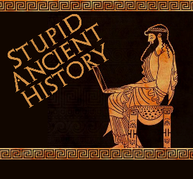
The Persians: 12 Udjahorresnet

Most of these questions can be short answers- the intention is knowledge acquisition and recall rather than
higher level conceptual thinking. Questions marked with a * will require prose answers.

- Who was Udjahorresnet?
- Which Persian king does his evidence relate to?
- What can we suggest about the relationship between Udjahorresnet and the Persians?
- Why might this make him more reliable?
- Why might this make him less reliable?

- Briefly outline what Udjahorresnet says about Cambyses.*

- Breifly outline what Udjahorresnet says about Cambyses and the Apis Bull.*

- Why is Udjahorresnet an important source?
- What sources did Herodotus use to get such a wildly different view of Cambyses?
- When was Udjahorresnet’s inscription made?
- Why would this be problematic?

Extension

- Quickly compare the details in Herodotus to Udjahorresnet- what are the similarities and differences between their versions of events?

Similarities | Differences

