Knowledge audit

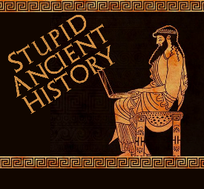
The Persians: 13 Darius becomes king

Most of these questions can be short answers- the intention is knowledge acquisition and recall rather than
higher level conceptual thinking. Questions marked with a * will require prose answers.

- How did Cambyses die?
- What problem did his death leave behind?
- What happened to his brother, Smerdis on the way back to Persia?
- Who secretly takes the thorne of Persia?
- Why do they think they can get away with this?
- Give one reason why the people don’t challenge them taking the throne.
- What does Otanes think about the new ‘king’?
- Why is he in a good position to find out whether ‘Smerdis’ is a fake?
- What does his daughter tell him that makes him even more suspicious?

- Briefly outline the plan Otanes hatches with his daughter.*

- Breifly outline what the Magi have Prexaspes do and what he does in return.*

- How do Darius and his friends get into the palace?
- Who kills the ‘fake Smerdis’
- How do they let the people know what has happened?

- Briefly outline the process for choosing the next king of Persia*

Extension

- Quickly compare the rise to power of Cyrus, Cambyses and now Darius. How do they compare?

Similarities | Differences

