Knowledge audit

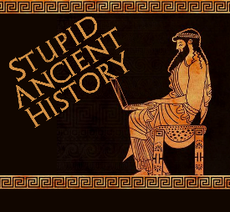
The Persians: 14 Darius secures his rule

Most of these questions can be short answers- the intention is knowledge acquisition and recall rather than
higher level conceptual thinking. Questions marked with a * will require prose answers.

- How did Darius come to power?
- Who is Atossa?
- Why is it important that Darius married her?
- How many kings revolt against Persian rule when Darius comes to power?

- Briefly outline how Darius responds to the 9 kings*

- What is the Behistun inscription and what does it tell us?

- How does Darius deal with the corrupt magistrate?
- How does Darius reorganise the empire?
- What does the ‘Grand Staircase’ tell us about Darius’ rule?
- Where would you find the grand staircase?

- Who/ what was Ahura-Mazda?

- Breifly outline how Darius viewed religion in his empire*

Extension

- Quickly compare how Darius ruled the empire compare to Cyrus and Cambyses. How much did Darius change about how the Persian Empire was ruled?

Continuity | Change

